Report
Air Quality Multi-Layer Web Application



João Nogueira
89262

https://github.com/Joao-Nogueira-gh/airQualitySpringBoot

1. Introduction

This document’s goal is to explain the strategy used while developing the ‘AirQuality’ application, taking note on the utilized sources, designed tests and code quality tools and its results.

2. Application Context and Sources

The application is based on the subject of air quality, aiming to provide values of pollutant gases and general air quality (Air Quality Index) of a given city anywhere in the world.

The source API utilized is developed by Weatherbit.io. The website provides several API’s related to air quality, including hourly weather forecasts, historical weather data, and data on the energy industry (total sun hours, wind direction, precipitation, etc).

Most of those are paid, excluding the Air Quality API. From their website:

“This Air Quality API returns a 3 day / hourly forecast of air quality conditions for any location in the world. It returns air quality data on the 6 major surface pollutants - PM 2.5, PM 10, CO, SO2, NO2, and O3. Additionally, this API returns an air quality index score (AQI).”

The API itself is rather ‘limited’ regarding the queries that can be made. It can be queried by city_id, postal code, latitude/longitude and city/country names. Given the options, the selected method to use on the website was to query by city and country.

In order to be able to utilize the API one has to register in the website and request a key that is provided after a short time. That key is required in order to make any request to the Air Quality API.

3. Application Technologies and Development

3.1 Technologies

As requested, the application was developed using the Spring Boot framework. Other used technologies/modules include Thymeleaf for the HTML data-binding, the H2 memory database to host the cached data, Junit for the multi-layer testing, Selenium for the web interface testing, and SonarQube/Jacoco for the code quality metrics.

3.2 Class Structure

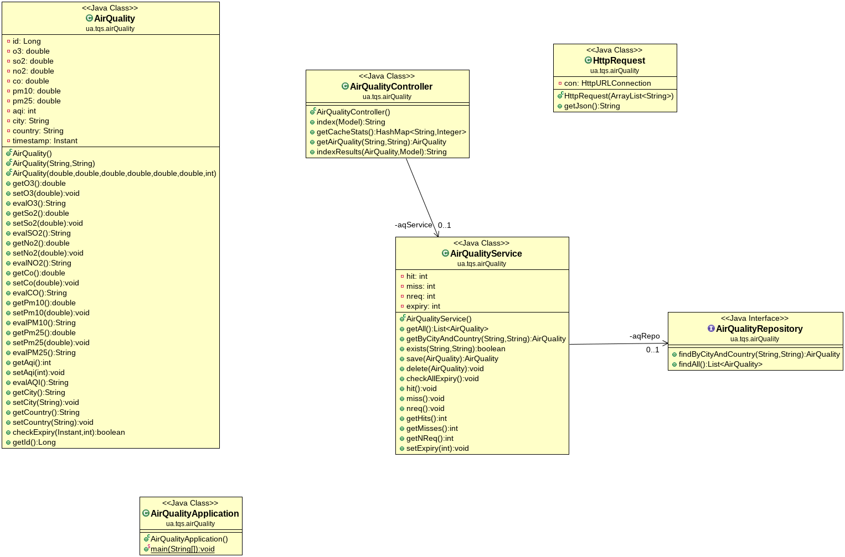Illustration 1: Class Diagram
Above is present the class diagram depicting the modules created in order to fully develop the application.

The main AirQuality class hosts objects containing the data for each user request (location, pollutant gases values and timestamp for caching purposes).
The helper class HttpRequest handles the connection from the website to the external API.

The AirQualityRepository, an interface implementing a normal Spring Boot JPA Repository, with useful methods for saving, deleting and querying objects in the H2 memory database.

The AirQualityService providing useful methods on the repository, serving as a bridge between it and the controller.

And finally the AirQualityController, coordinating everything happening on the web-page and internal API.

3.3 Application flow

All of these interactions are shown in the provided video ‘airquality.mp4’.

Website:

The user arrives on the main website page. He is asked to select a city and country in order to obtain its air quality information.

If the provided data isn’t valid a simple error page is returned and the user is given the option to go back to the main page.
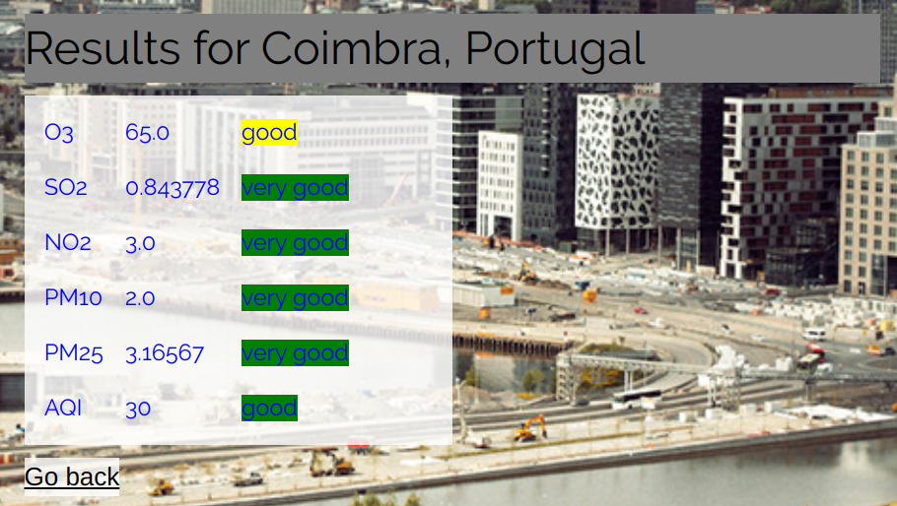
If the data is valid the results page is shown. The values of the 5 pollutant gases are shown in a table. By analyzing those data values range, a label/color pair is presented next to it, for example very good=green. According to the AQI Index the background image also changes between a polluted/non polluted city.

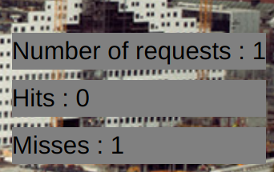
On the side of the page stats on the implemented cache are shown. The number of total requests, cache hits and cache misses.

Internal API:

The internal API provides similar services to the web-page, giving the gases values when querying by location (http://localhost:8080/home/api?city=Paris&country=France), or providing the cache stats (http://localhost:8080/home/api/stats).

3.4 Cache

In order to implement a basic caching service, all the requests, related to a given location are stored in the H2 memory database with a timestamp of the created instant. Subsequent requests for locations already in the database are returned directly instead of querying the external API (cache hit).

After a predefined time (TTL) which is set to 20 seconds for testing/ demonstration purposes, the cached objects are ready to be deleted. However, this TTL is not checked in real-time, instead, it is checked only whenever a request is made to the application. This means the data can persist in the memory database for quite some time if the application services are not being used. Therefore it doesn’t seem to be an extreme problem to the application functionalities, given it was also asked to be implemented ‘in a basic way’.

4. Testing

TODO WHICH TESTES PER LEVEL

The application includes testing on the various layers, tests on the Controller, the Repository and the Service modules, examining their basic functions. The tests were developed and ran successfully.
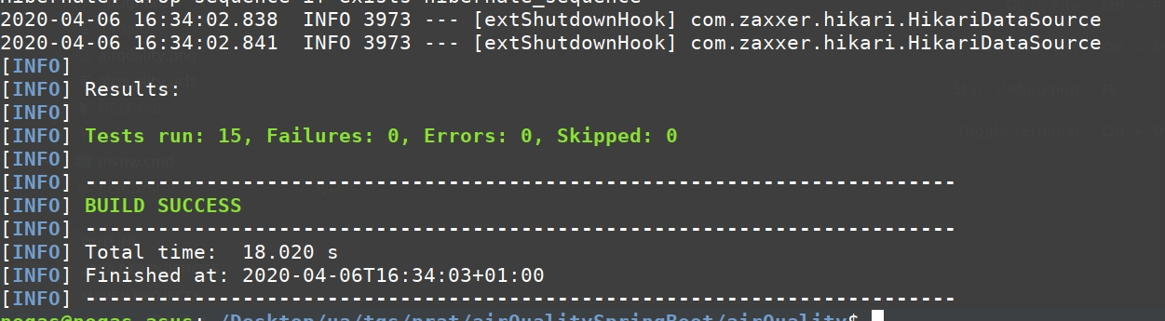
A simple test on the web interface was performed using the Selenium Web Driver, which was then exported to Java and adapted in order to run together with the remaining tests.

5. Code Quality Metrics

The code quality metrics and coverage were obtained using the SonarQube platform together with the Jacoco plugin.

REPORT.TXT

