12- Convergence of simulated annealing: how to formulate it, how to compute it.

- Does simulated annealing find the global optimum and under which conditions?

Simulated annealing can be analysed mathematically, it converges in probability.
It gives a solution arbitrary close to the global optimum with a probability arbitrary close to 1
- The conditions are:
  - Movements are inversible
  - Any point in the search space can be reached from any other point in a finite number of movements
  - The initial temperature must be large enough (do exploitation before exploration)
  - The temperature should not decrease too fast, at iteration t:
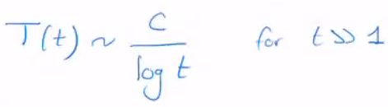

C is an unknown constant that reflects the variation of E in S.
!!! If temperature is decreased too fast, we risk not converging (quenching) !!!
- In practice, log t is too slow. So, temperature will decrease faster

How to compute it:


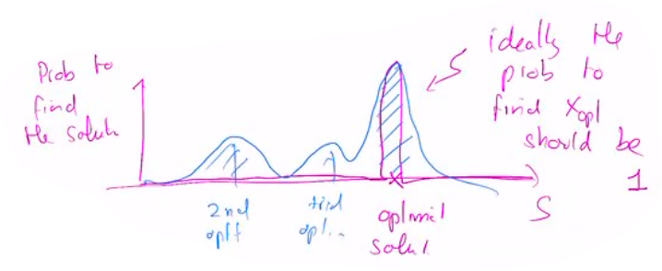
If we get 100% of success there is convergence, in practice it may end up sub optimal

