28- The parallel tempering.
- Parallel version of SA

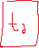
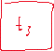
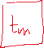
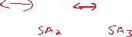
- We have many replicas of SA
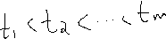

- As opposed to standard SA, here the temperature of each Sai is constant (might change just a bit), all these Sai run in parallel. They will interact by exchanging configurations (current solution)
- Neighbouring systems can exchange their current solution according to a probability law
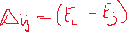
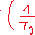
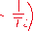
- Let’s consider 2 systems, i and j=i+1 (neighbours) with temperatures Ti and Tj, and current solution Ci and Cj, with energy Ei and Ej

- If Ti < Tj and Ei > Ej -> is negative, and pij = 1
- What this means, is that if we have a good solution at high temperature, it will always exchange with a less good solution at lower temp
- The opposite is also possible, a good solution in a high temp can also go to a higher temp, with p < 1

! in parallel tempering the temperature schedule is distributed across the replicas of SA, and not over iterations !
- At low temperature we exploit the solution
- At high temp we explore other solutions and other regions of S
- Exchanging configuration is a way to combine diversification and intensification

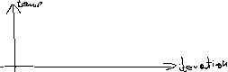
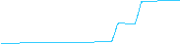
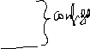
GUIDING PARAMETERS
It obviously depends on how we define our parameters
- How many SA? M is often: M=sqrt(N) -> N is the problem size
- At what frequency should we consider exchange of configuration? When both systems reach an equilibrium state, according to the SA definition
- What is the range of temperature between T1 and TM? T1 should be small enough to allow the convergence, TM should be large enough to allow exploration (TM = T0 of standard exploration)
- We can fine tune the temperature of each system over time, if the exchange rate is too large > 2% we increase the temperature difference between all systems
- If the exchange rate is too low < 0.5% all temperature difference between the systems is decreased

