10 - Simulated annealing, main principles and the Metropolis rule
- Inspired by nature (by physics and metallorgy more specifically)
- Annealing is a process by which a sample is cooled down slowly -> finds global min
- Quench it is a quick cooling down -> finds local min
- Fitness function is called energy function
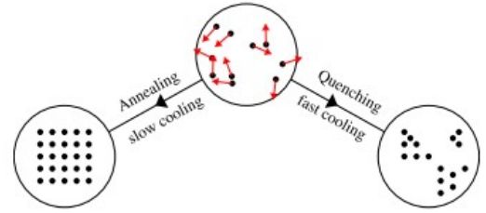
Nature minimizes energy with theses processes, and we want to capture this same property with our algorithm

- We start with high temperature, in this state the system explores many possible states
- When the temperature starts to cool down the system is “trapped” does exploitation process
The hope is to have found the global min with the use of both exploration and exploitation

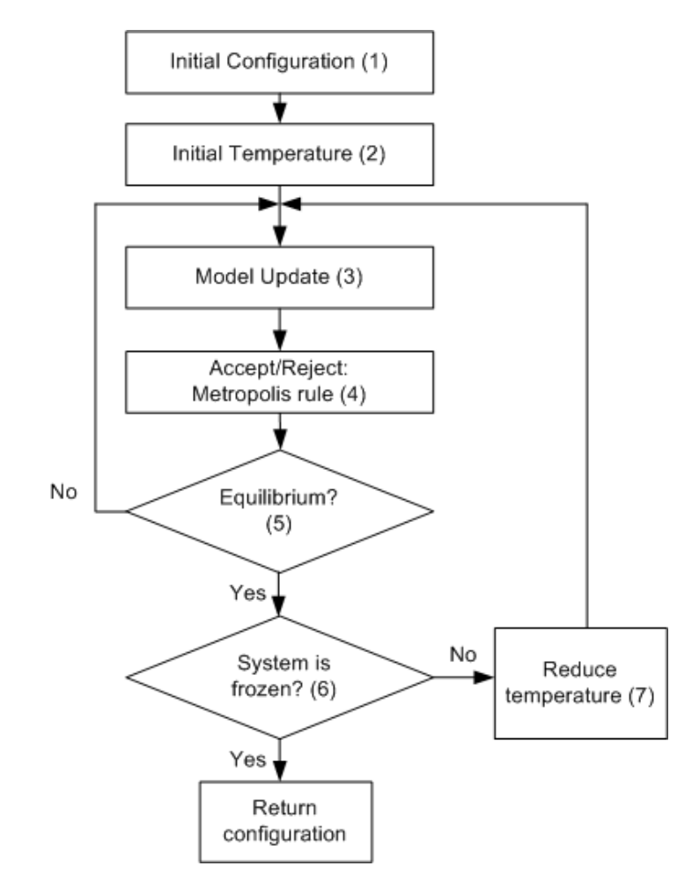
Algorithm:
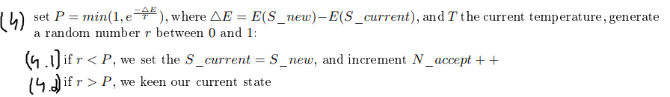
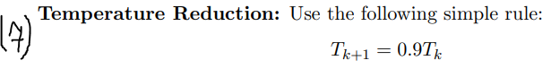

The current state at the last step -> is the one we return
Metropolis rule:

The metropolis rule makes sure we always accept a lower energy state:
  - Because: E(S_new) – E(S_curr) < 0 => E(S_new) < E(S_curr)
  - And when E(S_new) – E(S_curr) < 0 => P = 1, we accept the new state with probability P=1

If the state is of worse energy:
  - Because: E(S_new) – E(S_curr) > 0 => E(S_new) > E(S_curr)
  - Then there is a chance we accept it still, the higher the temperature, the higher chance to accepting it
