11 - Simulated annealing, flow chart and choice of parameters
- Inspired by nature (by physics and metallorgy more specifically)
- Annealing is a process by which a sample is cooled down slowly -> finds global min
- Quench it is a quick cooling down -> finds local min
- Fitness function is called energy function
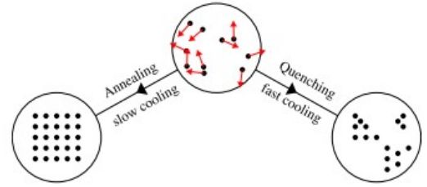
Nature minimizes energy with these processes, and we want to capture this same property with our algorithm

- We start with high temperature, in this state the system explores many possible states
- When the temperature starts to cool down the system is “trapped” does exploitation process
The hope is to have found the global min with the use of both exploration and exploitation

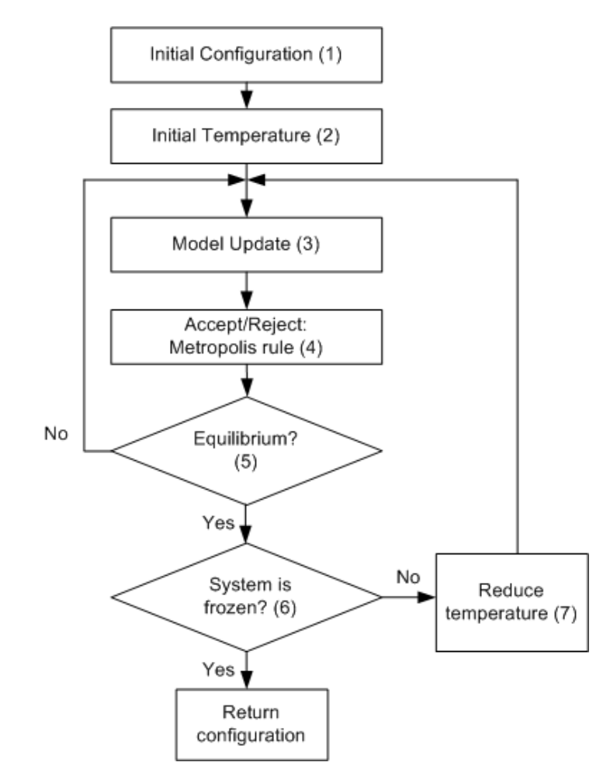
Algorithm:
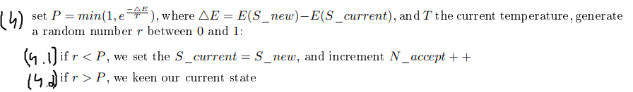
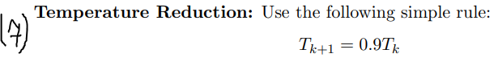

The current state at the last step -> is the one we return

choice of parameters:

equilibrium:
at step (5), to check if we are at an equilibrium, we check that we have tried 100*n states, or accepted 12*n states -> depending on these values it will be faster or slower have less good or better results

system frozen:
a system is frozen – stop condition – if for the last 3 temperatures there was no fitness improvement -> can increase the number or decrease

temperature:
tk+1 = tk *0.9 -> can lower 0.9 to be in quenching (faster cooling) -> usually worse results

initial temperature might be too low if our random initial state has a low energy

