13- Ant-like algorithms: swarm intelligence, the pheromone trail, and observations about real ants.
These are algorithms that try and mimic effects we see in nature
- Ants as a group can solve difficult tasks, like finding the best path between the ant colony and a food source

- The important properties of swarm intelligence are:
  - Collaboration is the key to the group’s success (the intelligence of the group is more than the sum of the individuals intelligence)
  - This effect of swarm intelligence is also called complex systems, which are a collection of simple entities that interact
  - It results in an emergent behaviour which cannot be understood by any single entity
  - Such behaviours are visible through large scale spatial and temporal organization, sometimes called self-organizations
  - !!! there is no central control, every action is spontaneous !!!

Advantages:
- Robustness to fault tolerance: the process can continue even if an entity disappears
- Possibility of adaptation to new situation
- Natural parallelism in the process, since all entities are ‘independent’

Pheromone trail:
- Ants use pheromones to find the shortest path, ants can deposit pheromones to attract other ants to a promising location
- This process is called chemotaxy
- Ants choose the path that smells the strongest
- Pheromones will evaporate over time (how ants forget a suboptimal path)

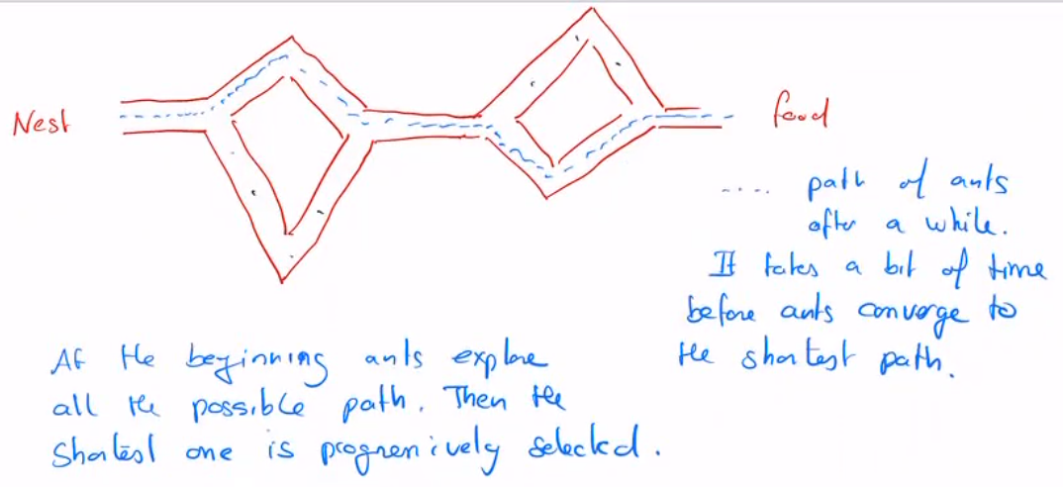
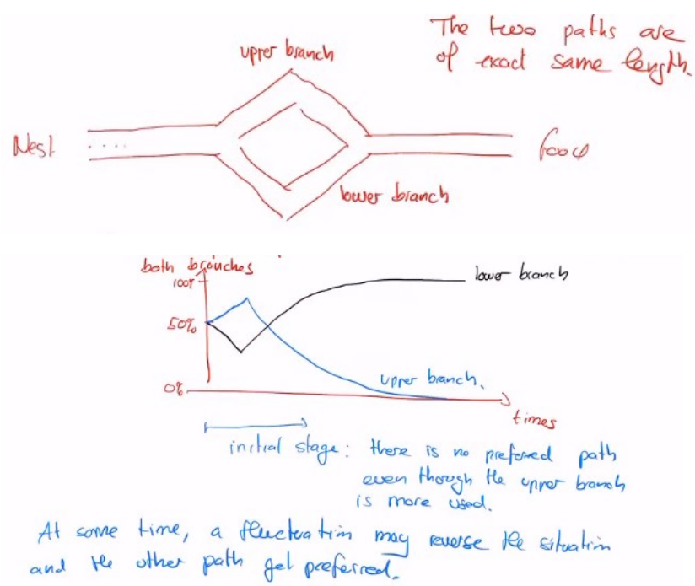
This experiment was run 10 times, and 9 times out of 10, 100% of the ants were on the shortest path. The 10th run, only 80% were on the shortest path.

Explanation:
- We start with no pheromones on the path, so every ant chooses a path at random, leaving pheromones in the trail
- At the second run, it uses the pheromones to choose a path, this path then receives even more pheromones, which attracts even more ants, and so one
- At the end they end up with the shortest path

