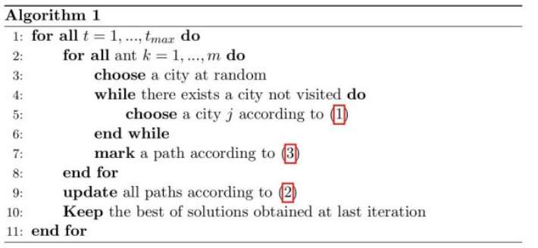
14- Ant System: description of the algorithm for the TSP problem

(1)
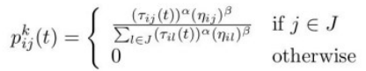
First off, J is a set of cities not yet visited in the ant’s path, so only cities unvisited can be the next city chosen.
Each unvisited city has a probability of being chosen, this probability is a function of:
(Pheromones in a path to a city * visibility of the city)/
(Sum of all pheromones*visibility for all cities unvisited)

(2)
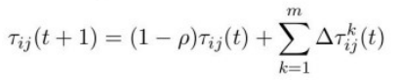
This function allows us to update the pheromones in each path at each iteration, there is an evaporation rate ρ, so each path has some of its pheromones that evaporates + an integer that is a function of how many ants took this path -> this value is given by formula (3)

(3)
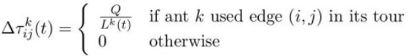
Q is a constant, Lk is the length of the path taken by the ant -> the longer the path -> the smaller is the result -> less pheromones in this path during the next iteration
