15- Ant algorithms: the simple version in {0,1}^N, and discussion of performance
What we are doing here is a benchmark of this algorithm!
- We will consider a simpler version of the ant algorithm
- We want to find a bit string which maximizes a given fitness function: S={0,1}^N
- This makes it so the search space is a tree structure, at each step (node) we have two options for the next bit, 0 or 1. This tree has length of N

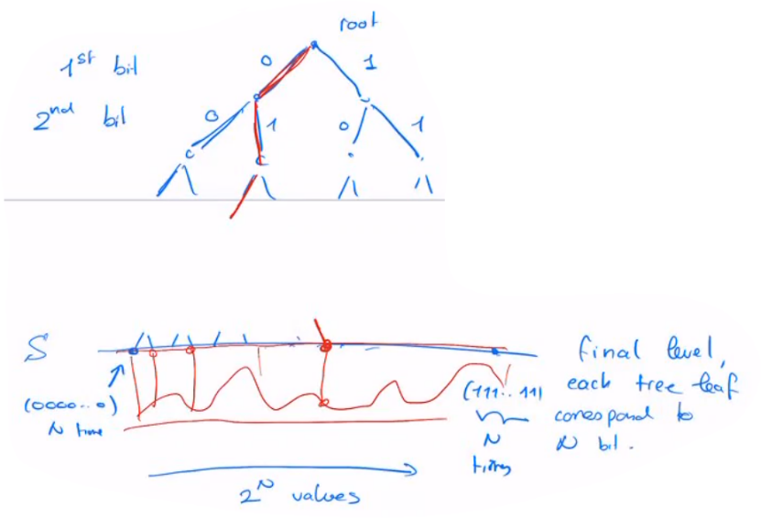
Visually it looks like this:

For every value of the search space -> 2^n, there is a fitness function that evaluates the path, then the deposited pheromone on this path is a function of the fitness function result
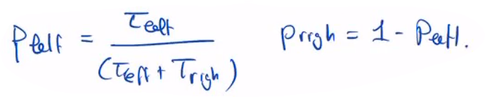
- At each bifurcation an ant will more likely choose the path that has the most pheromone, each path has the following probability of being chosen:

