2 - Main principles of metaheuristics, neighbourhood, movements, exploration operator, population metaheuristics

GOAL of metaheuristics: explore a large search space in a clever way. It is needed to solve large problems, for which only exponential algorithms are known
- It is a compromise between CPU time and quality of solution
- No guarantee on the quality of the solution
- As opposed to heuristic where the algorithm is specific to a problem, metaheuristic algorithm can be applied to many different problems

Characterization:
- no hypothesis on the mathematical properties of the fitness function
- Require guiding parameters that defines how the space should be explored. The quality of the solution will depend on how good these parameters are
- need a starting point (usually random)
- need a stopping condition (iteration, no more improvement, time, value …)
- inspired by natural processes (ant system, beehive …)
- can be parallelisable
- most of them are stochastic, use random numbers to guide a search

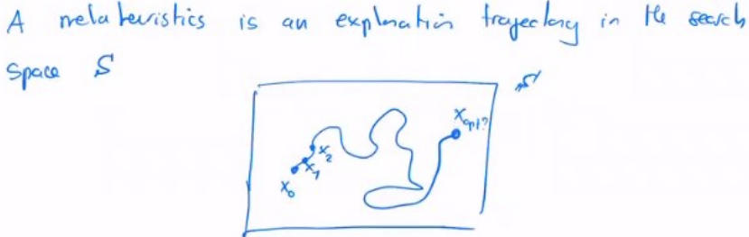
Main principle:

To move across the search space, we use the concept of neighbourhood.
- If we are currently exploring a point x, the next point we explore is a neighbour of x
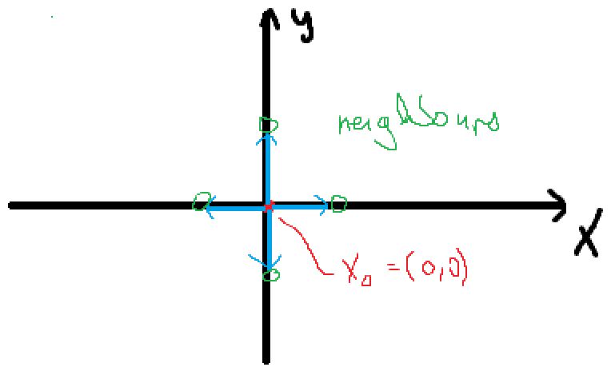
- The neighbourhood is found by doing elementary transformations on the current explored state. neighbourhood of x is called V(x)
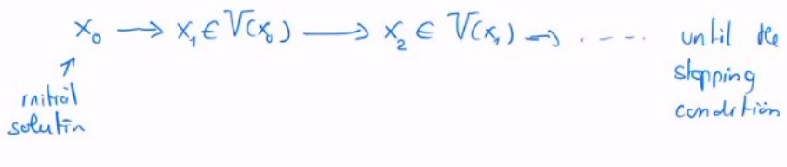
Search operator:
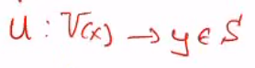
- When we are at a state x, we find its neighbourhood V(x), and now we need to choose which neighbour to explore next.
- This is done via the search operator ->
