5 - Random search, random walk, hill climbing

Random search:
The simplest search method is random search where the next point to test in the search is chosen uniformly at random in the whole search space S. Usually, one keeps the solution having the best fitness after having performed a prescribed number of steps.
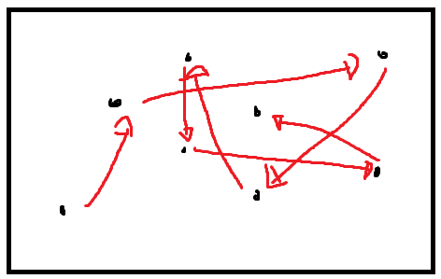

Random walk:
random search to the neighbourhood of the current solution then we have what is called a random walk-in search space.
- We don’t use the operator function to choose which is the best neighbour to explore
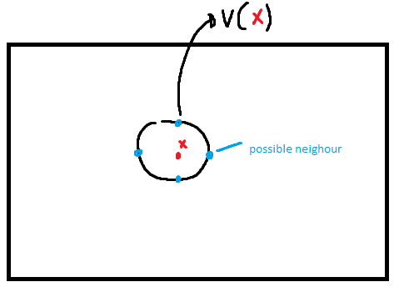

Hill climbing:
More logical one, we start at a random point x, loot at all our neighbours and choose the one that has the highest (or lowest, depending on the type of problem) fitness to explore next, gives it an effect of climbing (or descending) an hill
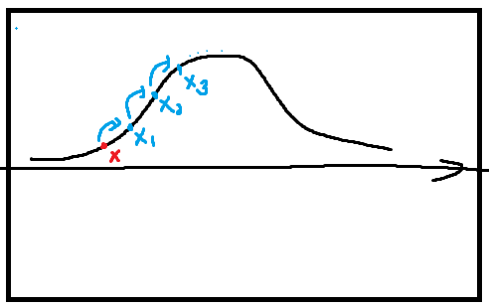

We stop when we have climbed the hill -> all neighbours are lower fitness than the current state.

Comment:
Of the three methods the one with the highest chance is the hill climbing. However, it is very easy to get stuck in a local minimum / maximum, it highly depends on the starting point:

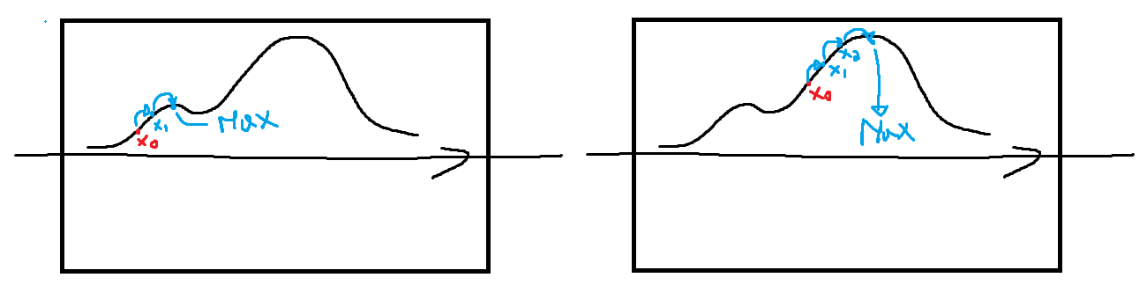
as we can see, on the left we got stuck in a local maximum.

Its performance highly depends on the landscape as well

