7- Tabu Search: main principles and convergence
Used for quadratic assignment problem and TSP
- The search space is explored by going from neighbour-to-neighbour xn → xn+1 ∈ V(xn)
- The xn+1 is chosen by the search operator, as the non-tabu xn+1 that locally optimizes fitness -> (independent of the current fitness of xn -> can be worse) -> if many points have the same fitness, it is random choice
- A tabu list, is a list of already explored states, so that we don’t go back
- However, it is possible for a state to leave the tabu list -> after a certain amount of iterations

Tabu list -> prevents us from going back
The fact that xn+1 can have worse fitness than xn means we won’t get stuck in local max
A state can go out of tabu list, so that the code doesn’t get stuck
- This is why we need the list to be updated (if we are in red state, we are stuck):
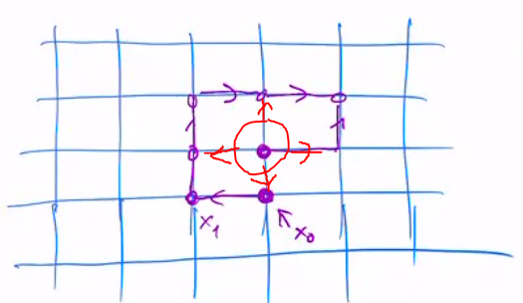

Convergence:
To converge means to find the global optimum!!
-tabu search will converge if:
- the search space is finite
- neighbourhood is symmetric: x in v(y) ⬄ y in v(x)
- any state in the search space is reachable by a finite number of steps

- Memorizes all the visited points, but allows the trajectory to use the oldest tabu point to unlock itself -> will visit all the search space -> and find the optimal solution

Flowchart of tabu list algorithm:
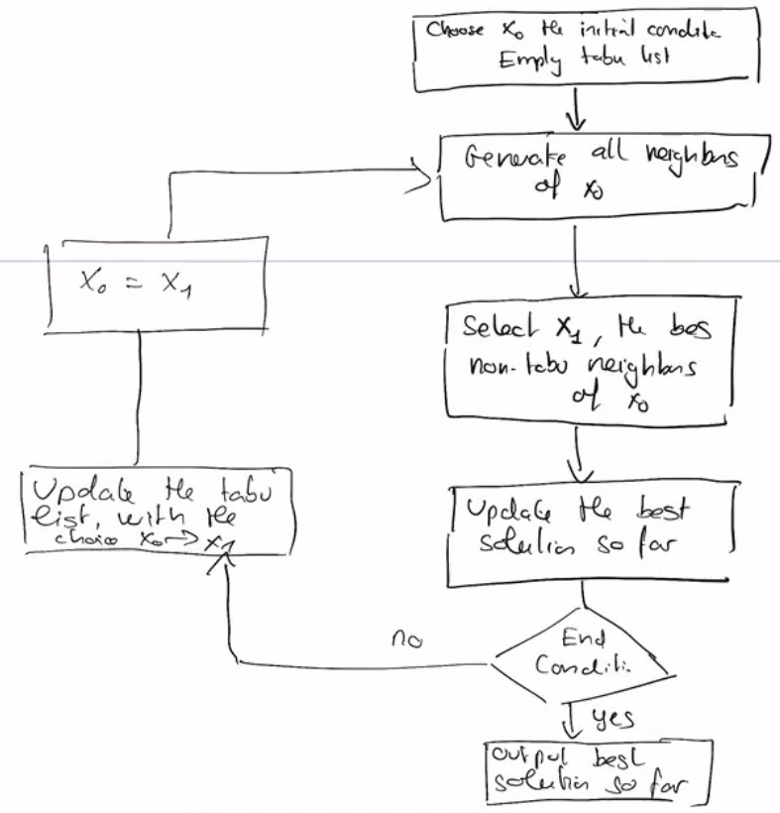

Example of the same search space, with 2 different tabu list memories:

