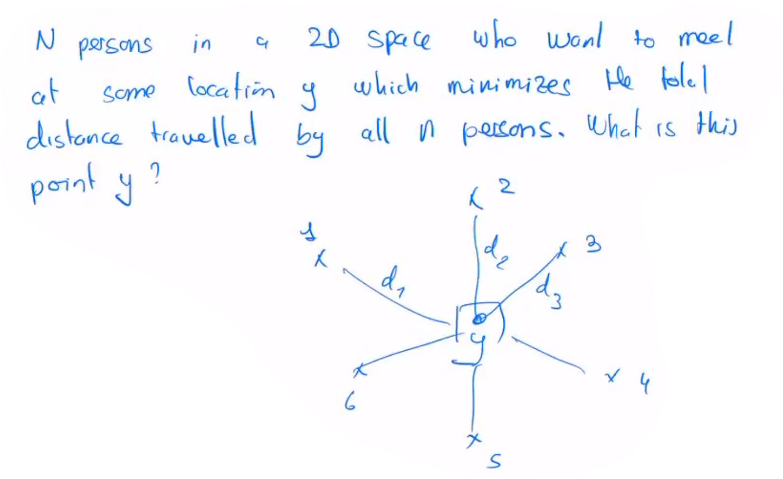
1 - Optimization problems and the search space

- The search space S, is a set of possible values for y
- If the problem is in R^2 -> the search Space is R^2, all different possible values for y
- The search space can be continuous discrete finite or infinite
- If the search space is too big, we can’t do an exhaustive search

- Lets define a function f: S -> R, this function is called objective function, cost function, energy function, fitness function ..

- Its goal is to quantify a possible value y of the search space S, this way we can compare 2 different possible values for y and choose the best one. The main goal being to find the best value possible for y.

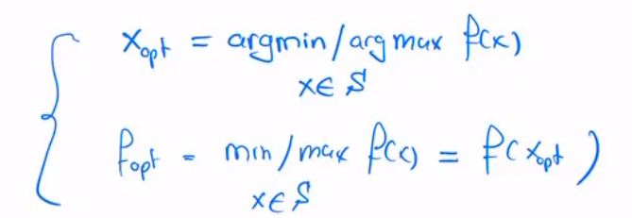
- This optimal value will either minimize of maximize the function f

- This Xopt may not be unique

- One difficulty for these problems will be to distinguish global optimums from local optimums, visually it looks like this:
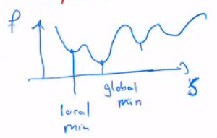

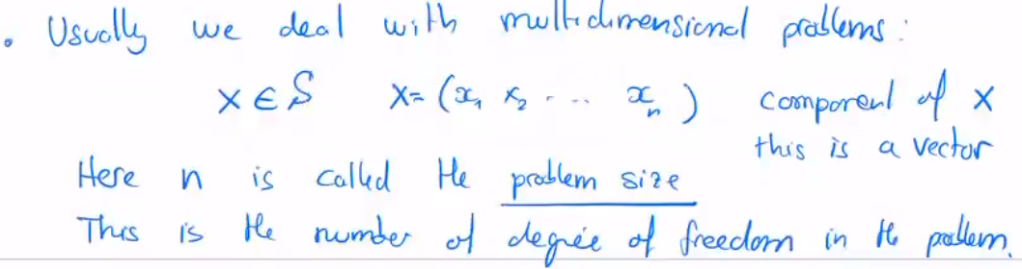
s

metaheuristics is the way to explore S when no polynomial algorithms exist to find the optimal solution

