4 - Complexity and the need for metaheuristics, exploration versus Exploitation
Complexity classes:

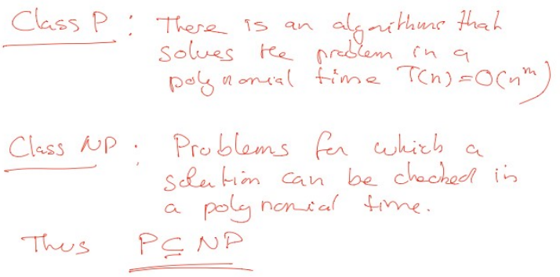
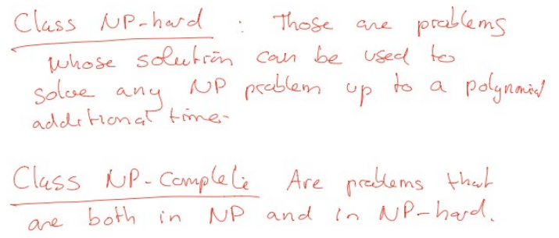

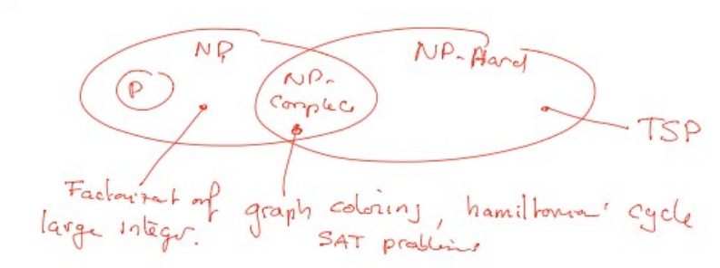

Typically, NP-hard and NP-complete problems can be solved by exponential algorithms

Example:
Hamilton cycle: find a graph that goes through all nodes once and only once can use TSP to be solved.

Exploration vs exploitation:
In all cases, a metaheuristic traverses the search space trying to combine two actions: intensification and diversification, also called exploitation and exploration respectively
- (exploitation) intensification phase the search explores the neighbourhood of an already promising solution in the search space
- (exploration) diversification a metaheuristic tries to visit regions of the search space not already seen

