17 - The Firefly algorithm
- Inspired by PSO
- Fireflies attract a mate or prey by emitting light, the higher intensity the higher the attraction is
- For continuous optimization, but exists for discrete

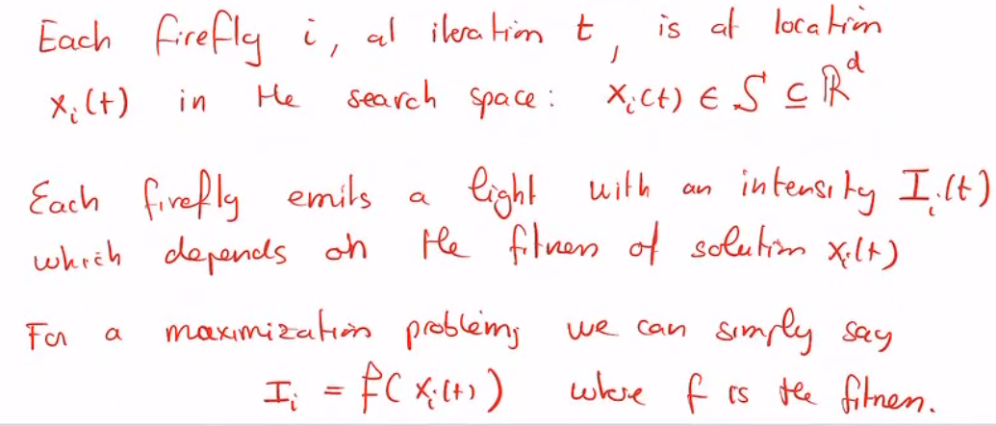
ALGORITHM

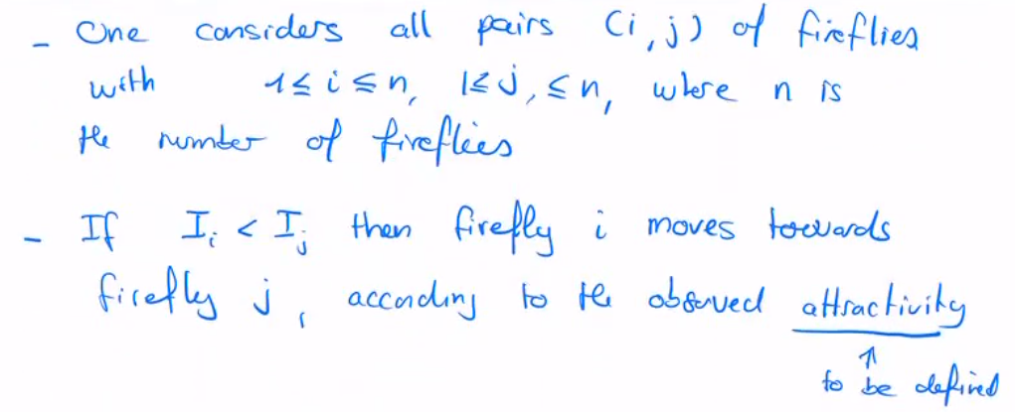
At each iteration, the fireflies move according to:

Attractivity:
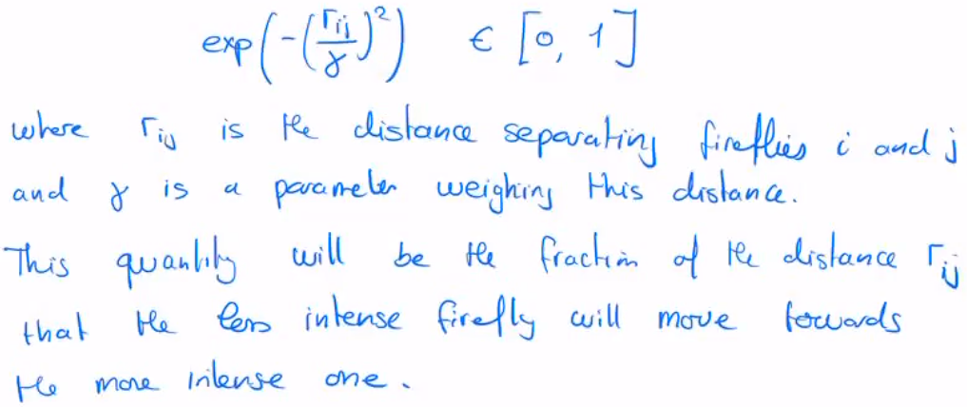

Depending on how we define this attractivity will affect far away fireflies, depending on how it is tuned it will be exploration vs exploitation
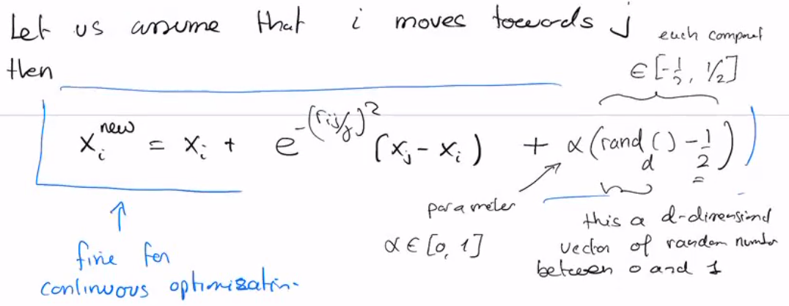
Movement:

Code:
- Initialize the fireflies position randomly in the search space
- for every couple (i,j) of fireflies
- if intensity of i < intensity of j, we update position and intensity of firefly i

- we don’t change firefly j!!!

