18- Genetic algorithms: inspiration and algorithm
- Inspired by Darwin evolution
- On représente les individus dans S par des chromosomes ou son patrimoine génétique
- Le degré d’adaptation est donné par la fitness
- The population evolves at each generation
- We choose the best individuals over the less fit ones
- The population size stays constant over generations

- We will mostly consider maximization problems

ALGORITHM:
- We start with a randomly generated generation
- The next generation is derived from the previous one by following the steps bellow

- Select the best individuals in the population (many strategies can be applied here)
- Apply recombination/ crossover among the individuals as well as mutation

- If the genetic process loses the best individual, it is readded to the population by replacing the current worse! Which means we track the global best

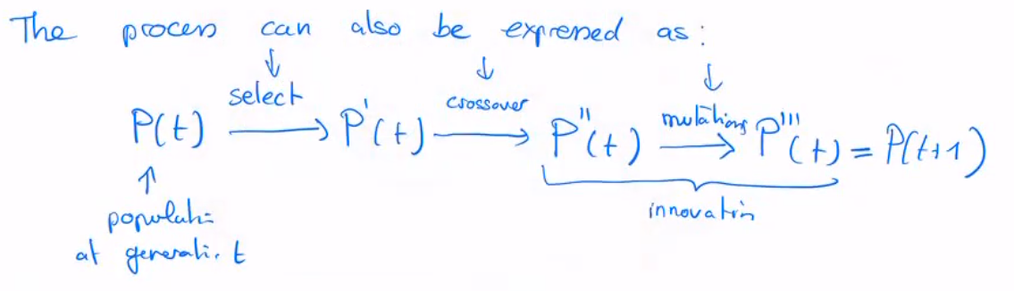

The selection process focusses on exploitation, and mutation focus on exploration
Crossover does a bit of both -> exploration a bit more

