19- The different selection operators
There are several ways to implement the selection step
- Fitness proportional
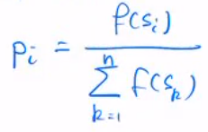
Draws with replacement, we choose randomly n times an individual from the current population. The induvial is chosen proportional to its fitness
More chance to choose a high fitness individual
There can obviously be copies of individuals
Il faut faire attention à s’il y a des individus avec une fitness négative
- Selection by rank
We set the individuals in an order depending on their fitness value (by rank), this works with negative fitness results, as well as for minimization problems
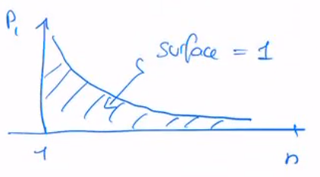
For each rank we assign a probability of the individual being chosen, by having higher probability for higher ranked individuals

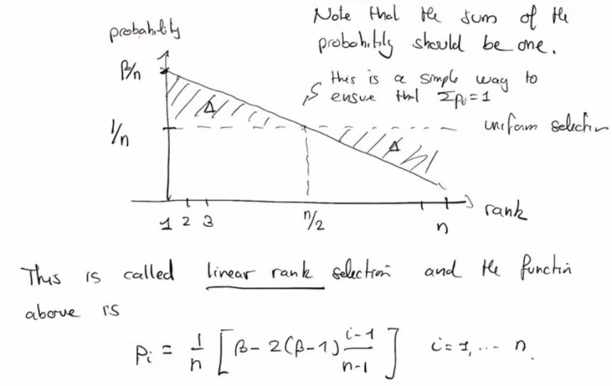
- Selection by linear rank



- Selection by tournament
k-tournament selection -> draw k random elements from the population, each individual having 1/n probability of being chosen
from the k chosen individuals, select the one with the highest/lowest fitness depending on the problem
do this process n times
- One doesn’t need to define a fitness function, just needs to be able to compare individuals

