20- The takeover time in genetic algorithms: goal, definition, value for tournament selection.
Quantify how fast a selection mechanism eliminates all but the best individuals
Let’s define the takeover time as the number of selection rounds (no crossover and mutation), to have only the best individuals
It measures the intensity of selection:
- Is small -> strong selection

- Is large -> weak selection
“large” and “small” is proportional to size of population n -> we will show that
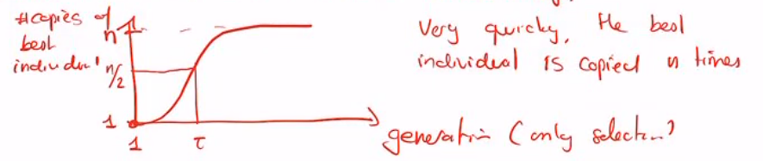
- Selection is often exponential
Theory:
- The number o copies m(t) of the best individual at generation t goes as:
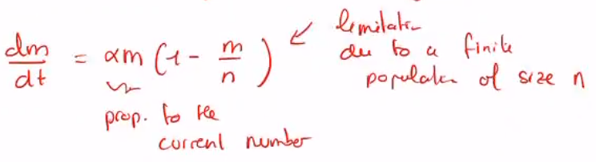
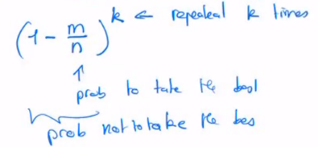
This solution for tournament selection:
At each selection we have a probability of choosing the best individual:

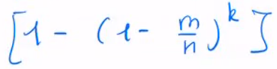
As well as the probability of choosing the individual at least once:

