24- Evolution Strategy: individual and population versions.
Single individual metaheuristic evolving by mutation only

Population version also including crossover
Metaheuristic for continuous optimization

(1+1) ALGORITHM -> 1 parent and 1 child
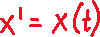
- The child is produced by a gaussian mutation of the parent:
- X’ is the child, x(t) the parent, and N(0, ) is the mutation
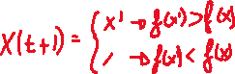
- The mutation follows a normal distribution
- The child is only accepted if its fitness is better than the parents
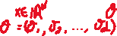
- The which means is also a vector

- Each dimension can have a different
- (1+1)-ES is much like a random walk search with hill climbing strategy
- If we are accepting too many children, we increase , to make larger jumps
- If we accept too few children, we decrease
- We should want to be around 1/5 acceptance rate
POPULATION ALGORITHM
The size of the population (nb of solutions) is denoted
Each individual is represented as
Is the associated mutation parameter
There are 2 variants of the population approach:
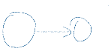
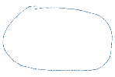

( )-ES: children generated from parents

( )-ES: in this case children are generated from the parents, are selected

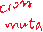
This last selection is deterministic, we choose the
best individuals

CHILDREN GENERATION
MUTATION
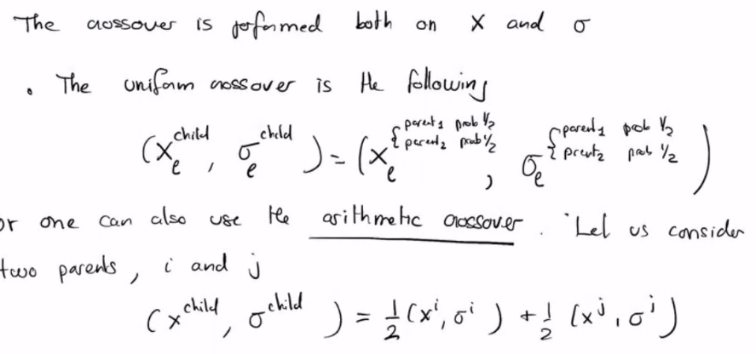
- Choose 2 parents among the possible parents
- Apply mutation to that child
- Repeat times to generate children
