25- Performance of metaheuristics: examples, specificities of the performance evaluation, metrics, approach, "No Free Lunch" theorem
- No guarantee of quality of solution
- They are stochastic, so the behaviour is always different
- To determine the success of an algorithm in a problem, we must use statistics
EXAMPLE:
- Let’s consider SA for TSP, we have n towns randomly placed in a 2x2 spatial region
- We will generate many such problems, varying N
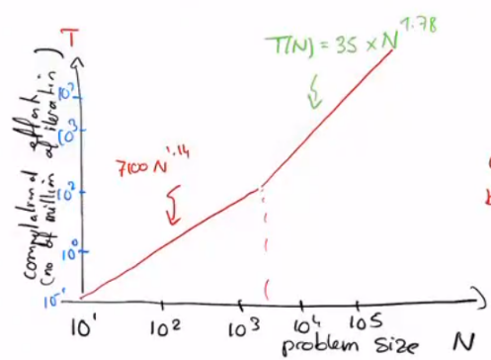
- Our question is: how long does it take does it take for SA to give an answer? (This does not mean that the answer is the global optimum, but when SA stops)
- Performance speed:
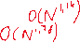
  - With N [20,2000], the difficulty is linear
  - With N [5000,50000], difficulty is which is smaller than quadratic

  - It is also much better than exhaustive search

- Performance quality (1):
  - To compute the quality of a solution one must know the best solution for a given problem
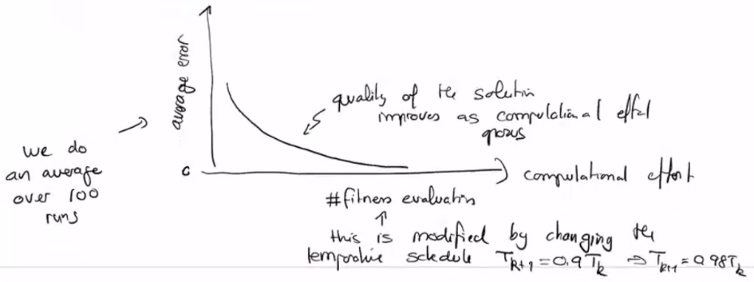
  - We will place 50 cities in a circle and see how SA finds an accurate solution

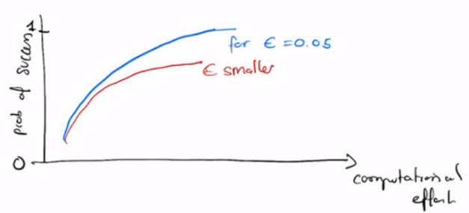
- Performance quality (2):
  - We can also compute the probability of success, out of 100 runs, how many gave us the global optimum? (accuracy of )

The metrics used to evaluate a metaheuristic are:
- The complexity in time to get a solution
- Average error as a function of computational effort
- Probability of success
- Statistics are needed, between 100 and 1000 runs



