26- Phase transition in optimization problems: problem description and properties.
We will analyse statistically a metaheuristic for solving problems of increasing difficulty
We will consider a sub-class of satisfaction problems
We will analyse this problem analytically, we will define the probability that a random instance of the problem has a solution and whether the metaheuristic will find this solution


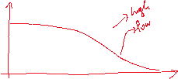
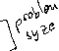
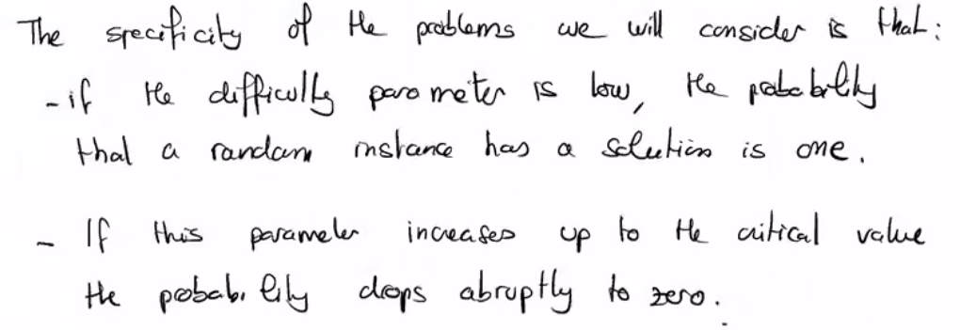
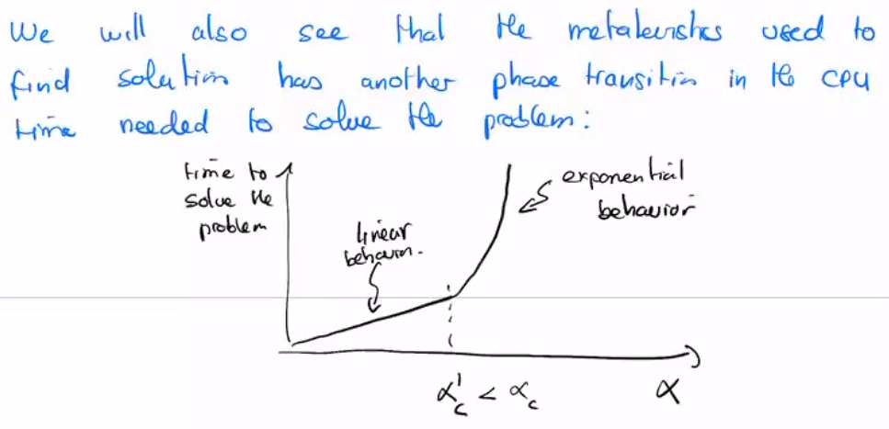
This abrupt behaviour is called phase transition

SAT Problem has N Boolean variables and M Boolean equations
We want to find an assignment of these N variables that satisfy all M equations
The goal is to find an assignment of these N variables that satisfy all M equations, if it exists, we say the problem is satisfiable
These problems can be turned into an optimization problem, the goal is to minimize the energy E, which is the number of unsatisfied equations
- Example with only XOR operation
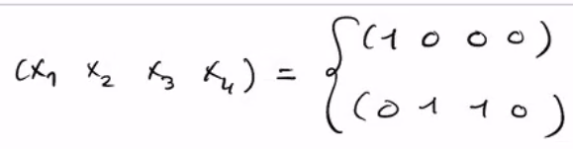
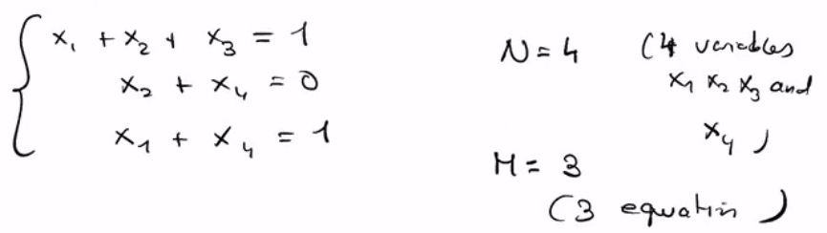
- This problem has a solution, so the minimal energy is 0, if a problem can’t be satisfied, then its energy optimal is 1

