27- Phase transition in optimization problems: the RWSAT algorithm and its behaviour.
RWSAT (random walk SAT) can be used to find solution to any SAT problem, in particular XORSAT problems.

Pseudocode:
- N variables, M equations, k variables per equation
- Initialize all N variables at random
- Compute E # of UNSAT equations
- t=0 # number of iterations
- while E>0 and t< tmax:
  - choose at random one of the non-sat equations
  - choose at random one of its k variables
  - set this variable to its complement # 1 -> 0, 0 -> 1
  - compute E #might have worse energy than before the change
  - t = t + 1
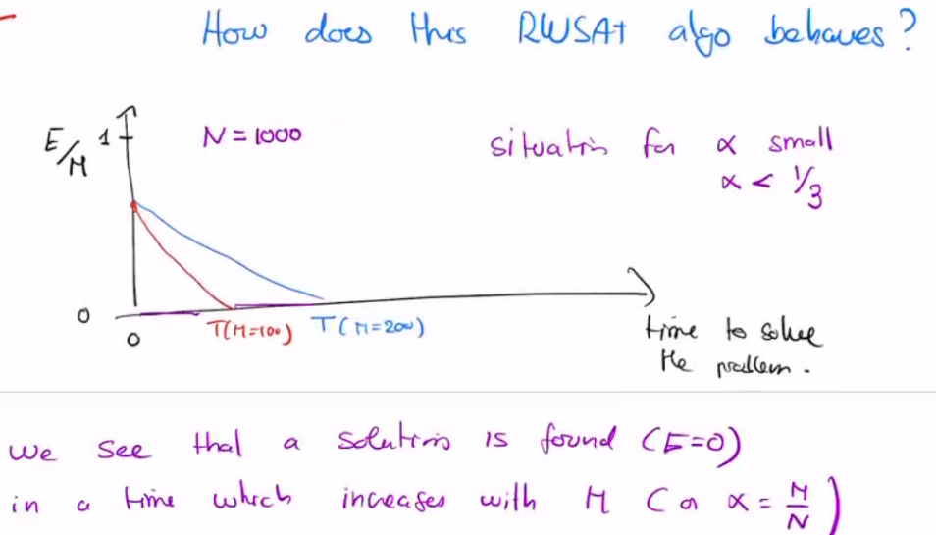
- print E, t # t is time to solution

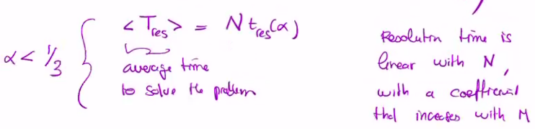

HOWEVER, when = M/N increases, the average execution time becomes exponential
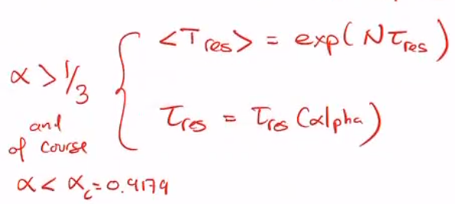
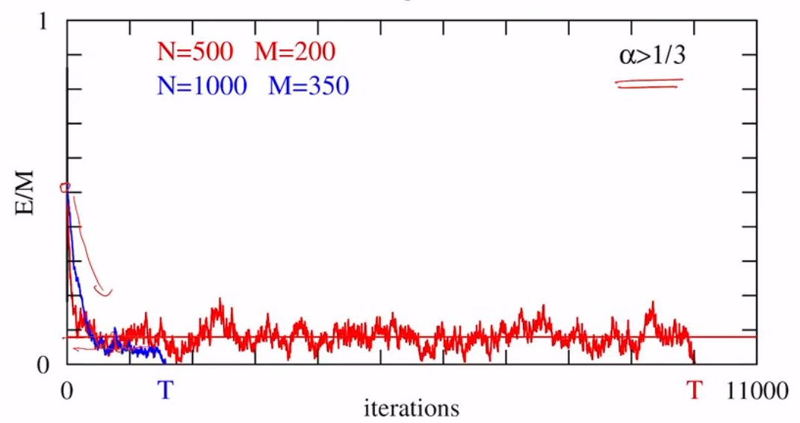 as we get to 0, we start oscillating

