Joao Filipe Costa da Quinta
Chosen chapters – computational imaging TP3

(1)
Obviously, phase is an important part of the FT of an image, so when applying the inverse transformation, if we change the phase parameter, the reconstructed image won’t be good. Might not even be recognizable.
For example, take the infamous image of lena, and the image of aldo. And let’s reconstruct an image using the magnitude of Lena and the phase of aldo. The resulting image is completely unrecognizable from both original images. However, I should say that some other mixes of images might result in a better reconstruction, this one is especially bad quality.
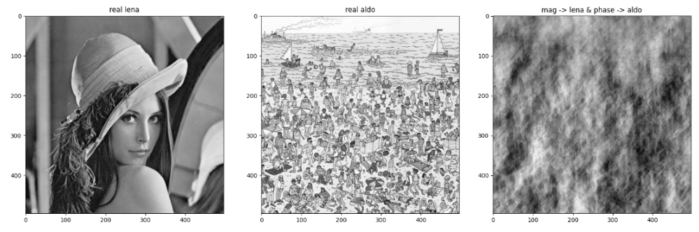
(I couldn’t run the matlab script, but I did one of my own with different images)

(2)
The goal of the Fourier ptychographic microscopy (FPM) is to reconstruct a high-resolution image from a low-resolution image.
This algorithm consists of acquiring a set of images under the illumination of a coherent light source, each image of the set is illuminated at a different angle. The images set is then combined by using another algorithm, the phase retrieval algorithm. This results in a high-resolution image.
This technique can be used on a conventional microscope, resulting in an improvement of the resolution by a factor of 2. One can also use the microscope with a lower numerical aperture (for a larger field of view) and keep the same resolution.

While running the script that tests the described algorithm, we can see that the quality of the reconstructed images is excellent, as seen in the image below:
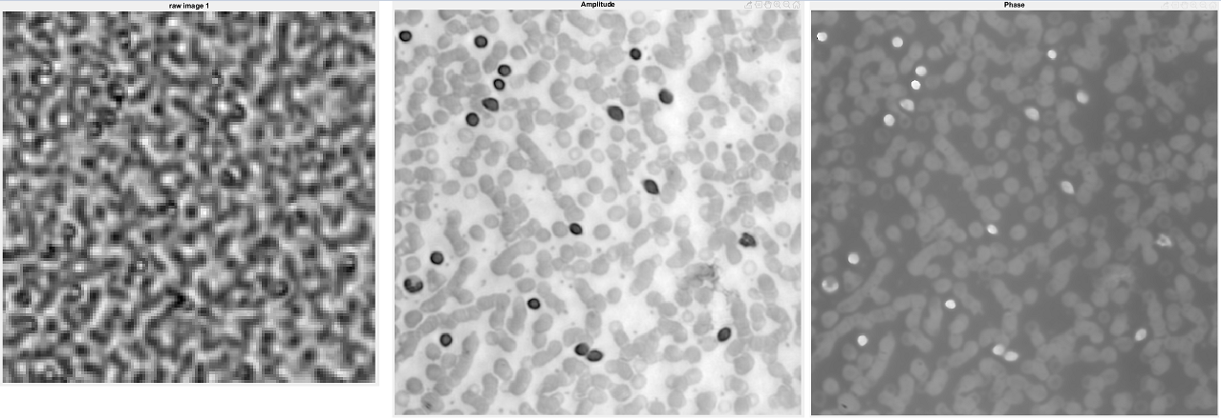
On the left the low-resolution original image, and the other two are the amplitude and phase of the reconstruction respectively. One can easily see that the resolution is much higher!
This was the case for all the different reconstructions we were able to perform!

