7 -> (1.7)
Explain the difference between additive and quantization embedding/modulation
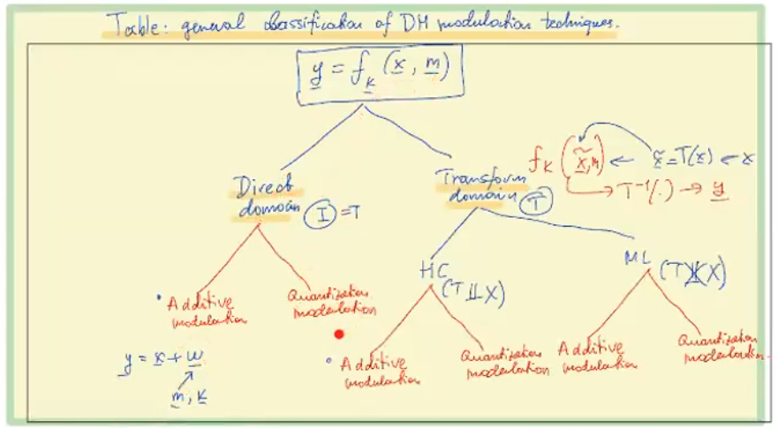
ADDITIVE MODULATION :
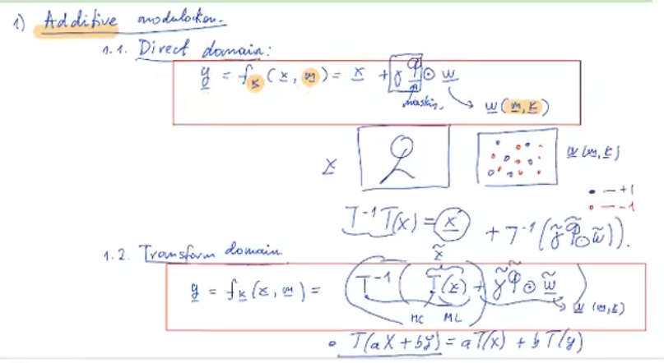

In direct: we compute w a function of m and k, then we compute a mask matrix that tells us where it is wise/safe to have higher amplitude watermarks, and where it is better to have lower watermarks, we simply add elementwise to the input data x
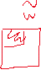
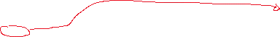
In transform: we compute the transform of x T(x) = x~, we compute our now watermark w~ and mask function~, this matrices have to change because we are now working on a transform domain, so the watermark will be localised in the top left corner of the 2D image, we simply add the w~ to x~, and we apply the inverse transform, and the result is our image in direct domain with a watermark applied in a transform domain.
- Small note, in HC transformations, since they are linear and orthogonal (unlike ML transform) we can apply the transform only to the watermark
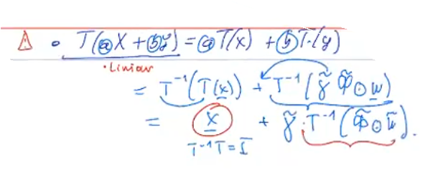
- !! gamma value is a multiplier that controls our watermark actual value (+-3, +-7, +-1), and mask function is basically a edge detection matrix -> TO REDO NOT SURE

QUANTIZATION MODULATION :

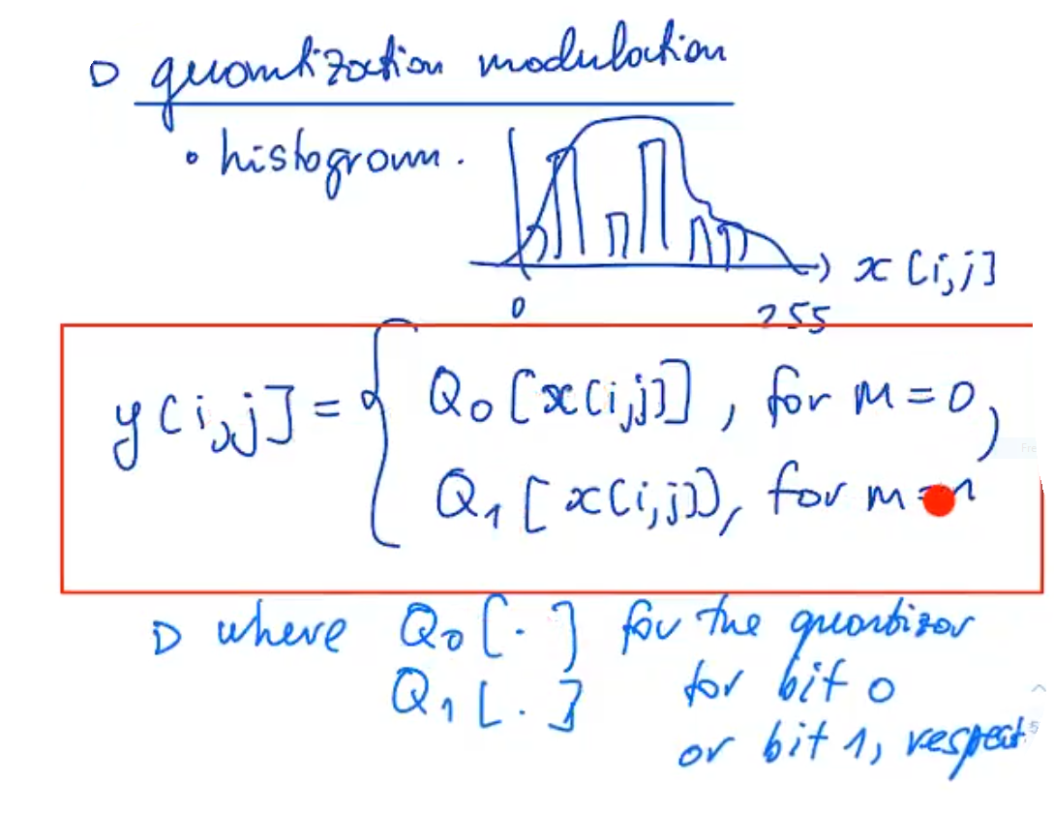
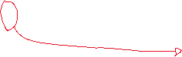
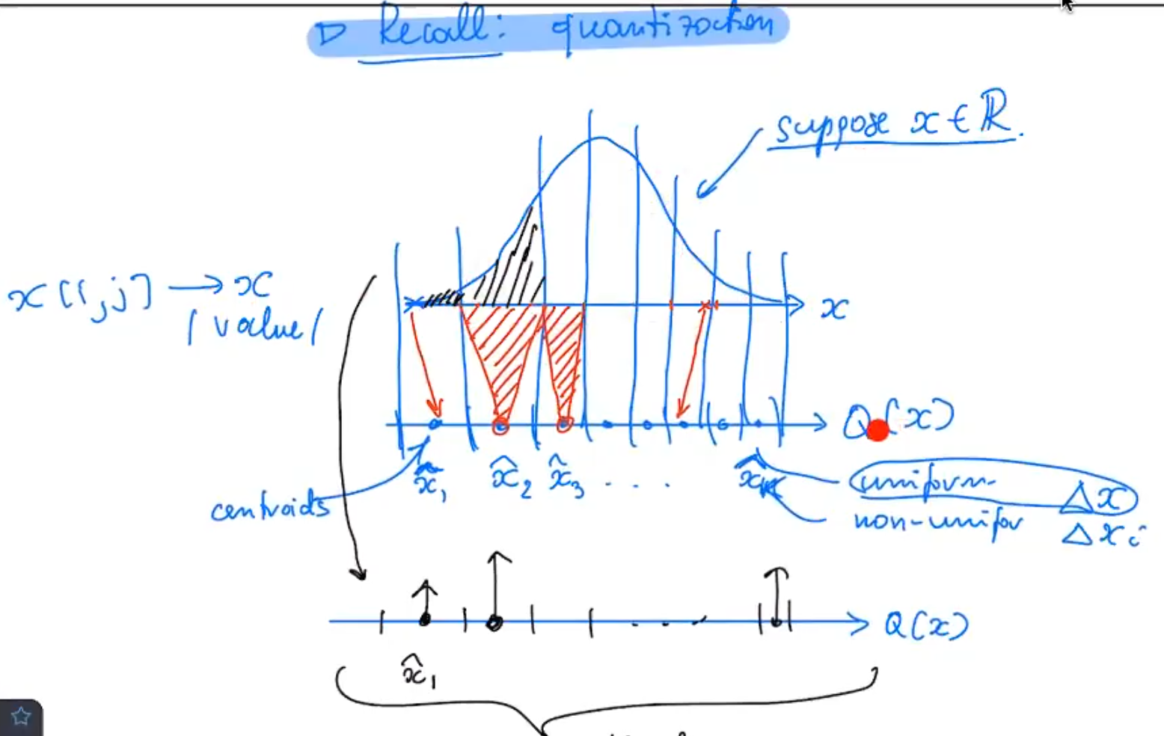
This delta function represents the integral of the area on the corresponding centroid interval
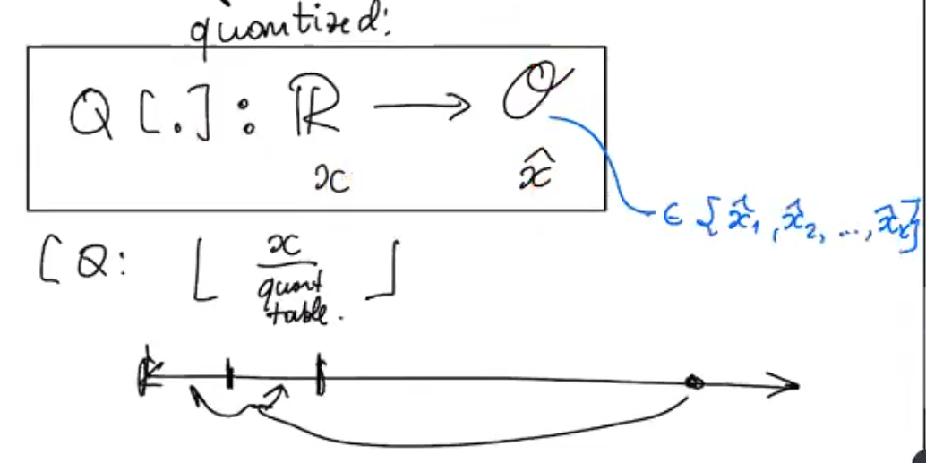
Intervals can be uniform or not, there are k intervals (k centroids) -> representation of quantifier

ALGORITHM FOR EMBEDING:
For a specific position (i,j) where you have to embed a value, this position is generated by the key, you check its current value, let’s say x[i,j]=125. Now you must check if you want to embed a 0 or a 1, to know you check the bit that must be embedded in this location, if it is a 0, you use Q0, if it is a 1, you use Q1.
Both quantifiers work the same way, you just take your value, and round it to the corresponding centroid.
- In this method, keys also generate the quantifiers Q1 and Q0, they generate the decision regions, and the corresponding centroids
Advanced security -> you as an encoder, add noise to the value of the centroid! This will add robustness!

ALGORITHM FOR EXTRACTING:
(Attacker might add some noise z to watermarked image y, if this noise is small enough, it might not affect the extraction at all.)
As a decoder you can generate Q0 and Q1 as well as the locations where the watermark was embedded, using the secrete key.
Lets say there is an embedded bit at position v[i,j] (v=x+y+z), you get check its value, lets say it is 127, now you simply check the centroids of both quantifiers Q0 and Q1, whichever has a centroid closer to 127, you assume that the embedded bit corresponds to that quantifier, lets say Q0 has the closes centroid at 128, and Q1 at 131, then you can assume with probability p (of being correct), that the hidden bit is a 0 (corresponding to Q0).
To increase the probability p, one can increase the length of the intervals, however, by doing this we are also creating an image y that is of less quality.

As an attacker, the larger your noise z is, the larger probability of bad extraction, however, if your noise is too large, image will lose its quality!

Interestingly enough, if you add too much noise, you might add so much distortion to a pixel, that its “loops” back, that it results in a good extraction!

DIFFERENCES:
Additive modulation is easy to extract in flatter areas, however harder in very un-flat areas.
Whereas in the quantization modulation, it doesn’t matter because it doesn’t depend on a prediction x^ of original x.

