5 -> (1.5)
Explain the main classes of attacks against robust watermarking

Removal/interference attacks
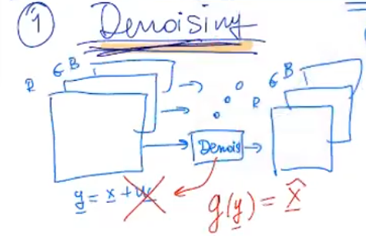

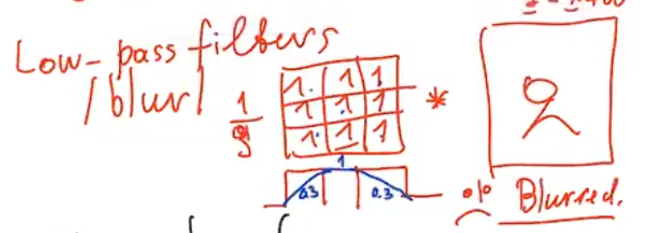
low pass filter will add a blurr effect, might not be the best result, there are better filters, like gaussian

COMPRESSION attacks
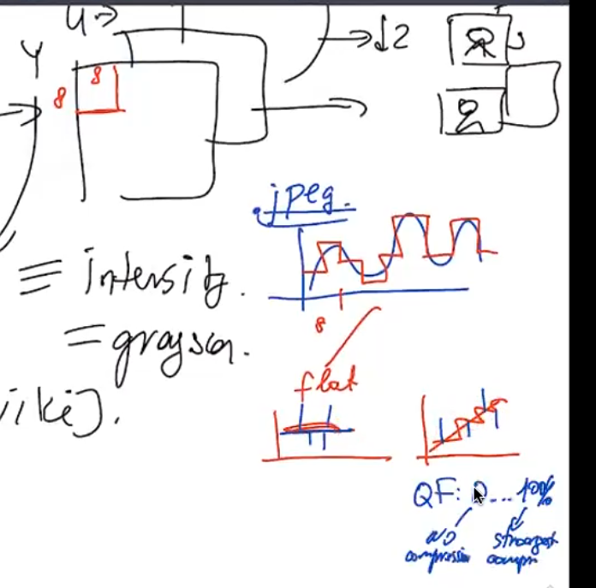
Using compression on edges costs a lot of image quality, so it is most often used on flat areas -> good to hide in edge!

GEOMETRICAL ATTACKS

Geometrical distortionsto try and delete watermarks -> loss of quality

