8 -> (1.8)
Explain digital watermarking in the transform domain. What are the main advantages?

Why do we need transform domain?
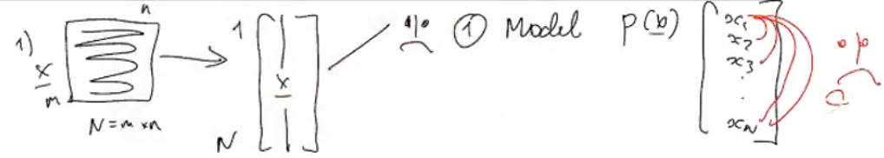
Too complex to establish statistical relationship between all values in x.
Makes it a bad domain for compression

What is transform domain and why is it used?

To compute a transformation so that Wt * x results in x~ that
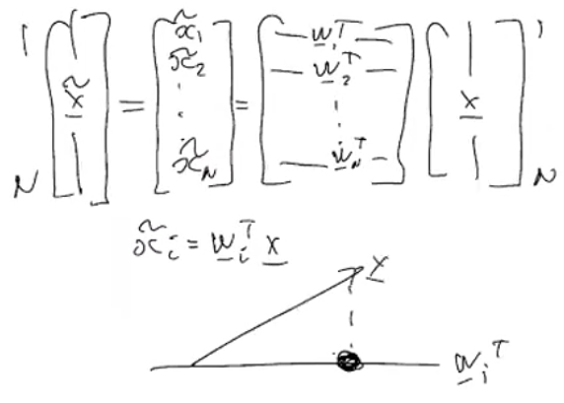
Input is image x, we apply a transformation, that is crafted so that we have some desired properties:
- Statistical independence between all x~I (decorrelation property)
- Energy compaction -> first coefficients have larger energy than the rest (var(x~i)>var(x~i+1))
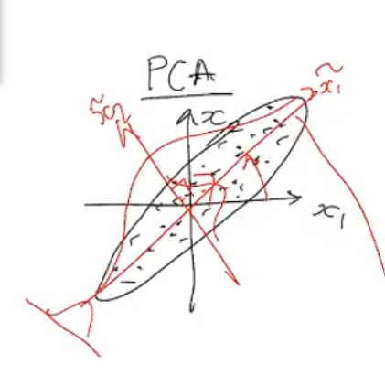
This energy compaction is achieved by changing the axis so that the variability is larger for smaller x~i
By achieving this energy compaction, we will be able to remove a very large amount of values from x~ without losing too much image quality (we can keep 10% of x~)
- Invertibility is possible by doing (W-1*x~)
- Fast computation

Types of transformation :
- Hand crafted (discrete Cosine/fourier/wavelet Transform) these matrices are completely independent from the data (x)
- Machine learning, the matrices are computed by using neural networks to optimize
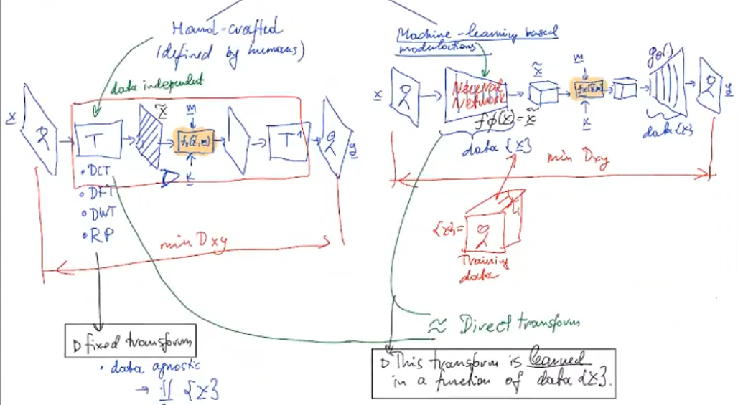

Advantages:
- Transformation helps you know which information is important, by hiding your watermark in essential information, you know you will be more robust and perceptual invisibility

HC vs ML:
Hand crafted transformations are public.
ML transformations are secret!!

ML needs to train (costs money and time)
ML has better feature extraction (important vs unimportant)
ML is the most robust to compression or any distortion (x is an image, and x’ is a rotation of x, if you train your model correctly, x~ = x’~)

