2 -> (1.2)
Explain the difference between the watermarking and data hiding. Explain when each technology can be used. Explain the block diagrams and the difference between the decoding and detection problems.

Digital data hiding -> embed information (change bits) in any multimedia file. The goal is for the placement of the bits to be secrete, and only detectable if you have a secrete key (symmetric)

General application -> you have original image x, private data m, and a key k: (k1, k2). The Embedder will first encode the secrete message using k1 (encode_{k1}(m)), and will embed (0 => 1, 1=> +1)the encoded data in the original image x, using k2 as seed for random locations in x. this results in image y. (y and x must be undistinguishable). As an extractor you can use key k2 to know where the data was embedded and can now extract it.
X is the cover, the message is what we hid, and the key tells us where (specifically) we hide

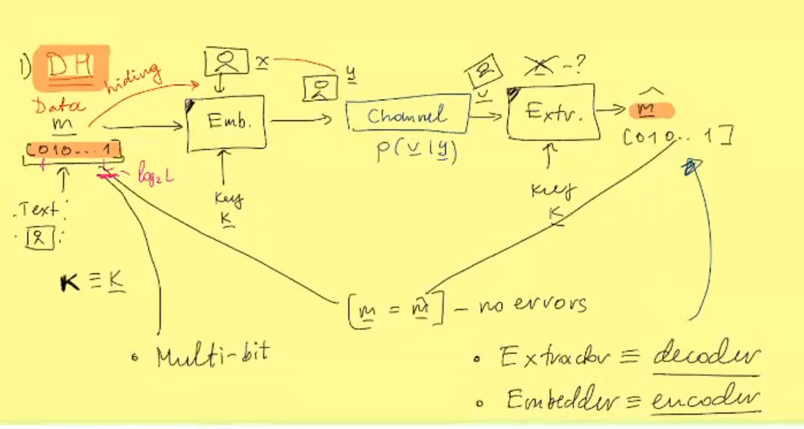
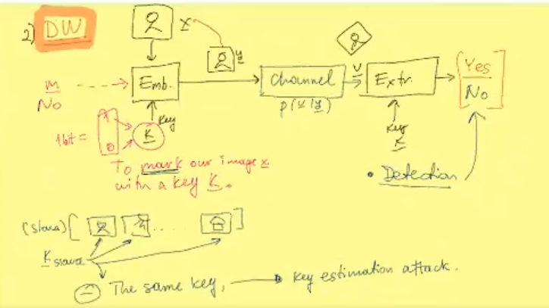

In DH we want to extract the whole hidden message m
In DW we want to detect the watermark presence, -> yes or no answer
(we don’t actually hide ~data)

In both cases -> y = x + w -> in DW w is only a function of the key, whereas in DH w is a function of the message and the key

