3 -> (1.3)
Explain the watermark detection problem. Explain the difference between the Neyman-Pearson and Bayesian hypothesis testing. Explain the different types of errors

Detection problem -> 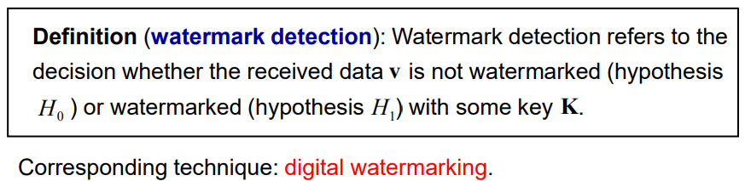
H0 -> no watermark
H1 -> watermark (present)
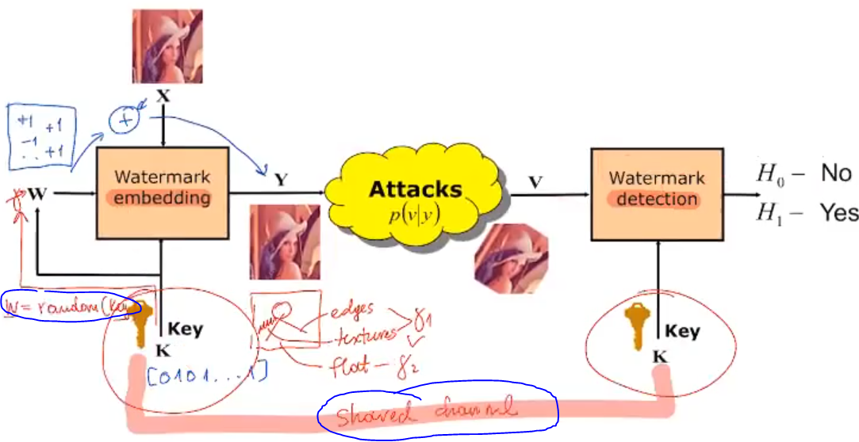
The detector having the key, can create w

Attacks:
- Maximize probability of miss
- Maximize probability of false acceptance

Set: v = z + y (z is attacker noise)
To detect if w is present in v, we need to compute the correlation between v and w -> w is known as the detector possesses de key k

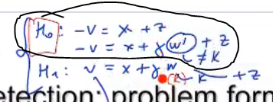
H0 is the lack of watermark, or the presence of a watermark not ours
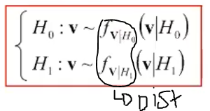
FOR 1 DIMENSION

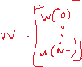

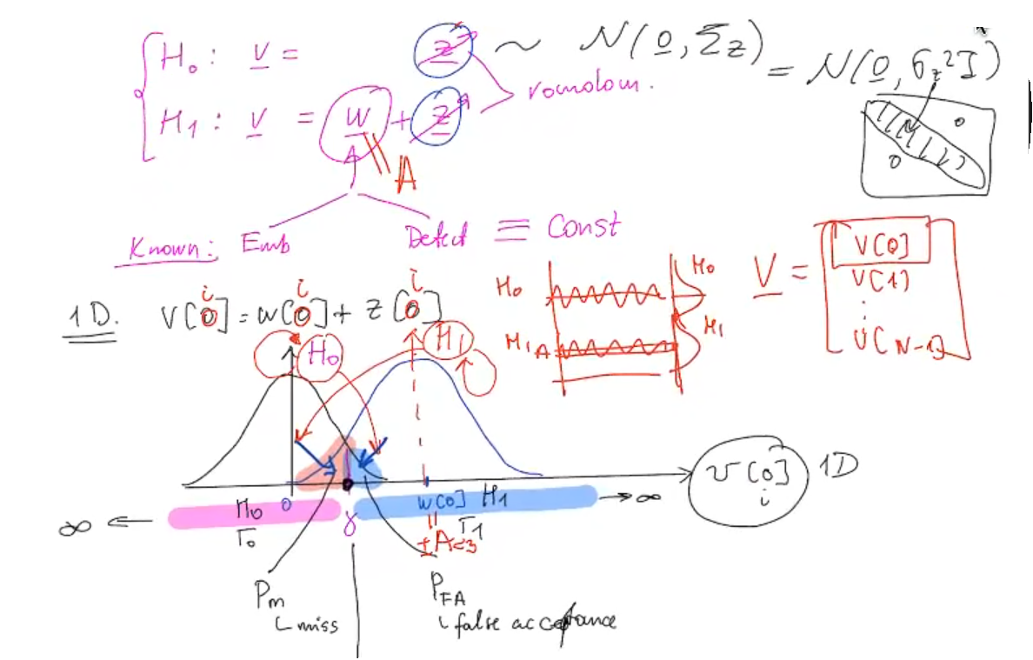
Our noise is of value A, so H0 is a gaussian dist with mean 0, and H1 is a gaussian dist with mean A.

The larger A is, the most likely it is that both dists don’t overlap, however it will also be easier for attacker to delete it -> as it will make the image more “irregular”.

- In real life there will be overlap between both dists, so we need to set a threshold, to decide if an image is H0 or H1.
- On the right of the threshold we will say “there is a watermark” errors will be false acceptance, on the left of the threshold “there is no watermark” the errors are miss
- The threshold we set defines the Pm and Pfa.

The choice of this threshold can be made with two techniques, baysian of neyman pearson
- Baysina tries to equally minimize both probabilities
- Pearson tries to minimize one probability as much as necessary/wanted, and doesn’t care about what happens to the other probability

FOR N DIMENSION

If we do dot multiplication between v and w, we can assume that the result follows a gaussian dist, because it is a summation of N different dists, Central Limit Theorem tells us that if N is large, then the result dist is a gaussian

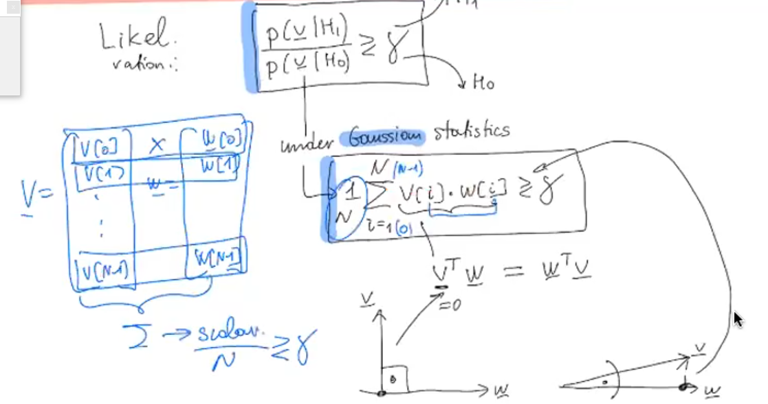
If w and v are close to each other (small angle between them), the result is large
Is w and v are far away (large angle), the result is small

