10 -> (2.2)
Explain the usage of content fingerprinting in various applications. What are the main advantages?

Main usages -> there are 2 usages: authentication and identification

Authentication -> for example, if a phone wants to unlock itself via face recognition, it has to snap a picture of the user, and decide “is it an accepted/verified user, or not?” it is a yes or no question.

Why not use the “classic” crypto hash for this authentication? -> 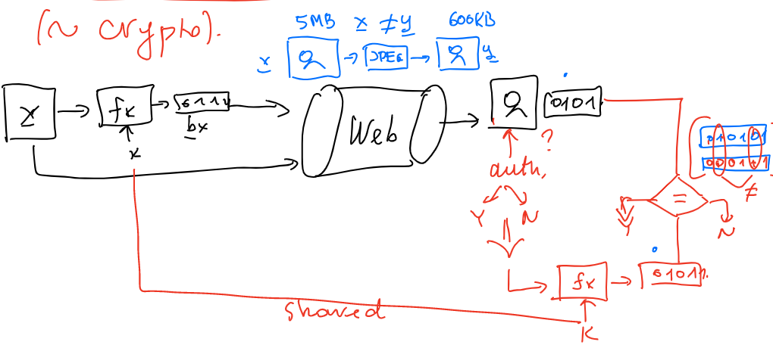
You can only compute the correct hash if you have access to the key. If input changes (compression) you will get a similar hash, this wouldn’t happen with classic cryptographic hashing functions.

Identification -> a phone wants to create an album, each containing pictures of the same person, if you take a new picture, it has to identify who it is, so it can catalogue it in the correct album. This is a information retrieval problem.
To do this it keeps a hash table/dictionary of all images of faces on the phone, if a group of hashes are similar, then we say that they are the same person in the image. (so we group images by their corresponding hashes)
In here there are various possible outputs, you can say that it corresponds to any person’s group, or that it corresponds to none -> no previous photo of this person

Problems -> (1) to identify who is in a picture we compute the Euclidean distances between the image (-> x, of size m*n=N) we want to identify, and all other images in our library (-> J images). The identification of x will be the image that it has the least distance (might be none). This would mean a complexity of: O(J*N) -> N is an image, so it is large. And if J is large as well, it will take a lot of time.
(2) Euclidean distance computation will not be a good measure of “likeness” in an image, if they are misaligned, or from different angles, or different light etc.

Solution/advantages -> (1) by computing a FP hash for every image in our library, We will have J hashes, which means our complexity is now O(J*L), by making sure that L << N ! this process is much faster. (2) Also, because the vectors are binary, one can replace Euclidean distance with hamming distance, that is much faster/efficient

