7 -> (1.7)
Explain the difference between additive and quantization embedding/modulation
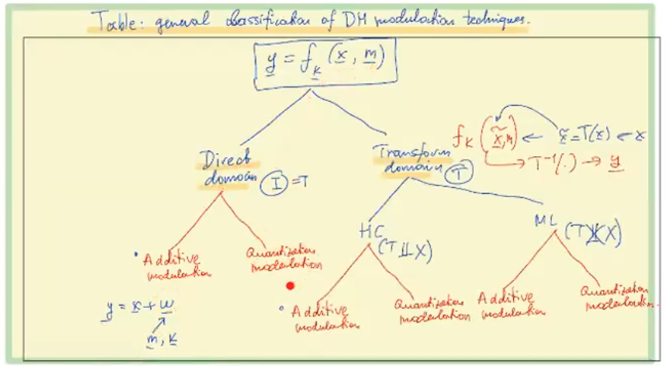
ADDITIVE MODULATION :
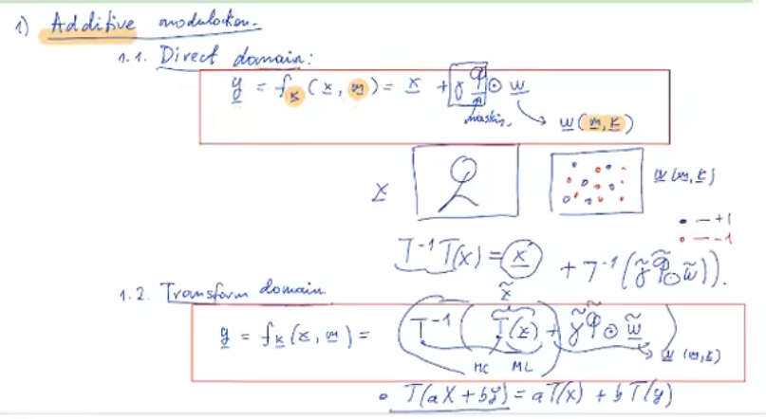

In direct: we compute w a function of m and k, then we compute a mask matrix that tells us where it is wise/safe to have higher amplitude watermarks, and where it is better to have lower watermarks, we simply add elementwise to the input data x
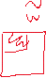
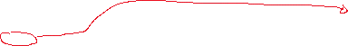
In transform: we compute the transform of x T(x) = x~, we compute our now watermark w~ and mask function~, this matrices have to change because we are now working on a transform domain, so the watermark will be localised in the top left corner of the 2D image, we simply add the w~ to x~, and we apply the inverse transform, and the result is our image in direct domain with a watermark applied in a transform domain.
- Small note, in HC transformations, since they are linear and orthogonal (unlike ML transform) we can apply the transform only to the watermark
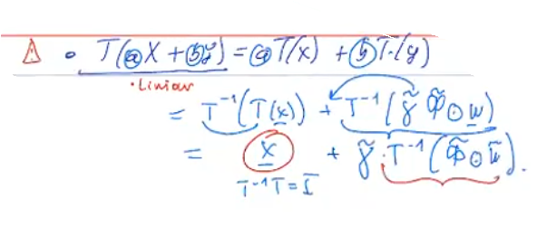
- !! gamma value is a multiplier that controls our watermark actual value (+-3, +-7, +-1), and mask function is basically a edge detection matrix -> TO REDO NOT SURE

