1 -> (1.1)
Explain the difference in the usage of and requirements to digital robust watermarking, steganography and tamper proofing.

Digital data hiding -> embed information (change bits) in any multimedia file, without the overall quality of the media file changing. The goal is for the placement of the bits to be secrete, and only detectable if you have a secrete key (symmetric)

Example of bad (DH) system -> hide in least significant bits, all information would be lost a bit of compression, and attackers would be able to remove or change it as well (no robustness), removing the hidden data would not compromise the quality of the multimedia file either.

General application -> you have original image x, private data m, and a key k: (k1, k2). The Embedder will first encode the secrete message using k1 (encode_{k1}(m)), and will embed (0 => -1, 1=> +1)the encoded data in the original image x, using k2 as seed for random locations in x. this results in image y. (y and x must be undistinguishable). As an extractor you can use key k2 to know where the data was embedded and can now extract it.

Attack Logic -> Between the embedding and extraction process, there can be distortions applied to the image y, this means your watermark must resist the attacks, and your decoder must be able to extract the information post distortion.

Attack types -> (1) apply image processing filters in order to delete the hidden data (damage decoding of information Pr[m !=m’] = 1 (m’ -> decoded message)). (2) find key by using ML methods (use same key for multiple embeddings) =>cryptoanalysis. (3) guess the message m (possible in copyright), by having the message, you might be able to get the key.

Watermarking vs steganography ->
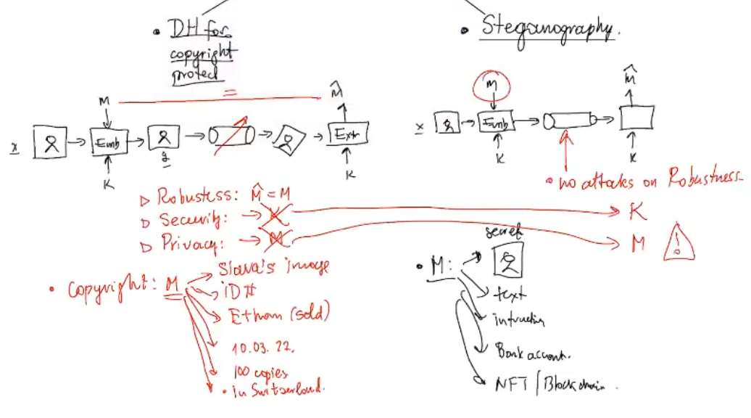
Attacks made on them are different type/goal.
- On steganography one can only try to find if there is a hidden message or not, but cant actually find oud what is hidden
(cours 4)
