11 -> (2.3)
Explain the construction of content fingerprinting function based on random projections and binarization

content fingerprinting is a process where you take as an input a vectorized image X, and create a hash x~.

this is done by a function.

This function is quite simple, it uses a mattrix W, and simply does a dot multiplication between Wt and X. Depending on the dimentions of W, we get a smaller or larger hash x~.

X being of dimension N, and y L, we have that L << N → loss of information.

Even knowing W, one cant reconstruct X from x~.

the difference between hand crafted and machine learning methods is how W is computed.

Hand crafted -> hand crafted methods that may use keys to compute a hash. Does not depend on the data (no ml involved). The mechanism:
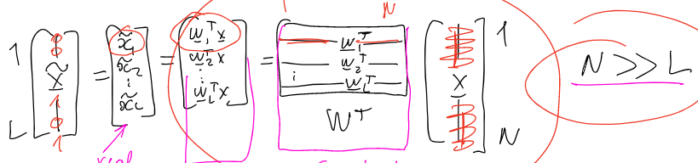
So the computation of the FP, is just a projection of X onto the Wt, however we don’t compute the projection, we compute the scalar result of the dot multiplication from Wt with X. uses the symetric secrete key to generate W (seed)

Machine learning -> (no key!) we have an encoder that constructs a hash, and a decoder that reconstructs the original image (as close to the original as possible) from the hash. You compute the encoder values with ML by trying to minimize the error between the original image and its reconstruction
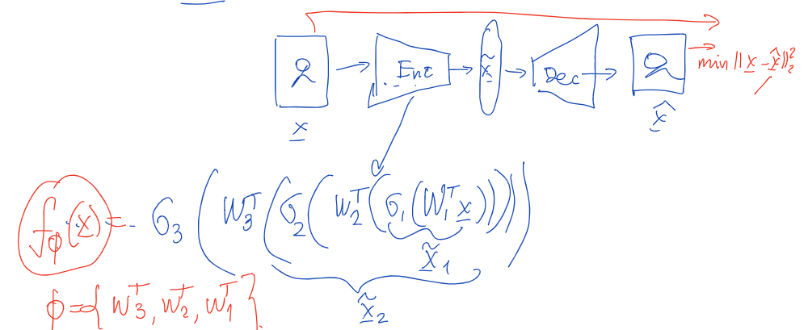

It means that there is such a decoder that can reconstruct x.

uses data to compute W (encoder and decoder), meaning an attacker may use the same data, or similar data to aproximate the encoder and decoder.

this W is very well optimized, and results in a x~ that is more robust to compression/geometrical distortions thant HC methods.

Binarization:

once we compute a scalar value that is the result of the projection, we have to decide if it is a 0 or a 1, since our hash is binary string

this means we have to decide on a threshold !!

