12 -> (2.4)
Explain the statistics of coefficients under random projections used in content fingerprinting. Properties.

content fingerprinting is a process where you take as an input a vectorized image X, and create a hash x~.

this is done by a function.

This function is quite simple, it uses a mattrix W, and simply does a dot multiplication between Wt and X. Depending on the dimentions of W, we get a smaller or larger hash x~.

X being of dimension N, and y L, we have that L << N → loss of information.

Even knowing W, one cant reconstruct X from x~.

the difference between hand crafted and machine learning methods is how W is computed.

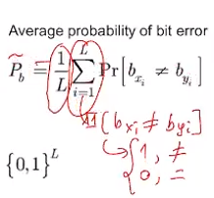
→ lets say we have x, original image, and y = x + z (noise), if we use a fingerprinting function on both images x and y, we d like to get bx and by that have a small hamming distance

→ we can compute Pb avg probability error :

bx(i) is statistically independent to bx(i+1)
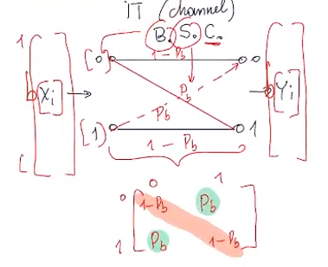


E[hamming dist x y] = L* Pb
var(hamming dist x y) = L * Pb * (1 – Pb)

X is unknown dist, but dH(bx, by) is known dist → B(L,Pb) (binomial dist, with L length of hash (number of repetitions of a certain event), Pb prob of bit flip (prob of event occurring))

as L gets larger, B(L,Pb) will look more like a gaussian shape distribution, up to a delta function

because it looks like a gaussian it is easy to put a threshold and compute Pmiss, and Pfa

→ its important to note some bits are more reliable than others !! lets say we can compute with certainty the reliability of a bit bxi. Now we only need to chech hamming idst between the bits that we are of certain reliability. (schema X colineaire avc Wti)

