9 -> (2.1)
Explain the main differences between content fingerprinting (robust perceptual hashing) and cryptographic hashing.

Passive technology

Cryptography -> a hashing function is a function that has the following properties: (1) input is a binary string of any length, (2) output is a binary string of a given length, (3) if you change a single bit in the input, the resulting output will be at least 50% different (4) from the hash value it is impossible to find the input, (5) it is “impossible” to find collisions, (6) this function can use a key or not H(x) = H(x), Hk1(x) != Hk2(x)

Fingerprinting -> a hashing function that has the following properties: (1) input is any multimedia file, can be an image, a music, (2) output is a binary string of a given length, (3) if you slightly change the input, ie -> add noise, the output might stay the same, or change a bit (but won’t completely change like in crypto), (4) from the hash value it is impossible to find the input (some information might be recoverable from the digest, but not the whole data), (5) there are many collisions, it is the goal ! (6) this function can use a key or not

Hand crafted -> hand crafted methods that may use keys to compute a hash. Does not depend on the data (no ml involved). The mechanism:
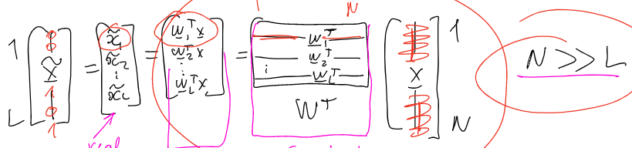
So the computation of the FP, is just a projection of X onto the Wt, however we don’t compute the projection, we compute the scalar result of the dot multiplication from Wt with X. This W matrix can be generated from the key itself.

Levels of security ->
(1)first level of security
We set N >> L to: (1) have a digest of size L that is much smaller than the input data, (2) no reversibility, if we had N = L, one could compute Wt-1, and find X from x~ (3) computation time (4) easy comparison between hashes

FP loss of information -> entropy of image is image size (N = m*n) times entropy of a pixel = H(xi) = log2(256) = 8 bit -> H(image) = N * 8. Whereas H(hash) = L (size of hash) * H(Bxi) = L * 1 = L => massive loss of information -> no reconstruction possible

(2)second level of security
We set a threshold, every value in x~ is transformed into a 0 or a 1, depending on a threshold, for example if xi~<0 -> it becomes 0, if >0, it becomes 1

Machine learning -> (no key!) we have an encoder that constructs a hash, and a decoder that reconstructs the original image from the hash. You compute the encoder values with ML by trying to minimize the error between the original image and its reconstruction
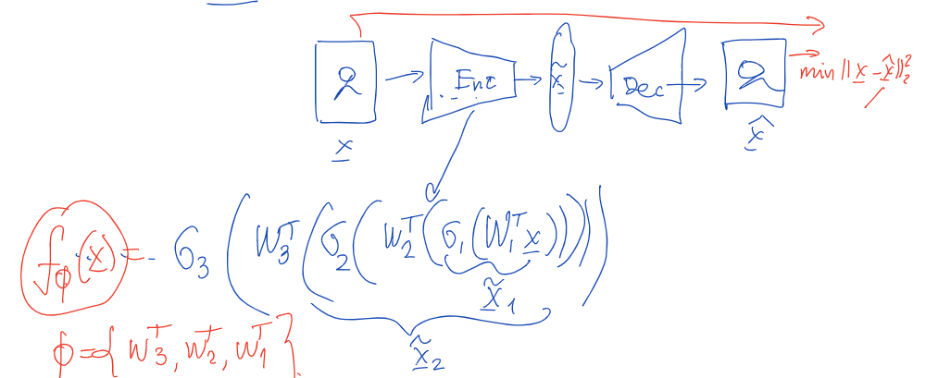

Reconstruction is available!

