H2
GROUP 51
João Moniz nº 83480
Liana Baghdasaryan nº 104708

Work Distribution
Liana Baghdasaryan: q1.1 (a,b,c), q1.2 and q2
João Moniz: q1.1(b) and q3
in Question 1 question b was made by both members, João showed that M exists that z’ = Mx’, and Liana did the general expression for element (i,j).

Question 1:
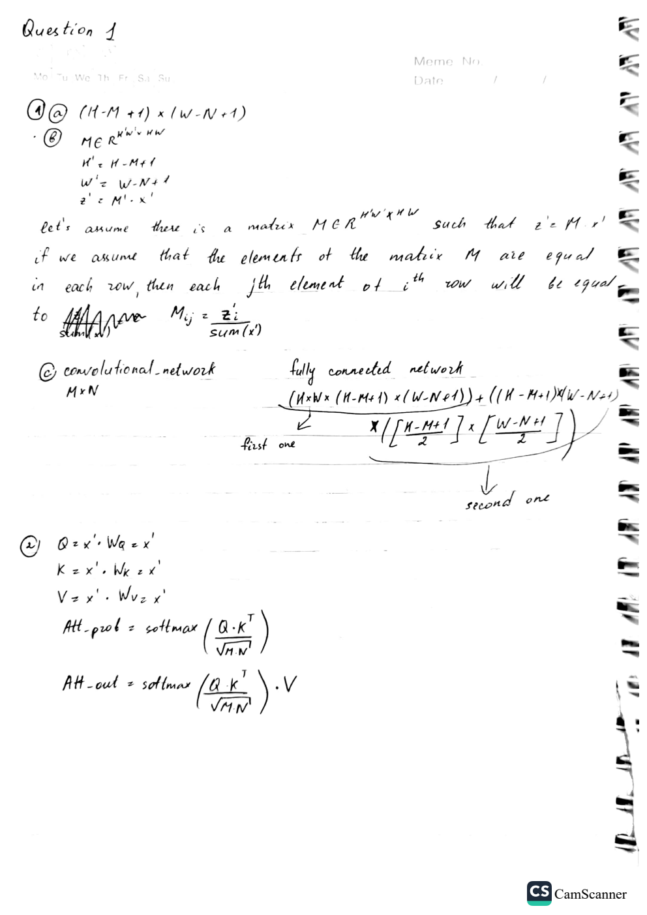

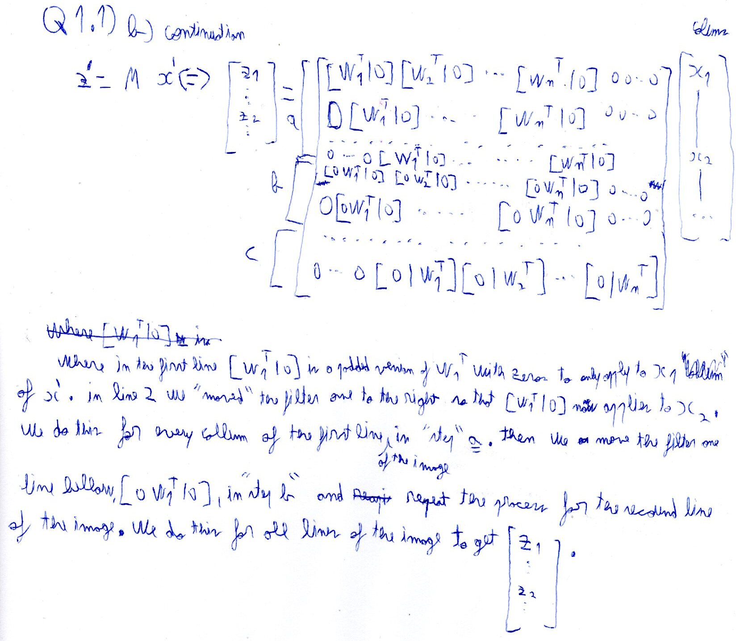

Question 2: 1) 2) 3)
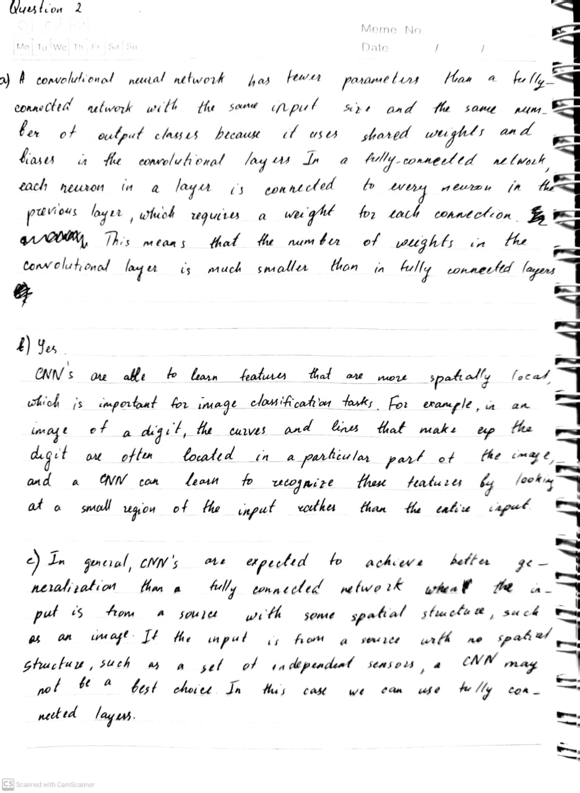

Question 2:

4) Best Learning Rate: 0.0005
Training loss: Validation accuracy:
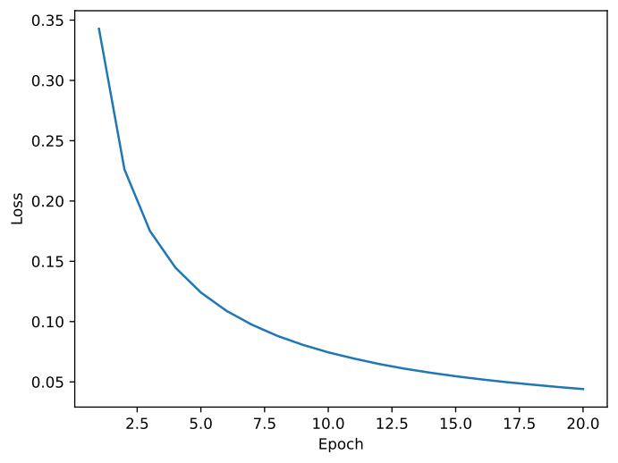

5) Original: Activation maps:
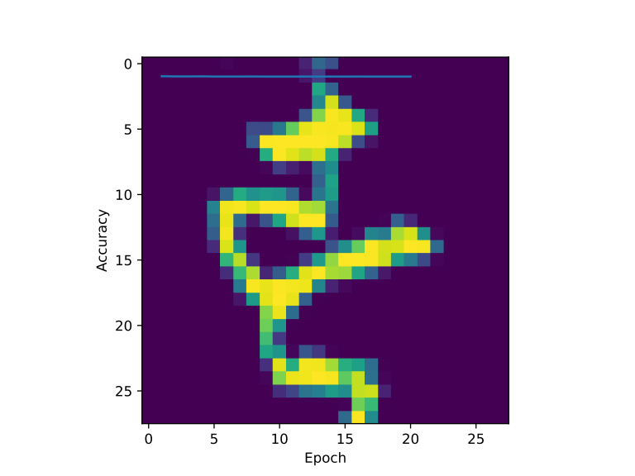
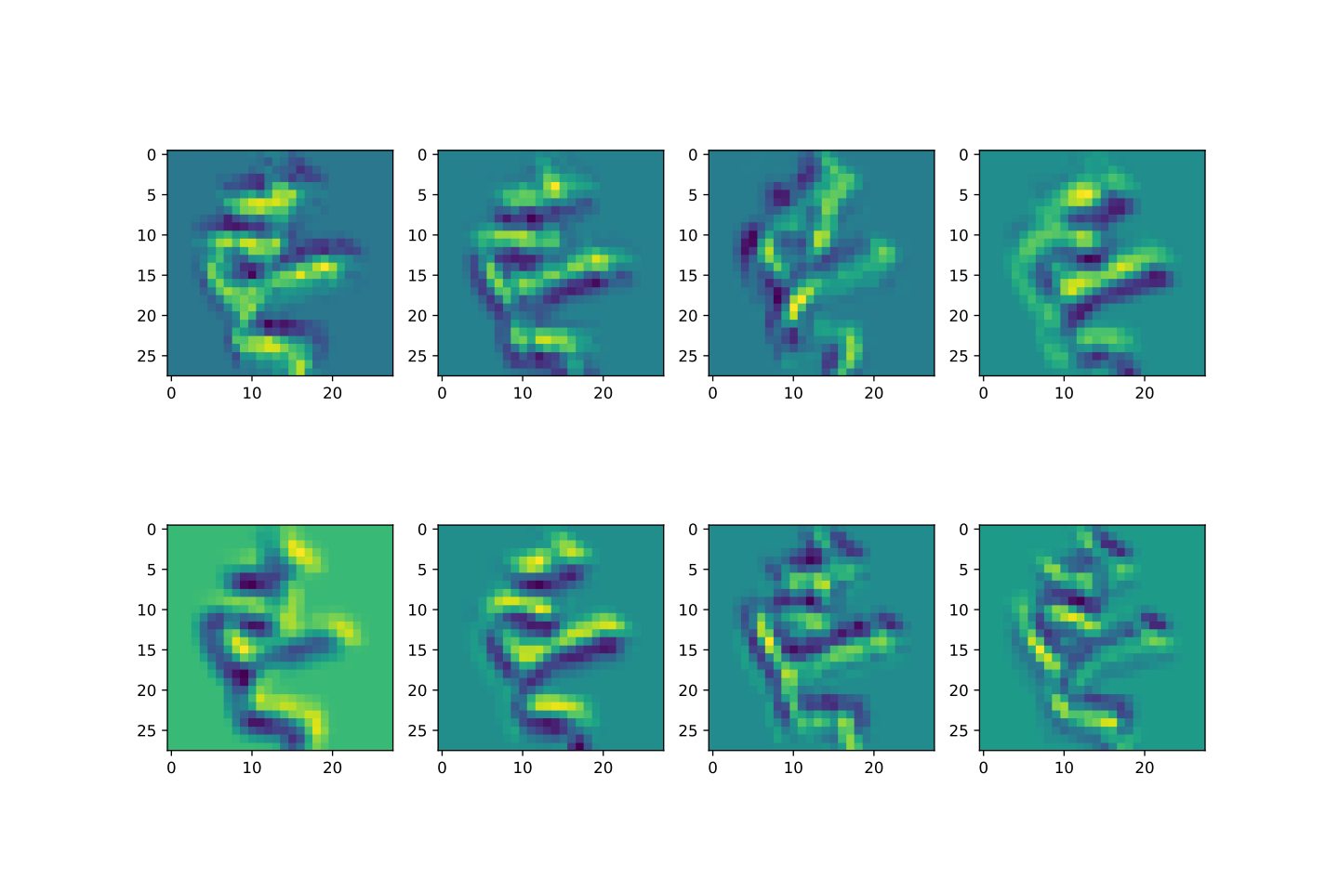

Analysis: The activation maps seem to be highlighting different borders between parts of the image, for example the second one from the top starting from the right is highlighting the upper borders of the figure.

Question 3:
a)
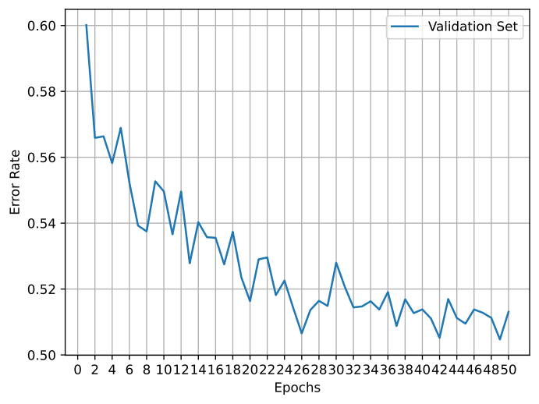
Final validation error rate: 0.5131
Test error rate: 0.5178

b)
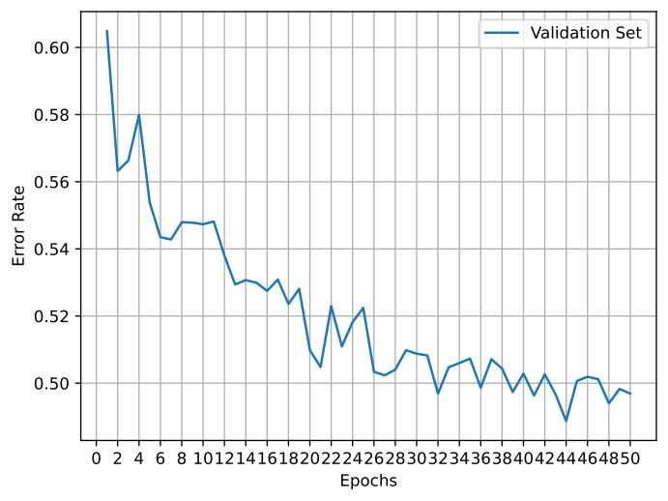

Final validation error rate: 0.4969
Test error rate: 0.5046

c)It is possible to improve the results by adding beam search, by tracking K of the most probable partial translations, and not just the best one, helps preventing the model from getting stuck with one bad decision and sticking with it for the rest of the translation.

