V-Model Presentation

Presentation for the class of ESOF

T2 - Software Processes

What Is The V-Model?

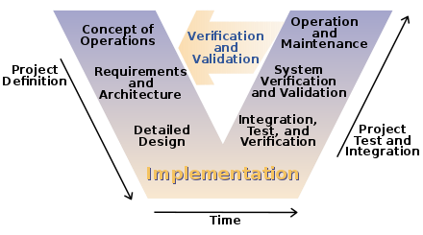

What Is The V-Model?

●V-Model is a strict model for software development developed as an extension from the Waterfall model ●It can be summarized by its shape, a V:

●The left side has the verification stages

●The right side is comprised of the validation stages

●At the point where both sides meet, at the bottom of the V, code is developed and implemented

Origin of the V-Model

●The V-Model, or Vee Model, was created by the German government in the 1990s to manage project development in their defence department.

●It was developed as a counter-part to the PRINCE2 model, and is to this day still used by the UK and USA’s governments.

The Stages

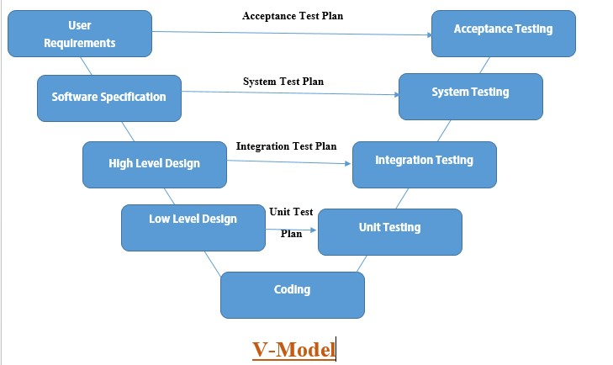

The Stages – Left Side (Verification Stages)

User Requirements – Where the user’s needs and respective solutions are determined

System Design – Where the techniques and methods that will be needed to accomplish the solutions are decided

Architecture Design – Where the high-level concepts for the code are designed, making use of tools such as class diagrams

Module Design – Where the functions to be developed in the implementation stage are defined