# Contains Instruction coverage

  public boolean contains(String key) {

if (key == null) //I1

throw new IllegalArgumentException("argument to contains() is null"); //I2

return get(key) != null; //I3

}

|  |  |  |  |
| --- | --- | --- | --- |
| Test case | Test case values | Expected values | Instruction Coverage |
| containsException | null | IllegalArgumentException | I1 , I2 |
| containsReturn | “someKey” | false | I1, I3 |

# Size instruction coverage

public int size() {

return n; //I1

}

|  |  |  |  |
| --- | --- | --- | --- |
| Test case | Test case values | Expected values | Instruction Coverage |
| sizeTest | Not applied | 0 | I1 |

# Get instruction coverage

public T get(String key) {

if (key == null) //I1

throw new IllegalArgumentException("calls get() with null argument"); //I2

if (key.length() == 0) //I3

throw new IllegalArgumentException("key must have length >= 1"); //I4

Node<T> x = get(root, key, 0); //I5

if (x == null) //I6

return null; //I7

return x.val; //I8

}

|  |  |  |  |
| --- | --- | --- | --- |
| Test case | Test case values | Expected values | Instruction Coverage |
| getNull | null | IllegalArgumentException | I1, I2 |
| getEmptyString | “” | IllegalArgumentException | I1, I3, I4 |
| getNonExistentValue | “someKey” | null | I1, I3, I5, I6, I7 |
| getExistentValue | “key” | “value” | I1, I3, I5, I6, I8 |

# Put instruction coverage

public void put(String key, T val) {

if (key == null) //I1

throw new IllegalArgumentException("calls put() with null key"); //I2

if (!contains(key)) //I3

n++; //I4

root = put(root, key, val, 0); //I5

}

|  |  |  |  |
| --- | --- | --- | --- |
| Test case | Test case values | Expected values | Instruction Coverage |
| putNull | null, “value” | IllegalArgumentException | I1, I2 |
| putNewValue | “someKey”, “value” | No exception | I1, I3, I4, I5 |

# LongestPrefixOf coverage

public String longestPrefixOf(String query) {

if (query == null) //I1

throw new IllegalArgumentException("calls longestPrefixOf() with null argument"); //I2

if (query.length() == 0) //I3

return null; //I4

int length = 0; //I5

Node<T> x = root; //I6

int i = 0; //I7

while (x != null /*I8*/ && i < query.length() /*I9*/) {

char c = query.charAt(i); //I10

if (c < x.c)/*I11*/ x = x.left; //I12

else if (c > x.c)/*I13*/ x = x.right; //I14

else {

i++; //I15

if (x.val != null) //I16

length = i; //I17

x = x.mid; //I18

}

}

return query.substring(0, length); //I19

}

|  |  |  |  |
| --- | --- | --- | --- |
| Test case | Test case values | Expected values | Instruction Coverage |
| longestPrefixOfNull | null | IllegalArgumentException | I1, I2 |
| longestPrefixOfEmpty | “” | null | I1, I3, I4 |
| longestPrefixOfAllInstructions | “c” | “c” | I1, I3, I5, I6, I7, I8, I9, I10, I11, I12, I13, I14, I15, I16, I17, I18, I19 |

# Keys coverage

public Iterable<String> keys() {

Queue<String> queue = new LinkedList<>(); //I1

collect(root, new StringBuilder(), queue); //I2

return queue; //I3

}

|  |  |  |  |
| --- | --- | --- | --- |
| Test case | Test case values | Expected values | Instruction Coverage |
| keysTest | None | Empty Iterator | I1, I2, I3 |

# KeysWithPrefix coverage

public Iterable<String> keysWithPrefix(String prefix) {

if (prefix == null) //I1

throw new IllegalArgumentException("calls keysWithPrefix() with null argument"); //I2

Queue<String> queue = new LinkedList<>(); //I3

Node<T> x = get(root, prefix, 0); //I4

if (x == null) //I5

return queue; //I6

if (x.val != null) //I7

queue.add(prefix); //I8

collect(x.mid, new StringBuilder(prefix), queue); //I9

return queue; //I10

}

|  |  |  |  |
| --- | --- | --- | --- |
| Test case | Test case values | Expected values | Instruction Coverage |
| keysWithPrefixNull | null | IllegalArgumentException | I1, I2 |
| keysWithPrefixEmpty | “somePrefix” | Empty Iterator | I1, I3, I4, I5, I6 |
| keysWithPrefixContains | “c” | Iterator with size 1 | I1, I3, I4, I5, I6, 7, I8, I9, I10 |

# KeysThatMatch coverage

public Iterable<String> keysThatMatch(String pattern) {

Queue<String> queue = new LinkedList<>(); //I1

collect(root, new StringBuilder(), 0, pattern, queue); //I2

return queue; //I3

}

|  |  |  |  |
| --- | --- | --- | --- |
| Test case | Test case values | Expected values | Instruction Coverage |
| keysThatMatchTest | “pattern” | Empty Iterator | I1, I2, I3 |

# Edge coverage

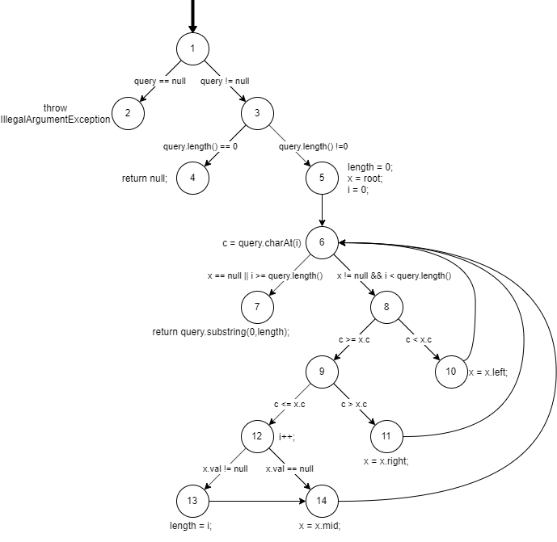

|  |  |  |  |
| --- | --- | --- | --- |
| Test case | Test case values | Expected values | Edges  Covered |
| lpoEdgeCoverage1 | null | IllegalArgumentException | [1,2] |
| lpoEdgeCoverage2 | “” | null | [1,3],[3,4] |
| lpoEdgeCoverage3 | “a” | “” | [1,3],[3,5],[5,6], [6,8], [8,10], [10,6],[6,7] |
| lpoEdgeCoverage4 | “d” | “” | [1,3],[3,5],[5,6], [6,8],[8,9], [9,11], [11,6],  [6,7] |
| lpoEdgeCoverage5 | “c” | “” | [1,3],[3,5],[5,6], [6,8],[8,9],[9,12], [12,14], [14,6],  [6,7] |
| lpoEdgeCoverage6 | “c” | “c” | [1,3],[3,5],[5,6], [6,8],[8,9],[9,12], [12,13], [13,14], [14,6], [6,7] |