MASTER'S PROJECT CONCEPT
Trait-Graph Co-Evolution
Can reciprocal evolution keep producing new, useful specializations?

Concept visualization: two populations explore branching evolutionary pathways under finite resources.
CORE QUESTION Does reciprocal evolution produce deeper, more diverse, and more persistent trait pathways than one-sided evolution?

The idea in plain language
Two groups of digital agents compete for limited resources. Agents inherit traits, mutations unlock nearby branches in a trait graph, and natural selection determines which branches survive. The study compares one-sided evolution with reciprocal evolution to test whether competition creates lasting innovation or simply repeats old strategies.

How the trait graph works
The graph acts like an evolutionary possibility map. It gives agents room to specialize without pretending they can invent unlimited traits from nothing.
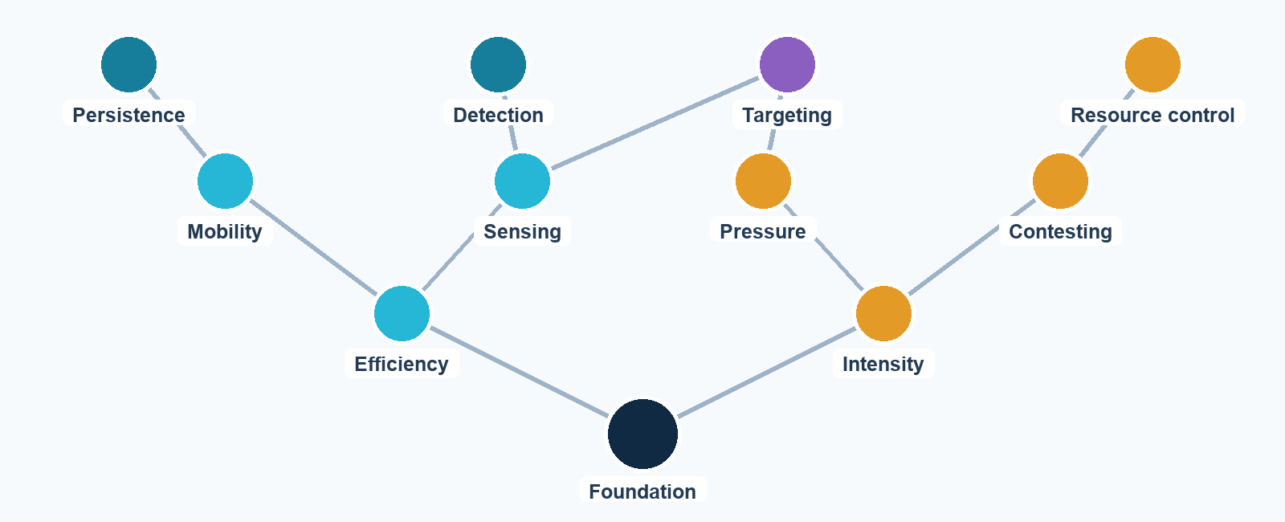
Illustrative structure only; final nodes and trade-offs would be calibrated before confirmatory runs.

Evolutionary rules
- Mutation proposes change. Agents may activate a neighboring node, modify its strength, duplicate a module, or lose an active node.
- Selection decides what persists. Useful combinations improve survival or reproduction; ineffective combinations disappear.
- Every capability has a cost. Active nodes consume energy so larger graphs are not automatically stronger.
- No universal best path. Benefits depend on resources, population density, and the opposing population's current traits.

Why a graph instead of unlimited traits?
A completely unrestricted trait generator is difficult to interpret: extra genome components may be useless clutter rather than innovation. A branching graph keeps trait effects functional, measurable, and computationally compatible with fixed-shape JAX arrays while still allowing multiple evolutionary pathways.

Proposed experiment
All conditions begin from the same starting populations, resource layout, policy checkpoints, and paired random seeds. Only the allowed evolutionary pathway changes.
Condition | Population A | Population B | Purpose
Frozen | No evolution | No evolution | Ecological baseline
Neutral drift | Neutral mutation | Neutral mutation | Mutation-only comparison
A-only | Evolves | Frozen | One-sided adaptation
B-only | Frozen | Evolves | Reverse one-sided control
Reciprocal | Evolves | Evolves | Primary treatment

What would be measured
- Branch depth: how far populations move from their starting capabilities.
- Functional diversity: how many meaningfully different trait combinations coexist.
- Persistence: whether new branches survive across multiple population turnovers.
- Historical novelty: whether later populations differ functionally from their ancestors.
- Cross-play: whether current populations outperform archived opponents or merely cycle back to old strategies.
PRIMARY COMPARISON Reciprocal evolution versus the average of both one-sided conditions, evaluated across paired seeds and multiple pretrained policy checkpoints.

Scientific value and honest limits

Why this is worth studying
- It tests a clear causal question about reciprocal versus one-sided evolution.
- The trait graph creates visible evolutionary pathways that can be explained and analyzed.
- Cross-play can distinguish continued escalation from recurring evolutionary cycles.
- The simulator can become a platform for later work on environmental modification and more flexible genomes.

What the project cannot claim
- A finite, researcher-designed graph is not proof of unlimited open-ended evolution.
- More active traits do not automatically mean greater complexity or intelligence.
- Results may depend on graph topology, trait costs, and resource rules, so these must be fixed before confirmatory runs.

Recommended scope
Use approximately 20-30 trait nodes, including trade-offs, incompatible branches, and frequency-dependent benefits. Begin with pretrained trait-conditioned policies frozen during the primary experiment. Treat continuous online learning as a later extension so learning instability does not obscure the evolutionary result.

Project phases
1 | Ecology | Build a stable fixed-shape environment and verify energy accounting.
2 | Behavior | Train and validate trait-conditioned policies with evolution disabled.
3 | Evolution | Add graph mutation, inheritance, costs, and turnover tracking.
4 | Validation | Test metrics on synthetic saturation, drift, expansion, and cycling.
5 | Experiment | Freeze the design, preregister outcomes, and run confirmatory seeds.

Advisor discussion point
DECISION Is a bounded trait graph the right balance between scientific ambition, computational feasibility, and a defensible Master's thesis?

