Advice report



By

Eero-Pekka Halinen,

Martynas Rančys,

João Silva,

Ted Vlemmings &

Olivier Wouters

30-03-2012

# Introduction

For the last two weeks our group, containing persons of multiple nationalities and backgrounds, tried to get to know Marques Soares better by mining their existing data from web sales and their website. While doing this we made some dashboards and views for the management to have a quick overview of how the data is now, and how it should be in the future. These measurements are derivatives of our formulated KPI’s (Key Performance Indicators). The KPI’s are formulated by us with the information we have gotten from the marketing and IT representative of Marques Soares who we interviewed in an early stage of this project.

For the dashboards and views we made use of Qlikview, Excel and SPSS. The data we used to make these interactive views and dashboards are made available by Marques Soares by and Excel file and their Google Analytics account. We are not responsible for the integrity of this data.

This document is made to give Marques Soares more insight in their online sales, and by this document we hope that Marques Soares gets the insight it needs to improve their online business. We will do our best to present everything as clear as possible and give conclusions and advice on where to improve and/or implement changes.

Table of Contents

1. Introduction 2

2. Team description 4

3. Marques Soares 5

4. Present data 6

Data understanding: 6

Data quality: 6

Understanding: 6

Output: 6

Business Strategy 7

Internet Strategy 8

Business Questions 8

5. Data and processing 9

Our results 10

6. Conclusions / Suggestions 20

# Team description

Our team consists of five students all from different nationalities. These are the following:

* Eero-Pekka Halinen: Finland, Helsinki Metropolia University of Applied Science
* Martynas Rančys: Lithuania, Vilniaus University of Applied Science
* João Silva: Portugal, Universidade Portucalense
* Ted Vlemmings: the Netherlands, Fontys University of Applied Science
* Olivier Wouters: Belgium, University College of Namur – Liège – Luxembourg

# Marques Soares

Marques Soares is a retail company that offers a wide variety of products and brands that include ready-made garments for men, women, youth and children, lingerie, shoes, leather, watches, perfumes, sportswear, optics, home décor and many more. Marques Soares reaches their customers through its stores, catalog and the online store, which is [www.marquessoares.pt](http://www.marquessoares.pt).

Marques Soares has its roots in Porto, where the first store opened in November 1960. It all started only with clothing fabrics, knitwear and hosiery. Nowadays they sell clothing, sportswear, lingerie, accessories, electronic appliances etc. in ten stores in the following regions: Porto, Braga, Aveiro, Santarém, Beja, Évora, and Vila Real.

The founders are António José **Marques** Pinho and Manuel José **Soares** Antunes. They already worked together for decades before starting Marques Soares.

Marques Soares has 70.000 loyal customers who can buy their equipment online, in the stores or order it from the 260 pages counting colored brochure.

In 1995 Marques Soares was awarded by the European Foundation for Entrepreneurship Research as one of the five hundred most dynamic companies in Europe.

# Present data

Marques Soares delivered a lot of data to us to analyze. In the next page we will analyze this information and explain how we interpret this information ourselves.

## Data understanding:

### Data quality:

Order number “99999” is a dummy order which have been placed during the testing of the new website.

### Understanding:

When we look at customer “84381” we see that this person is born 26th of January 1958, lives in postal area 2260-313 which is in Tancos. This person, a female, is customer since 20th of February 1997 and usually pays with ATM. During fall 2011-2012 (Fall Winter) she ordered product code “320222139” or “Casaco Malha” by brand CPM with reference “41004” from store department SRA in the color CZA with the price of 82,75 in size 46 and “320822069” or “Casaco Malha” by brand MAYORAL with reference “12207” from store department CRI in the color MAR with the price of 47,85 in size 3. They were both ordered in December 2011, one on the 5th and the other on the 14th with order number “99999” they paid over ten months. The customer profession is: “PROFESSORA - ESC.D.MARIA II” and she is a customer that pays with credit. She also made another purchase the 26th of January 2010 with order number “157372”. For this transaction there is other data available.

### Output:

Things you can figure out with this information is what a certain person buys, and when he/she buys it, in what sizes and via what kind of payment methods. With this data you can see patterns in the future for the same customer and see how he/she changes over time. You can also figure out if there are more people who buy a certain type of product and where they come from, and what kind of person they are, via this method you can compare those persons and for example send relevant sales information to them.

The best way to output this data is via a balanced scorecard we think in a dashboard-environment which does not have to contain minute-to-minute updates but more like weekly or even monthly since usually you do not need this kind of information every second.

We also investigated Marques Soares in a couple of segments. These segments are the business strategy and the internet strategy. With these strategies in mind we formulated some business questions that might be of interest for Marques Soares. The following pages will contain the strategies and business questions.

## Business Strategy

Key Partners

- The brands the company works with (the company owned 2 of them)

Key Activities

- Clothes

- Perfume

- Accessories

- Electronics

- Creams

- Decoration

- Sport clothes

- Shoes

Value proposition

- Quality of service

- Keep their old and loyal Portuguese customer

Customer Relationships

-Loyalty Card with an overdraft

Customer Segments

- Men/Women

- Kids

Cost Structure

- Advertising - Employees

- New website - Furniture (the product)

- Rent costs

- The magazine

Revenue Streams

- Cash selling

- Credit selling

Key Resources

- Salesman

- Brands

- Market guy

- IT guy

- Other Departments

- CTT (post mail)

Channels

- Stores

- Website

- Catalogue by phone

## Internet Strategy

Marques Soares are creating a Facebook page and twitter for their “modern” customers. With these types of social media the customer can track Marques Soares’ activities and for example future sales etc. Via these pages they can also do new promotions, show of new products and send general information or newsletters to their customers. Of course the main reason for such sites is to attract new customers and satisfy the existing ones.

## Business Questions

|  |  |  |
| --- | --- | --- |
| Product | Which product is most sold? | How much to produce of this product? |
| Customer | What kind of clothes does someone of a certain age buy? | Do we keep up with the “modern” fashion? |
|  | What is the average age of our online customers? | How the attract other age groups? |
| Channel | Which payment methods are most common? | How to make online sales cheaper for the company? |
| Marketing | Where do people find our advertisements? | Where to advertise? |
|  | Does the living location influence what kind of products people buy? (difference between north and south Portugal) | Should we market these regions in different ways? |
|  | Do customers buy products which are suggested to them when buying whatever they are buying? | Whether to introduce such kind of system? |
| Sales | Do discounts influence sales? | Should we introduce some kind of discount? |

We also concluded that Marques Soares is currently a very competitive business in catalogue and shop sales (offline sales) but we came to the conclusion that for online sales there is a lot to improve.

# Data and processing

We formulated three KPI’s with whom Marques Soares should measure improvements towards important business objectives. The KPI’s are as following:

1st KPI:

Double internet sales before the end of March 2013.

2nd KPI

400% more customers between the age of 16 and 30 buy online at Marques Soares before the end of 2013.

3rd KPI

Increase male customers from 12%* to 25% before the end of 2013.

* calculated with data sample

We connected these KPI’s with the following ambitious criteria:

KPI 2:

* + <=174 RED
  + >174 or <200 YELLOW
  + >=200 GREEN
  + 100 = start number (%)

KPI 3:

* + <=300 RED
  + >300 or <400 YELLOW
  + >=400 GREEN
  + 100 = start number (%)

KPI 4:

* #M / (#F+M) * 100 =
  + <=20 RED
  + >20 or <25 YELLOW
  + >=25 GREEN

Our results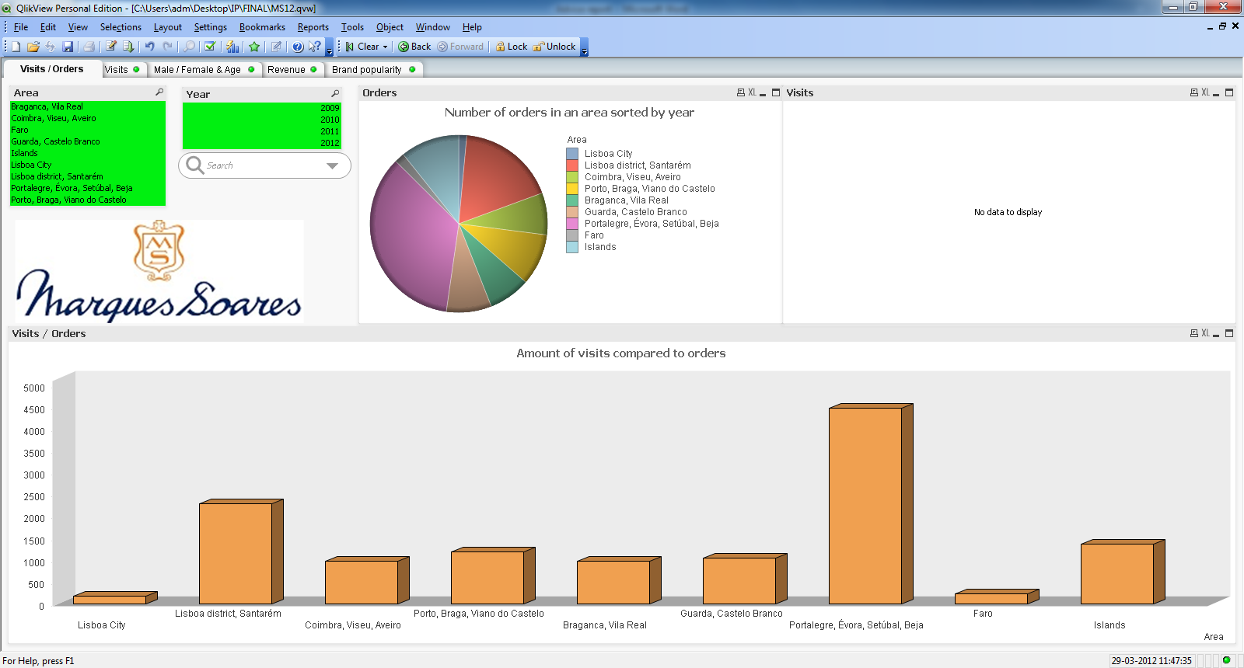 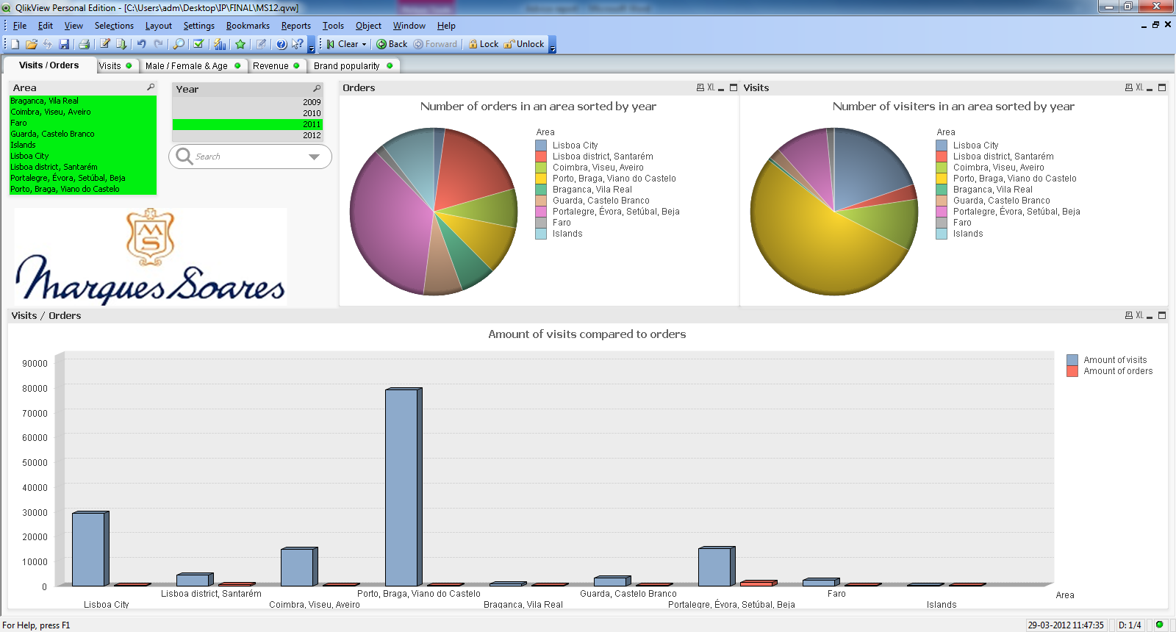

Here you see an overview (made in Qlikview) of the online orders versus the online visitors in the year 2011 in all areas in Portugal.

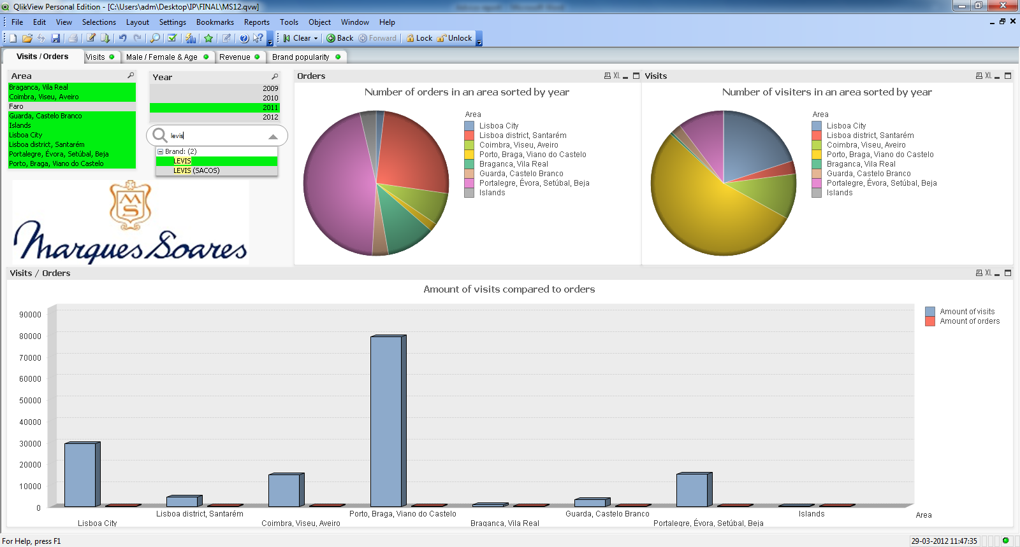

Here you see an overview (Qlikview) of the online orders versus the online visitors in the year 2011 sorted on the brand “Levi´s” in all areas in Portugal. You can also see that there has been no one in the Faro area that bought Levi´s online in 2011.

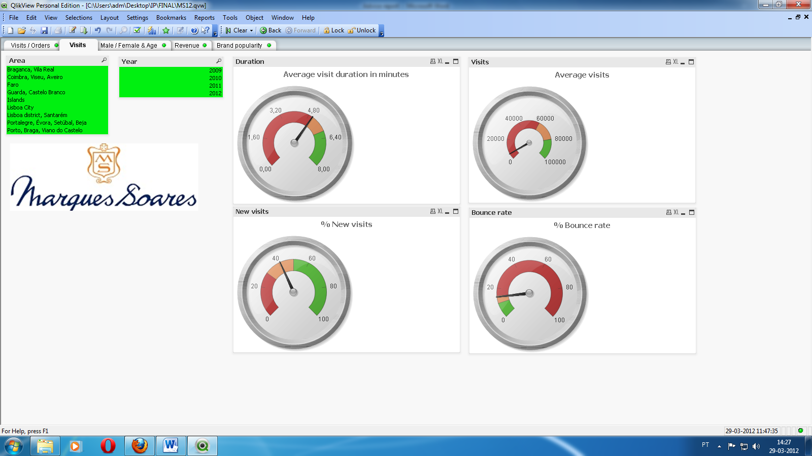In this view (Qlikview) you can see the average visit duration in minutes, the average visits, the percentage of new visitors and the percentage of bounce. Al this information is dynamic on year and area. In the guages you can see how good or bad things are going. Green means ofcourse good, while red means bad and orange is in between. These colors are based on KPI´s. (Google Analytics exported information)

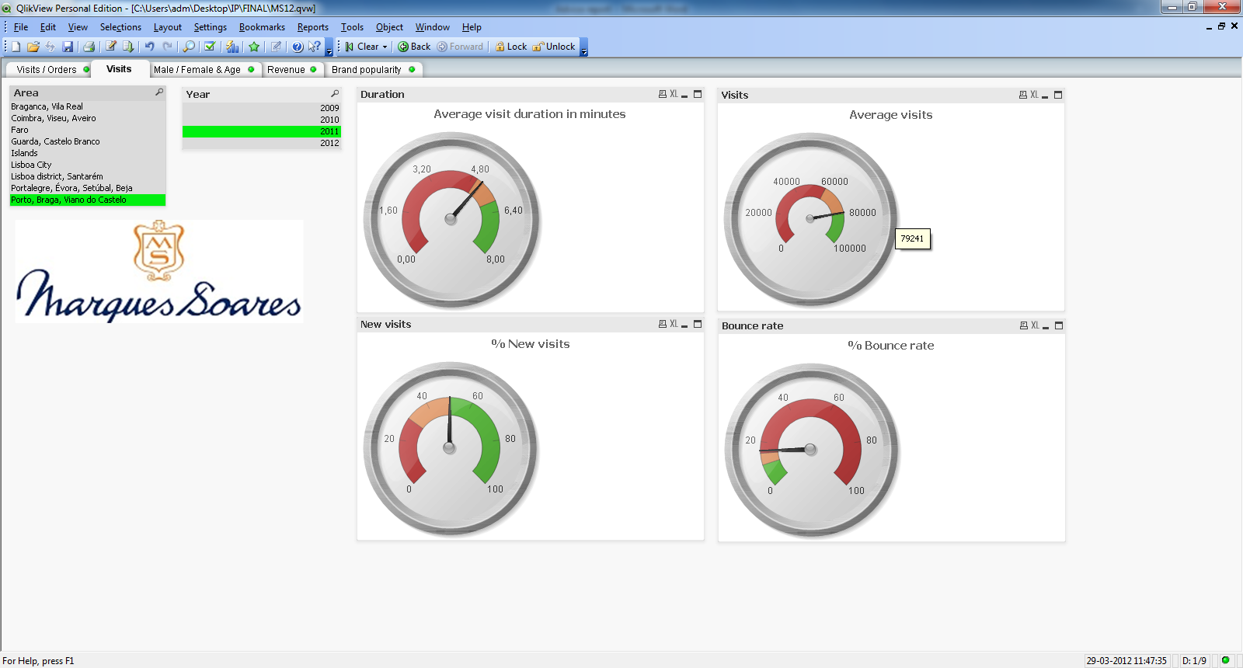In this view (Qlikview) you can see the average visit duration in minutes, the average visits, the percentage of new visitors and the percentage of bounce. Al this information is dynamic on year and area. In the guages you can see how good or bad things are going. Green means ofcourse good, while red means bad and orange is in between. These colors are based on KPI´s. In this case you see the guages of Porto, Braga and Viano do Castelo with the infromation of 2011 (Google Analytics exported information)

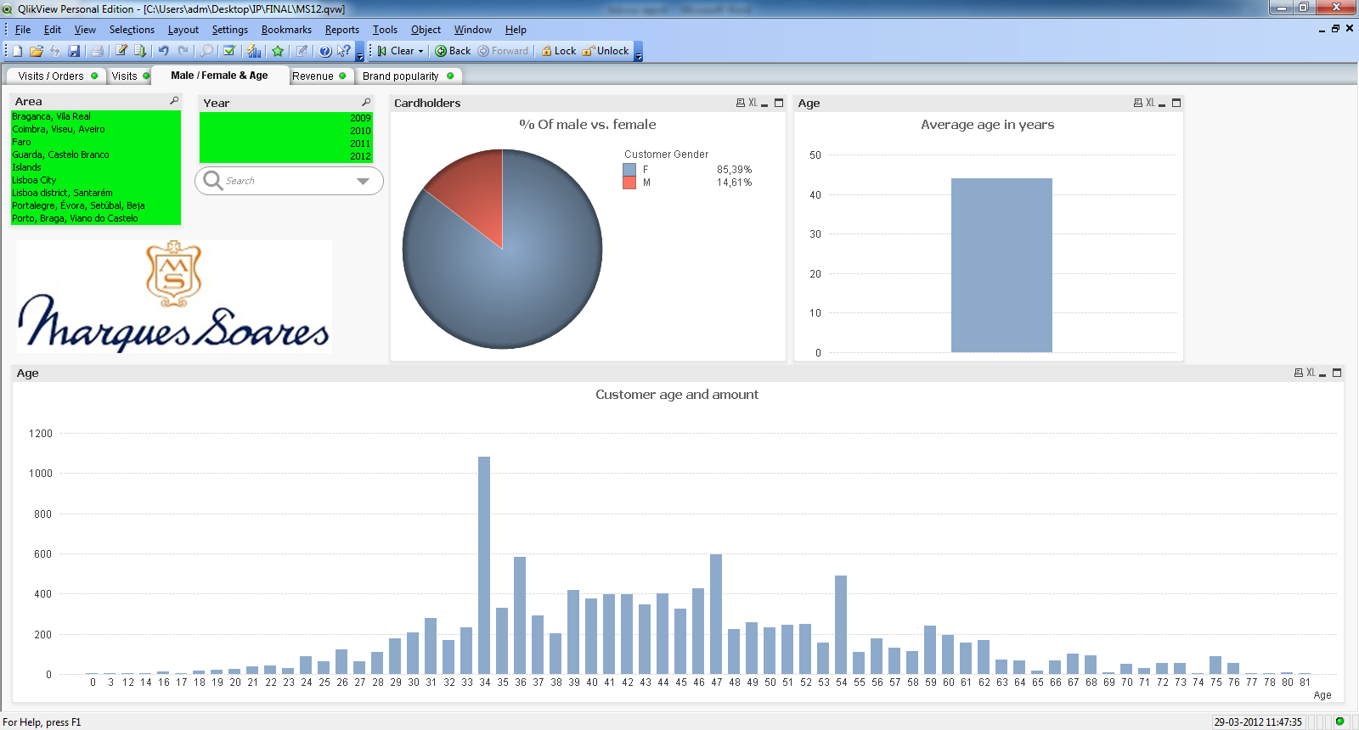In this view (Qlikview) it is easy to see how the devotion between men and women is from who are cardholders of Marques Soares, average age, and amount of customers per age age visible. Again you can select on area and year, als well als search for a perticular brand, product and departement. This view is very useful to see the age and sex of people in general and very specific.

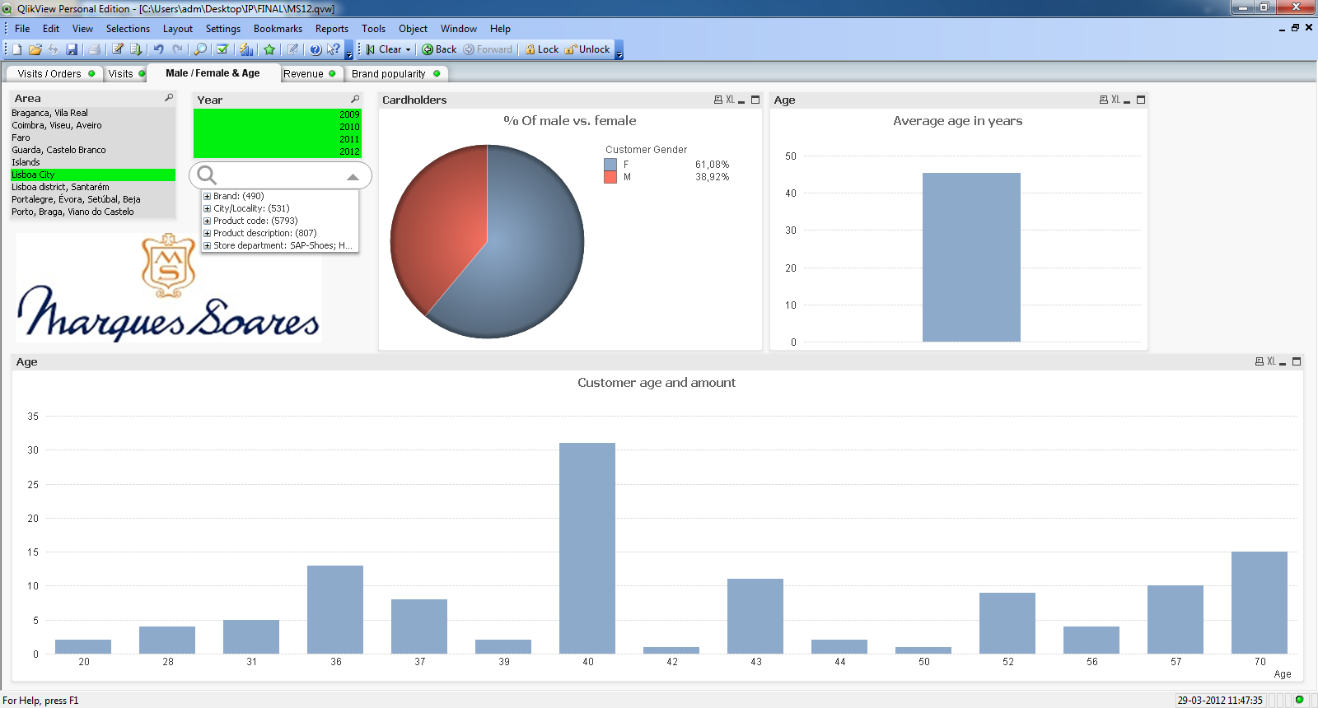In this view (Qlikview) it is easy to see how the devotion between men and women is from who are cardholders of Marques Soares, average age, and amount of customers per age age visible. Again you can select on area and year, als well als search for a perticular brand, product and departement. This view is very useful to see the age and sex of people in general and very specific. In this picture we selected Lisboa City as area in alle available data (years) with no specific search criteria.

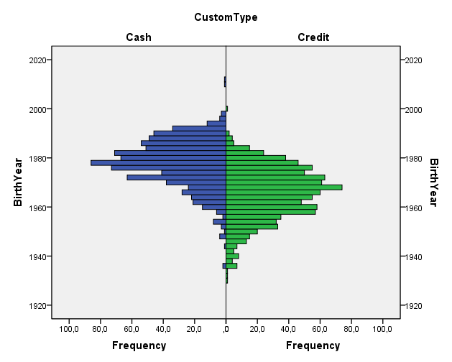

In this graph (made in SPSS) you can see the devotion between payment method and when people who use these methods are born. It is very easy to see that how older people get, how more frequently they use credit over cash.

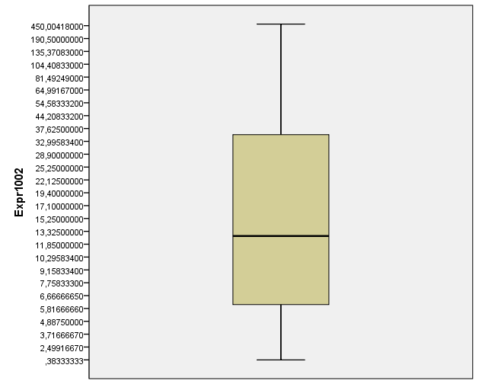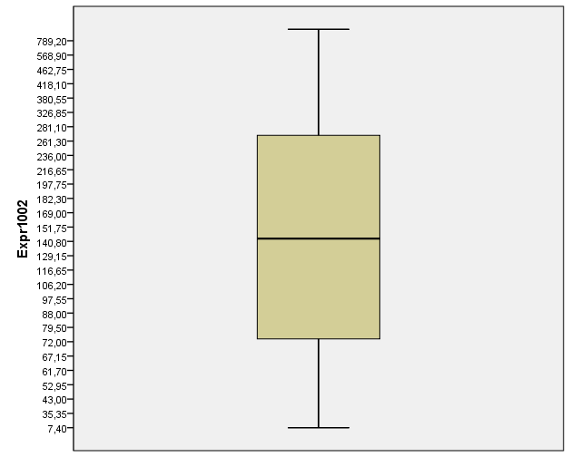

25 %

25 %

25 %

25 %

25 %

25 %

25 %

25 %

In this (SPSS) graphic you can see what people spend in a “normal” month on the right and in their “birth month” on the left. As you can see people spend more in the month they are born than in other months.

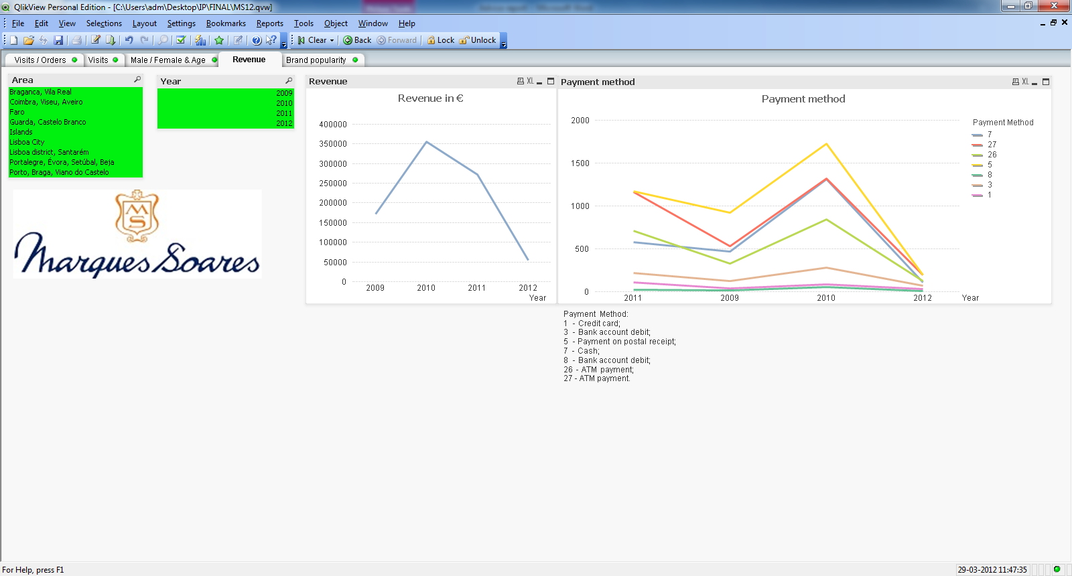This view (Qlikview) shows us the revenue in Euro´s per year and area, or in total and the payment methods people prefer. As you can see here the revenue in 2010 was better than 2011, which can be confirmed by the financial crisis. You can also see that bank account debit does not grow as rappidly as for example ATM payments.

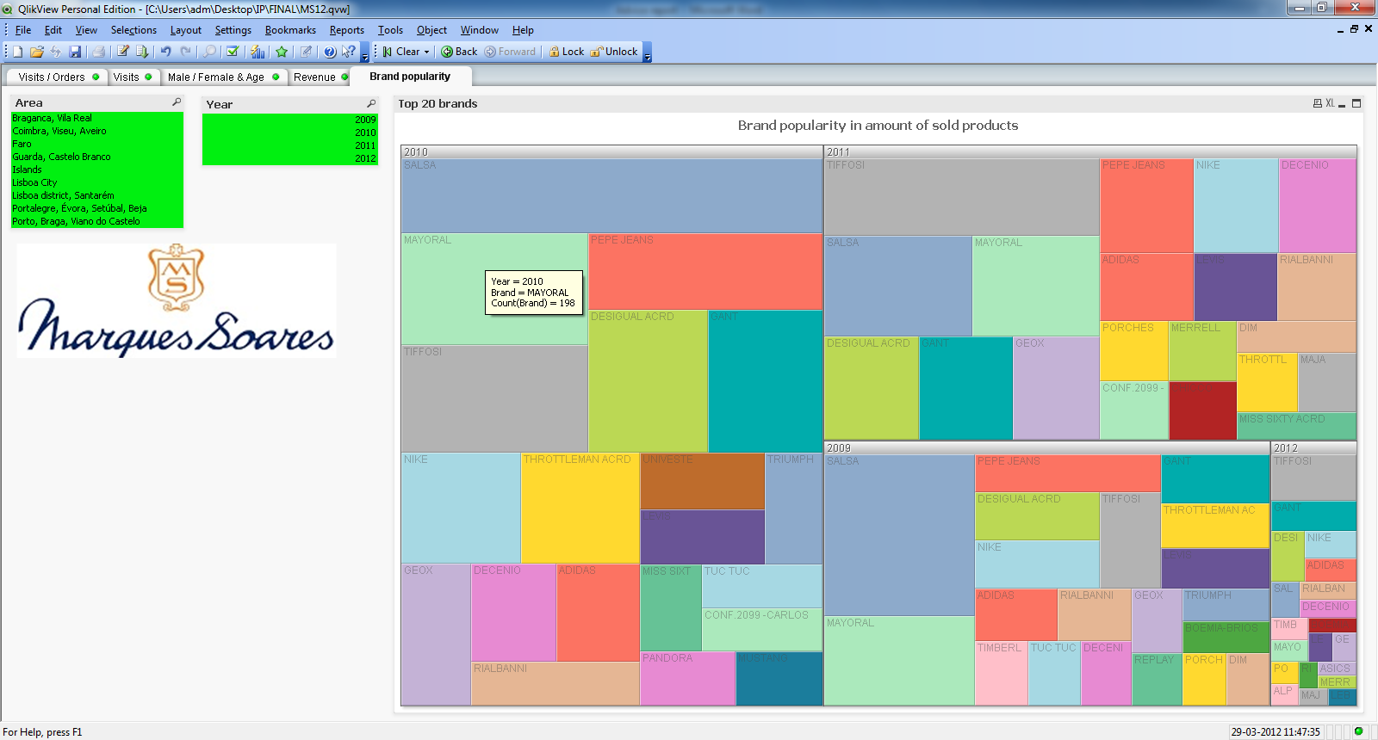This view (Qlikview) shows us how popular brands are in online sales (only the top 20 since the rest is so close together and irrelevant). The bigger the box is, the more this brand has been sold in a particular year. The years are ordered on total revenue, that is why you see 2010 as largest, than 2011, 2009 and 2012 (which is so small because it is still going). You can see that in 2011 the most sold brand was “Tiffosi”, while in 2010 this was “Salsa”

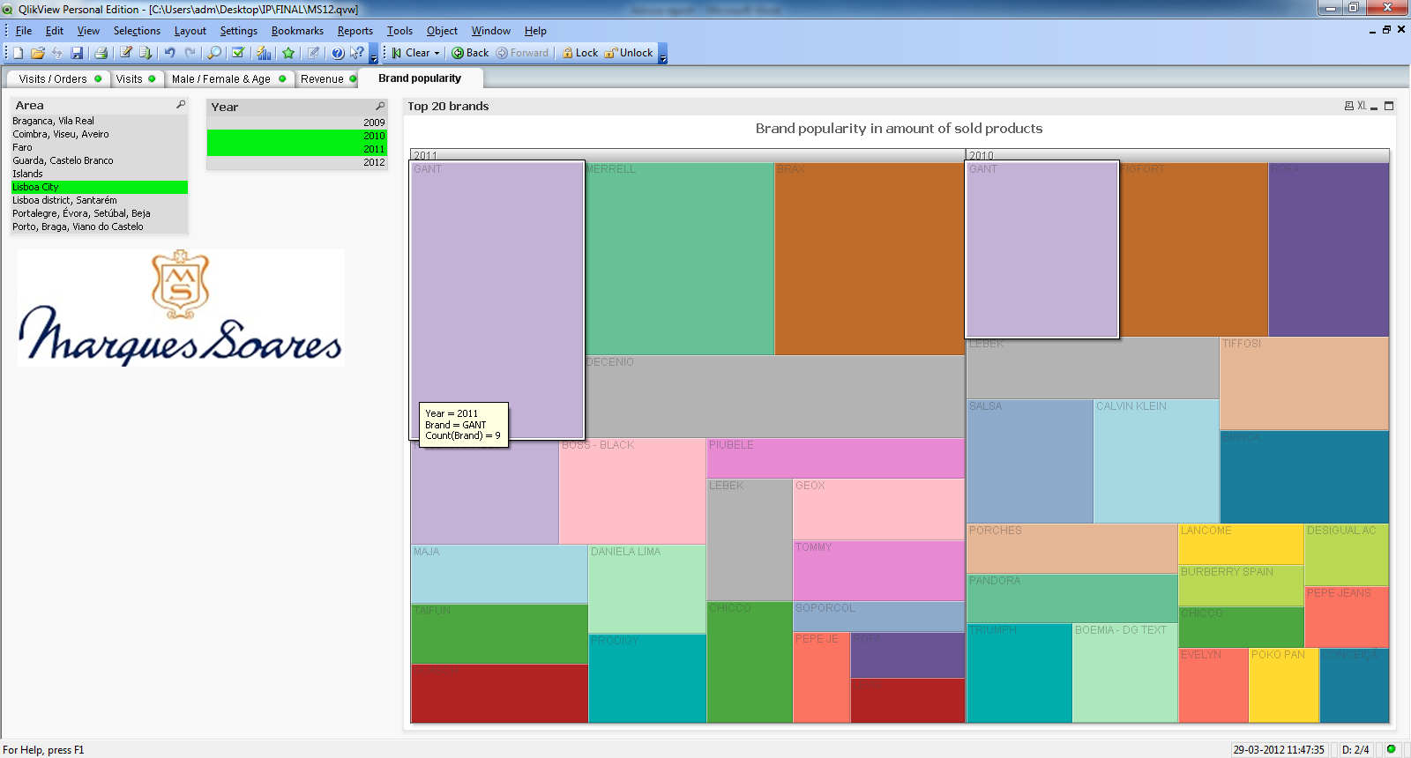This view (Qlikview) shows the same as the one above, only selected in years 2010 and 2011 and for Lisboa City area. The brands you see here are particulary popular in Lisboa.

# Conclusions / Suggestions

We think Marques Soares would have benefit by implementing an interactive catalogue instead of a static PDF catalogue. Via this catalogue people can directly be linked to the products they want to buy instead of that they need to search for the article on the website themselves. This can also be applied on the newsletter. Instead of linking to the homepage it would be beneficiary to link to the products themselves directly.

We also think it would be useful to improve sales by recommending other products. For example recommending a matching tie to a shirt or suit. Or things that other customers buy together. A good example for this would be Amazon.com

Since social media nowadays is booming it would be better to have good social media integration on the website. You could think of things like a Facebook “Like” contests where you do a lottery of followers who “Like” Marques Soares and give the winners for example some discount(s). You could also think of special Twitter offers, for example you send out coupon codes via Twitter and only the first 100 users of that code get a discount.

Also when you look to the bigger international (national orientated) companies you see that a lot of these companies have no shipping costs, or free shipping costs above spending for example €100. No shipping cost lowers the threshold for the customer to buy their needed goods online. It is also possible to make exceptions for frequent buyers. When someone is a loyal online customer you could give them free shipping.

Another immensely used method of marketing is sending people coupons in the month that their birthday is. With coupons we mean that they get for example €20 discount when they buy goods within a month of their birthday, with a minimal order amount of €100. This is applicable for online sales (coupon codes) and normal in-store sales.