Final paper – Marques Soares

**2012**

Group 4

*‘Intensive project’ Porto*

30-3-2012

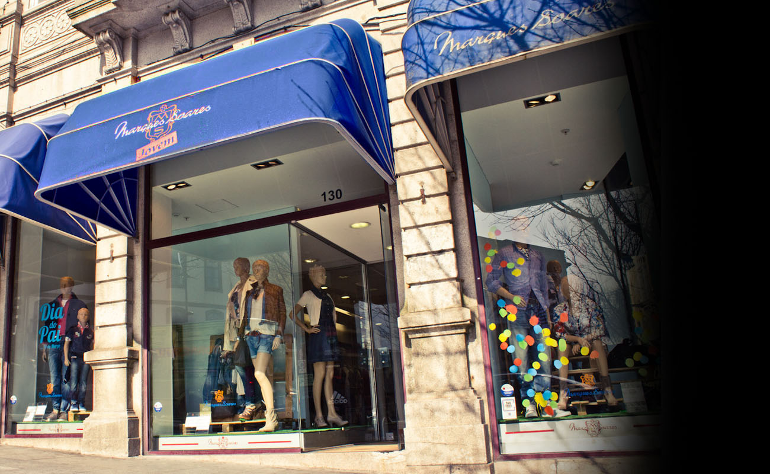

# Team Introduction

We are team 4 and we consist out of:

* Natan Meekers (**BELGIUM**)
  + **AGE:** 22
  + **STUDIES:** IT management and systems – Performance management
  + **ROLE:** Co-ordinator / Finisher
* Mantas Truncė (**LITHUANIA**)
  + **AGE:** 22
  + **STUDIES:** Computer science
  + **ROLE:** Team leader
* Arthus Šarõpi (**ESTONIA**)
  + **AGE:** 23
  + **STUDIES:** IT Development
  + **ROLE:** Team worker
* Dennis Gyldendahl/Jense (**DENMARK**)
  + **AGE:** 35
  + **STUDIES:** Game development
  + **ROLE:** Team worker
* Juan Martí (**SPAIN**)
  + **AGE:** 27
  + **STUDIES:** Computer Science
  + **ROLE:** Team worker

# Customer Description

Marques Soares’ key activity is selling clothes. They are selling over three different channels to insure their cash flow. Besides selling clothes they sell also a whole range of other products true their website. To get a good overall view of the company we have been working on a business canvas model, internet strategy and some business questions.

Marques Soares is targeting as much people as possible to buy the clothes or other products they sell. Now, with their aim on selling more via their website they are targeting younger people from 18 years and older.

The

## Business Canvas model

|  |  |  |  |  |  |
| --- | --- | --- | --- | --- | --- |
| **Key Partners** They don’t have partners but they are willing to look for partners.  But they only will start looking for partners when they really have to. | **Key Activities** Selling clothes and other products in the stores and online | **Value proposition** The stores have a wide range of brands and it’s easy for the customer to put it on to see if it’s fit.  The member card makes it very easy to order products online and gives the customer the opportunity to choose another payment plan, like paying in segments.  When the customer’s order products online, the ordered products are delivered at home. | | **Customer relationships** They offer member cards which gives the customers the option to purchase products by just giving their card number instead of all their personal data.  They also can pay in segments instead of paying all at once. | **Customer segments** *‘ Mass market’*  Targeting as much people as possible by offering as much products as possible.  They now started focusing a little bit more on young adults by adding a Facebook page and promoting to shop online. |
| **Key Resources** Because of the wide range of products our key resources are: clothes, perfume, accessories, shoes, | **Channels** Catalogue  Internet   * Website * Newsletter * Social media   Stores |
| **Cost structure** The brochures are a pretty big cost of the company. They also have the stores, the maintenance of the site and the clothes that have to be bought. | | | **Revenue streams** The revenue stream in this company is what the customer’s pay.  **It would be good for the company to find other ways to insure their revenue streams!** | | |

## SWOT – analysis

A SWOT analysis is a strategic planning method used to evaluate the Strengths, Weaknesses, Opportunities and Threats involved in our business plan.

**Strengths**

* Exists since 1960 so they have much experience
* A wide range of popular brands
* Selling over 3 different channels
* Nice looking website

**Weaknesses**

* Prices in the stores are the same
* Prices are pretty high
* Shipping costs
* There are no advantages by buying clothes online

**Opportunities**

* Gain new younger customers
* Bigger revenue stream
* They can reach more customers

**Threats**

* Crisis
* Average wage is low

## Internet strategy

When we are thinking about an online strategy for our company we have to try to image how people will be attracted to buy products from our website.

First of all we need a nice website that is easy to use for the customers and that has a nice performance. Otherwise the company will already lose potential customers because of that. We think that Marques Soares has already a nice website and that the overall performance is pretty good but they have to do something about the security of the website:

It is possible to register online with an address that doesn’t exists without confirming the email address we used for registration. They could check if the postal code used in the registration form is a valid postal code and sent an confirmation email.

Next to a nice looking website we need some kind of a promotion plan that will attract customers to buy our products online instead of our stores. We also have to keep in mind that the customers will have to pay shipping costs on top.

Marques Soares entered the world of social media and is trying to make the best of it but they still can use a lot of improvement. The Facebook page is the one they use the most but there is no interaction with customers. The Twitter page is even worse because they are active there but they don’t have any followers.

Mostly young people are buying products on the internet. When we see this graph we can see that the average customer is between thirty and fifty years old. This is kind of a problem when you want to improve your online sales because the actual customers file isn’t suited to buy products online. We shouldn’t see to this as a threat but as a potential to extend our customer file when we are able to gain more young customers for our online sales.

## Business Questions

These business questions are the ones that the company would like to be answered:

1. How they can improve the website to sell more products and get more customers?
2. What is the typical customer profile?
3. What they can do to promote the new Facebook site?
4. How to ensure customer loyalty?
5. What brands or products clients prefer?
6. How they can get new clients?

# Case data

The data from the Excel sheet in its current form is not useful as we need to translate it into understandable information and filter out the useless parts. We think that the amount and completeness of the data was not enough to find some useful patterns in it.

Access to the Google analytics account was pretty nice although we have a few remarks about it. Google analytics is a great tool to track your website information and get some nice looking graphs out that are easily understandable.

But to use the full potential of this tool there need to change some things about the structure of the website. As an example: In this figure we can see the different pages visited by customers and we have no idea when they visit the checkout page.

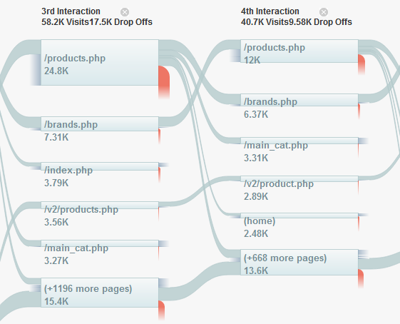

# Processing & analysis of data

In this graph you see the bounce rate from the website. The bounce rate shows us how many visitors that come to the site are immediately leaving again. If this rate is to high we should start looking in the graph we see on the previous page to find out on what page the visitors are leaving again.

If we find out what page customers are leaving we should think about adjusting the page to make it more attractive

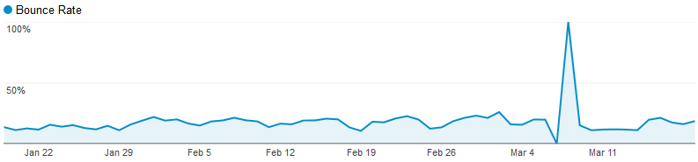

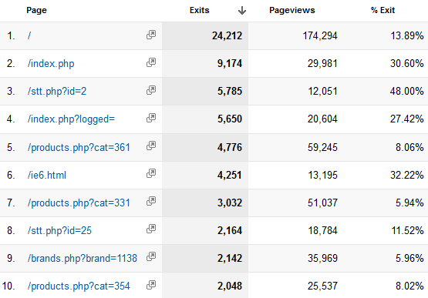As an example: In the following graph we see an overview of the pages and how many people exit when they visit this page:

As we can see most of the people leave when they visit the front page. One of the solutions can be to make a distinction between man and woman on the front page.

When the visitor makes his/hers selection, they will be redirected to a more customized site for their gender.

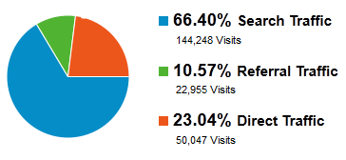In this graph on the right we get a nice overview of the amount of visitors and how they reached the website. If we as a company think that we should receive more visits due referral traffic we could start thinking about how we could improve this.

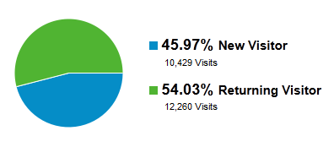In the graph on the left we have a overview of the visitors and the visitors that return to our website.

It is good to see that 54% of are visitors are returning which means they are interested in what we sell. On the other hand you can look at this graph and say that there are only 45% new visitors and that you would like to improve this as a company.

We also applied data mining on the Excel sheet we received. As you can see in the answers of the business questions we mined some patterns like the items that are frequently bought together. Also the age and gender graphs are created by using the date from the Excel sheet.

# Conclusions & suggestion

* First of all we suggest that they improve the way they store their data.
* Improve the interaction with your customers through social media
* Make the site accessible for mobile devices
* Optimize the site for Google Analytics
* Add security to the website
* Perform a check when new customers register to see if they entered a valid postcode
* Sent an registration email to complete a registration
* Add special tags in links when you sent a newsletter so you can track which customers are coming to your website because of the newsletters.
* Make the site accessible for mobile devices
* Improve the interaction with customers on your social media pages
* Put a stronger encrypted password or a more difficult one because the one that is on your database now, was cracked really easily. So we got access to your database
* Encrypt the passwords from your customers to protect their private data
* Add a function to the website that people can see the shop that is the nearest by their location
* Add some kind of game to attract new and younger customers to your website. As you can see in the picture below, this is a game of a Belgium company to award there loyal customers and to attract new customers by giving them small gifts when they buy something from that company.

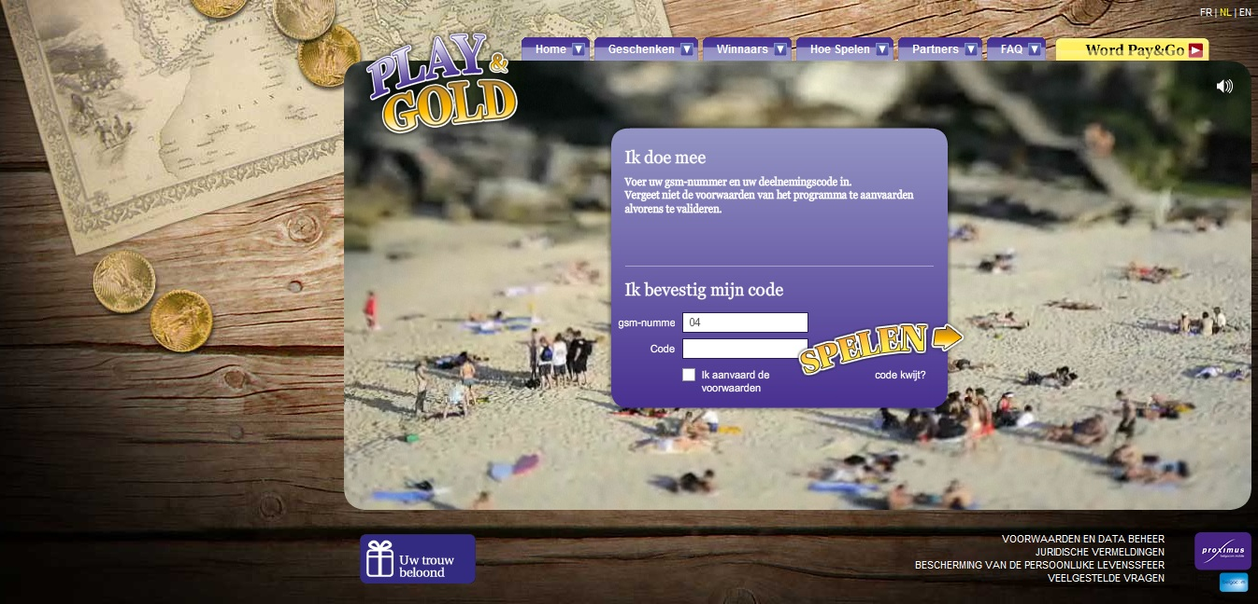

## Answered business questions

##### How they can improve the website to sell more products and get more customers?

These are several tips and ideas to improve the online sales:

* Reduce the prices of online products (perhaps even only the most popular products)
* Some kind of element on the right with items that are frequently bought together by other customers or items that fit together with the item the customer is viewing.
* Classify (registered)users into segments and personalize the website experience accordingly (don’t offer expensive items to poor regions, young buyers, etc) or let users
* Sent mails about new products to these people that already bought clothes of that specific brand

We applied some data mining and found out that the next items are frequently are bought together:

|  |  |  |  |
| --- | --- | --- | --- |
| Selected Item | Bought together | Linked Sales | Avg value of recommendation |
| Bermuda | Boots | 10 | 55,62619048 |
| Bermuda | Polo | 10 | 29,33095238 |
| Bermuda | Trousers | 10 | 23,13333333 |
| Bermuda | T-Shirt | 12 | 18,65238095 |
| Bermuda | Sweat-Shirt | 10 | 15,31428571 |

On the site it would look like this:

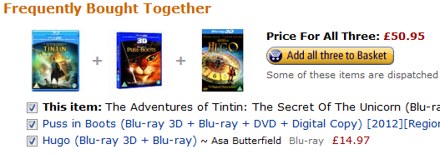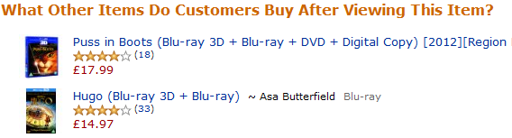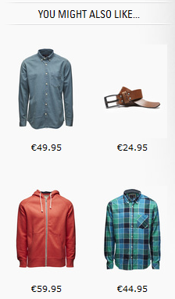

##### What is the typical customer profile?

We made two graphs to give you an idea about the typical customer profile. In the first graph we see the age of the average customer. Of course we have to keep in mind that these data is gathered from the member cards and that members of one family can by with the same card.

As we clearly see in this graph the average age of our customer is between 30 and 50 years old. If we want to improve our online sales we have to start targeting younger people that are more familiar with the internet. In the second graph we see that the most of our customers are female

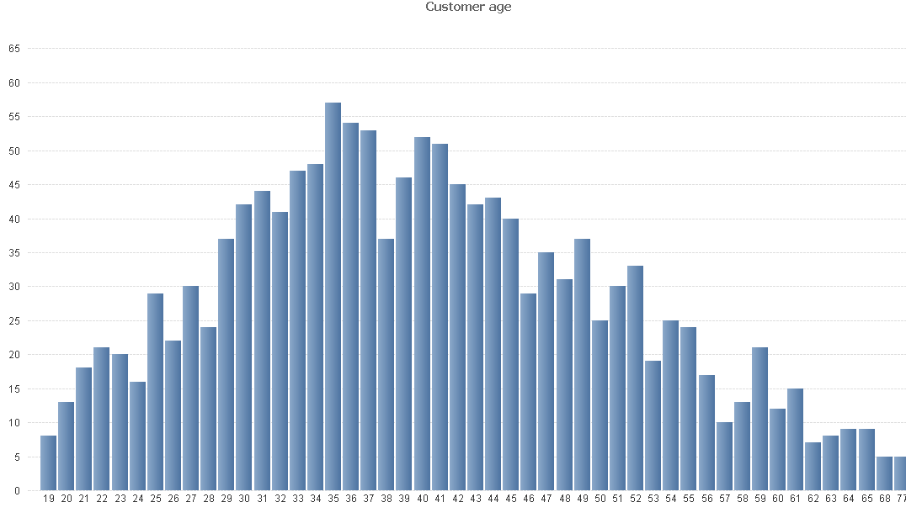

##### What WE can do to promote the new Facebook site?

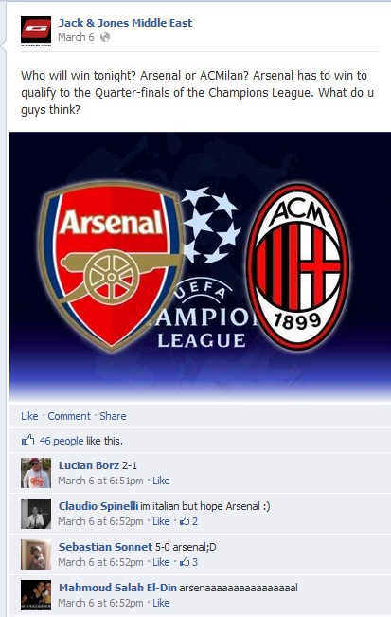The Facebook page looks not bad but it’s all about the company Marques Soares. Try interacting with customers about other stuff that people are really interested in. As an example:

This is from the Facebook page of Jack & Jones. This company posts Facebook updates about sports to get interaction with their customers.

Because almost every person is interested in sports, is this a very good way to get interaction.

Another great way to attract people to your Facebook page is to give them in return. As example if you give every season some kind of discount code to your customers than they will most likely every now and then come to Facebook to check it out.

A good mix of these different kinds of interaction will make the Facebook page more interesting and perhaps if your customers are very happy about it they will start inviting their friends. This is called ‘Branding‘

##### How to ensure customer loyalty?

Your customers have to be happy about the products they buy and about the company. Rewarding loyal customers gives you a little bit more assurance that they will keep coming back.

Monitoring social media to see what people say about your company is pretty important today. If you notice a bad remark about your company you should take initiative to solve ‘ the problem’ . Tools like MicroStrategy – WISDOM.

This tool gives you the possibility to easily monitor social media!

##### What brands or products clients prefer?

As we can see in this graph we have an overview of the most popular brands sold over our website. If you use this on a dashboard that is linked to the database of your transactions you have the possibility to drill through to see the most popular brand of one year or even the most popular brand of the month.

##### How can we get new clients?

Getting new customers:

* Offer to the normal customer a reward for bringing new clients. Discounts, gift cards...
* Mail campaign: like Facebook pages of the brands
* ‘Branding’ – trying to make existing customers to start talking about your company against their friends
* Advertising

It’s not easy to say to a company how to get new customers. The most important for a company is to maintain its “old” customers because they are more cheap to maintain than to get new customers. If these customers are satisfied about the products and services your company delivers, they will attract new customers for you.

As a wise man once said:

“It’s eight times more expensive to gain new customers than  
 to keep your old customers“