

Distribution and Genomic Variation of Thermophilic Cyanobacteria in Diverse Microbial Mats at the Upper Temperature Limits of Photosynthesis
RESEARCH ARTICLE


Eric D. Kees,ª Senthil K. Murugapiran,ª* Annastacia C. Bennett,ª Trinity L. Hamilton^{a,b}

aDepartment of Plant and Microbial Biology, University of Minnesota, St. Paul, Minnesota, USA bBiotechnology Institute, University of Minnesota, St. Paul, Minnesota, USA

ABSTRACT Thermophilic cyanobacteria have been extensively studied in Yellowstone National Park (YNP) hot springs, particularly during decades of work on the thick lami- nated mats of Octopus and Mushroom springs. However, focused studies of cyanobacte- ria outside these two hot springs have been lacking, especially regarding how physical and chemical parameters along with community morphology influence the genomic makeup of these organisms. Here, we used a metagenomic approach to examine cyano- bacteria existing at the upper temperature limit of photosynthesis. We examined 15 alkaline hot spring samples across six geographic areas of YNP, all with various physical and chemical parameters and community morphology. We recovered 22 metagenome- assembled genomes (MAGs) belonging to thermophilic cyanobacteria, notably an uncul- tured Synechococcus-like taxon recovered from a setting at the upper temperature limit of photosynthesis, 73°C, in addition to thermophilic Gloeomargarita. Furthermore, we found that three distinct groups of Synechococcus-like MAGs recovered from different temperature ranges vary in their genomic makeup. MAGs from the uncultured very- high-temperature (up to 73°C) Synechococcus-like taxon lack key nitrogen metabolism genes and have genes implicated in cellular stress responses that diverge from other Synechococcus-like MAGs. Across all parameters measured, temperature was the primary determinant of taxonomic makeup of recovered cyanobacterial MAGs. However, total Fe, community morphology, and biogeography played an additional role in the distribu- tion and abundance of upper-temperature-limit-adapted Synechococcus-like MAGs. These findings expand our understanding of cyanobacterial diversity in YNP and provide a ba- sis for interrogation of understudied thermophilic cyanobacteria.
IMPORTANCE Oxygenic photosynthesis arose early in microbial evolution—approxi- mately 2.5 to 3.5 billion years ago—and entirely reshaped the biological makeup of Earth. However, despite the span of time in which photosynthesis has been refined, it is strictly limited to temperatures below 73°C, a barrier that many other biological processes have been able to overcome. Furthermore, photosynthesis at temperatures above 56°C is limited to circumneutral and alkaline pH. Hot springs in Yellowstone National Park (YNP), which have a large diversity in temperatures, pH, and geochemistry, provide a natural laboratory to study thermophilic microbial mats and the cyanobacteria within. While cyanobacteria in YNP microbial mats have been studied for decades, a vast majority of the work has focused on two springs within the same geyser basin, both containing similar community morphol- ogies. Thus, the drivers of cyanobacterial adaptations to the upper limits of photo- synthesis across a variety of environmental parameters have been understudied. Our findings provide new insights into the influence of these parameters on both taxonomic diversity and genomic content of cyanobacteria across a range of hot spring samples.

Editor Hans C. Bernstein, UiT—The Arctic University of Norway
Copyright © 2022 Kees et al. This is an open- access article distributed under the terms of the Creative Commons Attribution 4.0 International license.
Address correspondence to Trinity L. Hamilton, trinityh@umn.edu.
*Present address: Senthil K. Murugapiran,
Diversigen, New Brighton, Minnesota, USA.
The authors declare no conflict of interest.
Received 28 March 2022 Accepted 1 August 2022 Published 18 August 2022

KEYWORDS cyanobacteria, Synechococcus, photosynthesis, metagenomes, metagenome assembled genomes, MAGs, microbial mats, hot springs, nitrogen fixation, ecotypes

xygenic photosynthesis in Cyanobacteria is among the most impactful microbial innovations in Earth’s history and accounts for the largest source of O₂ in the atmosphere. While photosynthesis has had approximately 2.5 to 3.5 billion years of evolution (1–3), it is constrained to temperatures of ,73°C in alkaline environments
O
and ,56°C in acidic environments (4–8).
Characterizations of high-temperature cyanobacteria have been most extensively done in Hunter’s Hot Springs, Oregon, USA, and in thick laminated microbial mats of alkaline Mushroom Spring, Octopus Spring, and the mat and streamer communities in White Creek (9) in Yellowstone National Park (YNP), Wyoming, USA, hot springs. A lim- ited number of studies have focused on phototrophic hot spring communities else- where in YNP (10–14). The most prevalent cyanobacteria found at or near the 73°C limit in these springs are those in a Synechococcus-like clade (15–17). Since these ther- mophilic Synechococcus-like cyanobacteria form a basal clade, distantly related to all other known Synechococcus species, they were recently classified under the proposed genus name Leptococcus (18, 19) or, more recently, Thermostichus (20). For the pur- poses of clarity and contextualization around existing literature, we refer to these cya- nobacteria in the present study as belonging to the Synechococcus-like A/B lineage (10, 15, 17, 21–24).
Molecular probing of Synechococcus-like cyanobacteria in Octopus and Mushroom springs revealed several “ecotypes,” or sequence variants occupying different niche spaces defined by environmental variables such as temperature and light (15, 21, 22, 24–26). These ecotypes were organized into major categories designated “A” and “B.” “A” ecotypes (including the isolated and sequenced strain JA-3-3Ab, referred to here and elsewhere as OS-A) tend to occupy the highest temperatures up to 73°C, while “B” ecotypes [including
JA-2-3B9a(2-13), or OS-B9] occupy a slightly lower range, up to 65°C (15, 17, 25). A and B ecotypes have been more finely delineated along temperature gradients into A, A9, A99, B9 and so on, generally with each “prime” designation indicating a temperature range trend-
ing upward (15). Similar niche differentiation along temperature gradients was described for Synechococcus-like cyanobacteria in Hunter’s Hot Springs, and at present, the only cul- tured A9-like cyanobacteria were isolated from this location at 70°C (27–30). Biogeography
plays an additional role in genetic divergence of ecotypes within A/B-lineage clades (10).
In the present study, we were primarily interested in the genetic factors that drive ecologi- cal diversification among A/B-lineage populations, particularly in YNP hot springs with dif- fering pH, temperature, and geochemistry.
While the underlying genetic factors driving adaptation to different temperatures among Synechococcus-like A/B-lineage organisms remain largely unresolved, some specific adaptations to the highest temperatures have been identified. For example, more thermostable variants of RuBisCO have been found to extend the thermal niche in an A/B-lineage clade from Hunter’s Hot Springs (30). Comparisons between OS-B9
(53 to 60°C) and OS-A (58 to 70°C) isolates from Octopus Spring also revealed different
strategies for phosphorus assimilation: in contrast to OS-B9, OS-A lacks a C-P lyase op- eron and is unable to grow heterotrophically in the dark from phosphonates (26). Since focused studies of high-temperature Synechococcus-like A/B-lineage ecotypes
have been largely limited to the thick laminated mats of Octopus Spring, Mushroom Spring, and Hunter’s Hot Springs, it is unknown whether they are driven by the same adaptations in other springs. Specifically, the degree to which pH influences tempera- ture adaptation and taxonomic makeup of A/B-lineage cyanobacteria is understudied.
Here, we leveraged metagenomic sequencing of samples across a range of pH, tem- perature, geochemistry, and community morphology to further define the taxonomic distribution and genomic content of the A/B-lineage and other thermophilic cyanobac- teria within YNP hot springs. We focused specifically on communities existing in a

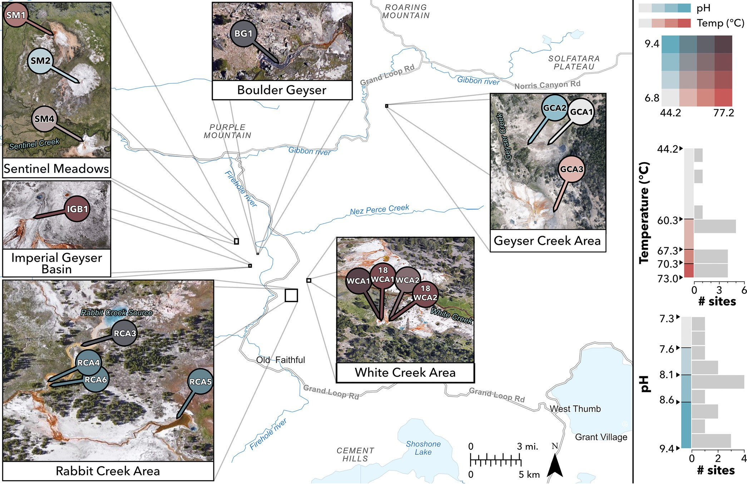

FIG 1 Sample locations. Samples were collected in Yellowstone National Park at locations with various temperatures, pH, and community morphology. Samples are shown sorted into 4 temperature (red) and 4 pH (blue) color coordinates. Sorting was done according to geometric intervals to account for skewed data and better differentiate temperatures near the upper limits. Research conducted under Yellowstone Research Permit YELL-2017-SCI-7020.

range of temperatures at circumneutral to alkaline pH and in communities with mor- phologies ranging from thin and thick mats to filaments. We asked whether the niches defined for the Synechococcus-like A/B lineage in Mushroom and Octopus springs are applicable to other Yellowstone hot springs and whether the distribution and relative abundances of phototrophic taxa are constrained by a combination of temperature and pH. Using a pangenome approach, we detail genomic comparisons of 15 Synechococcus-like A/B-lineage metagenome-assembled genomes (MAGs) from three distinct clades.

RESULTS AND DISCUSSION
Sample site descriptions and recovery of MAGs. We asked whether the tempera- ture constraints placed on laminated, cyanobacterial mats in alkaline Mushroom and Octopus springs were similar to those in other Yellowstone hot springs with varying geography, community morphology, and pH. Additionally, we examined the extent to which pH constrains the upper temperature limit and taxonomic composition of ther- mophilic cyanobacteria. We collected 16 samples from 11 hot springs within 3 geyser basins in 2017 and 2018 (Fig. 1; Table 1), targeting the transition between pigmented photosynthetic communities and chemotrophic zones, termed the photosynthetic “fringe.” YNP regions sampled include the Middle Geyser Basin (Rabbit Creek area [RCA]), Lower Geyser Basin (Boulder Geyser, Imperial Geyser Basin, Sentinel Meadows, White Creek area [WCA]), and Gibbon Geyser Basin (Geyser Creek area [GCA]). Generally, sample temperatures ranged from 44.2°C to 73.0°C, and pH ranged from 7.3 to 9.4. Sulfide concentrations ranged from 0.22 mM to 4.93 mM (with one exception at 18.99 mM), chloride from 7.7 mM to 12.0 mM, and iron from 93.8 nM to 765.3 nM. In

TABLE 1 Metagenome sample descriptions
Sample namea | Sample ID | IMG genome ID | BioSample accession | Total assembly length (bp)b | Gene count | pH | T (°C) | Community morphology
BG1 | 170629B | 3300028893 | SAMN26200800 | 196,918,189 | 436,827 | 8.7 | 68.5 | Red mat and filaments
GCA1 | 170630B | 3300038630 | SAMN26200803 | 222,603,420 | 441,247 | 7.6 | 59.9 | Orange/yellow mat
GCA2 | 170630C | 3300040982 | SAMN26200804 | 291,888,643 | 632,804 | 8.3 | 44.2 | Pink/white/grey mat
GCA3 | 170630D | 3300028820 | SAMN26200805 | 213,192,026 | 395,775 | 7.3 | 62.7 | Red/grey mat
IGB1 | 180603O | 3300036711 | SAMN26200807 | 117,128,738 | 264,866 | 8.2 | 66.6 | Orange/yellow mat
RCA3 | 170626A | 3300028606 | SAMN26200794 | 114,093,415 | 252,304 | 9.1 | 68.4 | Thin yellow/orange mat
RCA4 | 170626B | 3300028609 | SAMN26200795 | 195,353,357 | 412,629 | 9.2 | 62.3 | Orange/yellow mat
RCA5 | 170626C | 3300028611 | SAMN26200796 | 108,943,318 | 208,402 | 9.4 | 62.4 | Orange/yellow mat
RCA6 | 170626D | 3300028818 | SAMN26200797 | 182,682,112 | 386,452 | 9.3 | 62.3 | Orange/yellow mat
SM1 | 170627A | 3300028613 | SAMN26200798 | 316,999,032 | 710,899 | 7.9 | 68.4 | Thin yellow/orange mat
SM2 | 170627E | 3300028839 | SAMN26200799 | 475,303,863 | 1,088,432 | 8.1 | 51.4 | Orange/yellow mat
SM4 | 180602L | 3300038980 | SAMN26200806 | 76,631,469 | 142,361 | 8.0 | 62.3 | Orange/yellow mat
WCA1 | 170629F | 3300028816 | SAMN26200801 | 104,661,654 | 234,717 | 8.8 | 71.0 | Green filaments
18WCA1 | 180603R | 3300038981 | SAMN26200808 | 101,090,071 | 215,532 | 8.4 | 73.0 | Green filaments
WCA2 | 170629H | 3300028617 | SAMN26200802 | 131,707,792 | 292,784 | 8.6 | 69.4 | Green filaments and mat
18WCA2 | 180603S | 3300038484 | SAMN26200809 | 142,901,704 | 282,903 | 8.2 | 71.9 | Green filaments
aRCA, Rabbit Creek Area; SM, Sentinel Meadows; BG, Boulder Geyser; WCA, White Creek area; GCA, Geyser Creek area; IGB, Imperial Geyser Basin. bA 150-bp minimum scaffold length was used.

samples taken from 2018, nitrate concentrations were detectable up to 14.3 mM, while ammonium concentrations were detected up to 6 mM. No fixed-nitrogen data were available for 2017 samples.
In the Middle Geyser Basin, samples taken from the RCA consisted of yellow/orange mats. Samples RCA3, RCA4, and RCA6 were collected from Rabbit Creek, a fast-moving outflow in a length along the channel spanning ;70 to 150 m from the source spring and between 68.4 and 62.3°C. Sample RCA5 was collected at 62.4°C from a separate slow-moving outflow of Smoking Gun Spring, ;20 m from the source. pH values across all RCA samples were similar (9.1 to 9.4). RCA5 had the highest sulfide concentration (18.99 mM) compared to the other RCA samples, which ranged from 0.25 to 0.44 mM (Table 1; also, see Data Set S1 in the supplemental material).
In the Lower Geyser Basin, Sentinel Meadows (SM) samples were collected from shallow outflows of three separate springs, all close to their source (5 to 12 m down- stream). Samples SM1, SM2, and SM4 all had pHs near 8, while temperatures were 68.4°C, 51.4°C, and 62.3°C, respectively (Table 1). WCA samples had temperatures among the highest (69.4 to 73°C) and consisted exclusively of communities with green filament structures (Table 1). Beyond community morphologies and temperatures, other distinguishing physical and geochemical parameters were not observed for WCA samples, although samples 18WCA1 and 18WCA2 were the only samples for which ni- trate and ammonium concentration data are available. Nitrate was detectable in both samples (14.3 mM), while ammonium was below detection limit in 18WCA1 and
6.0 mM in 18WCA2 (Data Set S1). Micromolar concentrations of nitrate and/or ammonia have been previously reported in Lower Geyser Basin springs (31, 32), and thus we expect that 2017 samples would have had similar concentrations. It is possible that unmeasured parameters and/or biogeography are primary predictors of the character- istic extremely thermophilic green filaments in these springs. Imperial Geyser Basin samples include BG1 and IGB1. The BG1 sample, at pH 8.7 and 68.5°C, consisted of a red mat with filaments, while IGB1 was taken from an orange/yellow mat at pH 8.2 and
66.6°C. Samples in the Lower Geyser Basin had sulfide concentrations ranging from
0.22 to 4.93 mM.
In the Gibbon Geyser Basin, samples taken from the GCA consisted primarily of or- ange, pink, and red mats overlaid on black and gray sediments. Two samples (GCA1 and GCA2) were from a single shallow outflow within ;10 m of the source spring, while a third (GCA3) was from a shallow outflow further downstream of its source. Temperatures in the GCA ranged from 44.2 to 62.7°C and pH from 7.3 to 8.3 (Table 1). Sulfide concentrations ranged from 0.6 to 2 mM, while sulfate (1.2 to 1.4 mM) and

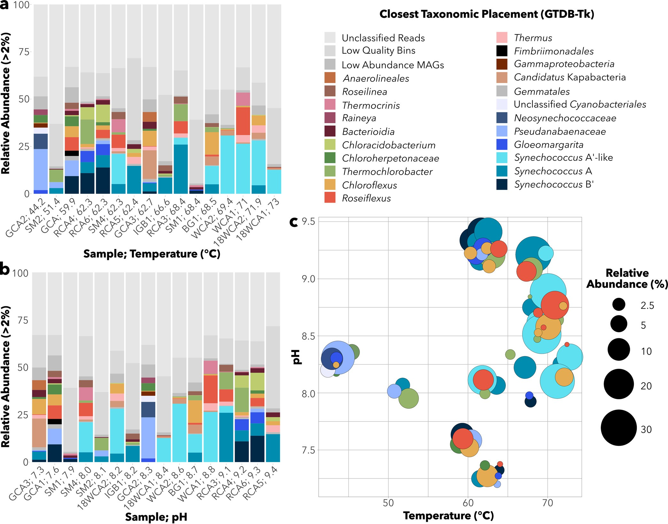

FIG 2 MAG abundance across samples. Relative abundance of all MAGs with .2% abundance in at least one sample. Samples are ordered by (a) temperature or (b) pH. (c) Abundances of phototrophic MAGs along combined pH and temperatures. Unmapped reads, low-quality bins, and low- abundance MAGs are grouped per sample (shown in gray).

chloride (11 to 13 mM) were elevated compared to those in other sample areas (;0.2 mM and 6 to 9 mM, respectively) (Data Set S1).
A total of 360 metagenome bins were recovered in this study, 221 of which met minimum
criteria to be considered medium- to high-quality MAGs (.50% completeness, ,10% con- tamination) (as defined in reference 33). Taxonomic abundance estimates of MAGs revealed that Cyanobacteria, Chloroflexi, and Chlorobi were the most common photosynthetic phyla observed across samples (Fig. 2), consistent with previous work in YNP hot springs (14, 34). In total, 38 medium- to high-quality cyanobacterial MAGs were recovered (Table 2).
Recovery of novel Synechococcus-like A/B-lineage MAGs from the upper tem-
perature limit of photosynthesis. Our primary focus in this study was Synechococcus A/B-lineage (genus-level) MAGs, as they were present across nearly all sites (Fig. 2). A/ B-lineage MAGs were recovered from all samples between 51.4°C and 73°C, with three distinct taxa identified by the Genome Taxonomy Database Toolkit (GTDB-Tk) (35). Two other MAGs classified at the order and family level with the A/B lineage were recovered in low relative abundance from the two lowest-temperature samples (GCA2.22 = 1.13% at 44.2°C; SM2.3A = 0.57% at 51.4°C).
Of 22 total medium- to high-quality A/B-lineage MAGs (Table 2), 10 had greater than 99% average nucleotide identity (ANI) with the closest reference genome from

TABLE 2 Cyanobacterial MAG descriptions
MAGª | Relative abundance (%) | Completeness (%) | Contamination (%) | Taxonomic assignment | Closest reference genome^{b} | ANI to reference (%)^{b} | High quality^{c}
RCA3.9B | 3.51 | 64.47 | 0.52 | Synechococcus-like A9 type | JA-3-3Ab (OS-A) | 85.16
BG1.9A | 9.69 | 79.82 | 4.87 | Synechococcus-like A9 type | JA-3-3Ab (OS-A) | 87.29 | Y
18WCA2.12A | 23.65 | 81.58 | 4.39 | Synechococcus-like A9 type | JA-3-3Ab (OS-A) | 87.32 | Y
WCA2.4 | 30.76 | 86.84 | 0 | Synechococcus-like A9 type | JA-3-3Ab (OS-A) | 87.3 | Y
SM4.3A | 15.86 | 94.74 | 0.88 | Synechococcus-like A9 type | JA-3-3Ab (OS-A) | 87.11 | Y
WCA1.12 | 26.42 | 96.49 | 0 | Synechococcus-like A9 type | JA-3-3Ab (OS-A) | 87.47 | Y
18WCA1.11 | 12.68 | 98.25 | 0 | Synechococcus-like A9 type | JA-3-3Ab (OS-A) | 87.47 | Y
18WCA2.12B | 4.48 | 51.27 | 0 | Synechococcus-like A type | JA-3-3Ab (OS-A) | 99.61
RCA6.5B | 6.51 | 55.78 | 0.44 | Synechococcus-like A type | JA-3-3Ab (OS-A) | 99.32
BG1.9B | 4.99 | 62.96 | 0 | Synechococcus-like A type | JA-3-3Ab (OS-A) | 99.24
SM4.3B | 5.14 | 64.04 | 0 | Synechococcus-like A type | JA-3-3Ab (OS-A) | 99.21
RCA4.11B | 5.81 | 72.37 | 0 | Synechococcus-like A type | JA-3-3Ab (OS-A) | 99.21 | Y
SM2.9A | 3.00 | 76.41 | 4.66 | Synechococcus-like A type | JA-3-3Ab (OS-A) | 99.31 | Y
RCA3.9A | 25.99 | 86.55 | 0.88 | Synechococcus-like A type | JA-3-3Ab (OS-A) | 99.15 | Y
GCA3.42A | 4.28 | 89.3 | 0.1 | Synechococcus-like A type | JA-3-3Ab (OS-A) | 99.23 | Y
IGB1.12 | 8.54 | 91.23 | 0.1 | Synechococcus-like A type | JA-3-3Ab (OS-A) | 99.34 | Y
RCA5.7 | 14.73 | 94.3 | 0.88 | Synechococcus-like A type | JA-3-3Ab (OS-A) | 99.16 | Y
RCA6.5A | 13.88 | 53.9 | 4.39 | Synechococcus-like B9 type | NA | NA
RCA4.11A | 10.92 | 59.91 | 3.2 | Synechococcus-like B9 type | JA-2-3B9(2-13) (OS-B9) | 96.96
SM1.7B | 1.66 | 71.93 | 8.33 | Synechococcus-like B9 type | JA-2-3B9(2-13) (OS-B9) | 97.99 | Y
GCA3.42B | 1.22 | 72.19 | 0 | Synechococcus-like B9 type | JA-2-3B9(2-13) (OS-B9) | 98.12 | Y
GCA1.24 | 9.32 | 91.23 | 1.75 | Synechococcus-like B9 type | JA-2-3B9(2-13) (OS-B9) | 97.93 | Y
GCA2.22 | 1.13 | 98.72 | 0 | A/B-lineage relative (family) | NA | NA | Y
SM2.3A | 0.57 | 82.32 | 7.42 | A/B-lineage relative (order) | NA | NA | Y
RCA6.18 | 5.85 | 62.73 | 3.42 | Gloeomargarita sp. | G. lithophora Achichica-D10 | 79.93
GCA2.30 | 1.94 | 64.14 | 0 | Gloeomargarita sp. | G. lithophora Achichica-D10 | 83.51
RCA4.1 | 5.88 | 64.67 | 1.71 | Gloeomargarita sp. | G. lithophora Achichica-D10 | 79.91
GCA3.22 | 0.39 | 84.62 | 0 | Gloeomargarita sp. | G. lithophora Achichica-D10 | 79.43 | Y
SM1.2 | 0.56 | 86.05 | 2.32 | Gloeomargarita sp. | G. lithophora Achichica-D10 | 79.2 | Y
GCA1.18 | 0.53 | 74.21 | 0.59 | Pseudanabaenaceae bacterium | Pseudanabaenaceae M5B4 | 77.84 | Y
GCA2.3 | 21.65 | 88.09 | 0.24 | Pseudanabaenaceae bacterium | Pseudanabaenaceae M5B4 | 78.63 | Y
SM2.6A | 0.68 | 89.27 | 1.65 | Pseudanabaenaceae bacterium | NA | NA | Y
SM2.6B | 2.48 | 74.4 | 5.07 | Pseudanabaenaceae bacterium | NA | NA | Y
RCA6.13 | 1.89 | 91.04 | 0.47 | Pseudanabaenaceae bacterium | NA | NA | Y
GCA3.6 | 0.43 | 95.28 | 0.63 | Pseudanabaenaceae bacterium | NA | NA | Y
GCA1.15 | 7.77 | 95.4 | 2.67 | Pseudanabaenaceae bacterium | NA | NA | Y
GCA2.36 | 3.22 | 94.52 | 0.67 | Cyanobacteriales bacterium | Cyanobacteriales bacterium | 75.88 | Y
 |  |  |  |  | JAAUUE01
GCA2.6 | 8.12 | 85.26 | 0.24 | Neosynechococcaceae | Neosynechococcaceae GCF- | 75.91 | Y
 |  |  |  | bacterium | 001939115
aRCA, Rabbit Creek Area; SM, Sentinel Meadows; BG, Boulder Geyser; WCA, White Creek area; GCA, Geyser Creek area; IGB, Imperial Geyser Basin. bNA, data not available.
cY, yes.

strain OS-A. Meanwhile, five MAGs had ;96 to 98% ANI with OS-B9, suggesting relatively higher diversification among B9 MAGs recovered (Data Set S2). MAGs assigned to the A taxon were recovered from temperatures between 51.4 and 71.9°C, while B9 MAGs occu- pied temperatures between 59.9°C and 68.4°C but were most abundant below 62.3°C
(Fig. 2a and 3). The remaining seven A/B-lineage MAGs recovered from 62.3 to 73.0°C sam- ples had ;85 to 88% ANI to the OS-A reference genome. MAGs representing this taxon were most abundant at the highest temperature range in our samples (69 to 73°C; Fig. 2a),
suggesting they are A9-like ecotypes (15, 16). Two MAGs (SM2.3A and GCA.22) were classi-
fied near the A/B-lineage at the order or family level but had no closely related reference genome available. A phylogenomic analysis using 120 concatenated marker genes (the GTDB bac120 set) (36) from 38 cyanobacterial MAGs and 79 reference genomes showed that SM2.3A and GCA2.22 each branched individually from the A/B lineage while also con- firming clustering of the three A/B-lineage clades (Fig. S1).
To better define the taxonomy of the suspected A9-like clade of MAGs, we per-
formed a phylogenetic analysis of 11 PsaA and 16 RbcL protein sequences recovered from A/B-lineage MAGs. PsaA sequences recovered from our putative A9-like MAGs cluster with sequence PEA9 from another putative A9-like ecotype in YNP (24) (Fig. S2).
RbcL sequences recovered from A9-like MAGs cluster with a Synechococcus-like isolate,
strain OH28, which has also been classified as an A9-like ecotype (30). These observa- tions suggest that this highest-temperature clade of Synechococcus-like A/B-lineage
MAGs most likely constitutes a A9-like ecotype, for which no genomes had been previ- ously sequenced.

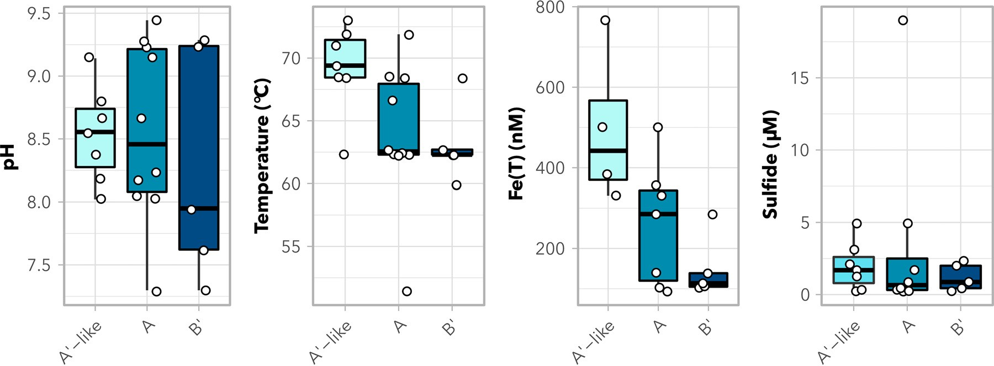

FIG 3 Synechococcus-like A/B-lineage MAG ranges with environmental parameters. Presence of cyanobacterial MAGs by taxon across pH, temperature, total iron, and sulfide concentrations in sample water. Box-and-whisker plots represent medians, 25 to 75% interquartile ranges, and ranges of values. Dots represent parameters associated with individual MAGs.

Recovery of Pseudanabaenales MAGs and novel thermophilic Gloeomargarita MAGs. Two other sets of cyanobacterial MAGs that we recovered belong to Pseudanabaenaceae and Gloeomargarita taxa. A total of seven Pseudanabaenaceae MAGs were recovered from samples up to 62.7°C and pH 7.3 to 9.3 in the Geyser Creek area, Rabbit Creek area, and Sentinel Meadows. Two MAGs placed within the family Pseudanabaenaceae—GCA1.18 and GCA2.3—had ;78% ANI to cyanobacterial MAG M5B4 recovered from a hot spring in Lakash, India (37) (Fig. S1; Table 2). Five other MAGs—GCA3.6, GCA1.15, SM2.6A, SM2.6B, and RCA6.13—had unknown taxonomic placement within Pseudanabaenaceae. Phylogenomic analysis placed GCA3.6, GCA1.15, SM2.6A, and RCA6.13 in a single clade (Fig. S1); none were closely associated with any of the seven included Pseudanabaenaceae reference GTDB genomes.
A total of five MAGs were assigned to the genus Gloeomargarita, with ;79 to 82%
ANI to the closest reference genome, Gloeomargarita lithophora Alchichica-D10 (38, 39). Phylogenomic analysis placed Gloeomargarita MAGs in two clades associated with Alchichica-D10 (Fig. S1). Four MAGs formed a cluster, while the fifth MAG (GCA2.30) was alone but more closely associated with Alchichica-D10. Gloeomargarita MAGs were recovered from samples with temperatures up to 68.4°C and from samples between pH 7.3 and 9.3 (Fig. 2) but were most abundant (.2%) at pH 9.2 to 9.3. This distribution is consistent with previous 16S rRNA amplicon results indicating the pres- ence of Gloeomargarita operational taxonomic units (OTUs) up to 70.8°C in Rabbit Creek and Bison Pool (11). In comparison, the G. lithophora Alchichica-D10 isolate has a growth range of 15 to 30°C in the lab (38, 39). Considering Gloeomargarita is an early branching genus of cyanobacteria (38–40), recovery of MAGs (and potentially future isolates) at such high temperatures, may yield new insights into the evolution of ther- mophily in cyanobacteria.
Influence of environmental parameters on A9-like MAG distributions. Temperature,
pH, and sulfide have all been demonstrated to be the primary environmental con- straints on photosynthesis in hot springs (8, 41, 42). However, in our samples, the only environmental parameters that impacted the distribution of medium- to high-quality
A9-like versus B9-like MAGs were temperature (adjusted P = 0.0249; Dunn’s test with Bonferroni correction) and total Fe concentration (adjusted P = 0.0149) (Fig. 3). Sulfide
concentration did not predict the distribution of A9-like MAGs compared to other A/B- lineage MAGs (adjusted P = 0.8469). A9-like MAGs were generally recovered from out- flows with higher temperatures (62 to 73°C) than B9 MAGs (60 to 68°C). Differences in temperature ranges between A9-like and B9 MAGs are consistent with previous work showing shifted, yet overlapping, temperature ranges among B9, A, and A9 ecotypes, both in situ and in laboratory cultures (15, 17, 27). A9-like MAGs were also recovered

from samples with higher total iron [Fe(T)] concentrations [383 to 501 nM Fe(T)] than B9 MAGs [101 to 285 nM Fe(T)]. It is possible that the impacts of temperature and iron on the distribution of A9-like MAGs are interlinked. Since iron is essential for the con-
struction of photosystem II (PS II) and chlorophyll synthesis and is a cofactor for PS I
and the photosynthetic electron transport chain, cyanobacteria require an estimated 10-fold-higher intracellular concentration than similarly sized nonphotosynthetic bac- teria (43–45). A higher total iron concentration in samples where A9-like MAGs were
recovered than in other samples in the study might suggest higher demands for PS
repair and turnover in cyanobacteria near the upper temperature limit, potentially due to increased heat stress on the photosynthetic apparatus.
Beyond differences in iron concentration and temperature, A9-like MAGs were recovered primarily from filament communities. These include four green filament samples (WCA1, WCA2, 18WCA1, and 18WCA2) and one red mat/filament sample
(BG1). A9-like MAGs were also recovered from two of the orange mats (RCA3 and SM4) (Tables 1 and 2; Data Set S1). B9 MAGs were recovered only from mat communities, while A MAGs were recovered from eight mat communities and two filament commun-
ities. Given that green filament samples containing A9-like MAGs were observed only in White Creek Area samples, we expected biogeography to impact phylogenomic dis- tance among A9-like, A, and B9 clades. An influence of biogeography on variation in
psaA genes among A/B-lineage organisms was demonstrated previously (10). In our
data set, geographic distance was not significantly predictive of phylogenomic dis- tance among A/B-lineage MAGs (Mantel test; P = 0.095, r = 0.135). This result suggests that dispersal barriers were not a factor in the distribution of A/B-lineage MAGs across YNP. Thus, temperature and iron concentration likely play primary roles in the distribu- tion of A9-like MAGs.
A9-like MAGs were recovered only from pH of 8.0 to 9.1, in contrast to A MAGs (7.3
to 9.4) and B9 MAGs (7.3 to 9.3) (Fig. 2b and Fig. 3), suggesting that one or multiple physiological components have narrower pH constraints in A9-like MAGs, perhaps as a
consequence of adaptation to the highest temperatures at which phototrophy has been observed. In general, while sample size is limited, all phototrophic fringe com- munities observed above 70°C in this study were limited to pH 8.1 to 8.8 (Fig. 2c). Similar constraints on phototrophs observed above 70°C were previously seen across much larger sample sets within YNP (8, 14). In those studies, chlL/bchL and bchY ampli- cons at sample temperatures between 65°C and 70°C were observed between pH 5.5 and pH 9.5, while amplicons above 70°C were more limited to pH ;7.5 to 9.2.
Pangenomes of A/B-lineage metagenome-assembled and reference genomes.
Given that A/B-lineage taxa were the most widely distributed among cyanobacterial MAGs we recovered and that each phylogenomically distinct clade occupies a different temperature range, we narrowed our focus to A/B-like MAGs to elucidate shared and unique genome content among them. The pangenome analyses were conducted on 15 A/B-lineage MAGs with .70% completeness and ,10% contamination (based on assessment of MAG quality by CheckM [46]). We removed the MAGs below these thresholds to decrease the likelihood of including MAGs with spuriously missing genes due to metagenome assembly and binning errors. These criteria have been used in ge- nome-wide comparisons of MAGs elsewhere (47).
We performed pangenome analysis within anvi’o (48) using A/B-lineage MAGs and the OS-A and OS-B9 reference genomes. The pangenome (Fig. 4) was composed of a total of 3,274 gene clusters, with a core genome of 489 universally shared clusters. An auxiliary
core of 1,229 gene clusters was shared by multiple representatives in each of the A9-like, A, and B9 clades. Of particular interest were gene clusters that were unique to or absent from A9-like MAGs, given that they are capable of occupying the thermal limit of photo- synthesis and that they form a separate clade from A and B9 genomes (Fig. S1).
Recovered A9-like MAGs do not encode nitrogenase or protochlorophyllide re- ductase (DPOR). To examine potential gene gain or loss within A9-like strains that may
suggest adaptation to higher temperatures, a functional enrichment analysis was per- formed within anvi’o (49). Here, the term “enriched” is used when a gene cluster or a

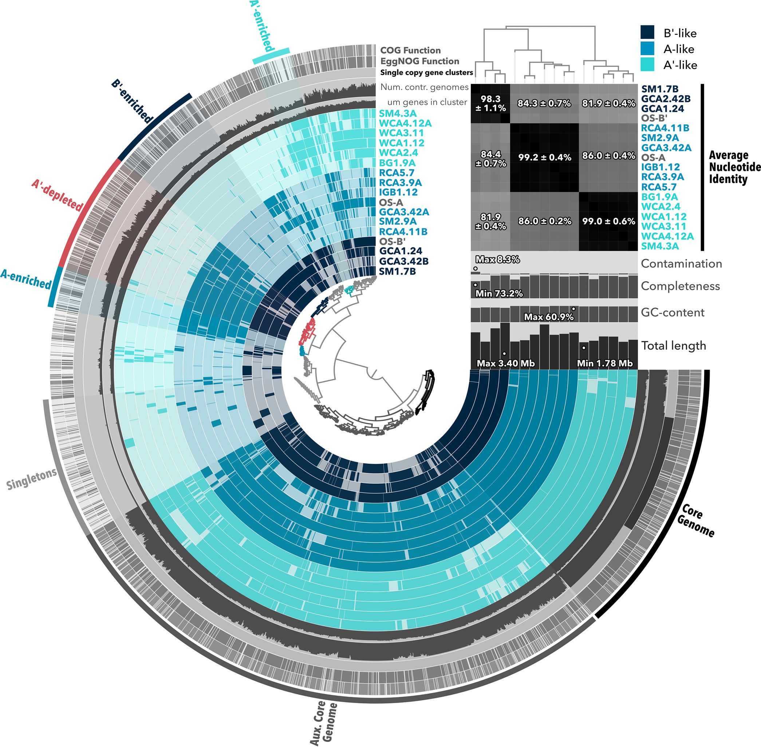

FIG 4 Pangenome of Synechococcus-like A/B-lineage MAGs. Gene clusters present in 15 A/B-lineage MAGs and two reference genomes are shown in colored rings. The central dendrogram depicts ordering of gene clusters by frequency and was used to select gene clusters unique to or enriched in different MAGs or clades (outermost rings and highlighted gene cluster selections). Genomes were ordered based on a phylogenomic tree produced in RAxML. Percent average nucleotide identity comparisons are statistically represented on a clade-by-clade basis. Contamination and completion were calculated by checkM and the anvi’o pangenomics suite, and ANI was calculated by pyANI within anvi’o. NCBI COGs were identified using the 2020 release within anvi’o, and EggNOG functions were predicted based on the 5.0.1 database.

set of gene clusters is present more often in one clade of MAGs (A9-like, A, or B9) than the others and supported by an adjusted q value of ,0.05 in the functional enrichment
analysis. Likewise, a gene cluster is considered depleted in a clade when it is found more often in two others. More gene clusters were depleted (258 clusters) than enriched (80 clusters) in the A9-like clade, which suggests a streamlining of the A9-like genome to accommodate a high temperature range. These results are consistent with a general trend
previously noted for thermophilic cyanobacteria, including the A/B lineage (50, 51). Gene clusters depleted in A9-like MAGs include those predicted to encode nitrogenase—nifH,

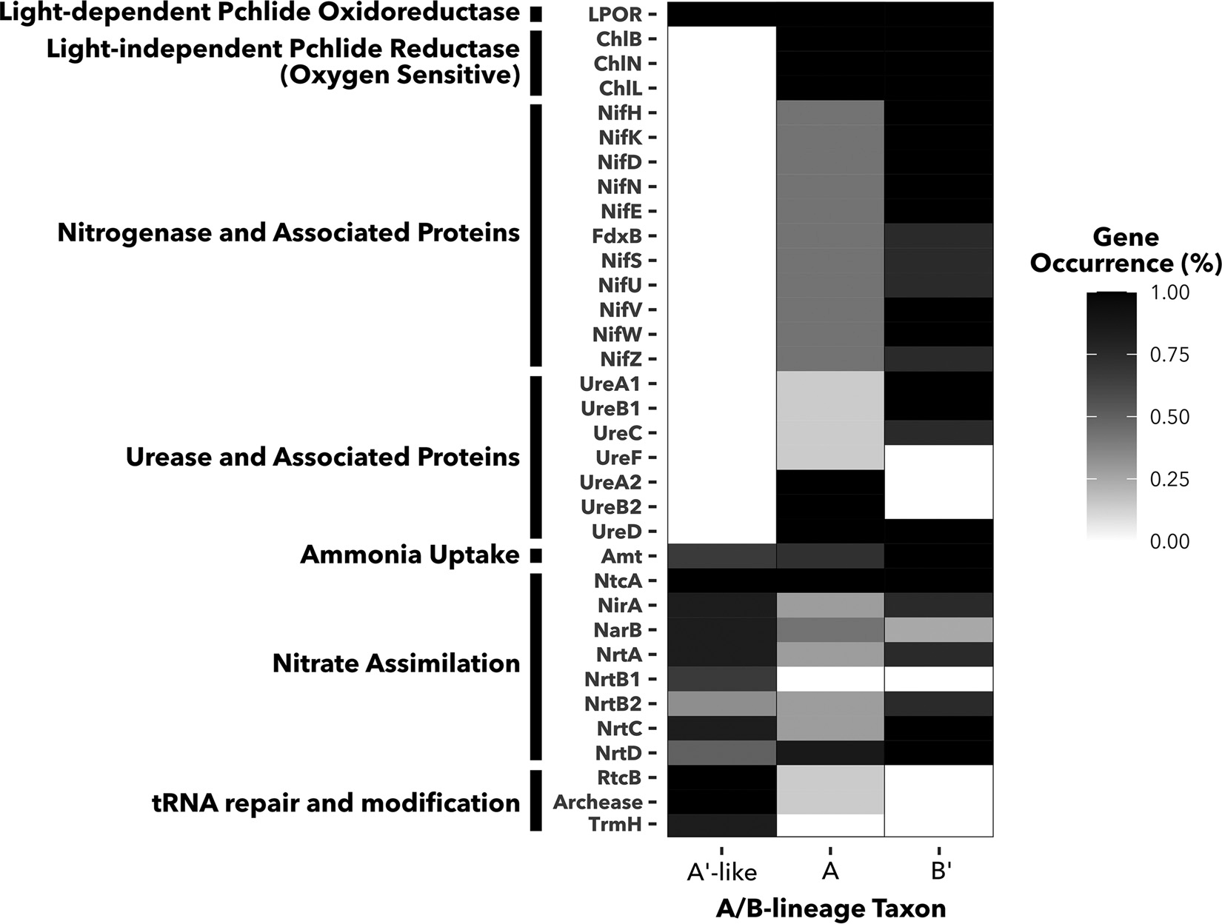

FIG 5 Occurrence of chlorophyllide synthesis, nitrogen metabolism, and tRNA repair and modification genes in A/B- lineage taxa. Heat map fill indicates percentage of A9-like (n = 6), A (n = 7), and B9 (n = 4) MAGs in which each gene cluster is present. Gene clusters are labeled by names of predicted proteins they encode and ordered by function.

nifD, and nifK (Data Set S3). Although functional enrichment scores for individual nif genes were just above the 0.05 threshold to be considered statistically significant (q = 0.0514), a consistent qualitative pattern emerges in the representation of nif operons and accessory
genes across MAGs (Fig. 5; Table S1). OS-A and OS-B9 reference genomes and at least two MAGs assigned to each of these clades encode a nitrogenase enzyme, while these genes
were absent from the A9-like clade. Other genes necessary for nitrogenase assembly are similarly absent from A9-like MAGs.
These results suggest that A9-like cyanobacteria adapted to the upper temperature lim- its of photosynthesis must rely on fixed nitrogen, which can come from communities as well as the overflowing water. Unlike A and B9 MAGs and reference genomes, which
encode clade-specific variants of urease (25), no urease genes were recovered from A9-like
MAGs (Fig. 5). The ammonium transporter Amt along with a full suite of nitrate assimila- tion genes were present in the A9-like clade, suggesting that nitrate and/or ammonia could be the primary nitrogen sources for these organisms. Genes encoding nitrogenase
were present in all metagenomes where A9-like MAGs were recovered except the highest- temperature sample (18WCA1, 73°C). In 18WCA1, the only nitrogenase genes present in the metagenome assembly were a nifHBDK cassette from Roseiflexus. No associated matu-
ration genes were present, consistent with the genomes of Roseiflexus isolates, for which no evidence of diazotrophy has been observed (52, 53). However, micromolar nitrate detected in 18WCA1 suggests that the overflowing water may provide bioavailable nitro- gen. Thus, we expect the overflowing water and/or diazotrophy by other members of the community to be the most likely sources of fixed nitrogen for A9-like MAGs.
The genes chlLNB, which encode the dark-operative DPOR, an oxygen-sensitive enzyme
sharing evolutionary history with nitrogenase, were also absent in A9-like MAGs. Conversely,
chlLNB were present in all A-type and B9-type MAGs and in the OS-A and OS-B9 reference

genomes. In the absence of DPOR, the oxygen-tolerant light-dependent protochlorophyllide oxidoreductase (LPOR) is essential for chlorophyllide synthesis. Accordingly, the gene encod- ing LPOR, por, was found in all A/B-lineage MAGs and reference genomes, including A9-like
MAGs. We can only speculate on the mechanisms that drove the A9-like clade to lose both
nitrogenase and DPOR. Given the oxygen-sensitive nature of nitrogenase and DPOR, a loss of both enzymes in A9-like MAGs might suggest a loss of the ability to protect them. However, given the short distance of these samples from the source spring, low solubility of
oxygen at these high temperatures (68 to 73°C), and ability of both enzymes to function at night when mats are anoxic (54, 55), we do not expect oxygen sensitivity to be an evolution- ary force driving their loss. Instead, since nitrate/ammonium is available in the overflowing water in these sites and nitrogenase/DPOR-encoding genes are present in the metage- nomes, we expect loss of nitrogenase and DPOR to be most likely due to their dispensability. The evolutionary history of diazotrophy is replete with examples of intra- and interphylum gene transfers as well as trait loss (56–58). Similar trait loss of DPOR is common to many pho- tosynthetic taxa, often associated with maintenance of multiple por genes (59, 60). Loss of these genes in the highest temperature clade of A/B-lineage MAGs is also consistent with a general trend toward genome reduction in thermophiles (50, 51).
The A9-like clade of MAGs is enriched for noncyanobacterial tRNA damage response proteins. Two gene clusters enriched in the A9-like clade of the A/B-lineage pangenome are those encoding a tRNA-splicing ligase, RtcB, a predicted archease
involved in RtcB activation, and a tRNA methyltransferase, TrmH (Data Set S3). Archease and RtcB are conserved across all domains of life (61) and are thought to assist in recovery from stress-induced tRNA damage (62, 63), while TrmH is implicated in regulating transcriptional response to stress conditions in Escherichia coli (64). Archease sequences were recovered only from A9-like MAGs and the OS-A genome. A
BLASTp search of A9 RtcB against the NCBI nr database returned hits belonging to a
small group of A/B-lineage genomes (;96% identity over 100% query coverage), including the OS-A genome, followed by RtcB sequences belonging to members of the family Methylothermaceae (;75 to 76% identity over 100% query coverage). BLASTp searches of A9-like archease against the full nr database produced similar results. These
results suggest that RtcB and archease in the A/B lineage are highly diverged from
those in other cyanobacteria. The top hit resulting from a BLASTp search for A9-like RtcB against all other cyanobacteria was for a tRNA-splicing ligase in a Cyanobium spe-
cies at ;60% identity over 100% query coverage, while other hits were below 50% identity. Furthermore, the top hit for A9-like archease against cyanobacteria outside the A/B-lineage had only ;30% identity over 99% gene coverage. These results indi- cate that archease and RtcB in the A/B-lineage diverged from other cyanobacteria early
in their history. Similarly, top hits from A9-like TrmH sequences searched against the NCBI nr database were from Firmicutes, Proteobacteria, Actinobacteria, Chloroflexi, and the Fibrobacteres/Chlorobi/Bacteriodetes (FBC) superphylum. Meanwhile, no significant similarity was found in BLASTp searches of A9-like TrmH against strains OS-A and OS- B9. Altogether, these results suggest a difference in tRNA repair and modification in
response to stress between A9-like organisms and other A/B lineages, perhaps acquired
through horizontal gene transfer.
Functional divergence of conserved genes in Synechococcus-like MAGs. We asked whether any genes present in A9-like MAGs diverged from genomes in the A and B9 clades in ways that might indicate adaptation to higher temperatures. Among
gene clusters that were conserved across clades, we queried those without paralogs,
with functional homogeneity (defined by point mutations) below 85% and geometric homogeneity (defined by gaps) above 85%. We calculated phylogenetic distance mat- rices of the 22 annotated gene clusters that met these criteria and compared them to distance matrices produced from a phylogenomic tree of 71 conserved marker genes in A/B-lineage MAGs (Fig. 6a; Table S2). We then sought gene clusters with a pattern of divergence that places A9-like sequences further away from A and B9 sequences than
would be predicted by the phylogenomic tree, a pattern that would be suggestive of
functional adaptation in the A9-like clade. One such cluster encodes a transcription

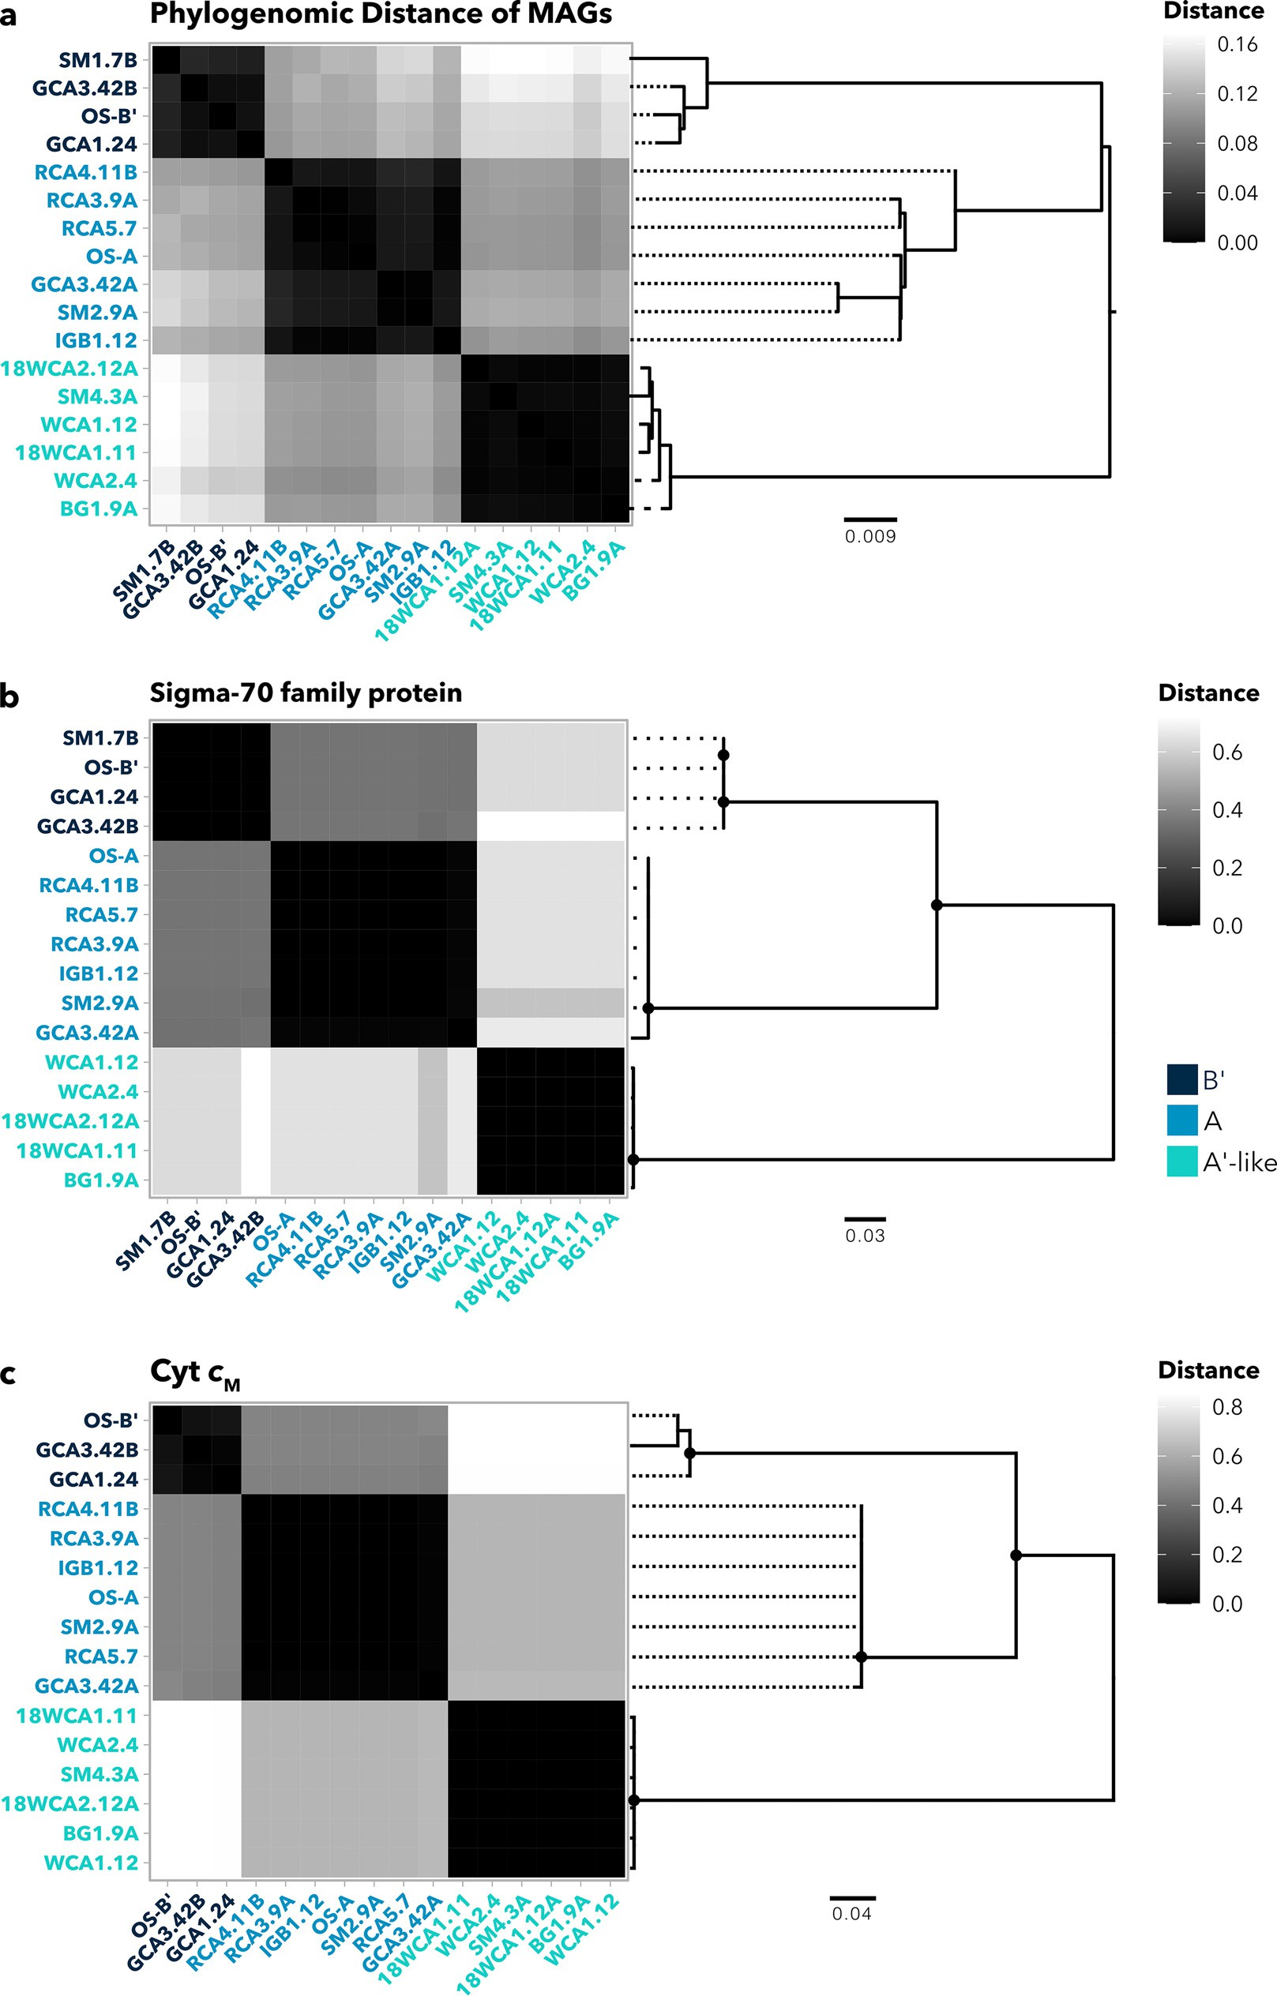

FIG 6 Phylogenetic distances of select gene clusters. (a) Phylogenomic distance heat map and corresponding tree using an aligned, concatenated set of 71 conserved marker genes from the A/B-lineage pangenome. (b) Phylogenetic distances of cytM genes extracted from A/B-lineage MAGs. (c) Uncharacterized sigma-70 family protein extracted from A/B-lineage MAGs and reference genomes. Node symbols denote bootstrap values above 80 from 100 bootstraps within RAxML. Each MAG is colored according to its taxon (A9-like, A, and B9).

factor in the sigma-70 family, which displays a clear pattern of divergence of A9-like sequences away from A and B9 sequences (Fig. 6b). Although this protein is uncharac- terized, its divergence from other A/B-lineage types represents a potential regulon that is specialized in A9-like organisms.
Another gene cluster with high phylogenetic distance between the A9-like clade and the other two A/B-lineage clades encodes cytochrome c_{M} (Cyt c_{M}) (Fig. 6c), which is pres- ent across cyanobacterial taxa but whose physiological role is still debated (65, 66).
Transcription of cytM increases under conditions such as low temperature, high-intensity light, oxidative stress, osmotic stress, and nitrogen and sulfur limitation (67, 68). It has been suggested that under these stress conditions, Cyt c_{M} either plays a regulatory role or alleviates photosynthetic overreduction of electron carriers (65, 69, 70). Furthermore, studies in Synechocystis 6803 have shown that Cyt c_{M} suppresses both heterotrophy in the dark and photosynthesis during photomixotrophy (66, 70), supporting the notion that it performs a regulatory function. Divergence in Cyt c_{M} between A9-like MAGs and
other A/B-lineage genomes may suggest that they differ in their response to stress con-
ditions. Since A9-like populations often occupy environments at the absolute limits of photosynthesis, it is possible that temperature fluctuations require faster or stronger suppression of photosynthesis. Alternatively, since cytM expression is induced under N li-
mitation, it is possible that a reliance on bioavailable nitrogen from overlying water or neighboring microbes may have required modification of the Cyt c_{M} regulon. Similar to phylogenomic distances, a clear influence of biogeography on intraclade variation of sigma-70 factor or Cyt c_{M} was not observed, particularly among sequences from the A9-
like clade. Since intraclade variation was small, we conclude that variation observed is
clade specific. Considering their potential to affect responses to environmental fluctua- tions, divergence in both Cyt c_{M} and this sigma-70 factor may guide future transcrip- tomic work into differences in stress responses between A/B-lineage clades in YNP hot springs. For a full summary of gene clusters, including annotations, functional/geometric homogeneity scores, and amino acid sequences, see Data Set S4.
Conclusions. Cyanobacteria in Yellowstone hot springs have been widely studied
for decades, yet much of the work has focused on thick laminated mats in only two hot springs within the same geyser basin. Here, we expanded this large body of work to include metagenome assembled genomes recovered from hot springs spanning dif- ferent regions of YNP, with various temperatures, pH, geochemistry, and community morphologies. Particularly, our work focused on genomic divergence among three clades (A, B9, and A9-like) of Synechococcus-like A/B-lineage MAGs, adding to existing literature on differentiation within this lineage. Using phylogenetic trees constructed from aligned PsaA and RbcL sequences, we found that six A/B-lineage MAGs were most closely related to A9-like ecotypes previously found in YNP and Hunter’s Hot Springs. These A9-like MAGs, which were recovered from the highest temperatures in our samples, have not been successfully cultured or fully sequenced to date, and re-
covery of multiple MAGs provides new potential to uncover adaptations to the thermal limits of photosynthesis. We found that within the samples tested, both temperature and total Fe controlled the range of A/B-lineage MAGs, while the pH range of A9-like
MAGs was narrow in comparison to the two other clades, suggesting that pH limits
adaptations to high temperatures within these organisms. We uncovered genes that were enriched or depleted in each clade of A/B-lineage MAGs. Specifically, genes encoding both the light-independent protochlorophyllide reductase (DPOR) and nitro- genase were entirely absent from A9-like MAGs, suggesting that A9-like organisms must rely on fixed nitrogen from their environment, either from the overflowing water or from other diazotrophs in the community. Finally, we uncovered genes that diverge between clades of the A/B lineage, particularly Cyt c_{M}, which provides an avenue for future work into the regulation of photosynthesis under thermal stress and nutrient- limited conditions in these organisms. Both the genome content of A9-like MAGs and environmental context will underpin future efforts to isolate this elusive clade. Overall,

our work serves as an entry point for future hypothesis-based approaches to uncover physiological distinctions between YNP hot spring cyanobacterial taxa.

MATERIALS AND METHODS
Sample collection, sequencing, metagenome assembly, and binning. Eleven sites throughout Yellowstone National Park were sampled, with 16 total samples collected for metagenomic analysis. Sample temperatures ranged from 44°C to 73°C, and pH ranged from 7.3 to 9.4. Generally, the border between pigmented mats or filaments and the unpigmented chemotrophic zone was targeted for sequencing, with a variety of microbial structures sampled, thin and relatively thick mats to filaments. Samples for DNA extraction and water analysis were collected as previously described (14). Briefly, pH and temperature were measured using a WTW pH 3310 meter (Xylem Analytics, Weilheim, Germany). A YSI 30 conductivity meter (YSI Inc., Yellow Springs, OH, USA) was used for conductivity measurements. A DR1900 portable spectrophotometer (Hach Company, Loveland, CO), was used to measure Fe²¹, sulfide, silica, nitrate, and ammonia in overlying water on site. Cation concentration and trace element concen- tration were measured from 0.2-mm-filtered water as previously described (71–73).
Total DNA was extracted from triplicate ;250-mg samples using a DNeasy PowerSoil kit (Qiagen, Carlsbad, CA, USA). Triplicate DNA samples were pooled and sequenced on an Illumina HiSeq 2500 platform at the University of Minnesota Genomics Center (UMGC). Sickle (v. 1.33) was used to trim reads using a PHRED score of .20 and a minimum length of .50 as criteria. De novo assembly of short reads was performed on a per-sample basis using metaSPAdes (within SPAdes v. 3.11.0) for all samples except SM1 and SM2, which, due to high short-read yield and computational limitations, were assembled using the Ray assembler (v. 2.3.1). Contigs with sequence lengths of .2,500 bp were binned into MAGs using MetaBAT2 (v. 2.12.1). Unless otherwise noted, all bioinformatic tools were run using default parameters.
MAG quality assessment, refinement, and taxonomic abundance estimation. The CheckM (v. 1.1.3) lineage workflow (46) was used to assess completeness, contamination, and strain heterogeneity of all MAGs collected via binning. For MAGs with more than 10% contamination, manual coverage- based refinement was performed. Briefly, contigs with low coverage were removed, or in cases where two distinct clusters of contigs formed when GC and coverage were plotted, bins were split into sepa- rate MAGs by coverage. Refined bins were reassessed with CheckM.
Taxonomic classification was determined by pplacer (74) and/or fastANI (75) within GTDB-Tk (v. 1.3.0) (35), using the classify workflow and database version 89. The classify workflow used an aligned set of 120 concatenated bacterial single-copy marker genes (bac120) (35) from the 221 MAGs intro- duced in this study and 45,776 GTDB genomes. The percent abundances of recovered MAGs were esti- mated using read mapping with BBMap (v. 38.82) (76), adapted from an RPKG (reads per kilobase of genome per gigabase of metagenome) method described previously (50, 77). Briefly the percentage of sample reads mapped to each MAG was normalized to genome size, then divided by the sum of normalized read abundances, and multiplied by the ratio of mapped reads to total reads within a sample.
The formula used to calculate percent abundances was as follows:
% of total reads mapped to MAG ÷ X% of total reads mapped to MAG × total mapped reads

MAG size(bp)
MAG size(bp)
total sample reads

or, briefly,

% abundance = normalized % read abundance of MAG × % sample reads mapped total normalized % read abundances

The results of this method are directly proportional to RPKG, except that they sum to 100. This was chosen because our conclusions were primarily drawn from intrasample relative abundances. Furthermore, low overall RPKG values in some samples compared to others limited the ability to inter- pret intrasample relative abundance. For comparison, an RPKG plot corresponding to Fig. 2 can be found in Fig. S3.
Phylogenomic analysis. From the 45,997 total aligned and concatenated bac120 sequences provided by the GTDB-Tk classify workflow, a selected set pertaining to 38 cyanobacterial MAGs and 79 reference genomes (74 RefSeq and 5 GenBank genomes) was extracted. Reference genomes included those related to the 38 cyanobacterial MAGs (relatedness determined by GTDB-Tk) along with a set of outgroups. A phy- logenomic tree was constructed from selected alignments using RAxML (v. 8.2.11; 1,000 bootstraps, pro- tein gamma model automatically selected) (78) and rooted by the midpoint (Fig. S1).
Pangenome analysis and functional annotation. Pangenomes for MAGs predicted as A/B-like Synechococcus clades were constructed, visualized, and analyzed using the anvi’o pangenomics workflow as previously described (79), including closely related reference genomes in the analysis where possible. Gene clusters were predicted by first calculating open reading frame similarities using BLASTp (80) and then using the MCL algorithm (81) to identify clusters within the BLASTp results. The inflation parameter for MCL was set to 10, to allow for high sensitivity in gene clustering across closely related genomes and decrease the occurrence of paralogs within clusters. Hierarchical clustering of gene clusters was performed using Euclidean distance and Ward linkages, and gene clusters were ordered in pangenome visualizations accord- ing to frequency. The BLASTp algorithm (80) was used to predict clusters of orthologous groups (COGs) by

searching against the 2020 NCBI COG database (82). A second set of annotations, including EggNOG (v5 database) (83), KEGG pathways/modules/orthologs (84), gene ontology (GO) terms (85), and CAZy terms (86), were all provided with eggNOG-mapper (v. 2.0.1) (87). A set of 71 bacterial single-copy marker genes was extracted from MAGs and reference genomes in the Synechococcus-like pangenome, concatenated and aligned within anvi’o, and used to construct a maximum-likelihood tree using with RAxML (100 bootstraps; PROTGAMMA variable set to auto). MAGs were then ordered by the maximum-likelihood tree for displaying the pangenome, including average nucleotide identity heat maps constructed using pyANI (default ANIb, using blast1 for alignments) (88) within anvi’o (48). MAGs were grouped into taxonomic clusters within anvi’o, which were then used to calculate enrichment of gene clusters with predicted functions.
Functional homogeneity analysis. Gene cluster summaries were exported from the Synechococcus- like pangenome, which included aligned sequences, annotations, paralogs per genome, and function/ geometric homogeneity scores. Gene clusters were then filtered in R by setting the maximum number of paralogs to 1, maximum functional homogeneity to 0.85, and minimum geometric homogeneity to be greater than functional homogeneity. Sequences from the resulting filtered gene clusters were extracted from the pangenome and aligned on a per-cluster basis using Clustal Omega (89). Each align- ment was used to construct a distance matrix and tree using RAxML (78) and then used to generate a heat map with R. Gene clusters that were diverged in the A9 clade from the other clades were then
selected by curation, using distance heat maps as a guide.
Data availability. Metagenome-assembled genomes have been deposited under NCBI BioProject no. PRJNA807728 and BioSample no. SAMN26200794 to SAMN26200809. Full metagenome assemblies have been deposited in the Joint Genome Institute Integrated Microbial Genomes and Microbiomes database under the accession numbers listed in Table 1.

SUPPLEMENTAL MATERIAL
Supplemental material is available online only.
DATA SET S1, XLSX file, 0.02 MB.
DATA SET S2, XLSX file, 0.1 MB.
DATA SET S3, XLSX file, 0.3 MB.
DATA SET S4, XLSX file, 3.7 MB.
FIG S1, TIF file, 1.9 MB.
FIG S2, TIF file, 1.1 MB.
FIG S3, TIF file, 1.3 MB.
TABLE S1, DOCX file, 0.02 MB.
TABLE S2, DOCX file, 0.01 MB.

ACKNOWLEDGMENTS
We acknowledge that the research conducted for this work was done in Yellowstone National Park, which was created from land stolen from multiple Native American Nations, especially the Tukudeka (as well as other Shoshone-Bannock and Eastern Shoshone peoples) and Apsáalooke (Crow). These acts were done in part through the guise of Article 2 of the 1868 Fort Bridger Treaty and Article 2 of the 1868 Fort Laramie Treaty. We support efforts to give the lands encompassing YNP back to the native peoples who call it home.
This research was supported by NASA Exobiology award number 80NSSC20K0614.
T.L.H. conducts field research under permit YELL-2018-SCI-7020 issued to T.L.H. and Jeff Havig and reviewed annually by the Yellowstone Research Permitting Office. We are thankful to the Yellowstone Research Permitting Office, especially Annie Carlson and Erik Oberg, for provision of research permits and assistance in the process. We acknowledge the support of Minnesota Supercomputing Institute for providing crucial computing resources and data storage. We thank C. Grettenberger,
A. Czaja, A. Gangidine, J. Miller, L. Penrose, L. Brengman, T. Djokic, A. Rutledge, L. Seyler, and J. Kuether for technical assistance in the field and A. Borowski for assistance processing samples in the lab.

REFERENCES
- Martin WF, Bryant DA, Beatty JT. 2018. A physiological perspective on the origin and evolution of photosynthesis. FEMS Microbiol Rev 42:205–231. https://doi.org/10.1093/femsre/fux056.

- Cardona T, Sánchez-Baracaldo P, Rutherford AW, Larkum AW. 2019. Early Archean origin of photosystem II. Geobiology 17:127–150. https://doi
.org/10.1111/gbi.12322.

- Fischer WW, Hemp J, Johnson JE. 2016. Evolution of oxygenic photosyn- thesis. Annu Rev Earth Planet Sci 44:647–683. https://doi.org/10.1146/ annurev-earth-060313-054810.
- Toplin JA, Norris TB, Lehr CR, McDermott TR, Castenholz RW. 2008. Biogeo- graphic and phylogenetic diversity of thermoacidophilic cyanidiales in Yel- lowstone National Park, Japan, and New Zealand. Appl Environ Microbiol 74:2822–2833. https://doi.org/10.1128/AEM.02741-07.
- Boyd ES, Hamilton TL, Spear JR, Lavin M, Peters JW. 2010. [FeFe]-hydro- genase in Yellowstone National Park: evidence for dispersal limitation and phylogenetic niche conservatism. ISME J 4:1485–1495. https://doi
.org/10.1038/ismej.2010.76.
- Brock TD. 1973. Lower pH limit for the existence of blue-green algae: evo- lutionary and ecological implications. Science 179:480–483. https://doi
.org/10.1126/science.179.4072.480.
- Brock TD, Brock ML. 1968. Measurement of steady-state growth rates of a thermophilic alga directly in nature. J Bacteriol 95:811–815. https://doi
.org/10.1128/jb.95.3.811-815.1968.
- Hamilton TL, Vogl K, Bryant DA, Boyd ES, Peters JW. 2012. Environmental constraints defining the distribution, composition, and evolution of chlor- ophototrophs in thermal features of Yellowstone National Park. Geobiol- ogy 10:236–249. https://doi.org/10.1111/j.1472-4669.2011.00296.x.
- Ward DM, Castenholz RW, Miller SR. 2012. Cyanobacteria in geothermal habitats, p 39–63. In Whitton BA (ed), Ecology of cyanobacteria II: their di- versity in space and time. Springer, Cham, Switzerland.
- Becraft ED, Wood JM, Cohan FM, Ward DM. 2020. Biogeography of Ameri- can northwest hot spring A/B9-lineage Synechococcus populations. Front Microbiol 11:77. https://doi.org/10.3389/fmicb.2020.00077.
- Bennett AC, Murugapiran SK, Hamilton TL. 2020. Temperature impacts community structure and function of phototrophic Chloroflexi and Cya- nobacteria in two alkaline hot springs in Yellowstone National Park. Envi- ron Microbiol Rep 12:503–513. https://doi.org/10.1111/1758-2229.12863.
- Inskeep WP, Jay ZJ, Tringe SG, Herrgård MJ, Rusch DB, YNP Metagenome Project Steering Committee and Working Group Members. 2013. The YNP metagenome project: environmental parameters responsible for micro- bial distribution in the yellowstone geothermal ecosystem. Front Micro- biol 4:67. https://doi.org/10.3389/fmicb.2013.00067.
- Fecteau KM, Boyd ES, Lindsay MR, Amenabar MJ, Robinson KJ, Debes RV, Shock EL. 2022. Cyanobacteria and algae meet at the limits of their habitat ranges in moderately acidic hot springs. JGR Biogeosci 127:e2021JG006446. https://doi.org/10.1029/2021JG006446.
- Hamilton TL, Bennett AC, Murugapiran SK, Havig JR. 2019. Anoxygenic phototrophs span geochemical gradients and diverse morphologies in terrestrial geothermal springs. mSystems 4:e00498-19. https://doi.org/10
.1128/mSystems.00498-19.
- Ferris MJ, Ward DM. 1997. Seasonal distributions of dominant 16S rRNA- defined populations in a hot spring microbial mat examined by denatur- ing gradient gel electrophoresis. Appl Environ Microbiol 63:1375–1381. https://doi.org/10.1128/aem.63.4.1375-1381.1997.
- Ward DM, Bateson MM, Ferris MJ, Kühl M, Wieland A, Koeppel A, Cohan FM. 2006. Cyanobacterial ecotypes in the microbial mat community of Mushroom Spring (Yellowstone National Park, Wyoming) as species-like units linking microbial community composition, structure and function. Philos Trans R Soc Lond B Biol Sci 361:1997–2008. https://doi.org/10
.1098/rstb.2006.1919.
- Allewalt JP, Bateson MM, Revsbech NP, Slack K, Ward DM. 2006. Effect of temperature and light on growth of and photosynthesis by Synechococ- cus isolates typical of those predominating in the Octopus Spring micro- bial mat community of Yellowstone National Park. Appl Environ Microbiol 72:544–550. https://doi.org/10.1128/AEM.72.1.544-550.2006.
- Salazar VW, Tschoeke DA, Swings J, Cosenza CA, Mattoso M, Thompson CC, Thompson FL. 2020. A new genomic taxonomy system for the Syne- chococcus collective. Environ Microbiol 22:4557–4570. https://doi.org/10
.1111/1462-2920.15173.
- Walter JM, Coutinho FH, Dutilh BE, Swings J, Thompson FL, Thompson
CC. 2017. Ecogenomics and taxonomy of Cyanobacteria phylum. Front Microbiol 8:2132. https://doi.org/10.3389/fmicb.2017.02132.
- Komárek J, Johansen JR, Šmarda J, Strunecký O. 2020. Phylogeny and tax- onomy of synechococcus-like cyanobacteria. Fottea 20:171–191. https:// doi.org/10.5507/fot.2020.006.
- Ward DM, Weller R, Bateson MM. 1990. 16S rRNA sequences reveal numerous uncultured microorganisms in a natural community. Nature 345:63–65. https://doi.org/10.1038/345063a0.
- Ramsing NB, Ferris MJ, Ward DM. 2000. Highly ordered vertical structure of Synechococcus populations within the one-millimeter-thick photic
zone of a hot spring cyanobacterial mat. Appl Environ Microbiol 66: 1038–1049. https://doi.org/10.1128/AEM.66.3.1038-1049.2000.
- Papke RT, Ramsing NB, Bateson MM, Ward DM. 2003. Geographical isola- tion in hot spring cyanobacteria. Environ Microbiol 5:650–659. https://doi
.org/10.1046/j.1462-2920.2003.00460.x.
- Becraft ED, Cohan FM, Kühl M, Jensen SI, Ward DM. 2011. Fine-scale distri- bution patterns of Synechococcus ecological diversity in microbial mats of mushroom spring, Yellowstone National Park. Appl Environ Microbiol 77:7689–7697. https://doi.org/10.1128/AEM.05927-11.
- Bhaya D, Grossman AR, Steunou A-S, Khuri N, Cohan FM, Hamamura N, Melendrez MC, Bateson MM, Ward DM, Heidelberg JF. 2007. Population level functional diversity in a microbial community revealed by compara- tive genomic and metagenomic analyses. ISME J 1:703–713. https://doi
.org/10.1038/ismej.2007.46.
- Gomez-Garcia MR, Davison M, Blain-Hartnung M, Grossman AR, Bhaya D. 2011. Alternative pathways for phosphonate metabolism in thermophilic cyanobacteria from microbial mats. ISME J 5:141–149. https://doi.org/10
.1038/ismej.2010.96.
- Miller SR, Castenholz RW. 2000. Evolution of thermotolerance in hot spring cyanobacteria of the genus Synechococcus. Appl Environ Micro- biol 66:4222–4229. https://doi.org/10.1128/AEM.66.10.4222-4229.2000.
- Miller SR, Carvey D. 2019. Ecological divergence with gene flow in a ther- mophilic cyanobacterium. Microb Ecol 78:33–41. https://doi.org/10.1007/ s00248-018-1267-0.
- Pedersen D, Miller SR. 2017. Photosynthetic temperature adaptation during niche diversification of the thermophilic cyanobacterium Synechococcus A/ B clade. ISME J 11:1053–1057. https://doi.org/10.1038/ismej.2016.173.
- Miller SR, McGuirl MA, Carvey D. 2013. The evolution of RuBisCO stability at the thermal limit of photoautotrophy. Mol Biol Evol 30:752–760. https://doi.org/10.1093/molbev/mss327.
- Havig JR, Kuether JE, Gangidine AJ, Schroeder S, Hamilton TL. 2021. Hot spring microbial community elemental composition: hot spring and soil inputs, and the transition from biocumulus to siliceous sinter. Astrobiol- ogy 21:1526–1546. https://doi.org/10.1089/ast.2019.2086.
- Holloway JAM, Nordstrom DK, Böhlke JK, McCleskey RB, Ball JW. 2011. Ammonium in thermal waters of Yellowstone National Park: processes affecting speciation and isotope fractionation. Geochim Cosmochim Acta 75:4611–4636. https://doi.org/10.1016/j.gca.2011.05.036.
- Bowers RM, Kyrpides NC, Stepanauskas R, Harmon-Smith M, Doud D, Reddy TBK, Schulz F, Jarett J, Rivers AR, Eloe-Fadrosh EA, Tringe SG, Ivanova NN, Copeland A, Clum A, Becraft ED, Malmstrom RR, Birren B, Podar M, Bork P, Weinstock GM, Garrity GM, Dodsworth JA, Yooseph S, Sutton G, Glöckner FO, Gilbert JA, Nelson WC, Hallam SJ, Jungbluth SP, Ettema TJG, Tighe S, Konstantinidis KT, Liu WT, Baker BJ, Rattei T, Eisen JA, Hedlund B, McMahon KD, Fierer N, Knight R, Finn R, Cochrane G, Karsch- Mizrachi I, Tyson GW, Rinke C, Lapidus A, Meyer F, Yilmaz P, Parks DH, Eren AM, Schriml L, Banfield J, Hugenholtz P, Woyke T, Genome Standards Consortium`. 2017. Minimum information about a single amplified ge- nome (MISAG) and a metagenome-assembled genome (MIMAG) of bac- teria and archaea. Nat Biotechnol 35:725–731. https://doi.org/10.1038/ nbt.3893.
- Tank M, Thiel V, Ward DM, Bryant DA. 2017. A panoply of phototrophs: an overview of the thermophilic chlorophototrophs of the microbial mats of alkaline siliceous hot springs in Yellowstone National Park, WY, USA, p 87–137. In Hallenbeck PC (ed), Modern topics in the phototrophic prokar- yotes: environmental and applied aspects. Springer, Cham, Switzerland.
- Chaumeil P-A, Mussig AJ, Hugenholtz P, Parks DH. 2019. GTDB-Tk: a tool- kit to classify genomes with the Genome Taxonomy Database. Bioinfor- matics 36:1925–1927. https://doi.org/10.1093/bioinformatics/btz848.
- Parks DH, Chuvochina M, Waite DW, Rinke C, Skarshewski A, Chaumeil PA, Hugenholtz P. 2018. A standardized bacterial taxonomy based on ge- nome phylogeny substantially revises the tree of life. Nat Biotechnol 36: 996–1004. https://doi.org/10.1038/nbt.4229.
- Roy C, Rameez MJ, Mondal S, Bhattacharya S, Halder PK, Bakshi U, Ghosh W. 2018. Uncultured Cyanobacterium_M5B4 from hot spring metagenome of Laddakh, India. Unpublished. https://www.ncbi.nlm
.nih.gov/nuccore/PHFO00000000.
- Couradeau E, Benzerara K, Gérard E, Moreira D, Bernard S, Brown GE, López-García P. 2012. An early-branching microbialite cyanobacterium forms intracellular carbonates. Science 336:459–462. https://doi.org/10
.1126/science.1216171.
- Moreira D, Tavera R, Benzerara K, Skouri-Panet F, Couradeau E, Gérard E, Fonta CL, Novelo E, Zivanovic Y, López-García P. 2017. Description of Gloeomargarita lithophora gen. nov., sp. nov., a thylakoid-bearing, basal-

branching cyanobacterium with intracellular carbonates, and proposal for Gloeomargaritales ord. nov. Int J Syst Evol Microbiol 67:653–658. https://doi.org/10.1099/ijsem.0.001679.
- Ponce-Toledo RI, Deschamps P, López-García P, Zivanovic Y, Benzerara K, Moreira D. 2017. An early-branching freshwater cyanobacterium at the origin of plastids. Curr Biol 27:386–391. https://doi.org/10.1016/j.cub.2016.11.056.
- Cox A, Shock EL, Havig JR. 2011. The transition to microbial photosynthe- sis in hot spring ecosystems. Chem Geol 280:344–351. https://doi.org/10
.1016/j.chemgeo.2010.11.022.
- Boyd ES, Fecteau KM, Havig JR, Shock EL, Peters JW. 2012. Modeling the habitat range of phototrophs in Yellowstone National Park: toward the development of a comprehensive fitness landscape. Front Microbiol 3:
221. https://doi.org/10.3389/fmicb.2012.00221.
- Kranzler C, Rudolf M, Keren N, Schleiff E. 2013. Iron in Cyanobacteria. Adv Bot Res 65:57–105. https://doi.org/10.1016/B978-0-12-394313-2.00003-2.
- Raven JA, Evans MCW, Korb RE. 1999. The role of trace metals in photo- synthetic electron transport in O2-evolving organisms. Photosynthesis Res 60:111–150. https://doi.org/10.1023/A:1006282714942.
- Shcolnick S, Summerfield TC, Reytman L, Sherman LA, Keren N. 2009. The mechanism of iron homeostasis in the unicellular cyanobacterium Syne- chocystis sp. PCC 6803 and its relationship to oxidative stress. Plant Phys- iol 150:2045–2056. https://doi.org/10.1104/pp.109.141853.
- Parks DH, Imelfort M, Skennerton CT, Hugenholtz P, Tyson GW. 2015. CheckM: assessing the quality of microbial genomes recovered from iso- lates, single cells, and metagenomes. Genome Res 25:1043–1055. https:// doi.org/10.1101/gr.186072.114.
- Galambos D, Anderson RE, Reveillaud J, Huber JA. 2019. Genome- resolved metagenomics and metatranscriptomics reveal niche differen- tiation in functionally redundant microbial communities at deep-sea hydrothermal vents. Environ Microbiol 21:4395–4410. https://doi.org/10
.1111/1462-2920.14806.
- Eren AM, Kiefl E, Shaiber A, Veseli I, Miller SE, Schechter MS, Fink I, Pan JN, Yousef M, Fogarty EC, Trigodet F, Watson AR, Esen ÖC, Moore RM, Clayssen Q, Lee MD, Kivenson V, Graham ED, Merrill BD, Karkman A, Blankenberg D, Eppley JM, Sjödin A, Scott JJ, Vázquez-Campos X, McKay LJ, McDaniel EA, Stevens SLR, Anderson RE, Fuessel J, Fernandez-Guerra A, Maignien L, Delmont TO, Willis AD. 2021. Community-led, integrated, reproducible multi-omics with anvi’o. Nat Microbiol 6:3–6. https://doi
.org/10.1038/s41564-020-00834-3.
- Shaiber A, Willis AD, Delmont TO, Roux S, Chen LX, Schmid AC, Yousef M, Watson AR, Lolans K, Esen ÖC, Lee STM, Downey N, Morrison HG, Dewhirst FE, Mark Welch JL, Eren AM. 2020. Functional and genetic markers of niche partitioning among enigmatic members of the human oral microbiome. Ge- nome Biol 21 https://doi.org/10.1186/s13059-020-02195-w.
- Alcorta J, Alarcón-Schumacher T, Salgado O, Díez B. 2020. Taxonomic novelty and distinctive genomic features of hot spring Cyanobacteria. Front Genet 11:568223. https://doi.org/10.3389/fgene.2020.568223.
- Larsson J, Nylander JAA, Bergman B. 2011. Genome fluctuations in cyano- bacteria reflect evolutionary, developmental and adaptive traits. BMC Evol Biol 11:187. https://doi.org/10.1186/1471-2148-11-187.
- Hanada S, Takaichi S, Matsuura K, Nakamura K. 2002. Roseiflexus casten- holzii gen. nov., sp. nov., a thermophilic, filamentous, photosynthetic bac- terium that lacks chlorosomes. Int J Syst Evol Microbiol 52:187–193. https://doi.org/10.1099/00207713-52-1-187.
- van der Meer MTJ, Klatt CG, Wood J, Bryant DA, Bateson MM, Lammerts L, Schouten S, Sinninghe Damste JS, Madigan MT, Ward DM. 2010. Cultiva- tion and genomic, nutritional, and lipid biomarker characterization of Roseiflexus strains closely related to predominant in situ populations inhabiting Yellowstone hot spring microbial mats. J Bacteriol 192: 3033–3042. https://doi.org/10.1128/JB.01610-09.
- Steunou A-S, Bhaya D, Bateson MM, Melendrez MC, Ward DM, Brecht E, Peters JW, Kühl M, Grossman AR. 2006. In situ analysis of nitrogen fixation and metabolic switching in unicellular thermophilic cyanobacteria inhab- iting hot spring microbial mats. Proc Natl Acad Sci U S A 103:2398–2403. https://doi.org/10.1073/pnas.0507513103.
- Steunou A-S, Jensen SI, Brecht E, Becraft ED, Bateson MM, Kilian O, Bhaya D, Ward DM, Peters JW, Grossman AR, Kühl M. 2008. Regulation of nif gene expression and the energetics of N2 fixation over the diel cycle in a hot spring microbial mat. ISME J 2:364–378. https://doi.org/10.1038/ismej.2007.117.
- Latysheva N, Junker VL, Palmer WJ, Codd GA, Barker D. 2012. The evolu- tion of nitrogen fixation in cyanobacteria. Bioinformatics 28:603–606. https://doi.org/10.1093/bioinformatics/bts008.
- Raymond J, Siefert JL, Staples CR, Blankenship RE. 2004. The natural his- tory of nitrogen fixation. Mol Biol Evol 21:541–554. https://doi.org/10
.1093/molbev/msh047.
- Hartmann LS, Barnum SR. 2010. Inferring the evolutionary history of Mo- dependent nitrogen fixation from phylogenetic studies of nifK and nifDK. J Mol Evol 71:70–85. https://doi.org/10.1007/s00239-010-9365-8.
- Hunsperger HM, Randhawa T, Cattolico RA. 2015. Extensive horizontal gene transfer, duplication, and loss of chlorophyll synthesis genes in the algae. BMC Evol Biol 15–19. https://doi.org/10.1186/s12862-015-0286-4.
- Vedalankar P, Tripathy BC. 2019. Evolution of light-independent proto- chlorophyllide oxidoreductase. Protoplasma 256:293–312. https://doi
.org/10.1007/s00709-018-1317-y.
- Desai KK, Cheng CL, Bingman CA, Phillips GN, Raines RT. 2014. A tRNA splicing operon: archease endows RtcB with dual GTP/ATP cofactor speci- ficity and accelerates RNA ligation. Nucleic Acids Res 42:3931–3942. https://doi.org/10.1093/nar/gkt1375.
- Santamaría-Gómez J, Rubio MÁ, López-Igual R, Romero-Losada AB, Delgado-Chaves FM, Bru-Martínez R, Romero-Campero FJ, Herrero A, Ibba M, Ochoa de Alda JAG, Luque I. 2021. Role of a cryptic tRNA gene op- eron in survival under translational stress. Nucleic Acids Res 49: 8757–8776. https://doi.org/10.1093/nar/gkab661.
- Tanaka N, Shuman S. 2011. RtcB is the RNA ligase component of an Esche- richia coli RNA repair operon. J Biol Chem 286:7727–7731. https://doi.org/ 10.1074/jbc.C111.219022.
- Galvanin A, Vogt LM, Grober A, Freund I, Ayadi L, Bourguignon-Igel V, Bessler L, Jacob D, Eigenbrod T, Marchand V, Dalpke A, Helm M, Motorin
Y. 2020. Bacterial tRNA 29-O-methylation is dynamically regulated under stress conditions and modulates innate immune response. Nucleic Acids Res 48:12833–12844. https://doi.org/10.1093/nar/gkaa1123.
- Bialek W, Szczepaniak A, Kolesinski P, Kallas T. 2016. Cryptic c6-like and cM cytochromes of Cyanobacteria, p 713–734. In Cramer WA, Kallas T (ed), Cytochrome complexes: evolution, structures, energy transduction, and signaling. Springer, Cham, Switzerland.
- Solymosi D, Nikkanen L, Muth-Pawlak D, Fitzpatrick D, Vasudevan R, Howe CJ, Lea-Smith DJ, Allahverdiyeva Y. 2020. Cytochrome cM decreases photo- synthesis under photomixotrophy in Synechocystis sp. PCC 6803. Plant Phys- iol 183:700–716. https://doi.org/10.1104/pp.20.00284.
- Ludwig M, Bryant DA. 2012. Acclimation of the global transcriptome of the cyanobacterium Synechococcus sp. strain PCC 7002 to nutrient limi- tations and different nitrogen sources. Front Microbiol 3:145. https://doi
.org/10.3389/fmicb.2012.00145.
- Ludwig M, Bryant DA. 2012. Synechococcus sp. Strain PCC 7002 transcrip- tome: acclimation to temperature, salinity, oxidative stress, and mixotro- phic growth conditions. Front Microbiol 3:1–14. https://doi.org/10.3389/ fmicb.2012.00354.
- Bernroitner M, Tangl D, Lucini C, Furtmüller PG, Peschek GA, Obinger C. 2009. Cyanobacterial cytochrome cM: probing its role as electron donor for CuA of cytochrome c oxidase. Biochim Biophys Acta 1787:135–143. https://doi.org/10.1016/j.bbabio.2008.12.003.
- Hiraide Y, Oshima K, Fujisawa T, Uesaka K, Hirose Y, Tsujimoto R, Yamamoto H, Okamoto S, Nakamura Y, Terauchi K, Omata T, Ihara K, Hattori M, Fujita Y. 2015. Loss of cytochrome cM stimulates cyanobacte- rial heterotrophic growth in the dark. Plant Cell Physiol 56:334–345. https://doi.org/10.1093/pcp/pcu165.
- Hamilton TL, Havig J. 2017. Primary productivity of snow algae commun- ities on stratovolcanoes of the Pacific Northwest. Geobiology 15:280–295. https://doi.org/10.1111/gbi.12219.
- Hamilton TL, Havig JR. 2020. Inorganic carbon addition stimulates snow algae primary productivity. ISME J 14:857–860. https://doi.org/10.1038/ s41396-018-0048-6.
- Havig JR, McCormick ML, Hamilton TL, Kump LR. 2015. The behavior of biologically important trace elements across the oxic/euxinic transition of meromictic Fayetteville Green Lake, New York, USA. Geochim Cosmochim Acta 165:389–406. https://doi.org/10.1016/j.gca.2015.06.024.
- Matsen FA, Kodner RB, Armbrust EV. 2010. pplacer: linear time maximum- likelihood and Bayesian phylogenetic placement of sequences onto a fixed reference tree. BMC Bioinformatics 11:538. https://doi.org/10.1186/ 1471-2105-11-538.
- Jain C, Rodriguez-R LM, Phillippy AM, Konstantinidis KT, Aluru S. 2018. High throughput ANI analysis of 90K prokaryotic genomes reveals clear species boundaries. Nat Commun 9:5114. https://doi.org/10.1038/s41467
-018-07641-9.
- Bushnell B. 2015. BBMap (version 35.14). https://sourceforge.net/projects/ bbmap/.

- Reji L, Francis CA. 2020. Metagenome-assembled genomes reveal unique metabolic adaptations of a basal marine Thaumarchaeota lineage. ISME J 14:2105–2115. https://doi.org/10.1038/s41396-020-0675-6.
- Stamatakis A. 2014. RAxML version 8: a tool for phylogenetic analysis and post-analysis of large phylogenies. Bioinformatics 30:1312–1313. https:// doi.org/10.1093/bioinformatics/btu033.
- Delmont TO, Eren AM. 2018. Linking pangenomes and metagenomes: the Prochlorococcus metapangenome. PeerJ 6:e4320. https://doi.org/10
.7717/peerj.4320.
- Altschul SF, Gish W, Miller W, Myers EW, Lipman DJ. 1990. Basic local alignment search tool. J Mol Biol 215:403–410. https://doi.org/10.1016/ S0022-2836(05)80360-2.
- van Dongen S, Abreu-Goodger C. 2012. Using MCL to extract clusters from networks. Methods Mol Biol 804:281–295. https://doi.org/10.1007/ 978-1-61779-361-5_15.
- Galperin MY, Wolf YI, Makarova KS, Alvarez RV, Landsman D, Koonin EV. 2021. COG database update: focus on microbial diversity, model organ- isms, and widespread pathogens. Nucleic Acids Res 49:D274–D281. https://doi.org/10.1093/nar/gkaa1018.
- Huerta-Cepas J, Szklarczyk D, Heller D, Hernández-Plaza A, Forslund SK, Cook H, Mende DR, Letunic I, Rattei T, Jensen LJ, von Mering C, Bork P.
2019. EggNOG 5.0: a hierarchical, functionally and phylogenetically anno- tated orthology resource based on 5090 organisms and 2502 viruses. Nucleic Acids Res 47:D309–D314. https://doi.org/10.1093/nar/gky1085.
- Kanehisa M, Furumichi M, Tanabe M, Sato Y, Morishima K. 2017. KEGG: new perspectives on genomes, pathways, diseases and drugs. Nucleic Acids Res 45:D353–D361. https://doi.org/10.1093/nar/gkw1092.
- Gene Ontology Consortium. 2018. The Gene Ontology Resource: 20 years and still GOing strong. Nucleic Acids Res 47:D330–D338. https://doi.org/ 10.1093/nar/gky1055.
- Lombard V, Golaconda Ramulu H, Drula E, Coutinho PM, Henrissat B. 2014. The carbohydrate-active enzymes database (CAZy) in 2013. Nucleic Acids Res 42:D490–D495. https://doi.org/10.1093/nar/gkt1178.
- Cantalapiedra CP, Hernández-Plaza A, Letunic I, Bork P, Huerta-Cepas J. 2021. eggNOG-mapper v2: functional annotation, orthology assignments, and do- main prediction at the metagenomic scale. Mol Biol Evol 38:5825–5829. https://doi.org/10.1093/molbev/msab293.
- Pritchard L, Glover RH, Humphris S, Elphinstone JG, Toth IK. 2016. Genomics and taxonomy in diagnostics for food security: soft-rotting enterobacterial plant pathogens. Anal Methods 8:12–24. https://doi.org/10.1039/C5AY02550H.
- Sievers F, Higgins DG. 2014. Clustal Omega. Curr Protoc Bioinformatics 48:3.13.1–3.13.16. https://doi.org/10.1002/0471250953.bi0313s48.

