Documment Title

Chapter 1 Text

This is my text1   
Thist is still my text 1

Image

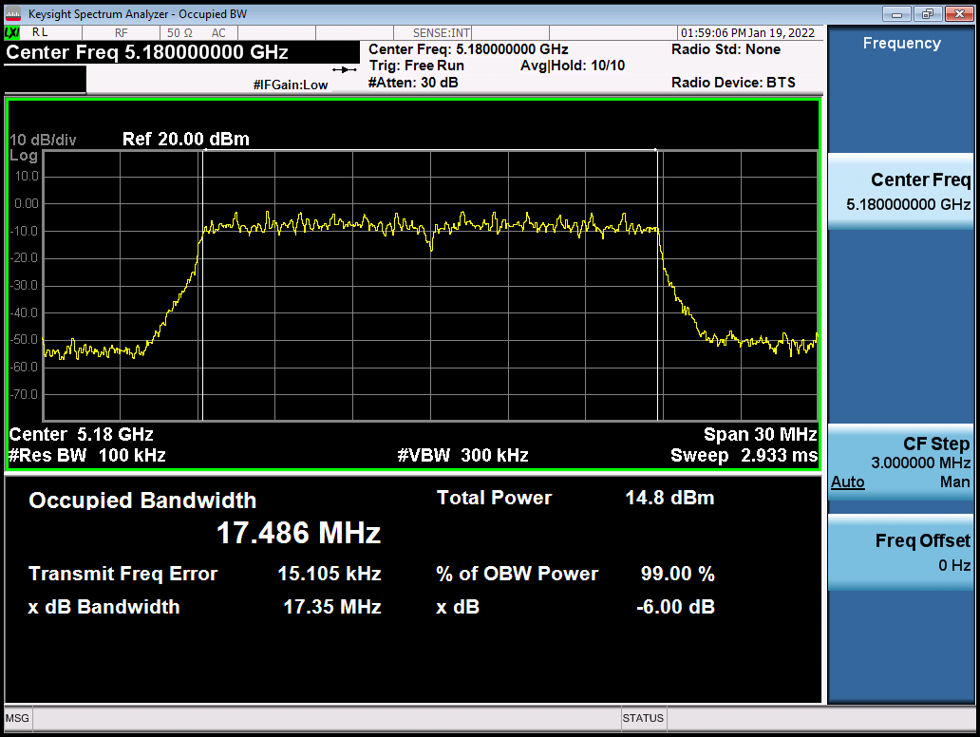

Table

|  |  |  |
| --- | --- | --- |
| Col1 | Col2 | Col3 |
| A 123 | B321 | C231 |

Chapter 2 Text

This is my text 2   
Thist is still my text 2

Image

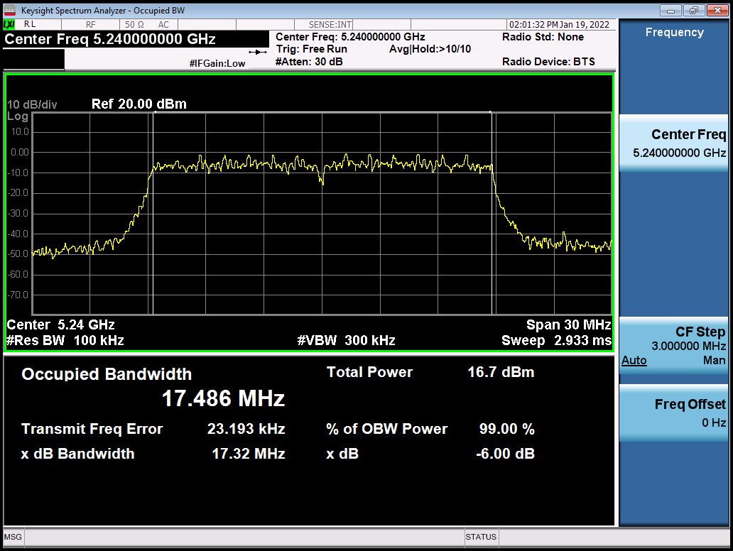

Table

|  |  |  |
| --- | --- | --- |
| Col1 | Col2 | Col3 |
| A456 | B654 | C564 |

Chapter 2 Text

This is my text 2   
Thist is still my text 2

Image

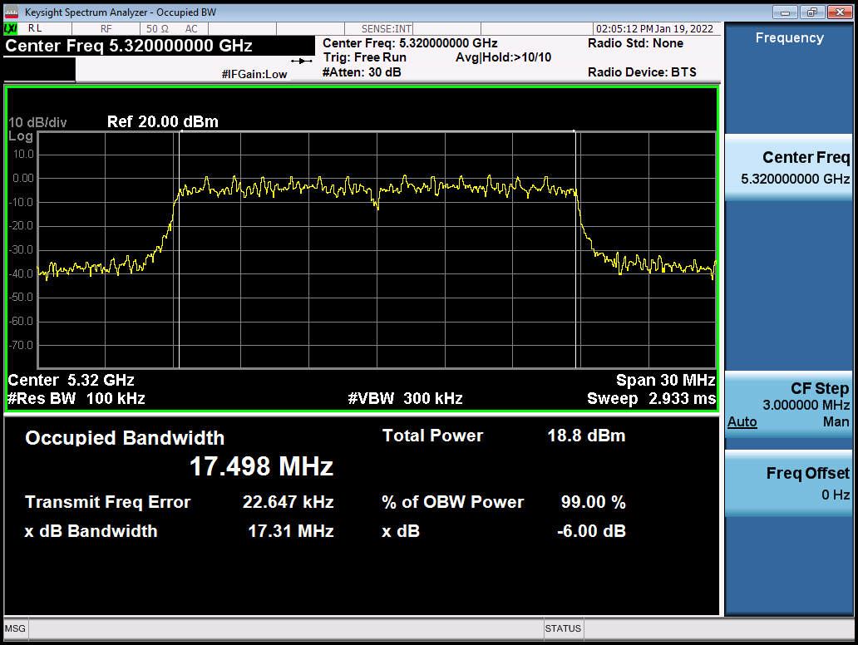

Table

|  |  |  |
| --- | --- | --- |
| Col1 | Col2 | Col3 |
| A789 | B987 | C897 |