Document Title

A plain paragraph having some **bold** and some *italic.*

# Heading, level 1

Intense quote

* first item in unordered list

1. first item in ordered list

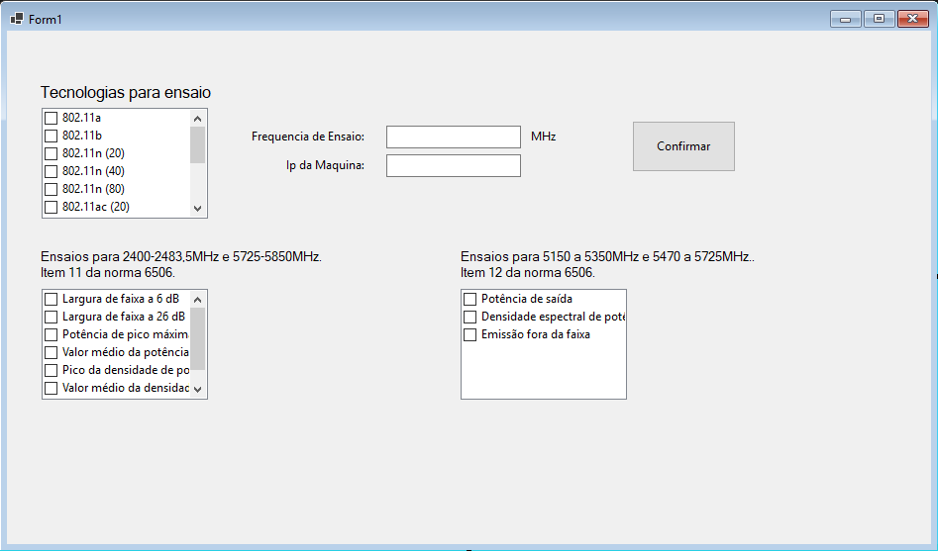

|  |  |  |
| --- | --- | --- |
| Qty | Id | Desc |
| 3 | 101 | Spam |
| 7 | 422 | Eggs |
| 4 | 631 | Spam, spam, eggs, and spam |