

Shenzhen Hailingke Electronics Co., Ltd.

HLK-LD2420 User Manual

Version: V1.3.2 Modification date: 2024-11-22 | Copyright@Shenzhen Hailingke Electronics Co., Ltd.

Table of Contents
1. Product Information 4
1.1. Main Features 4
1.2. Application Scenarios 5
Smart Home 5
Smart Business 5
Smart Security 5
Smart Lighting 5
2. System Description 5
2.1. Product 6
3. Hardware Description 7
4. Software Description 8
4.1. Firmware Configuration 8
4.2. Use of host computer 9
4.2.1. Parameter settings 9
4.2.2. Real-time data 10
Figure 4-4 Real-time data page 11
4.2.3. Data collection/analysis 13
4.2.4. Update Firmware 15
5. Communication Protocol 17
5.1. Protocol Format 17
5.1.1. Protocol data format 17
5.1.2. Command protocol frame format 17
5.2. Send command and ACK 18
5.2.1. Read firmware version command 18
5.2.2. Enable Configuration Command 18
5.2.3. End configuration command 19
5.2.4. Read Serial Number Command 19
5.2.5. Write Serial Number Command 20
5.2.6. Read radar register command 20
5.2.7. Configure radar register commands 21
5.2.8. Read radar parameter configuration command 21
5.2.9. Configure radar parameters command 22
5.2.10. Configuration system parameter commands 23
5.3. Radar reporting data 23
F4 F3 F2 F1 23 00 01 69 00 (F2 1B 6A 07 14 00 28 00 1D 00 19 00 14 00 20 00 0D 00 32 00 19 00 14 00 0A 00 0A 00 08 00 0A 00) F8 F7 F6 F5 24
Figure 5-2: Data frame example in reporting mode 24
6. Installation and detection range 26
6.1. Ceiling installation 26
6.2. Wall Mounting 28
6.3. Detection range test 29
7. Mechanical dimensions 30
8. Installation Instructions 30
9. Notes 31
10. Version History 32

Product Information
HLK-LD2420 is a high-performance 24 GHz radar module with a transmit-receive antenna from Hilink. Its human body sensing algorithm uses millimeter wave
Radar distance measurement technology and the S3 series chip's advanced proprietary signal processing technology enable accurate perception of motion, micro-movement and standing human bodies.
HLK-LD2420 is mainly used in indoor scene sensing to see if there is a moving or slightly moving human body in the area, and to refresh the detection results in real time.
The maximum sensing distance of a moving human body is 8 m. The sensing distance range, sensing sensitivity in different intervals and refresh time can be easily configured.
GPIO and UART interfaces are plug-and-play and can be flexibly applied to different smart scenarios and terminal products.

Main Features
- Equipped with single-chip intelligent millimeter wave sensor SoC and intelligent algorithm firmware
- Ultra-small module size: 20 mm × 20 mm
- Load the default human body sensing configuration, plug and play
- 24 GHz ISM band, can pass FCC, CE, and RF spectrum regulations certification
- 3.3 V power supply, supports 3.0 V ~ 3.6 V wide voltage range
- Average operating current 50 mA
- Detection target is moving or slightly moving human body
- Report detection results in real time
- Provides visualization tools to support configuration of detection distance intervals, setting sensitivity within intervals and result reporting time
- Supports sensing range division, completely shielding any interference outside the range
- Short distance sensing of 0.2 m, no blind spot
- Maximum distance of human motion sensing: 8 m
- Large detection angle, coverage range up to ±60°
- Support various installation methods such as ceiling hanging and wall hanging
- Trigger and hold states are configured independently, with strong anti-interference capability

Application Scenarios
HLK-LD2420 human body sensing sensor can detect and identify moving, standing and stationary human bodies, and is widely used in various IoT scenarios, covering the following types:

Smart Home
Sense the presence and distance of human body and report the detection results for the main control module to intelligently control the operation of home appliances.

Smart Business
Identify when a person is approaching or moving away within the set distance range; light up the screen in time and keep the device lit when a person is present.

Smart Security
Induction access control, building intercom, electronic cat's eye, etc.

Smart Lighting
Identify and sense the human body, accurately detect the position, and can be used for lighting equipment in public places (induction lamps, bulbs, etc.).

System Description
HLK-LD2420 is an intelligent and accurate human body sensing sensor developed based on the Hilink S3 series millimeter wave sensor chip.
Use FMCW frequency modulated continuous wave, combined with radar signal processing and built-in intelligent human body sensing algorithm to detect human targets in the set space and update the detection results in real time. Using the Hilink intelligent millimeter wave sensor reference solution, users can quickly develop their own precise human body sensing products.

Product
The hardware of HLK-LD2420 is mainly composed of the fully integrated Hilink intelligent millimeter wave sensor SoC, 24 GHz one-transmit-one-receive antenna and main control MCU; the software part is equipped with firmware and visual configuration tools released by Hilink, which can flexibly configure the sensing distance, sensitivity and human body sensing function for reporting time.
The specifications of HLK-LD2420 are shown in Table 2-1.
Parameter | Remark | Minimum | Typical | Maximum | Unit
Hardware specifications
Supported frequency bands | Comply with FCC, CE, and NFPA certification standards | 24 |  | 24.25 | GHz
Supports maximum sweep bandwidth | Comply with FCC, CE, and NFPA certification standards |  | 0.25 |  | GHz
Maximum equivalent isotropic radiated power |  |  | 11 |  | dBm
Supply voltage |  | 3.0 | 3.3 | 3.6 | VDC
Size |  |  | 20 × 20 |  | mm
Ambient temperature |  | -40 |  | 85 | °C
System Performance
Distance detection range (wall mounted) | Sports human target |  | 8 |  | m
Distance detection range (wall mounted) | Micro-motion human target |  | 6 |  | m
Distance detection range (ceiling mounted) | Moving human target (diameter) |  | 5 |  | m
Distance detection range (ceiling mounted) | Micro-motion human target (diameter) |  | 4 |  | m
Distance detection accuracy | Moving targets within 8m of the radar straight line distance |  | ±0.35 |  | m
Average operating current |  |  | 50 |  | mA
Data refresh rate |  |  | 10 |  | Hz
Table 2-1

Hardware Description
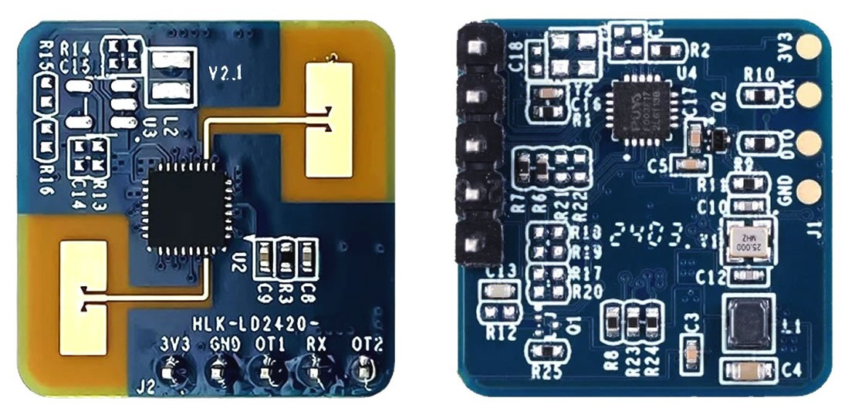
The following figure shows the front and back of the module. The module has 5 reserved pin holes (not equipped with pins when leaving the factory) called J2, which is used for power supply and communication; J1 is SWD interface, used for MCU program burning and debugging.
J2
5
1
J1
4
1
Table 3-1: J1 pin description
J#PIN# | Name | Function | Comment
J1Pin1 | GND | Grounding
J1Pin2 | DIO | SWD interface data cable | 0 ~ 3.3V
J1Pin3 | CLK | SWD interface clock line | 0 ~ 3.3V
J1Pin4 | 3V3 | Power Input | 3.0 ~ 3.6V, Typ. 3.3V
Table 3-2: J2 pin description
J#PIN# | Name | Function | Comment
J2Pin1 | 3V3 | Power Input | 3.0 ~ 3.6V, Typ. 3.3V
J2Pin2 | GND | Grounding
J2Pin3 | OT1 | UART_TX | 0 ~ 3.3V
J2Pin4 | RX | UART_RX | 0 ~ 3.3V
J2Pin5 | OT2 | Digital out, used to report detection status: high level means human detected, low level means no detection | 0 ~ 3.3V
Note: The pin spacing for J1 and J2 interfaces is 2.54 mm.

Software Description
This chapter introduces the firmware debugging of HLK-LD2420 and the use of host computer tools.
HLK-LD2420 has been pre-installed with system firmware. For details on the firmware version, please refer to the module packaging.
The visual host configuration tool software makes it convenient for developers to configure the parameters of HLK-LD2420 according to the usage scenarios and optimize the sensing effect.

Firmware Configuration
This section introduces the debugging method of HLK-LD2420 radar module firmware.
Step 1: Connect the host computer and radar module through a USB to TTL serial port adapter board like the one below. The pin-to-pin connections are shown in Table 4-1 and Figure 4-1.
Table 4-1: The corresponding relationship between the pins when the radar is connected to the USB serial port adapter board.
Radar Module | Serial Port Adapter Board
RX | TXD
OT1 | RXD
3V3 | 3V3
GND | GND
Figure 4-1: Connection between HLK-LD2420 hardware and USB serial port adapter board
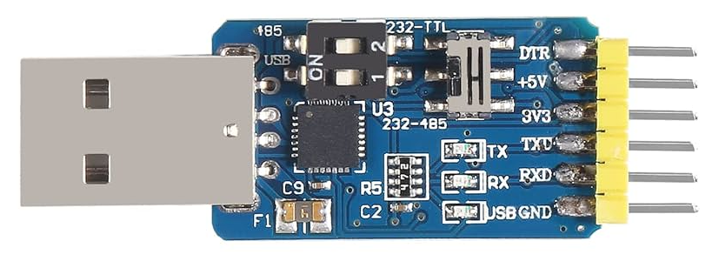
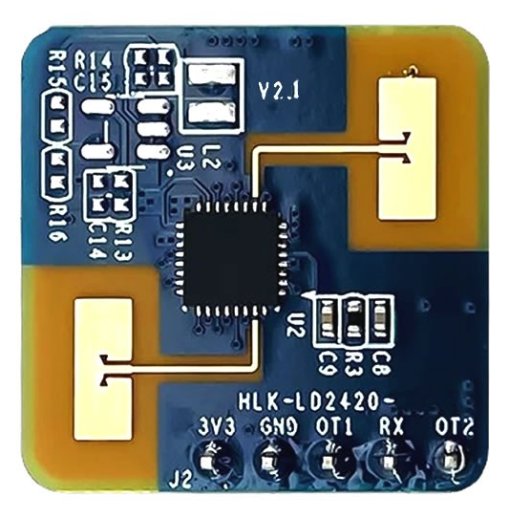
Step 2: Open the device manager of the host computer and check the serial port number of the radar module.
Step 3. Open the serial port tool, select the serial port number of the radar module, set the serial port baud rate to 115200, and then click the "Open Serial Port" button to view the detection results of the current radar at the output end of the tool interface.

Use of host computer
This section introduces the use of the host computer tool that comes with the HLK-LD2420 module to help users understand the meaning of related parameters and related parameters.
Connection Steps:
Step 1: Get the host computer tool "HLK-2420_TOOL.exe" for HLK-LD2420 from the official website of Hilink.
Step 2: Use the serial port adapter board to connect the radar module and the host computer according to Figure 4-1.
Step 3: Open the host computer tool, select the serial port number of the radar module, enter the baud rate 115200, and click the "Connect Device" button.
Read and write parameters (Note: serial port tools and host computer tools cannot be used at the same time).

Parameter settings
The upper computer tool interface is shown in Figure 4-2.

For detailed explanation of the parameters involved in the host computer tool interface, please see Table 4-2.
Table 4-2: Table 4-2 Parameter explanation of the host computer tool interface
Parameter name | Explanation | Parameter range
Minimum distance | Used to set the minimum distance gate for radar detection.  The resolution of the range gate is 70 cm. | 0 ~ 15
Maximum distance | Used to set the maximum distance gate for radar detection.  The resolution of the range gate is 70 cm. | 0 ~ 15  (must be no less than the minimum distance)
Target disappears | The target state needs to be switched from occupied to unoccupied for a period of time T: during this period, if a person is detected, the timer for this period will be restarted. | (Corresponding to the host computer setting) 0-90
Delay time | The state of no one will switch to no one after it lasts for a full T time.  Human status, report no one. | (Corresponding to serial port configuration) 0 ~ 1000000000
Trigger threshold | Used to set the sensitivity from no-man to manned state. It is recommended to set it at 5 times the energy.  For energy scanning and data viewing, please refer to 4.2.2 and 4.2.3. | (Corresponding to the host computer setting) 0-90  (Corresponding to serial port configuration) 0 ~ 1000000000
Keep Threshold | The sensitivity used to detect human micro-movement and maintain the status of people is recommended to be set at 2 ~ 5 times the background noise. For energy scanning and data viewing, please refer to 4.2.2 and 4.2.3 | (Corresponding to the host computer setting) 0-90  (Corresponding to serial port configuration) 0 ~ 1000000000
Threshold parameter description: Assume that N is the parameter configured by the host computer and M is the parameter configured by the serial port.
The parameter conversion relationship is N = (10 * log₁₀ M) or M = 10 ^{N/10}.
For example, if the serial port configuration distance gate 0 threshold value is 65536, in the host computer it should be (10 * log₁₀ 65536) ≈ 48.16.
Or, if the host computer parameter is set to 70, the corresponding serial port configuration parameters are 10 70/10 = 10,000,000 and the instruction converts to hexadecimal, with little endian, to: 0x80969800

Real-time data
The "Real-time Data" page of the host computer is shown in Figure 4-4. Its function page is introduced as follows:
- The colored light icon in the upper left corner indicates whether there is someone in the detection area: when the radar detects the presence of a human body, the colored light is red; when no human body is detected; when present, the colored light is green;
- The text display box behind the colored light shows the radial distance between the target human body detected by the radar and the radar;
- The "Start/Pause" switch button is used to start and pause radar detection;
- The "Generate Threshold" button is used to scan the ambient noise and calculate the "trigger threshold" and "hold threshold" of each range gate;
- The "Apply Threshold" button is used to send the "Trigger Threshold" and "Hold Threshold" obtained in the "Generate Threshold" function to the radar;
- The "Relative Power VS Range Gate" line graph is used to display the motion energy value (green line), trigger threshold value (red line) and hold threshold value (yellow line) of each range gate in real time; a black background indicates that the range gate is in the effective detection range, and a gray background indicates that the range gate is in the invalid detection range;
- The "Distance vs. Time" line graph is used to display the distance change of the target human body detected by the radar in the past 60 seconds in real time; the gray background area indicates that the radar detected the target human body during this period, and the black background area indicates that the radar did not detect the target human body during this period.

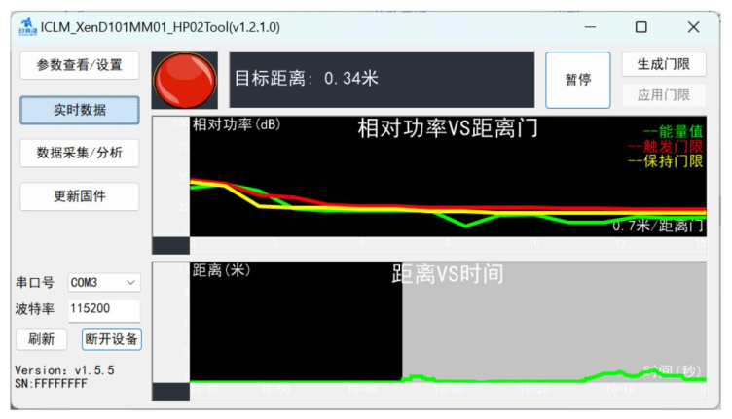
Figure 4-4 Real-time data page
The steps to view real-time data through the host computer are as follows:
Step 1: After connecting the XenD101MM module to the host computer tool, click the "Real-time Data" button to switch to this function page.
The tool automatically turns on the radar detection function, and the "Start/Pause" switch button displays "Pause". The two line graphs on the upper computer function page start to display the corresponding real-time data information;
Step 2: Click the "Start/Pause" switch button to pause the radar detection function. The colored light on the function page turns green and the target distance displays "0.00 Meters", the two line charts below stop updating.
The steps to generate/apply thresholds via the host computer are as follows:
Step 1: When the "Start/Pause" button on the "Real-time Data" page shows "Pause", click the "Generate Threshold" button and the host computer tool pops up the "Threshold Acquisition" information window. The table above shows the trigger energy and hold energy values of each distance gate in real time, and the progress bar below displays the scanning progress, as shown in Figure 4-5;
Step 2: Click the "Cancel" button to terminate the collection; if the user wants to save and apply the collected data, click "OK" after the data collection is completed;
Step 3 (optional): If the user selects "OK" in step 2, the "Apply Threshold" button on the page changes from a gray, unclickable state to a clickable state. Click the "Apply Threshold" button, and the host computer tool sends the threshold data calculated in step 2 to the radar, and a prompt window appears saying “Threshold setting successful” pops up.
After applying the generated threshold, the user can view the latest radar threshold parameter values on the "Parameter View/Set" page.
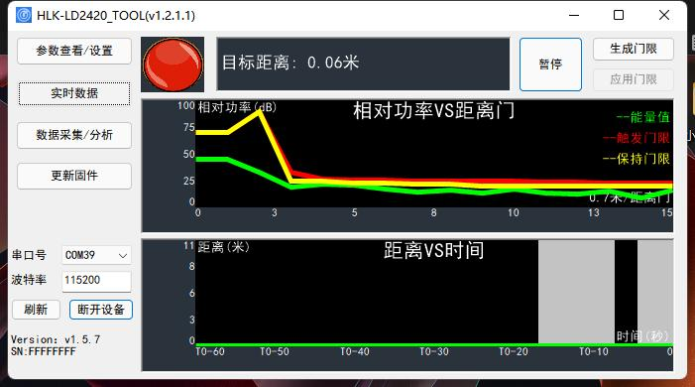
Figure 4-5 Threshold Collection Page

Data collection/analysis
The "Data Collection/Analysis" page of the host computer is shown in Figure 4-6. Its function page is introduced as follows:
- "Range gate scanning time (seconds)": used to set the environmental noise scanning time of each range gate, the default is 20 seconds, the value range is 0 ~ 65535;
- "File save path": used to set the save path of the collected data;
- "Select display range gate": used to select the range gate to be viewed, the optional range is 0 ~ 15;
- "Collect Data/Stop Collection" switch button: used to start and stop data collection. After stopping data collection, users can save the data in the set file.
- Under the path, you can see a .dat file with a file name starting with RadarData and ending with a timestamp;
- “Load Data” button: used to open the saved radar scan data for users to view and analyze;
- “Energy Information” line graph: used to display the sweep energy value, trigger threshold, and hold threshold on the range gate selected by the user. The horizontal axis is time. The vertical axis is the energy information expressed as relative power;
- “Distance Information” line chart: used to display the distance information of human targets detected within the radar detection range, with the horizontal axis representing time and the vertical axis representing distance.

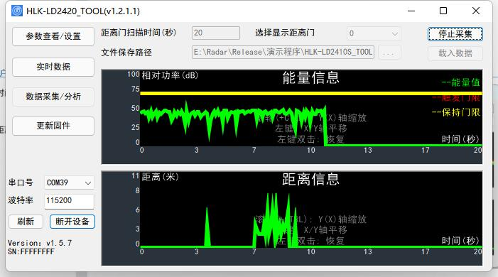
4-6 Data Collection/Analysis Page
The steps to collect energy data through the host computer are as follows:
Step 1: After connecting the XenD101MM module to the host computer tool, click the "Data Collection/Analysis" function button to switch to the function page;
Step 2: Enter the "range gate scanning time", set the "file saving path":, make sure there is no one in the radar detection area within a scanning cycle, and click the "Collect Data/Stop Collecting" switch button to start collecting data;
Step 3: After starting to collect data, the user can wait for the host computer tool to automatically stop collecting after the scan is completed, or click "Collect Data/Stop" button to stop data collection in advance; in both cases, the collected data will be saved in the file save path set in step 2.
Step 4: If you want to view the specific data of a certain point on the curve, place the mouse cursor at the position of interest on the curve, and a floating frame will appear next to the cursor. The energy value or distance information at that location is displayed, as shown in Figure 4-7.
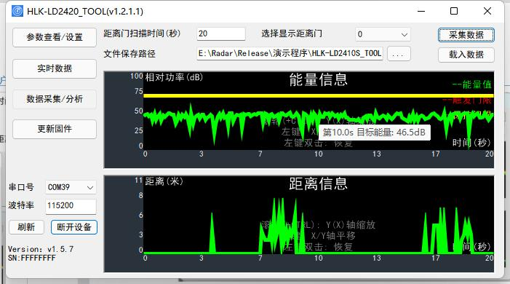
Figure 4-7 Data viewing page
When viewing data, users can zoom, pan, and restore the line chart:
- Zoom the horizontal coordinate: Put the mouse cursor on the graphics canvas, press the Ctrl key on the keyboard and roll the mouse wheel to zoom in (roll the mouse wheel up) or zoom out (roll the mouse wheel down) the graphics on the horizontal coordinate;
- Shift the data graph: put the mouse cursor on the graph canvas, press the left mouse button and move the mouse to move the graph accordingly, and the horizontal and vertical coordinates will also change synchronously;
- Restore graphics: Place the mouse cursor on the graphics canvas and double-click the left mouse button to restore the graphics to the default display settings.

Update Firmware
The "Update Firmware" page of the host computer is shown in Figure 4-8. The steps to update the radar module firmware through the host computer are as follows:
Step 1: After connecting the XenD101MM module to the host computer tool, click the "Update Firmware" function button to switch to the function page;
Step 2. Click the "Get Firmware Information" button on the function page, and the ID information of the current device will be displayed in the prompt box on the right;
Step 3. Click the "Select bin file path" button, select the required .bin file, and click the "Download" button to start upgrading the firmware. The information box will display the download results in real time, and the bin file information and current download progress will be displayed below.
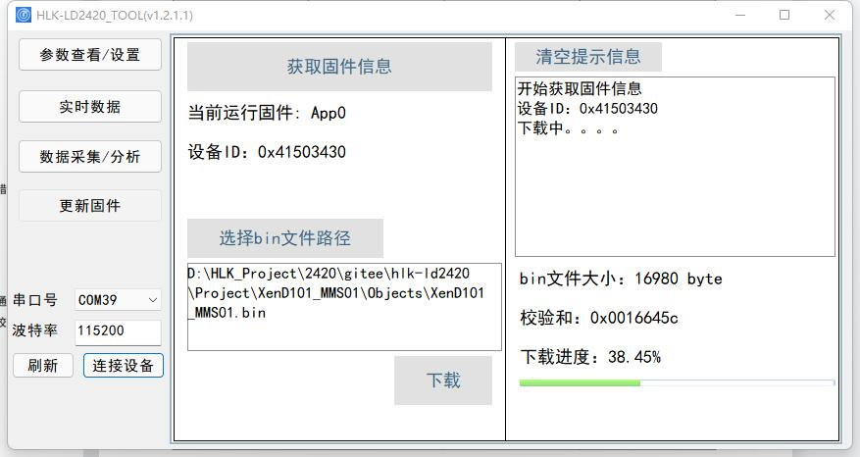
4-8 Firmware Upgrade Page
After the firmware upgrade is successful, the page prompt box will display "Download Successful!". If the firmware upgrade fails, the prompt box will display the corresponding error message information.

Communication Protocol
This communication protocol is mainly used by users who need to conduct secondary development without visualization tools. HLK-LD2420 communicates with the outside world through the serial port (TTL level). The radar's data output and parameter configuration commands are all carried out under this protocol. The default baud rate of the radar serial port is 115600, 1 stop bit, and no parity bit.
This chapter mainly introduces this communication protocol from three parts:
- Protocol format: including protocol data format and command frame format;
- Configure command package format: including command package format and command return package format;
- Upload data frame format: including the upload data frame format of the debugging mode and the upload data frame format of the reporting mode.
The basic process of using commands to configure parameters is:
- Enter command mode;
- Configuration parameter command/get parameter command;
- Exit command mode.

Protocol Format

Protocol data format
HLK-LD2420 data communication uses the little-endian format. All data in the following table are in hexadecimal.

Command protocol frame format
The radar configuration command and ACK command formats defined by the protocol are shown in Table 5-1 and Table 5-3.
Table 5-1 Send command protocol frame format
Frame Head | In-frame Data Length | In-frame Data | Frame Tail
FD FC FB FA | 2 bytes | See Table 5-2 | 04 03 02 01

Table 5-2 Data format in the sending frame
Command word (2 bytes) | Command value (N bytes)

Table 5-3 ACK command protocol frame format
Frame Head | In-frame Data Length | In-frame Data | Frame Tail
FD FC FB FA | 2 bytes | See Table 5-4 | 04 03 02 01

Table 5-4 ACK frame data format
Command word (2 bytes) | Command execution status (2 bytes) | Return value (N bytes)

Send command and ACK

Read firmware version command
This command reads the radar firmware version information.
Command word: 0x0000
Command value: None
Return value: Version number length (2 bytes) + version number byte string
Send data:
Byte 1 ~ 4 | Byte 5, 6 | Byte 7, 8 | Byte 9 ~ 12
FD FC FB FA | 02 00 | 00 00 | 04 03 02 01
Radar ACK (success):
Byte 1 ~ 4 | Byte 5, 6 | Byte 7, 8 | Byte 9, 10 | Byte 11, 12 | Byte 13 ~ 18 | Byte 19 ~ 24
FD FC FB FA | 0C 00 | 00 01 | 00 00 | 06 00 | 76 31 2E 35 2E 25 | 04 03 02 01

Enable Configuration Command
Any other command issued to the radar must be executed after this command is issued, otherwise it will be invalid.
Command word: 0x00FF
Command value: 0Xx0001
Return value: 2 bytes ACK status (0 success, 1 failure) + 2 bytes protocol version (0x0002) + 2 bytes buffer size (0x0020)
Send data:
Byte 1 ~ 4 | Byte 5, 6 | Byte 7, 8 | Byte 9, 10 | Byte 11 ~ 14
FD FC FB FA | 04 00 | FF 00 | 01 00 | 04 03 02 01
Radar ACK (success):
Byte 1 ~ 4 | Byte 5, 6 | Byte 7, 8 | Byte 9, 10 | Byte 11, 12 | Byte 13, 14 | Byte 15 ~ 18
FD FC FB FA | 08 00 | FF 01 | 00 00 | 02 00 | 20 00 | 04 03 02 01

End configuration command
End the configuration command. After execution, the radar resumes working mode. If you need to send other commands again, you need to send the enable configuration command first.
Command word: 0x00FE
Command value: None
Return value: 2 bytes ACK status (0 success, 1 failure)
Send data:
Byte 1 ~ 4 | Byte 5, 6 | Byte 7, 8 | Byte 9 ~ 12
FD FC FB FA | 02 00 | FE 00 | 04 03 02 01
Radar ACK (success):
Byte 1 ~ 4 | Byte 5, 6 | Byte 7, 8 | Byte 9, 10 | Byte 11 ~ 14
FD FC FB FA | 04 00 | FE 01 | 00 00 | 04 03 02 01

Read Serial Number Command
This command reads the radar's serial number.
Command word: 0x0011
Command value: None
Return value: 2 bytes ACK status (0 success, 1 failure)
Send data:
Byte 1 ~ 4 | Byte 5, 6 | Byte 7, 8 | Byte 9 ~ 12
FD FC FB FA | 02 00 | 11 00 | 04 03 02 01
Radar ACK (success):
Byte 1 ~ 4 | Byte 5, 6 | Byte 7, 8 | Byte 9, 10 | Byte 11, 12 | Byte 13, 14 | Byte 15 ~ 18
FD FC FB FA | 08 00 | 11 01 | 00 00 | 02 00 | CD AB | 04 03 02 01

Write Serial Number Command
This command writes the radar's serial number.
Command word: 0x0010
Command value: SN length (2 bytes) + SN byte string
Return value: 2 bytes ACK status (0 success, 1 failure)
Send data:
Byte 1 ~ 4 | Byte 5, 6 | Byte 7, 8 | Byte 9 ~ 12 | Byte 13 ~ 16
FD FC FB FA | 06 00 | 10 00 | 02 00 CD AB | 04 03 02 01
Radar ACK (success):
Byte 1 ~ 4 | Byte 5, 6 | Byte 7, 8 | Byte 9, 10 | Byte 11 ~ 14
FD FC FB FA | 04 00 | 10 01 | 00 00 | 04 03 02 01

Read radar register command
This command reads the radar's registers.
Command word: 0x0002
Command value: 2-byte chip address + (2-byte address) * N
Return value: (2 bytes of data) * N
Send data:
Byte 1 ~ 4 | Byte 5, 6 | Byte 7, 8 | Byte 9 ~ 12 | Byte 13 ~ 16
FD FC FB FA | 06 00 | 02 00 | 40 00 40 00 | 04 03 02 01
Radar ACK (success):
Byte 1 ~ 4 | Byte 5, 6 | Byte 7, 8 | Byte 9, 10 | Byte 11, 12 | Byte 13 ~ 16
FD FC FB FA | 06 00 | 02 01 | 00 00 | 07 02 | 04 03 02 01

Configure radar register commands
This command writes to the radar's registers.
Command word: 0x0001
Command value: 2-byte chip address + (2-byte address) * N
Return value: 2 bytes ACK status (0 success, 1 failure)
Send data:
Byte 1 ~ 4 | Byte 5, 6 | Byte 7, 8 | Byte 9, 10 | Byte 11 ~ 14 | Byte 15 ~ 18
FD FC FB FA | 08 00 | 01 00 | 40 00 | 40 00 07 42 | 04 03 02 01
Radar ACK (success):
Byte 1 ~ 4 | Byte 5, 6 | Byte 7, 8 | Byte 9, 10 | Byte 11 ~ 14
FD FC FB FA | 04 00 | 01 01 | 00 00 | 04 03 02 01

Read radar parameter configuration command
This command can read the current configuration parameters of the radar.
Command word: 0x0008
Command value: (2 bytes parameter ID) * N
Return value: (4 bytes parameter value) * N

Send data:
Byte 1 ~ 4 | Byte 5, 6 | Byte 7, 8 | Byte 9, 10 | Byte 11 ~ 14
FD FC FB FA | 04 00 | 08 00 | 01 00 | 04 03 02 01
Radar ACK (success):
Byte 1 ~ 4 | Byte 5, 6 | Byte 7, 8 | Byte 9, 10 | Byte 11 ~ 14 | Byte 15 ~ 18
FD FC FB FA | 08 00 | 08 01 | 00 00 | 0C 00 00 00 | 04 03 02 01

Configure radar parameters command
This command sets the parameters of the radar module. For specific parameter words, please refer to Table 5-5.
Table 5-5 Protocol parameter table
Parameter name | Parameter word | Parameter range
Minimum distance gate | 0x0000 | 0 ~ 15
Maximum distance gate | 0x0001 | 0 ~ 15
Target disappearance delay | 0x0004 | 0 ~ 65535 Unit: seconds
Trigger threshold | 0x0010 ~ 0x001F | 0 ~ 232 - 1, square of modulus value
Hold Threshold | 0x0020 ~ 0x002F | 0 ~ 232 - 1, square of modulus value
Command word: 0x0007
Command value: (2 bytes parameter ID + 4 bytes parameter value) * N
Return value: 2 bytes ACK status (0 success, 1 failure)
Send data: Maximum distance gate 12, Minimum distance gate 2
Byte 1 ~ 4 | Byte 5, 6 | Byte 7, 8 | Byte 9, 10 | Byte 11, 12 | Byte 13, 14 | Byte 15 ~ 18
FD FC FB FA | 08 00 | 07 00 | 01 00 | 12 00 | 00 00 | 04 03 02 01
Radar ACK (success):
Byte 1 ~ 4 | Byte 5, 6 | Byte 7, 8 | Byte 9, 10 | Byte 11 ~ 14
FD FC FB FA | 04 00 | 07 01 | 00 00 | 04 03 02 01

Configuration system parameter commands
This command can configure radar system parameters.
Command word: 0x0012
Command value: (2-byte parameter ID + 4-byte parameter value) * N
Return value: 2 bytes ACK status (0 success, 1 failure)
Send data:
Byte 1 ~ 4 | Byte 5, 6 | Byte 7, 8 | Byte 9, 10 | Byte 11 ~ 14 | Byte 15 ~ 18
FD FC FB FA | 08 00 | 12 00 | 00 00 | 04 00 00 00 | 04 03 02 01
Radar ACK (success):
Byte 1 ~ 4 | Byte 5, 6 | Byte 7, 8 | Byte 9, 10 | Byte 11 ~ 14
FD FC FB FA | 04 00 | 12 01 | 00 00 | 04 03 02 01

Radar reporting data
HLK-LD2420 firmware outputs the test results through the serial port in normal working mode. The output result is the string of ON/OFF and the target distance gate.
In special modes, the host machine can obtain data from the radar processing process, so the firmware provides two additional transmission formats in command line mode:
They are debug mode and report mode respectively.
In command line mode, by adjusting the working mode parameters in the command packet, the data format reported by the serial port can be controlled. Figure 5-1 shows a command packet example.
FD FC FB FA | 08 00 | 12 00 | 00 00 | 04 00 00 00 | 04 03 02 01
Frame header | Command part length | Command ID | Parameter ID | Parameter value | Frame tail
 |  |  | Command Parameter
5-1 Command Packet Format Example
In this command packet, the parameter value of the command parameter can determine the working mode of the radar: 0x0000 is the debugging mode, 0x0004 is the reporting mode, and 0x0064 is the normal mode.
Table 5-6 shows the data format of the debugging mode. The RDMAP modulus value data transmitted in the debugging mode is sent according to the data of all range gates of each chirp, that is, the modulus value data of the 16 range gates of the first chirp is sent first, and then the modulus value data of the 16 range gates of the second chirp is sent, and so on.
Table 5-6 Data frame format in debug mode
Frame Head | Data | Frame Tail
AA BF 10 14 | RDMAP: 20 (Doppler) * 16 (range gate) * 4 (squared modulus) | FD FC FB FA
Table 5-7 Data frame format of reporting mode
Header | Length | Detection result | Target distance | Energy value of each distance gate | Frame tail
F4 F3 F2 F1 | 2 bytes, total number of bytes of detection result, target distance and energy value of each distance gate | 1 byte,  00: no one  01: someone | 2 bytes | 32 bytes  16 (total number of distance gates) * 2 bytes | F8 F7 F6 F5

Figure 5-2 shows an example of a data frame transmitted from the serial port in reporting mode.

F4 F3 F2 F1 23 00 01 69 00 (F2 1B 6A 07 14 00 28 00 1D 00 19 00 14 00 20 00 0D 00 32 00 19 00 14 00 0A 00 0A 00 08 00 0A 00) F8 F7 F6 F5
Header
Length
Result
Distance
Tail
Energy value of each distance gate

Figure 5-2: Data frame example in reporting mode

In the example, the meaning of each part of the data is as follows:
Length field: indicates the total number of bytes occupied by the reported detection result + target distance + energy value of each range gate;
Detection result: Indicates whether there is a target in the current scene;
Target distance: indicates the distance between the target in the scene and the radar;
Energy value of each range gate: Indicates the energy value of each range gate from 0 to 15.
Therefore, the data frame analysis example in Figure 2 is as follows:
Length: 0x0023, indicating the total number of bytes occupied by the reported detection result + target distance + energy value of each range gate = 35
Detection result: 01, indicating that there is a person in the scene
Target distance: 0x0069, means target distance = 105 cm
Energy value of each range gate:
Range Gate Energies
Gate 0 | 0x1BF2 : 7154₁₀ | Gate 8 | 0x000D : 13₁₀
Gate 1 | 0x076A : 1898₁₀ | Gate 9 | 0x0032 : 50₁₀
Gate 2 | 0x0014 : 20₁₀ | Gate 10 | 0x0019 : 25₁₀
Gate 3 | 0x0028 : 40₁₀ | Gate 11 | 0x0014 : 20₁₀
Gate 4 | 0x001D : 29₁₀ | Gate 12 | 0x000A : 10₁₀
Gate 5 | 0x0019 : 25₁₀ | Gate 13 | 0x000A : 10₁₀
Gate 6 | 0x0014 : 20₁₀ | Gate 14 | 0x0008 : 8₁₀
Gate 7 | 0x0020 : 32₁₀ | Gate 15 | 0x000A : 10₁₀

Installation and detection range
HLK-LD2420 supports two installation methods: ceiling-mounted and wall-mounted. The recommended method is ceiling-mounted installation.
The orientation of the radar is shown in Figure 5-1. The Y axis is 0°, the X axis is 90°, and the Z axis is perpendicular to the XY plane (also called the line direction).

Y
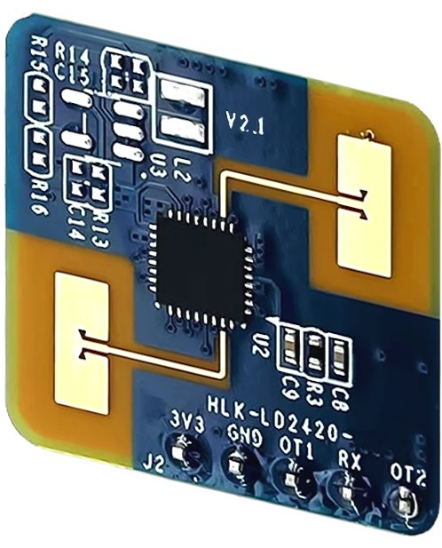
X
Z

Figure 5-1 Radar module orientation diagram

Ceiling installation
The recommended ceiling installation height is 2.7~3 m. The maximum motion sensing range of the ceiling-mounted HLK-LD2420 radar module under the default configuration is a conical three-dimensional space with a bottom radius of 5m is shown in Figure 5-2.
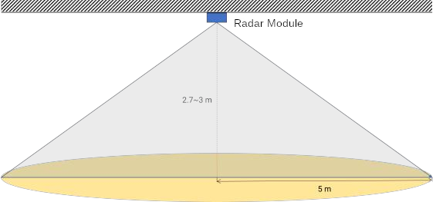
Figure 5-2 Schematic diagram of the detection range of the HLK-LD2420 radar module (ceiling mounted)
The schematic diagram of the motion and micro-motion detection range of this reference solution when the ceiling installation height is 2.7 m is shown in Figure 5-3.
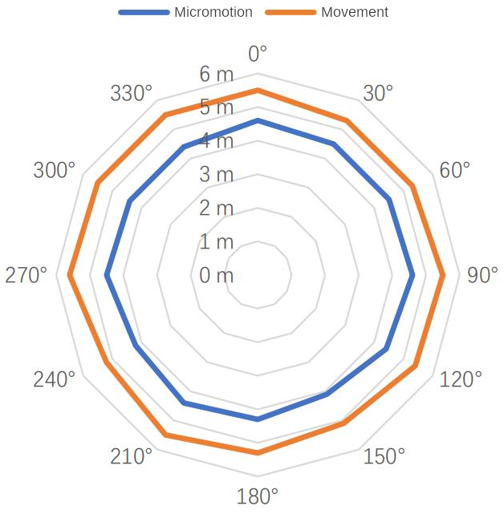

Wall Mounting
The recommended wall-mounted installation height is 1.5~2 m. When mounted on the wall, the X-axis of the radar module (see Figure 5-1) points horizontally and the Y-axis points upward.
The Z axis points to the detection area. The maximum motion sensing range of the wall-mounted HLK-LD2420 radar module in the default configuration is 8 m in radius and horizontal
A three-dimensional fan-shaped space with an angle of ±60° with the pitch direction, as shown in Figure 5-4.
The detection range diagram of this reference solution when the wall-mounted installation height is 1.5m is shown in Figure 5-5.
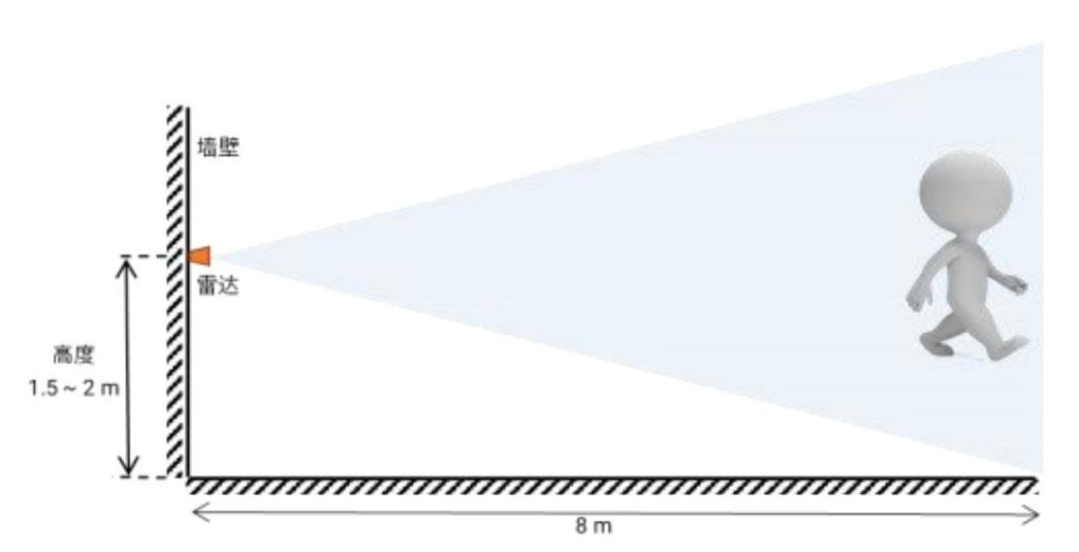
Figure 5-4 Schematic diagram of the detection range of the HLK-LD2420 radar module (mounted on the wall)

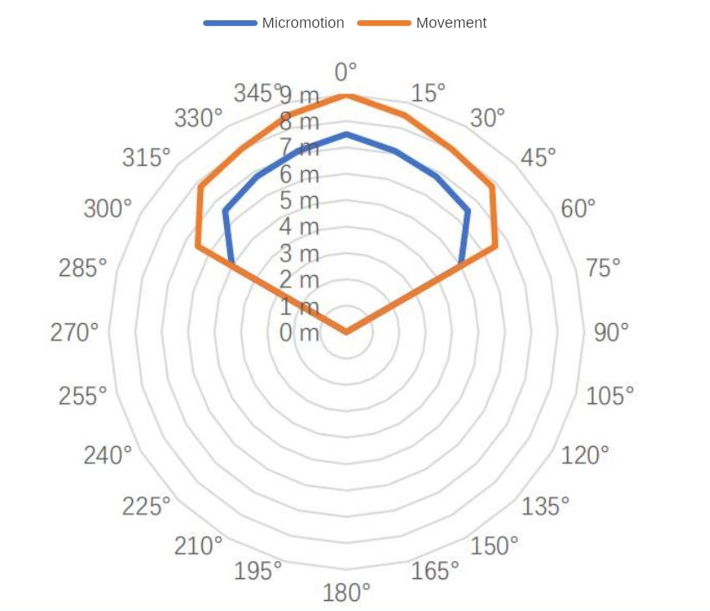
Figure 5-5 Wall-mounted sensing range

Detection range test
The test methods for radar triggering and maintaining detection range are introduced as follows:
- Trigger range:
The target person approaches the radar from a distance when the radar reports no person. When the radar starts to report that there is a person, it stops moving forward. The current position is the boundary of the radar trigger detection range; the area enclosed by the detection boundaries in all directions is the radar trigger detection range.
- Keep range:
When the target person keeps a small movement at the position to be detected, such as shrugging or raising his hand, the radar will detect the person within 60 seconds.
If there is someone reported all the time, the current position is within the radar detection range; otherwise, the detection position is outside the detection range.

Mechanical dimensions
Figure 6-1 shows the mechanical dimensions of the module, all units are in millimeters. The module board thickness is 1.2 mm, with a tolerance of ±10%.
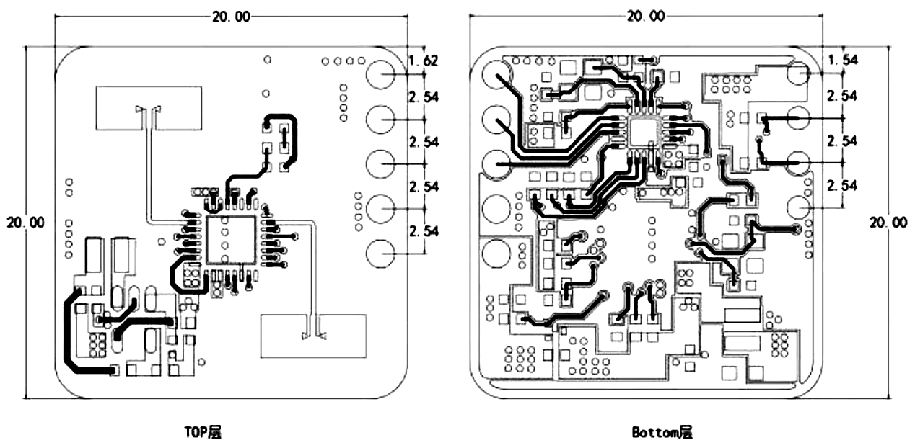
Figure 6-1 Hardware mechanical dimensions

Installation Instructions
Radar enclosure requirements
If the radar needs to be installed in a housing, the housing must have good wave-transmitting properties in the 24 GHz band and must not contain metal or electromagnetic wave shielding.
For more information, see the mmWave Sensor Radome Design Guide.
Installation environment requirements
This product needs to be installed in a suitable environment. If used in the following environment, the detection effectiveness will be affected:
- There are non-human objects that are in continuous motion in the sensing area, such as animals, continuously swinging curtains, and large green plants facing the air vents.
- There is a large area of strong reflective plane in the sensing area. Strong reflective objects facing the radar antenna will cause interference.
- When wall-mounted, external interference factors such as air conditioners and electric fans on the ceiling of the room need to be considered.
Notes on installation
- Try to ensure that the radar antenna is facing the area to be detected and that there is an open area around the antenna.
- Ensure that the sensor is installed firmly and stably. The shaking of the radar itself will affect the detection effect.
- Ensure that there is no movement or vibration of objects behind the radar. Since radar waves are penetrating, the antenna back lobe may detect moving objects behind the radar. Metal shielding covers or metal back plates can be used to shield the radar back lobe and reduce the impact of objects behind the radar.
- When there are multiple 24 GHz frequency band radars, please avoid direct beam alignment and install them as far away as possible to avoid possible mutual interference.
Power Supply Considerations
- The power input voltage range is 3.0 V~3.6 V, and the power ripple has no obvious spectrum peak within 100 kHz. This solution is a reference design.
- Users need to consider the corresponding electromagnetic compatibility design such as ESD and lightning surge.

Notes
Maximum detection distance
The maximum range of the radar to detect a target is 8 m in radial distance. Within the detection range, the radar will report the straight-line distance of the target from the radar.
It can only output the distance information of moving human bodies within 8 m, and does not currently support the close-range distance measurement function of stationary human bodies.

Maximum distance and accuracy
Theoretically, the radar ranging accuracy of this reference solution is 0.35 m. Due to the different body shapes, states, and RCS of human targets, the ranging accuracy will fluctuate, and the maximum detection distance will also fluctuate to a certain extent.
Target disappearance delay
When the radar module detects that there is no human presence in the target area, it will not immediately report the "no one" status in the area, but will be delayed.
The mechanism of delayed reporting is: once no human target is detected within the test range, the radar module will start timing, and the duration is the duration of no one. If no one is detected during the timing, the "no one" status will be reported after the timing ends; if a person is detected during this time period, the timing will be immediately ended and updated, and the target information will be reported.

Version History
Version | Date | Changes
V1.0 | 2023/2/15 | Initial draft.
V1.1 | 2023/3/23 | The pin function of the module has changed, the default baud rate has changed to 115200, and the host computer version has been updated
V1.2 | 2023/8/15 | Added serial port description, new version host computer usage instructions, serial port command protocol
V1.3 | 2023/12/11 | Modify parameter description
V1.3.1 | 2024/3/21 | Modify parameter description
V1.3.2 | 2024/11/22 | Modify parameter description

This step is required and cannot be skipped when the user updates the firmware using the host computer interface.

