Unsupervised Learning Methods
  - Clustering Patient Data: A Comparative Analysis
List of libraries used: pandas, matplotlib, numpy, seaborn, scikit-learn, skrebate, scipy, os, copy

Description of the Dataset
This project is going to use the heart disease dataset from UC Irvine Machine learning repository.
It contains 303 samples and 14 features, which are:
Feature | Data Type | Description
age | integer | Age (years)
sex | category | Sex (1 = male, 0 = female)
cp | category | Chest pain type (4 types: 0-3)
trestbps | integer | Resting blood pressure on admission (mmHg)
chol | integer | Serum cholesterol (mg/dl)
fbs | category | Fasting blood sugar (>120 mg/dl: 1 = true, 0 = false)
restecg | category | Resting ECG results (0, 1, 2)
thalach | integer | Max heart rate achieved
exang | category | Exercise-induced angina (1 = yes, 0 = no)
oldpeak | float | ST depression induced by exercise vs rest
slope | category | Slope of peak ST segment (0, 1, 2)
ca | integer | Major vessels coloured by fluoroscopy (0-3)
thal | category | Thal (3 = normal, 6 = fixed defect, 7 = reversible defect)
target | integer | 0 = no disease, 1-4 = disease present (binarise as 0 vs 1+)

The target variable shows a significant imbalance in classes, with more patients without the disease than in the other categories.
Different visualizations were used to analyze the distribution of the input variables depending on their type: histograms with density curves for continuous variables and bar charts (count plots) for categorical or binary variables.
Continuous variables generally exhibit unimodal distributions. Age is mainly concentrated between 45 and 65 years, while trestbps and chol exhibit slight positive skew with some high values. The thalach variable follows an approximately normal distribution centered around 150, while the oldpeak variable exhibits a clearly right-skewed distribution with many values close to zero. Bar charts, on the other hand, allow us to identify the frequency of categorical variables. There is a predominance of male patients in the sex variable, a higher frequency of category 4 in the cp variable, and a clear dominance of the value 0 in binary variables such as fbs and exang.
The relationship between numerical variables was analysed using a scatter matrix, which allowed the observation of both correlation patterns and potential class separation. In general, no strong linear correlations were identified among the features, suggesting low redundancy. However, a moderate negative correlation was observed between age and thalach, indicating that maximum heart rate tends to decrease with increasing age. Similarly, a relationship was identified between oldpeak and thalach, whereby higher oldpeak values are associated with lower thalach values.
Regarding the target, the colour-coded representation reveals significant overlap between classes in the two-dimensional projections, with no clear separation between groups when features are considered individually. This suggests that the discriminatory power relies on the combination of multiple features rather than on a single one, and that the underlying relationships may be non-linear.

Methodology & Preprocessing

Cleaning
Firstly, the raw data set was cleaned. There were only 6 missing values in the data set, so data imputation was performed using median values to avoid the influence of outliers. Next, the target variable was binarized (0 = no disease, 1 = disease stages 1 to 4), after which it was removed and taken apart from the feature data frame.

Encoding
Secondly, categorical variables were encoded using one-hot encoding. Redundant columns were dropped to avoid multicollinearity. We observed features increased from 13 to 22. This step prevents false ordering and improves model interpretation.

Scaling
Standardization was performed using the Standard Scaler, which transforms each feature to have a mean of zero and a standard deviation of one. This ensures that all variables contribute equally to the analysis and prevents bias toward features with larger numeric ranges. As PCA is distance-based, scaling prevents dominance of large values when features have different scales, and it is necessary to make PCA search for the maximum variance directions.

Principal Component Analysis (PCA)
After that, the Principal Component Analysis was applied to the standardized feature set to explore the underlying structure of the data and assess the potential for dimensionality reduction of the maximum variance directions.
- 85% of the variance was explained with the first 13 PCA components.
- PC1 explained 19.7% and PC2 explained 9.7%.
We can interpret that the data is complex and not low-dimensional. The 2D PCA projection in the figure below shows substantial overlap between classes, indicating that the first two principal components do not effectively separate the data. Extending the visualization to 3D slightly improves the spread of observations, as the third principal component captures additional variance. However, a significant overlap between classes remains, suggesting that the dataset is not linearly separable. This indicates that the underlying structure of the data is complex, and that PCA, being an unsupervised linear method, is insufficient for achieving clear class separation.
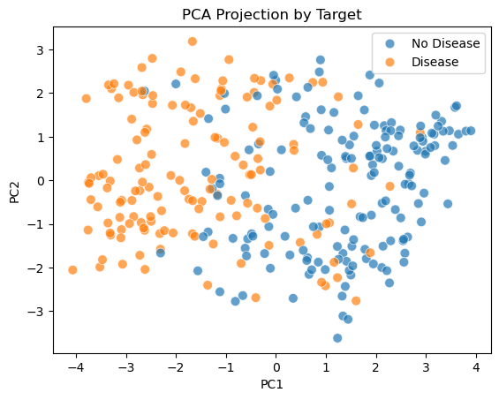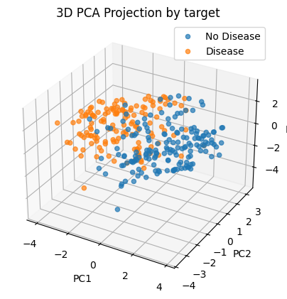

Feature Selection
Finally, some feature selection methods were applied. But, to do that, few preprocessing had to be performed:
- The encoded feature data frame, the target variable, and the PCA space were all divided using stratification: 80% for training, and 20% for testing.
- Features were rescaled using Standard Scaler but, in this case, the model was fitted just with the training feature data frame and then applied to both the training and test data frame. It was performed in this way to avoid data leakage. Standard Scaler was selected again to scale the data, because this is the data that is going to be used to apply the clustering methods, and the data must be normalized because clustering methods assume that the data follows a normal distribution, especially the Gaussian Mixture Model.
- The target variable was also encoded using Label Encoder but using the same approach: fitting the model with the training subset and then applying the model to both the training and testing subsets.

k-Best
The k-Best univariate method was performed and analyzed using the ANOVA test. 12 features were statistically relevant ($pValue < 0,001$), but after computing the $η^{2}$ , which is a measure of effect size that quantifies the proportion of variance in the target variable explained by a feature, only 7 features explained more than 14% of the variance ($η^{2}>14\%$).
The final selected features are: thalach, oldpeak, ca, cp_4, is_exang, thal_3, thal_7. This is the final feature selection that is going to be used for clustering. However, other multivariate methods are going to be performed to compare results and justify this feature selection.

ReliefF
It evaluates how well a feature distinguishes between nearby instances of different classes.
We kept the top 5 most important features: thal_3, thal_7, cp_4, is_exang, ca. These features are most powerful at distinguishing between patients locally. Median features: slope, thalach, oldpeak. These features contribute to class separation but are less dominant. Low features chol, trestbps, fbs and others. These features do not help to distinguish between nearby observations. The ReliefF confirms that the dataset has strong local structure, patients with similar profiles still differ clearly in thal, ca, cp, exang.

Wrapper (Forward feature selection)
We used sequential feature selection (SFS) with KNN, and the 7 best features were selected based on the model performance.
The results show that features such as ca,chol and thal_3 are consistently selected, indicating that a small subset of variables may be sufficient for effective classification.

Recursive Feature Elimination (RFE)
The model selected 7 features cp_4, slope_2, is_male, ca, thal_7, thalach, and trestbps that together optimize model performance. Key variables such as ca, thal_7, thalach, cp_4, were consistently, confirming then their strong predictive importance across methods. Conversely, some features identified as important by ANOVA and ReliefF, such as oldpeak and is_exang, were not retained, indicating potential redundancy when considered in combination with other variables.

Comparison of feature selection methods
The heatmap below shows the comparison of feature selection methods that shows strong agreement across ANOVA (k-Best), ReliefF, Wrapper, and RFE for key variables such as ca and cp_4, which were selected by all methods. Additional features including thal_7, thalach, and thal_3 were selected by most methods, confirming their importance. Features such as is_exang and slope_2 were identified by model-based methods, suggesting interaction effects. In contrast, variables like age, chol, and restecg were consistently excluded, indicating low relevance. Overall, the results demonstrate that a small subset of features drives most of the predictive power in the dataset.
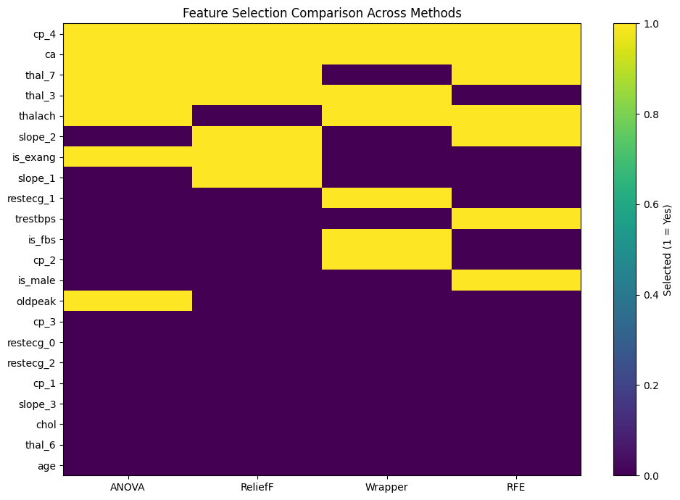

Algorithm Comparison

Assumptions
k-Means assumes that clusters are spheres, with the same variance in all directions, and all of them have the same shape.
GMM assumes that the data is generated by a mixture of gaussian distributions, allowing elliptic shapes.
Hierarchical Clustering assumes that the data has a nested structure or one based on step-by-step proximity relationships, without imposing an overall geometric shape.

Strengths
k-Means is computationally efficient, highly interpretable, and provides an excellent geometric baseline.
GMM offers probabilistic clustering, which is ideal for identifying patients with uncertain diagnoses. It better explains the variability of physiological and healthcare data.
Hierarchical Clustering does not need to set a k arbitrarily thanks to the dendrogram. It is deterministic, so it always produces the same result with the same data, and it is highly visual.

Limitations
k-Means is very sensible to outliers. In addition, it draws rigid decision boundaries, which may be unrealistic for borderline medical cases.
GMM if very susceptible to overfitting when having small datasets with complex covariance. It can also get stuck in local optima because it depends on where its initial centroids start. That is why we initialize the centroids randomly in the notebook, instead of using k-Means (by default).
In Hierarchical Clustering, merging decisions are irreversible, so if a patient is grouped incorrectly at the beginning, corrections cannot be made. Depending on the linking method, it can be sensitive to noise.

Evaluation
Hierarchical clustering ($k=2$) achieved the best ARI because we set $k=2$. Looking at its confusion matrix, we see that it captured the actual macroscopic separation of the data almost naturally: Cluster 1 predominantly groups healthy patients (109 vs. 32), and Cluster 0 predominantly groups sick patients (79 vs. 22). Since the target variable in the dataset was binarized as 0 (no disease) and 1 (disease present), the hierarchical model perfectly aligned with the dimensionality of the healthcare reality.
K-Means ($k=4$): It identified a group of “very healthy” patients (Cluster 1: 80 vs. 11) and a group of “very sick” patients (Cluster 2: 4 vs. 55). However, clusters 0 and 3 are mixed (borderline cases). Its ARI decreased because it fragmented the binary label into 4 profiles.
GGM ($k=7$): It received the lowest ARI score because it oversegmented the patients. Although it mathematically identified seven valid elliptical sub-distributions, the ARI penalizes it because the clinical reality we are evaluating has only two “categories” (healthy/sick). However, cluster 4 identified "very sick" patients (6 vs 59) and cluster 5 identified "very healthy" patients (57 vs 5). Cluster 3 also identified "very healthy" patients well, but also had false negatives (49 vs 24).

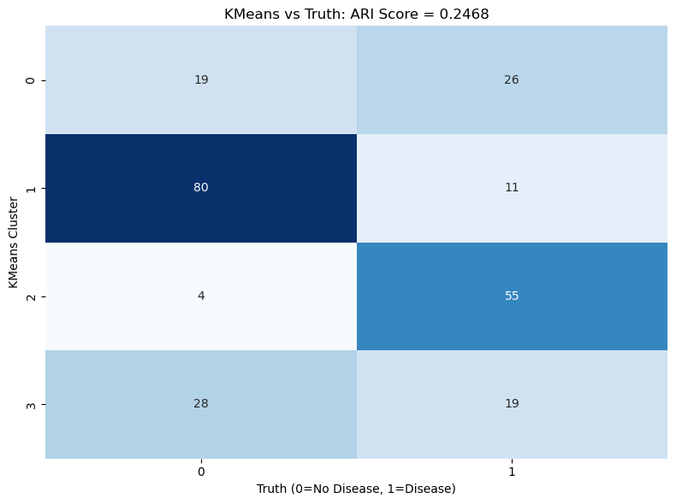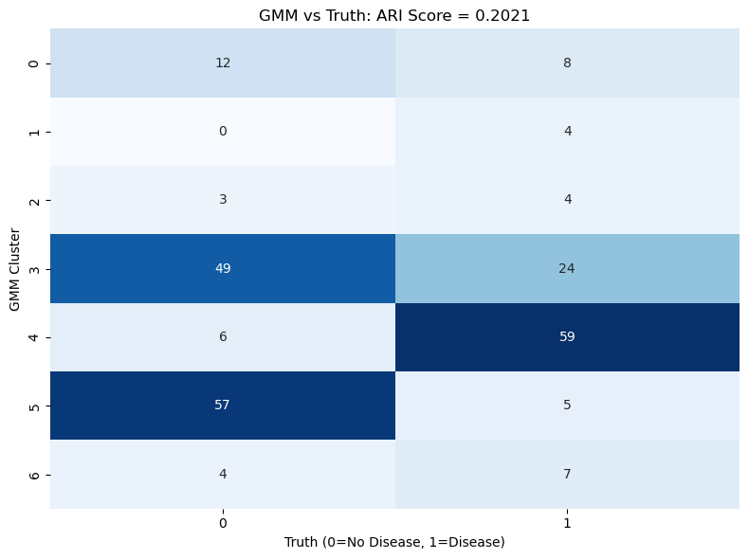
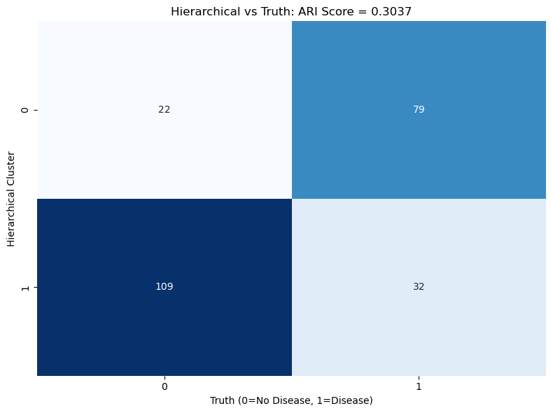

The Heart Disease UCI dataset is relatively small, with only 303 patient records and 13 clinical features.
k-Means works well here because, with so few patients, a simple parametric model avoids modeling noise.
However, the variability of healthcare variables makes the probabilistic flexibility of GMM better. The problem with GMM on this dataset is the sample size and the covariates complexity: 303 patients are too few to estimate the covariances.
Finally, hierarchical clustering proves very useful given the manageable sample size, allowing for a visual inspection of the entire patient cohort at once. However, it is unable to capture granularity: it does not detect individuals’ disease levels as well as the other two algorithms.

Limitations
A limitation of our current methodology is the use of a univariate approach (k-best with ANOVA testing) for feature selection. By evaluating each clinical variable in isolation, this method assumes independence among predictors and ignores clinical interactions. In the context of health data, all features have interactions among each other. Although we validate the selected features using multivariate methods, they are not our primary approach to feature selection.
Some artificial intelligence coding tools have been used to get help for coding syntax, but with the supervision of our analytical decisions and critical thinkings.

