**Machine Learning (COM624) Report**

|  |
| --- |
| Name: |
| João Pedro Soares Bota |

# **Introduction**

# The **Artificial Intelligence** is already moving towards a revolution comparable to the revolution caused by the Internet. It has been some time since AI left the **Sci-Fi** spectrum to gradually enter our lives, even though it is in an early stage.

# **Artificial Intelligence** is the combination of algorithms designed to create machines that have the same capabilities as humans. There are several types of artificial intelligence:

# Systems that think like humans that automate activities such as decision making, problem solving and learning (**artificial neural networks**).

# Systems that act like humans which perform tasks in a similar way to people (**robots**).

# Systems that think rationally which simulate the rational logical thinking of humans, in another words, they research how to make machines capable of understanding, reasoning and acting.

# Systems that act rationally which try to rationally imitate human behaviour.

The emergence of **AI** in our society has led international organizations to begin to consider the need to create a regulation to regulate their use, in order to avoid any problems that may arise in the future.

The five critical practices that need to be addressed in a responsible **AI** project are **governance**, **ethics and regulation**, **interpretation and explanation**, **robustness and security**, **impartiality and justice**, so companies understand the challenges and potential risks brought by this technology and ensure that the use of **AI** in their organizations is ethically correct.

## ***Proposed Solution***

This Project is about developing a **web-based app** with the help of **Artificial Intelligence** to allow to predict stock or equities prices on a daily, weekly, monthly and yearly basis. The user will be able to choose between 20 different companies

The proposed solution given by the **Module Leader**, was to develop a system that by using **decision-making Artificial Intelligence** (**artificial neural network**) will assist users in order to make decisions based in the stock interest of the user using the available data in **Yahoo Finance** in real-time.

The system will be a **web-based application**, which will display graphical performance, trends and another key areas with the help of appropriate data visualisation approach such as, graphs and charts, for the exact purpose of assist user plan and forecast investments. By using a efficient model with substantive amount of data for the prediction, it will forecast the stock price for the number of days that the user has selected.

## ***Need for the prototype***

The need to forecast financial markets has been a very popular topic lately, however, despite the existence of many studies of accurate prediction of future stock values, it is difficult to apply in real cases. Nonetheless, I believe it is more advantageous to transform this problem into a **decision making system** and predict the possible value of a company’s share with the help of an **artificial neural network**.

## ***The Problem***

To make predictions of the possible price of a company’s share in the stock market, I will use a **dataset** provided by **Yahoo Finance**. The **dataframe** has 6 columns (**Open, High, Low, Close, Adj Close and Volume**).

## ***Proposed Model***

The main goal of the proposed Model is to forecast the possible company’s stock price in a given a time frame. I will be using **Facebook Prophet** as it follows the **sklearn model API**, since the tool provided by **Facebook**, aims to contribute to problems of generation of forecasts and future scenarios for time series.

Using the Open Source tool provided by Facebook, it makes its implementation in Phyton much simpler. Also, it is an accurate and fast tool for producing reliable forecasts, with no manual effort.

The **Facebook tool** uses a cyclic process as shown in the image below.

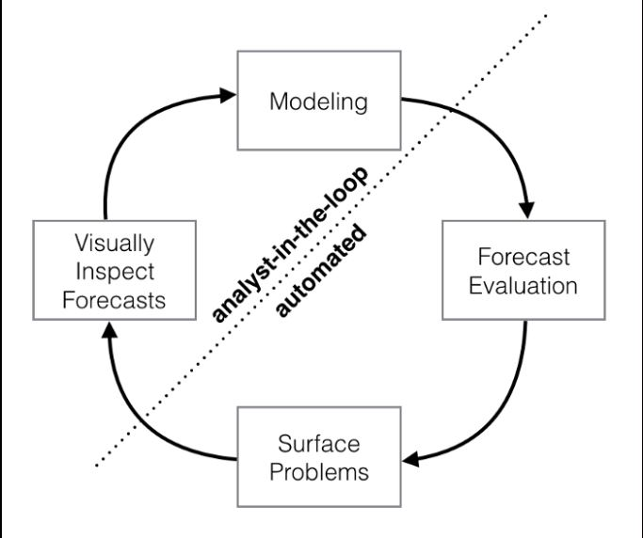

The three main components in **Prophet** are:

* The trend of linear growth curve or piece by piece logistics. (Prophet automatically detects changes in trends by selecting data change points)
* The annual seasonal component modelled using Fourier Series
* The weakly seasonal component using dummy variables

The core functionality of **Prophet** is based on the function which sums three time functions plus an error term.



**growth g(t) + seasonality s(t) + holidays h(t) + error e_t**

This function models the general trend of the data. However, the growth trend can be present at all data points or change at points of change.

## ***Prototype Design***

While developing the prototype, I have taken in consideration the user interaction with the **web-based app**, in order to allow users to achieve optimal interaction with the web-based prototype and be intuitive and simple to use, even if the user has little experience in performing actions with a web-based app.

I will be using the **Open Source Streamlit framework**, as it is an excellent tool to help demonstrate project data without resorting to **front-end tools**. This framework makes it possible to transform raw data from a science and machine learning project into an **interactive application**. Since one of the considerations of the design of the prototype is to make the way to present technical projects to users who have less experience in the area.

To make the forecasts, I will use the data that companies provide to the **Yahoo Finance API**, as it is free, provides access to up to five years of daily historical stock price data and is considered the standard for applications related to the stock market.

To create interactive graphs, I will use **plotly** as it is a **Python data visualization library** that allows the creation and publication of interactive and well-organized graphs.

## ***Prototype Development***

For the development of this prototype, I will use the code editor **Visual Studio** Code and I will use **Anaconda** as a platform for managing and deploying packages that allow using the features of artificial neural networks and also, get an easy configuration of the project work environment.

To begin with, after an intensive research on the subject, created the file **app.py**, which will contain the necessary imports and the necessary logic for the correct functioning of the web-based app.

Whitin this file, I started by setting up the timeline, in which the prototype will collect the entire data from **January 1, 2016**, to the user’s current date.

Then I created a **selection box** that will allow the user to choose between 20 different stocks from the stock market.

Next, I created a **slider** that allows the user to select the number of days he wants to predict the price of the selected stock, within a period of 1 day to 365 days. After the user selects the number of days, I created an object that will fetch information about the selected stock, such as the logo and name, and will demonstrate this information to the user.

Then, I created a function that will load the data of the stock selected and demonstrate it in a table with the name of “Updated Data”.

Afterwards, I created another function that will create a chart that will demonstrate the highest and lowest price of the selected stock.

To predict the price of the selected stock, I first had to select the data that I will use to train the prototype. Then, using the numbers of days which the user wants to forecast, prophet will carry out the forecast of the possible price of the selected stock and will demonstrate the results and components in graphs that allow the user to decide whether the selected stock is a good investment

## *How to run the code*

In order to run the code, you will first have to install **Anaconda** on your machine. Then you will have to install the **necessary dependencies** like **fbprophet, yfinance** and **streamlit** on the machine using the **Anaconda Prompt**.

For the prototype to work correctly, you will have to create a **conda virtual environment that will use Python 3.7.**

To run the prototype, you will have to run the command: **steamlit run app.py**, inside the file location.

After the prototype is compiled, you will need to access the URL: <http://localhost:8501> to access the web-based app.

These steps mentioned above are the requirements to access the prototype and execute its functions in the web browser.

## *Evaluation*

In order to evaluate the **accuracy** of the model used, one of the features of the tool provided by **Facebook**, allows the user to verify in the displayed graphs that were built using the previous data and verify if the prototype correctly predicted the price of the selected stock of the stock market. Also, prophet includes the functionality to use time series cross validation to measure historical data prediction error, as it gives a further description of simulated historical forecasts.

## *Limitation*

Some challenges and limitations were encountered while developing the project. One of them was the tunning of the prediction of Prophet, for the particular reason that I felt difficulties tunning properly the predictions and which parameters that needed to be tuned.

Also, as stated in the document done by Professor Cheng Si, a recent research study by the Chinese University of Hong Kong (CUHK) shows that the effectiveness of machine learning methods needs to be improved, but that does not mean that applying machine learning in predicting stock should not be used.

## *Conclusion*

To sum up everything that has been stated so far, this project we approach the subject **Machine Learning** by developing a prototype that predicts the stock price value.

I fulfilled the stated objectives by the **Module Leader**, also with the help of the **Module Leader’s notes**, I was able to understand how to design and develop a **simple web-based app**.

This project was very important for the deepening of my knowledge if this topic, as it allowed me to get to know it better and in addition it allowed to improve my developing skills.

## *Reference List (Harvard Style)*

Cheng,Si , (2020),The Limitations of Using Artificial Intelligence to Pick Stocks

<https://cbk.bschool.cuhk.edu.hk/the-limitations-of-using-ai-to-pick-stocks/> (visited 05-01-2021)

CSUSB ScholarWorks, (2021) Stock Market Forecasting Bases on Artificial Intelligence Technology

<https://scholarworks.lib.csusb.edu/cgi/viewcontent.cgi?article=2469&context=etd> (visited 05-01-2021)

Facebook, (2020) Quick Start Python API

<https://facebook.github.io/prophet/docs/quick_start.html> (visited 06-01-2021)

Robert Martin, (2022) Using python and scikit-learn to make stock predictions

<https://pythonrepo.com/repo/robertmartin8-MachineLearningStocks-python-deep-learning#creating-the-training-dataset> (visited 06-01-2021)

Facebook, (2020) Forecasting at scale

<https://facebook.github.io/prophet/> (visited 06-01-2021)

Facebook, (2020) Diagnostics

<https://facebook.github.io/prophet/docs/diagnostics.html> (visited 10-01-2021)

edureka!, (2020) Neural Network Python | How to make a Neural Network in python Tutorial | Edureka

<https://www.youtube.com/watch?v=9UBqkUJVP4g&ab_channel=edureka%21> (visited 08-01-2021)

Polycode, (2018) Create a simple Neural in Python from Scratch

<https://www.youtube.com/watch?v=kft1AJ9WVDk&ab_channel=Polycode> (visited 09-01-2021)

Ben Letham, (2017) Prophet: forecasting at scale

<https://research.facebook.com/blog/2017/02/prophet-forecasting-at-scale/> (visited 07-01-2021)

Builtin, (2019) What is Artificial Intelligence?

<https://builtin.com/artificial-intelligence> (visited 05-01-2021)