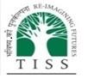
Tata Institute of Social Sciences
School of Skill Education

PROJECT REPORT ON
INTERVIEW SKILLS - THE KEY TO SUCCESS

SUBMITTED TO
Pal India

By
JOAQUIM CRISTIANO PAUL FERNANDES
IT0246/0110/S25
IT0246/C37/B01/S26

IN PARTIAL FULFILLMENT OF
BSC. In Software Development

MONTH, YEAR
RECEIVED BY |  | EXAMINED BY
NAME: |  | NAME:
SIGN: |  | SIGN:

Marks Obtained

HUB SEAL

Interview Skills – The Key to Success
A comprehensive academic project exploring the essential skills, strategies, and best practices for mastering the interview process and achieving career success.

Table of Content
03
Preparation Before an Interview
Company research, resume preparation, professional dressing, and practice strategies.
01
Introduction to Interview Skills
Meaning, importance, types of interviews, and the power of first impressions.
02
Communication Skills in Interviews
Verbal and non-verbal communication, body language, eye contact, and confidence.
04
Common Interview Questions & Best Answers
Frequently asked questions with sample answers and expert tips.
06
Group Discussion & Online Interview Skills
GD techniques, virtual etiquette, camera setup, and technical preparation.
05
Mistakes to Avoid During Interviews
Common pitfalls including poor preparation, attitude issues, and salary mistakes.

01 Introduction to Interview Skills

An interview is a structured conversation between an employer and a candidate to assess suitability for a role. Interview skills encompass the abilities and techniques that help a candidate present themselves effectively, communicate clearly, and leave a lasting positive impression.

- Why Interviews Matter
Interviews are the gateway to career opportunities. According to LinkedIn, 85% of jobs are filled through networking and interviews combined.
Interview success supports promotions, internships, campus placements and career transitions because it is often the stage where employers judge communication, professionalism and role fit more deeply than on a resume alone.

- First Impression
Research shows interviewers form an opinion within the first 7 seconds. Professional appearance and confident body language are critical.
Most people form opinions before the other person starts talking, according to first-impression research.
About 95% of people say first impressions matter, which shows why appearance, greeting and tone set the stage quickly.
Research cited in interview discussions suggests candidates may have only seconds to project trust, friendliness and competence.
Good posture, eye contact, neat dress and a calm introduction strengthen credibility before technical answers begin.

- Types of Interviews
- One-on-one Interview
A one-on-one interview is a direct conversation between a candidate and a single interviewer (often a hiring manager or team lead).
Tailored approach & preparation:
  - Research the interviewer’s role and the team’s work.
  - Prepare clear, structured answers using the STAR method (Situation, Task, Action, Result).
  - Emphasize two-way communication by asking questions about the role, expectations, and team culture.
- Panel Interviews
In a panel interview, multiple interviewers (e.g., HR, manager, and senior team member) assess the same candidate at the same time.
Tailored approach & preparation:
- Address everyone, not just the person who asked the question.
- Bring extra copies of your resume and notes to hand out.
- Practise scanning the room to maintain eye contact with all panel members.
- Prepare concise, strong examples that demonstrate leadership and collaboration.
- Group Interviews
A group interview places several candidates together, often in a group discussion or task, to observe how they interact and communicate.
Tailored approach & preparation:
- Focus on teamwork, active listening, and constructive contribution.
- Avoid dominating the conversation; balance speaking with facilitating others.
- Show leadership by summarising points, clarifying instructions, and keeping the group on track.
- Prepare examples of how you work in teams or handle group conflict.

- Case Interviews
Common in consulting and some corporate roles, case interviews present a business problem or scenario that you must analyse on the spot.
Tailored approach & preparation:
- Clarify the problem first by asking smart questions.
- Structure your response in a logical framework (e.g., profitability, market entry, operations).
- Think aloud so the interviewer can follow your reasoning.
- Practise with common case types (profitability, pricing, growth, operational efficiency).

85%
Jobs via Networking
Most positions are filled through connections and interviews
7s
First Impression
Time it takes for an interviewer to form an opinion

60%
Non-Verbal Impact
Of communication effectiveness comes from body language
3x
Prepared Candidates
More likely to receive job offers than unprepared ones

02 Communication Skills in Interviews
Strong communication skills are one of the most important things an interviewer looks for because they show how clearly, confidently, and professionally you can share ideas, listen, and collaborate.

What effective communication means in interviews
Effective communication in an interview means:
- Speaking clearly with a calm, steady tone (not too fast or too quiet).
- Answering the question directly and avoiding long, unfocused answers.
- Listening actively to the interviewer before responding.
- Using simple, professional language instead of slang or jargon.

Key communication skills to show
- Clear and concise speaking
- Use short, structured answers (for example, the STAR method: Situation, Task, Action, Result).
- Focus on the main point first, then add supporting details if needed.
- Avoid over-explaining or “rambling”, which can make you sound unconfident or unprepared.
- Active Listening
- Pay close attention to the question before answering.
- If you are unsure, politely ask for clarification:
“Do you mean…” or “Could you please repeat the last part?”
- Respond to what was actually asked, not what you assume the interviewer meant.
- Tone, pace, and body language
- Speak at a moderate pace and avoid rushing or pausing too much.
- Use a polite, confident tone and avoid filler words like “um”, “like”, “you know”.
- Maintain eye contact, sit straight, and use small, natural gestures to show engagement.

- Asking thoughtful questions
- At the end of the interview, ask 2–3 clear questions about the role, team, or expectations.
Examples:
  - “What does success look like in this role in the first 3 months?”
  - “Can you describe the team I would be working with?”
This shows you are interested, prepared, and comfortable in a professional conversation.

How to practice communication skills for interviews
- Record yourself answering common questions and then watch or listen to check:
  - Is your voice clear and confident?
  - Are your answers structured and easy to follow?
- Do mock interviews with a friend or mentor and ask for feedback on communication only.
- Read aloud daily to improve fluency, reduce filler words, and control your pace.
Why communication matters in your career
- It affects first impressions, teamwork, and client or stakeholder relationships.
- Good communicators are more likely to be seen as leaders, problem-solvers, and trusted colleagues.
In short, in an interview, good communication = clear answers + active listening + confident presence. Focus on these three and you’ll come across as professional and hireable.
Verbal Communication
- Speak clearly and at a moderate pace
- Use professional vocabulary
- Avoid filler words (um, like, you know)
- Structure answers using the STAR method
- Listen actively before responding

Non-Verbal Communication
- Maintain steady eye contact
- Sit upright with open posture
- Offer a firm handshake
- Use natural hand gestures
- Smile appropriately and genuinely

03 Preparation Before an Interview

Thorough preparation is the single most important factor in interview success. Candidates who research, practice, and plan ahead consistently outperform those who rely on improvisation.

Time Management Tip: Arrive 10–15 minutes early for in-person interviews. For virtual interviews, log in 5 minutes early to test your setup. Use the 24-hour rule: review everything the day before, not the morning of.

04 Common Interview Questions & Best Answers

Preparing for common interview questions is essential. Use the STAR method (Situation, Task, Action, Result) to structure behavioural answers. Below are frequently asked questions with sample responses and expert tips.

Interview Question | Sample Professional Answer | Key Tip
Tell me about yourself. | "I am a [degree] graduate with experience in [field]. I am passionate about [industry] and eager to contribute my skills in [specific area]." | Keep it professional, not personal. Focus on relevant experience.
What are your strengths? | "I am highly organized and a strong communicator. In my last role, I managed multiple projects simultaneously with 100% on-time delivery." | Give specific examples that prove your strength.
What is your greatest weakness? | "I tend to be a perfectionist, but I've learned to set realistic deadlines and prioritize tasks to maintain quality and efficiency." | Choose a real weakness and show how you're improving.
Why should we hire you? | "My combination of [skill 1], [skill 2], and hands-on experience in [field] directly aligns with the requirements of this role." | Connect your skills directly to the job description.
Where do you see yourself in 5 years? | "I see myself growing within this organization, taking on more responsibility, and contributing to long-term company goals." | Show ambition aligned with the company's growth.
Why do you want to work here? | "I admire your company's commitment to [value/mission]. I believe my skills in [area] can contribute meaningfully to your team." | Reference specific company values or achievements.

05 Mistakes to Avoid During Interview

Remember: Interviewers are not just evaluating your skills — they are assessing your professionalism, attitude, and cultural fit. Every detail matters.

06 Group Discussion & Online Interview Skills

Modern recruitment processes often include Group Discussions (GD) and Virtual Interviews. Both require a distinct set of skills beyond traditional face-to-face interviewing.

Group Discussion Skills
- Initiate or contribute meaningfully to the topic
- Demonstrate leadership without dominating
- Listen actively and build on others' ideas
- Stay calm and respectful during disagreements
- Use facts and data to support your points
- Maintain eye contact with the group

Online Interview Etiquette
- Test your camera, microphone, and internet beforehand
- Choose a clean, professional background
- Ensure proper lighting (face the light source)
- Dress professionally from head to toe
- Look at the camera, not the screen
- Minimize distractions and close unnecessary tabs

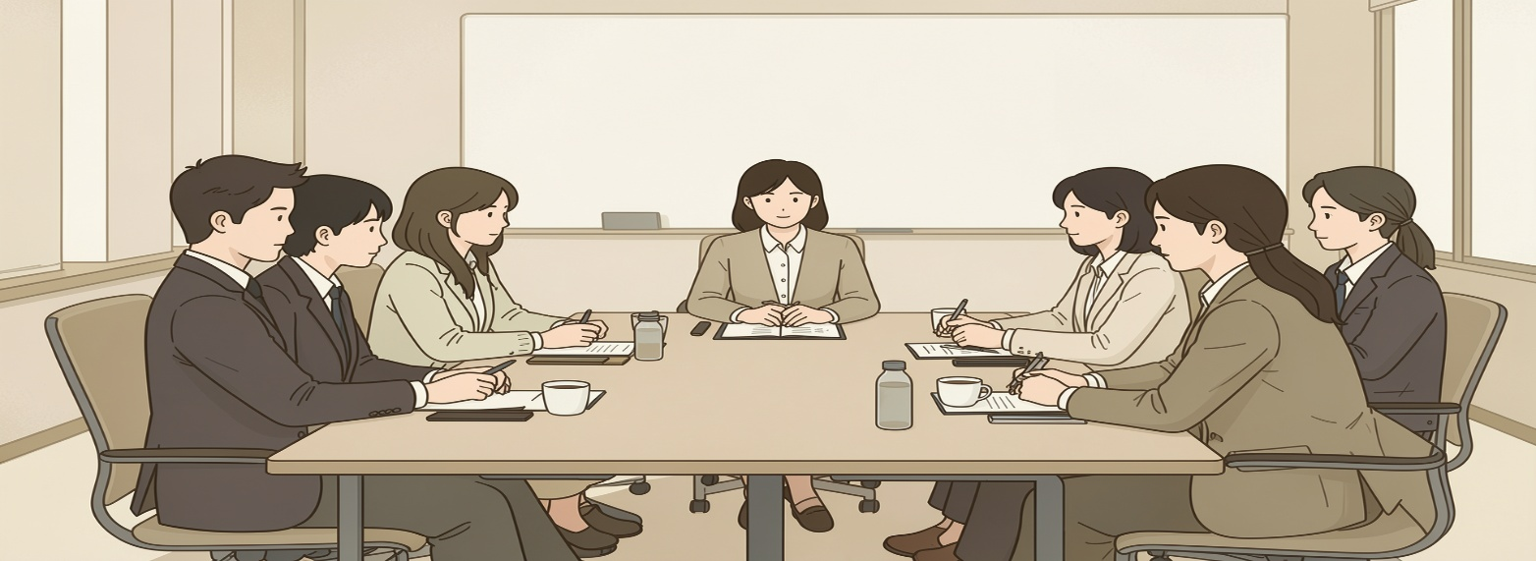
Effective GD Participation
Balance speaking and listening. Quality of contribution matters more than quantity. Show respect for diverse viewpoints.

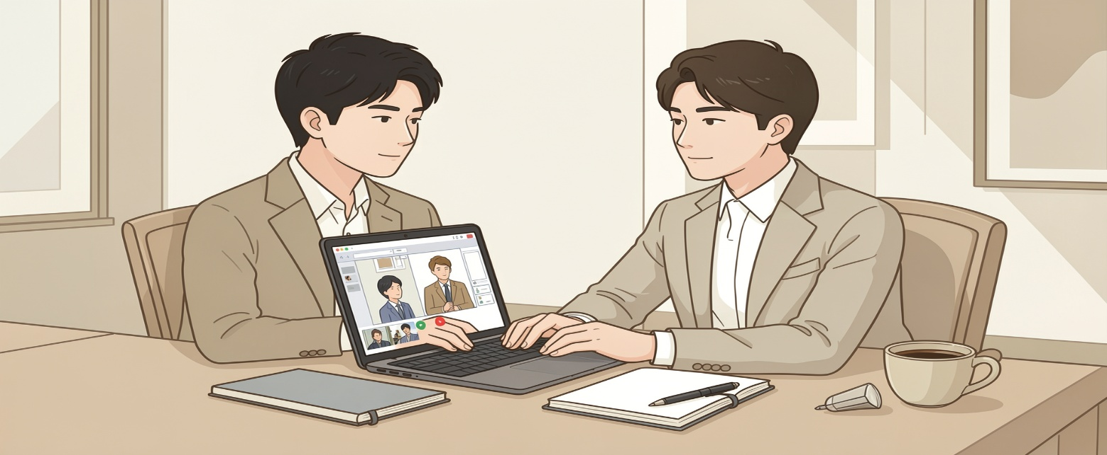
Virtual Interview Readiness
A stable internet connection, professional backdrop, and confident on-camera presence are essential for virtual interview success.

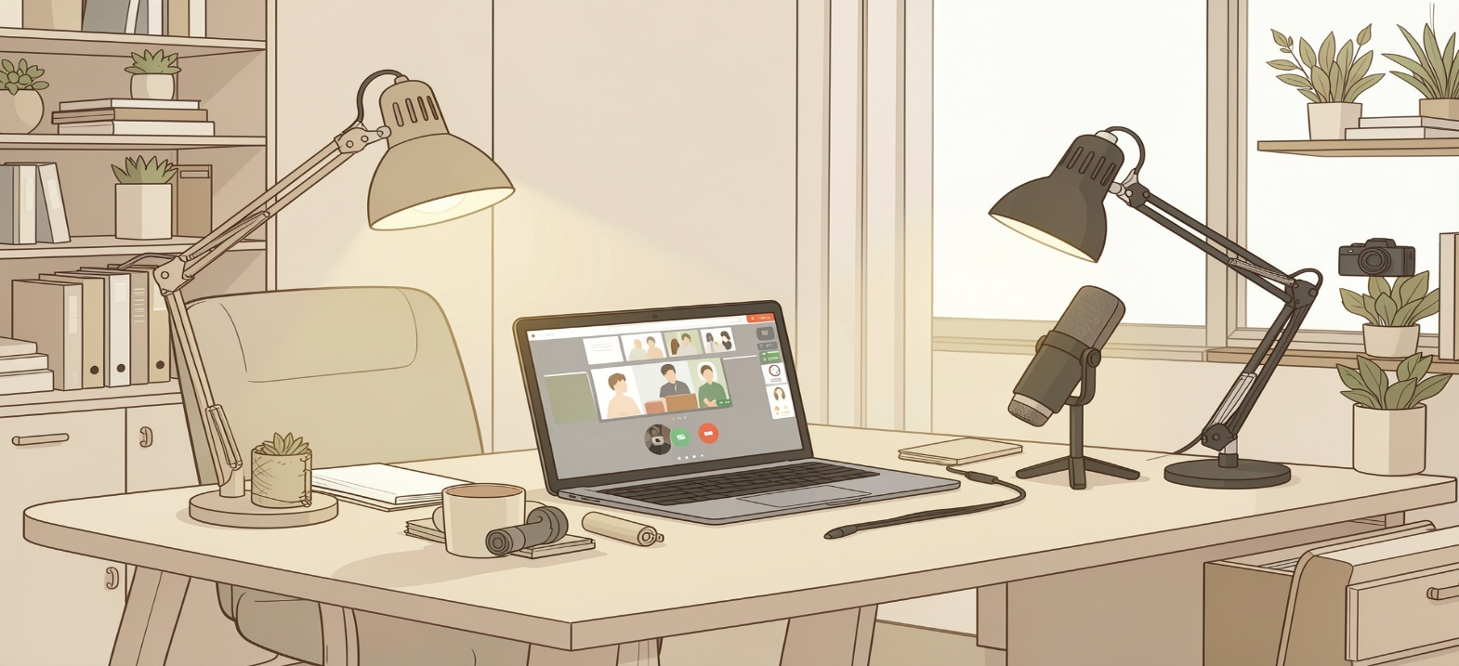
Technical Preparation
Run a test call 30 minutes before. Have a backup plan (phone hotspot) in case of technical failure during the interview.
References -
https://in.indeed.com/career-advice/interviewing/online-job-interview
https://blog.rgbsi.com/5-best-practices-to-ace-virtual-job-interview
https://www.youthcentral.vic.gov.au/jobs/job-interviews/how-prepare-online-interview
https://in.indeed.com/career-advice/interviewing/group-discussion-in-interview
https://online.jwu.edu/blog/online-interview-tips/

Image References -
https://gemini.google.com/

