**Instructions for adding new database connection to Visual Studio:**

**Step 1:**

**Locate and download the appropriate Access Database Engine provided for you in the Analysis Folder.**



**Step 2: Install**

**Step 3:**

**Locate the Server Explorer on the left-hand side (next to toolbar) of the Visual Studio Explorer.**

**After selecting Server Explore; next Select Data Connections as seen below.**

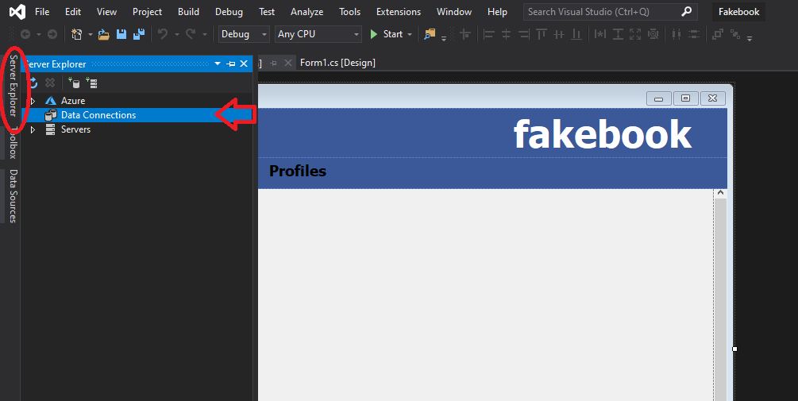

**Step 4:**

**Right-Click Data Connection and click Add New Connection.**

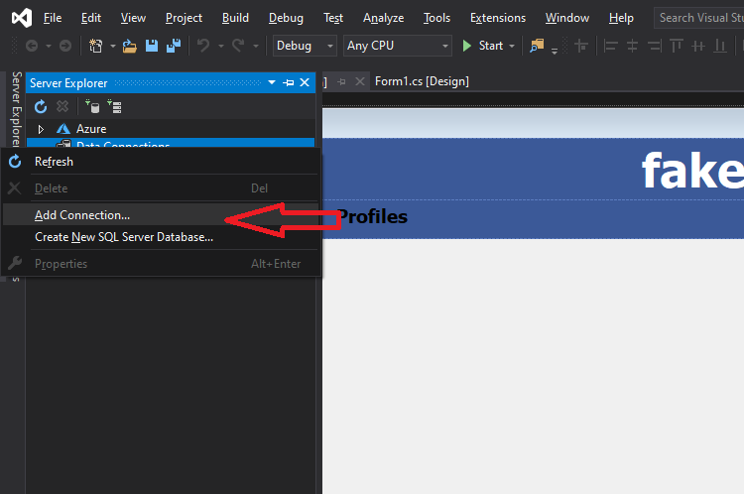

**Step 5:**

**Fill in as seen below, Click OK and now you have successfully connected to the DataBase!**

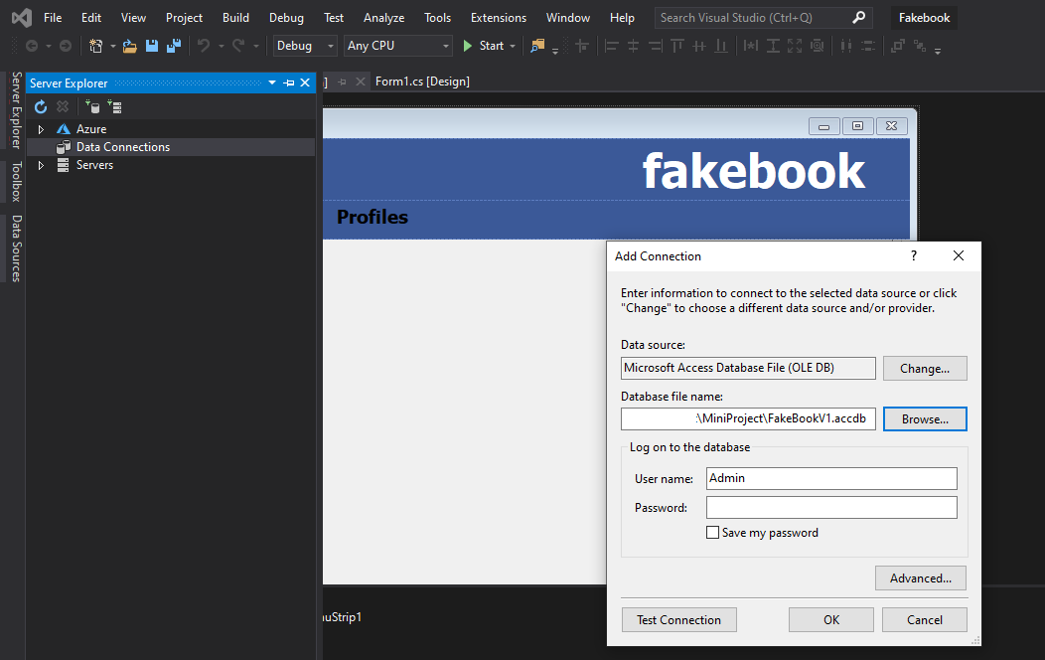

**Additional:**

**To add additional User Profiles; See below:**

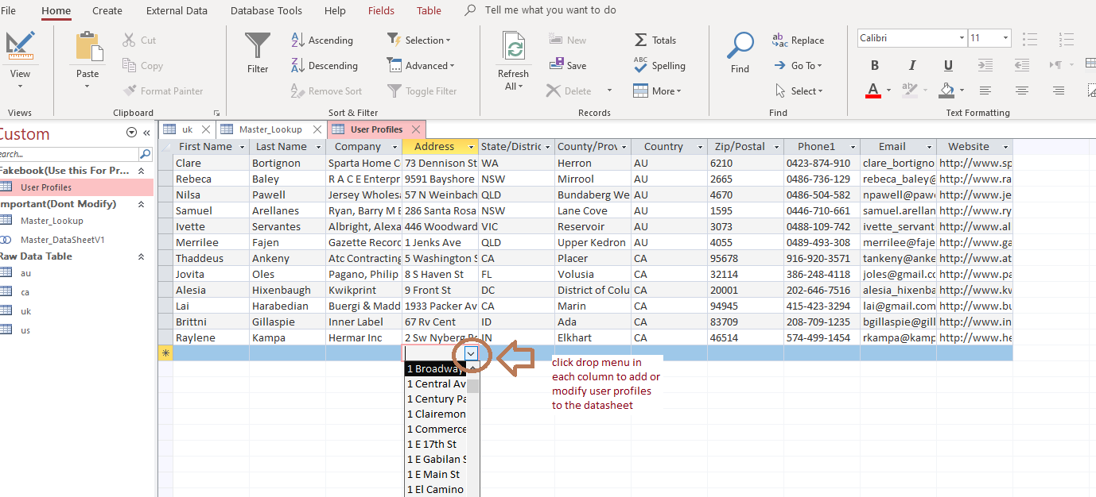

**Just select the from the drop down menu in each column to select from pre-configured selections!**