**Group Members:** Imtiaz Rayman, Abel Jacob, Jonathan Caussin, Ilhwan Jung

**OBJECTIVES:**

1. Create a user Interface which will allow for users to create a profile.
2. Abstract the information from the user.
3. Create an individual user profile.

**IMPLEMENTATION:** This design will be implemented using multiple forms which will in terms have different functional requirements to create a user profile which can be implemented into a database. The user can create relational associations with specified fields.

**USER INTERFACE:**

**Design Flow Chart**

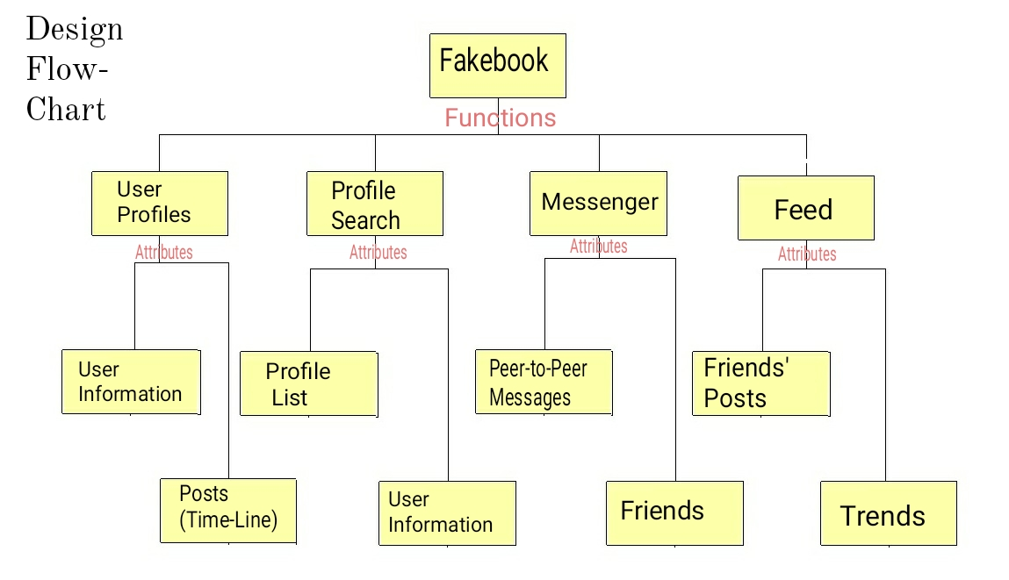

**Present Mock up**

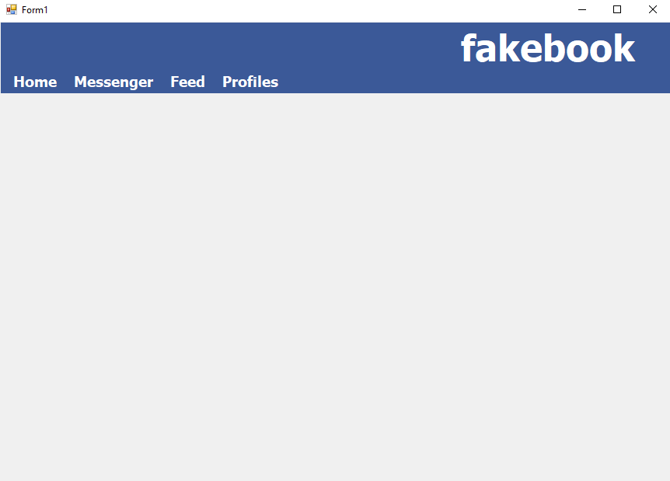

**Project Management tools.**

The program will be built collaboratively using tools such as GitHub for version control, the link to the master repository is <https://github.com/imtiazrayman/Fakebook> . The program will also be managed using to-dos, InProgress, and done objectives to implement each branch of the project. In addition to GitHub, the development teams will collaborate via Discord.