|  |  |  |
| --- | --- | --- |
| Assignment 5 | September 23  15338673 | |
| PW Janse van Rensburg | | Multivariate Statistical Analysis |

# Question 1

pca_method <- function(df, conversion = 0){

## PCA method for factor analysis

## param df: data to be used for pca method for factor analysis

## param conversion: conversion to apply, 1 then take correlation matrix,

## 2 then take covariance matrix, else use as is

## returns: estimated factor loadings, estimated cov matrix,

## communalities and proportion of total variance by each factor

if(conversion == 1){

conv_data <- cor(df)

}else if(conversion == 2){

conv_data <- cov(df)

}else{

conv_data <- df

}

conv_eigen <- eigen(conv_data)

row_nums <- sum(conv_eigen$values > 1)

loadings <- matrix(row_nums,ncol=ncol(conv_data),nrow=row_nums)

for (i in 1:row_nums){

for (j in 1:ncol(conv_data)){

loadings[i,j] <- sqrt(conv_eigen$values[i])*t(conv_eigen$vectors[j,i])

}}

loadings <- t(loadings)

est_cov_matrix <- diag(diag(conv_data-loadings%*%t(loadings)))

communalities <- rowSums(loadings^2)

prop_tot_var_exp <- conv_eigen$values[1:row_num]/ncol(conv_data)

return(list("est_fact_loadings" = loadings, "est_cov_matrix" = est_cov_matrix, "communalities" = communalities, "prop_tot_var_exp" = prop_tot_var_exp))

}

Table 8.4

library(data.table)

table_8_4 <- fread('T8-4.dat')

pca_method(table_8_4, 1)

$est_fact_loadings

[,1] [,2]

[1,] -0.7323218 0.4365209

[2,] -0.8311791 0.2804859

[3,] -0.7262022 0.3738582

[4,] -0.6047155 -0.6939569

[5,] -0.5630885 -0.7186401

$est_cov_matrix

[,1] [,2] [,3] [,4] [,5]

[1,] 0.2731542 0.0000000 0.0000000 0.0000000 0.0000000

[2,] 0.0000000 0.2304689 0.0000000 0.0000000 0.0000000

[3,] 0.0000000 0.0000000 0.3328604 0.0000000 0.0000000

[4,] 0.0000000 0.0000000 0.0000000 0.1527429 0.0000000

[5,] 0.0000000 0.0000000 0.0000000 0.0000000 0.1664878

$communalities

[1] 0.7268458 0.7695311 0.6671396 0.8472571 0.8335122

$prop_tot_var_exp

[1] 0.4874546 0.2814025

Example 9.3

cor_9_3 <- matrix(c(1, 0.02, 0.96, 0.42, 0.01, 0.02,

1, 0.13, 0.71, 0.85, 0.96, 0.13,

1, 0.5, 0.11, 0.42, 0.71, 0.5,

1, 0.79, 0.01, 0.85, 0.11, 0.79, 1),

ncol = 5, byrow = T)

pca_method(cor_9_3, 0)

$est_fact_loadings

[,1] [,2]

[1,] 0.5598618 -0.8160981

[2,] 0.7772594 0.5242021

[3,] 0.6453364 -0.7479464

[4,] 0.9391057 0.1049187

[5,] 0.7982069 0.5432281

$est_cov_matrix

[,1] [,2] [,3] [,4] [,5]

[1,] 0.02053865 0.00000 0.00000000 0.0000000 0.00000000

[2,] 0.00000000 0.12108 0.00000000 0.0000000 0.00000000

[3,] 0.00000000 0.00000 0.02411712 0.0000000 0.00000000

[4,] 0.00000000 0.00000 0.00000000 0.1070725 0.00000000

[5,] 0.00000000 0.00000 0.00000000 0.0000000 0.06776888

$communalities

[1] 0.9794614 0.8789200 0.9758829 0.8929275 0.9322311

$prop_tot_var_exp

[1] 0.5706181 0.3612665

# Question 2

factanal(T8_4, 2, rotation = 'none')$loadings

Loadings:

Factor1 Factor2

V1 0.121 0.754

V2 0.328 0.786

V3 0.188 0.650

V4 0.997

V5 0.685

Factor1 Factor2

SS loadings 1.622 1.610

Proportion Var 0.324 0.322

Cumulative Var 0.324 0.646

factanal(T8_4, 2, rotation = 'none')$uniqueness

V1 V2 V3 V4 V5

0.4165374 0.2746902 0.5420233 0.0050000 0.5298429

factanal(T8_4, 2, rotation = 'none', scores = 'regression')$scores

Factor1 Factor2

[1,] -1.80116560 0.38432667

[2,] 0.29777596 0.33420663

[3,] -0.15458204 -0.37937911

.

.

.

[100,] -0.19710860 0.07137066

[101,] -0.74260843 0.92011234

[102,] -0.24543966 0.16500183

[103,] -0.34492874 -0.82321258

libname pw "H:\Werk\Multivariate Statistical Analysis\msa\assignment_5\";

**data** pw.t8_4;

infile "H:\Werk\Multivariate Statistical Analysis\msa\assignment_5\T8-4.csv" dlm=',';

input JPM Citibank WellsFargo RDS Exxon;

**run**;

**proc** **factor** data=pw.t8_4 hey method=ml corr nfact=**2** score out=pw.fml;

**run**;

|  |  |  |
| --- | --- | --- |
| Factor Pattern | | |
|  | **Factor1** | **Factor2** |
| JPM | 0.11460 | 0.75529 |
| Citibank | 0.32229 | 0.78823 |
| WellsFargo | 0.18250 | 0.65168 |
| RDS | 1.00000 | -0.00000 |
| Exxon | 0.68338 | 0.03222 |

|  |  |  |
| --- | --- | --- |
| Variance Explained by Each Factor | | |
| Factor | **Weighted** | **Unweighted** |
| Factor1 | 1.34884989 | 1.61731679 |
| Factor2 | 4.41632213 | 1.61750207 |

|  |  |
| --- | --- |
| Squared Multiple Correlations of the Variables with Each Factor | |
| Factor1 | **Factor2** |
| 1.0000000 | 0.8153729 |

|  |  |  |
| --- | --- | --- |
| Standardized Scoring Coefficients | | |
|  | **Factor1** | **Factor2** |
| JPM | -0.00000 | 0.33488 |
| Citibank | 0.00000 | 0.52955 |
| WellsFargo | -0.00000 | 0.22199 |
| RDS | 1.00000 | -0.25720 |
| Exxon | 0.00000 | 0.01118 |

# Question 3

**data** pw.ex9_9(type=corr);

_type_='CORR';

input _name_$ taste money flavor snack energy;

cards;

taste 1.00 . . . .

money 0.02 1.00 . . .

flavor 0.96 0.13 1.00 . .

snack 0.42 0.71 0.5 1.00 .

energy 0.01 0.85 0.11 0.79 1.00

;

**proc** **factor** res data=pw.ex9_9

method=prin nfact=**2**rotate=varimax preplot plot;

var taste money flavor snack energy;

**run**;

|  |  |  |  |  |
| --- | --- | --- | --- | --- |
| Eigenvalues of the Correlation Matrix: Total = 5 Average = 1 | | | | |
|  | **Eigenvalue** | **Difference** | **Proportion** | **Cumulative** |
| 1 | 2.85309042 | 1.04675797 | 0.5706 | 0.5706 |
| 2 | 1.80633245 | 1.60184223 | 0.3613 | 0.9319 |
| 3 | 0.20449022 | 0.10208076 | 0.0409 | 0.9728 |
| 4 | 0.10240947 | 0.06873203 | 0.0205 | 0.9933 |
| 5 | 0.03367744 |  | 0.0067 | 1.0000 |

|  |  |  |
| --- | --- | --- |
| Factor Pattern | | |
|  | **Factor1** | **Factor2** |
| taste | 0.55986 | 0.81610 |
| money | 0.77726 | -0.52420 |
| flavor | 0.64534 | 0.74795 |
| snack | 0.93911 | -0.10492 |
| energy | 0.79821 | -0.54323 |

|  |  |
| --- | --- |
| Variance Explained by Each Factor | |
| Factor1 | **Factor2** |
| 2.8530904 | 1.8063325 |

|  |  |  |  |  |
| --- | --- | --- | --- | --- |
| Final Communality Estimates: Total = 4.659423 | | | | |
| taste | **money** | **flavor** | **snack** | **energy** |
| 0.97946135 | 0.87892002 | 0.97588288 | 0.89292750 | 0.93223112 |

|  |  |  |
| --- | --- | --- |
| Orthogonal Transformation Matrix | | |
|  | **1** | **2** |
| 1 | 0.83571 | 0.54917 |
| 2 | -0.54917 | 0.83571 |

|  |  |  |
| --- | --- | --- |
| Rotated Factor Pattern | | |
|  | **Factor1** | **Factor2** |
| taste | 0.01970 | 0.98948 |
| money | 0.93744 | -0.01123 |
| flavor | 0.12856 | 0.97947 |
| snack | 0.84244 | 0.42805 |
| energy | 0.96539 | -0.01563 |

|  |  |
| --- | --- |
| Variance Explained by Each Factor | |
| Factor1 | **Factor2** |
| 2.5373960 | 2.1220269 |

|  |  |  |  |  |
| --- | --- | --- | --- | --- |
| Final Communality Estimates: Total = 4.659423 | | | | |
| taste | **money** | **flavor** | **snack** | **energy** |
| 0.97946135 | 0.87892002 | 0.97588288 | 0.89292750 | 0.93223112 |

**proc** **factor** res data=pw.t8_4

method=prin nfact=**2**rotate=varimax preplot plot;

var JPM Citibank WellsFargo RDS Exxon;

**run**;

|  |  |  |  |  |
| --- | --- | --- | --- | --- |
| Eigenvalues of the Correlation Matrix: Total = 5 Average = 1 | | | | |
|  | **Eigenvalue** | **Difference** | **Proportion** | **Cumulative** |
| 1 | 2.43727312 | 1.03026046 | 0.4875 | 0.4875 |
| 2 | 1.40701266 | 0.90649991 | 0.2814 | 0.7689 |
| 3 | 0.50051275 | 0.10048116 | 0.1001 | 0.8690 |
| 4 | 0.40003159 | 0.14486170 | 0.0800 | 0.9490 |
| 5 | 0.25516988 |  | 0.0510 | 1.0000 |

|  |  |  |
| --- | --- | --- |
| Factor Pattern | | |
|  | **Factor1** | **Factor2** |
| JPM | 0.73232 | -0.43652 |
| Citibank | 0.83118 | -0.28049 |
| WellsFargo | 0.72620 | -0.37386 |
| RDS | 0.60472 | 0.69396 |
| Exxon | 0.56309 | 0.71864 |

|  |  |
| --- | --- |
| Variance Explained by Each Factor | |
| Factor1 | **Factor2** |
| 2.4372731 | 1.4070127 |

|  |  |  |  |  |
| --- | --- | --- | --- | --- |
| Final Communality Estimates: Total = 3.844286 | | | | |
| JPM | **Citibank** | **WellsFargo** | **RDS** | **Exxon** |
| 0.72684576 | 0.76953106 | 0.66713964 | 0.84725708 | 0.83351223 |

Comparing factor loadings:

From the output of question 1, we see that JPM, Citibank and WellsFargo mainly influence the first factor, whereas the second factor is mostly determined by RDS and Exxon.

In question 2 we implement the maximum likelihood method for estimating factors. The first factor is mostly determined by RDS and Exxon, while the second factor is determined by JPM, Citibank and WellsFargo.

Lastly in question 3 we use the varimax method. Again JPM, Citibank and WellsFargo are associated with the first factor and RDS and Exxon are associated with second factor.

This leads us to conclude that JPM, Citibank and WellsFargo make up the majority of Factor 1, while RDS and Exxon are associated with Factor 2.

# Question 4

factanal(table_8_4,2,scores="regression",rotation = "varimax")$loadings

Loadings:

Factor1 Factor2

V1 0.763

V2 0.819 0.232

V3 0.668 0.108

V4 0.113 0.991

V5 0.108 0.677

Factor1 Factor2

SS loadings 1.725 1.507

Proportion Var 0.345 0.301

Cumulative Var 0.345 0.646

factanal(table_8_4,2,scores="regression",rotation = "varimax")$scores

Factor1 Factor2

[1,] 0.16535864 -1.83427398

[2,] 0.36753184 0.25550919

[3,] -0.39519052 -0.10792854

[4,] 0.62520403 -1.28789064

[5,] -0.06003873 0.94945235

.

.

.

[99,] -0.71641574 -0.13816356

[100,] 0.04719622 -0.20425006

[101,] 0.82432694 -0.84767865

[102,] 0.13434943 -0.26347004

[103,] -0.85866218 -0.24362687

factors <- factanal(table_8_4,2,scores="regression",rotation = "varimax")$scores

factor1 <- factors[,1]

factor2 <- factors[,2]

plot(factor1,factor2,main="Factor Scores",xlab="Factor 1",ylab="Factor 2",col="blue")

abline(v=0)

abline(h=0)

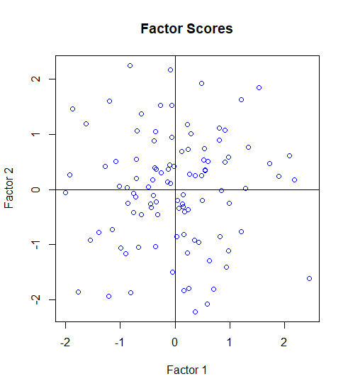

**proc** **factor** data=Question2 hey method=ml rotate=varimax nfact=**2** score out=Factor_analysis;

title "Question 4";

**run**;

**proc** **gplot** data=Factor_analysis;

plot factor2*factor1;

title "Question 4 - Factor Scores";

**run**;

|  |  |  |
| --- | --- | --- |
| Orthogonal Transformation Matrix | | |
|  | **1** | **2** |
| 1 | 0.11843 | 0.99296 |
| 2 | 0.99296 | -0.11843 |

|  |  |  |
| --- | --- | --- |
| Rotated Factor Pattern | | |
|  | **Factor1** | **Factor2** |
| JPM | 0.76355 | 0.02435 |
| Citibank | 0.82085 | 0.22668 |
| WellsFargo | 0.66871 | 0.10404 |
| RDS | 0.11843 | 0.99296 |
| Exxon | 0.11293 | 0.67475 |

|  |  |  |
| --- | --- | --- |
| Variance Explained by Each Factor | | |
| Factor | **Weighted** | **Unweighted** |
| Factor1 | 4.70094222 | 1.73075454 |
| Factor2 | 1.06422980 | 1.50406432 |

|  |  |
| --- | --- |
| Squared Multiple Correlations of the Variables with Each Factor | |
| Factor1 | **Factor2** |
| 0.81796229 | 0.99741058 |

|  |  |  |
| --- | --- | --- |
| Standardized Scoring Coefficients | | |
|  | **Factor1** | **Factor2** |
| JPM | 0.33253 | -0.03966 |
| Citibank | 0.52583 | -0.06271 |
| WellsFargo | 0.22043 | -0.02629 |
| RDS | -0.13697 | 1.02342 |
| Exxon | 0.01110 | -0.00132 |

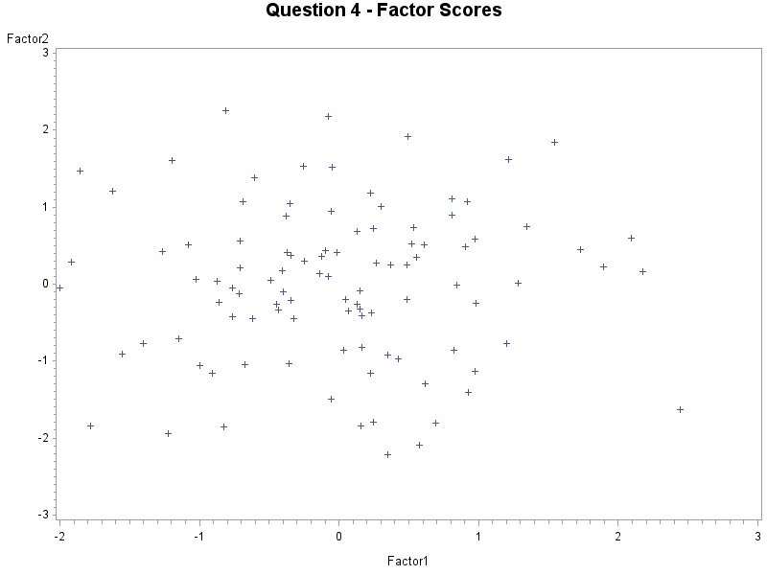

# Question 5

Exercise 9.3

q_5a <- function (rho, eigen_vecs, eigen_vals) {

## A function to answer question 5

## param rho: correlation matrix of data

## param eiven_vecs: eigen vector to be used

## param eigen_vals: eigen values associated with eigen vecs

## returns: estimated factor loadings, estimated cov matrix,

## and proportion of total variance by each factor

row_nums <- sum(eigen_vals>1)

loadings <- matrix(row_nums,ncol=ncol(eigen_vecs),nrow=row_nums)

for (i in 1:row_nums){

for (j in 1:ncol(eigen_vecs)){

loadings[i,j]<-sqrt(eigen_vals[i])*t(eigen_vecs[j,i])

}}

loadings <- t(loadings)

est_cov_matrix <- diag(diag(rho-loadings%*%t(loadings)))

prop_tot_var_exp <- eigen_vals[1:row_nums]/ncol(eigen_vecs)

list("est_fact_loadings"=loadings,"est_cov_matrix"=est_cov_matrix,"prop_tot_var_exp"=prop_tot_var_exp)

}

rho <- matrix(c(1,0.63,0.45,0.63,1,0.35,0.45,0.35,1),ncol=3,byrow=TRUE)

eigen_vals <- c(1.96,0.68,0.36)

eigen_vecs <- matrix(c(0.625,-0.219,0.749,0.593,-0.491,-0.638,0.507,0.843,-0.177),ncol=3,byrow=TRUE)

q_5a(rho, eigen_vecs, eigen_vals)

$est_fact_loadings

[,1]

[1,] 0.8750

[2,] 0.8302

[3,] 0.7098

$est_cov_matrix

[,1] [,2] [,3]

[1,] 0.234375 0.000000 0.000000

[2,] 0.000000 0.310768 0.000000

[3,] 0.000000 0.000000 0.496184

$prop_tot_var_exp

[1] 0.6533333

chick_bone <-matrix(c(1.000, 0.505, 0.569, 0.602, 0.621, 0.603,

0.505, 1.000, 0.422, 0.467, 0.482, 0.450,

0.569, 0.422, 1.000, 0.926, 0.877, 0.878,

0.602, 0.467, 0.926, 1.000, 0.874, 0.894,

0.621, 0.482, 0.877, 0.874, 1.000, 0.937,

0.603, 0.450, 0.878, 0.894, 0.937, 1.000)

,ncol=6, nrow=6, byrow=TRUE)

loadings <-matrix(c(0.602,0.200,0.467,0.154,0.926,0.143,1,000,0.874,0.476,0.894,0.327),ncol=2,byrow=2)

psi <- as.matrix(chick_bone-(loadings%*%t(loadings)))

[,1] [,2] [,3] [,4] [,5] [,6]

[1,] 0.597596 0.193066 -0.017052 0 -0.000348 -0.000588

[2,] 0.193066 0.758195 -0.032464 0 0.000538 -0.017856

[3,] -0.017052 -0.032464 0.122075 0 -0.000392 0.003395

[4,] 0.000000 0.000000 0.000000 0 0.000000 0.000000

[5,] -0.000348 0.000538 -0.000392 0 0.009548 -0.000008

[6,] -0.000588 -0.017856 0.003395 0 -0.000008 0.093835

spec_var <- diag(psi)

[1] 0.597596 0.758195 0.122075 0.000000 0.009548 0.093835

communalities <- rowSums(loadings^2)

[1] 0.402404 0.241805 0.877925 1.000000 0.990452 0.906165

eigen(chick_bone)$values[1:2]/6

[1] 0.7427414 0.1304017

The first factor explains 74.27% of the variation whereas the second explains 13.04% of the variation.

chick_bone-diag(diag(as.matrix(chick_bone)-loadings%*%t(loadings)))-loadings%*%t(loadings)

[,1] [,2] [,3] [,4] [,5] [,6]

[1,] 0.000000 0.193066 -0.017052 0 -0.000348 -0.000588

[2,] 0.193066 0.000000 -0.032464 0 0.000538 -0.017856

[3,] -0.017052 -0.032464 0.000000 0 -0.000392 0.003395

[4,] 0.000000 0.000000 0.000000 0 0.000000 0.000000

[5,] -0.000348 0.000538 -0.000392 0 0.000000 -0.000008

[6,] -0.000588 -0.017856 0.003395 0 -0.000008 0.000000

table_4_3 <- fread('T4-3.dat')

factanal(table_4_3 %>% select(-'V5'),1)

Uniquenesses:

V1 V2 V3 V4

0.029 0.167 0.175 0.158

Loadings:

Factor1

V1 0.985

V2 0.912

V3 0.908

V4 0.918

Factor1

SS loadings 3.470

Proportion Var 0.868

Test of the hypothesis that 1 factor is sufficient.

The chi square statistic is 13.08 on 2 degrees of freedom.

The p-value is 0.00144

factanal(table_4_3 %>% select(-'V5'),1,scores="regression")$scores

Factor1

[1,] -0.03287541

[2,] 1.52404873

[3,] 0.71928022

[4,] -0.80161710

[5,] 0.29943582

.

.

.

[25,] -0.31829952

[26,] -0.68263287

[27,] 0.70917778

[28,] -0.63464582

[29,] 1.45584396

[30,] -1.26817568

detect_outliers <- function (data) {

## Detects outliers from data passed through

## param df: dataframe to inspect for outliers

data <- as.matrix(data)

xbar <- matrix(apply(data,2,mean),nrow=1)

cov_mat <- var(data)

inv <- solve(cov_mat)

row_num <- nrow(data)

num_cols <- ncol(data)

distance <- matrix(rep(0,row_num),ncol=1)

for (i in 1:row_num){

distance[i,] <- (data[i,]-xbar)%*%inv%*%t(data[i,]-xbar)

}

j <- seq(1:row_num)

prob <- (row_num-j+0.5)/row_num

chi_value <- sort(qchisq(prob,num_cols))

sorted <- sort(distance)

plot(sorted,chi_value,ylab="Chi-square",xlab="Distance",main="Chi-Square plot",col="blue")

}

detect_outliers(table_4_3 %>% select(-'V5'))

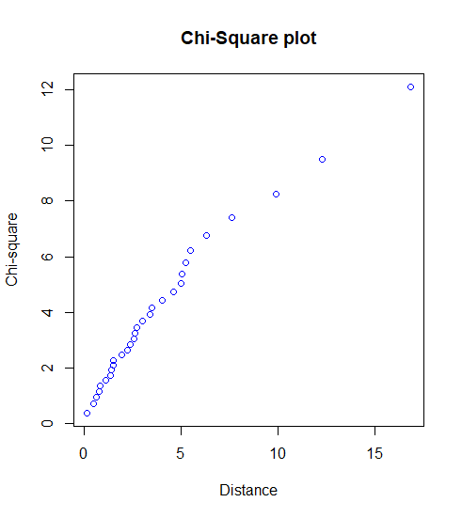

Points that are far from the origin are identified as outliers. From the above there are three points that can be deemed to be far from the origin.

# Question 6

**data** pw.t8_5;

infile "H:\Werk\Multivariate Statistical Analysis\msa\assignment_5\T8-5.csv" dlm=',';

input Total_Pop Prof_Degree Employed Gov_Empl Med_HV;

**run**;

**proc** **factor** data=pw.t8_5 method=prin rotate=varimax nfact=**2** score out=prin_result;

**run**;

**proc** **print** data=prin_result (obs=**15**);

var factor1 factor2;

**run**;

**proc** **gplot** data=prin_result;

plot factor2*factor1;

**run**;

*Rotated maximum likelihood method:*;

**proc** **factor** data=pw.t8_5 hey method=ml rotate=varimax nfact=**2** score out=ml_result;

**run**;

**proc** **print** data=ml_result (obs=**15**);

var factor1 factor2;

**run**;

**proc** **gplot** data=ml_result;

plot factor2*factor1;

**run**;

M=2, as the first eigenvalues are greater than 1.

|  |  |  |  |  |
| --- | --- | --- | --- | --- |
| Eigenvalues of the Correlation Matrix: Total = 5 Average = 1 | | | | |
|  | **Eigenvalue** | **Difference** | **Proportion** | **Cumulative** |
| 1 | 1.99191829 | 0.62439166 | 0.3984 | 0.3984 |
| 2 | 1.36752663 | 0.50336931 | 0.2735 | 0.6719 |
| 3 | 0.86415732 | 0.32909630 | 0.1728 | 0.8447 |
| 4 | 0.53506102 | 0.29372428 | 0.1070 | 0.9517 |
| 5 | 0.24133674 |  | 0.0483 | 1.0000 |

|  |  |  |
| --- | --- | --- |
| Factor Pattern | | |
|  | **Factor1** | **Factor2** |
| Total_Pop | -0.37060 | 0.54143 |
| Prof_Degree | 0.83743 | 0.38081 |
| Employed | -0.45967 | 0.70766 |
| Gov_Empl | 0.67632 | -0.29526 |
| Med_HV | 0.69611 | 0.58429 |

|  |  |
| --- | --- |
| Variance Explained by Each Factor | |
| Factor1 | **Factor2** |
| 1.9919183 | 1.3675266 |

|  |  |  |  |  |
| --- | --- | --- | --- | --- |
| Final Communality Estimates: Total = 3.359445 | | | | |
| Total_Pop | **Prof_Degree** | **Employed** | **Gov_Empl** | **Med_HV** |
| 0.43048955 | 0.84631108 | 0.71208458 | 0.54459173 | 0.82596798 |

|  |  |  |
| --- | --- | --- |
| Orthogonal Transformation Matrix | | |
|  | **1** | **2** |
| 1 | 0.81508 | -0.57935 |
| 2 | 0.57935 | 0.81508 |

|  |  |  |
| --- | --- | --- |
| Rotated Factor Pattern | | |
|  | **Factor1** | **Factor2** |
| Total_Pop | 0.01161 | 0.65601 |
| Prof_Degree | 0.90320 | -0.17477 |
| Employed | 0.03531 | 0.84311 |
| Gov_Empl | 0.38020 | -0.63249 |
| Med_HV | 0.90589 | 0.07296 |

|  |  |
| --- | --- |
| Variance Explained by Each Factor | |
| Factor1 | **Factor2** |
| 1.7823467 | 1.5770982 |

|  |  |  |  |  |
| --- | --- | --- | --- | --- |
| Final Communality Estimates: Total = 3.359445 | | | | |
| Total_Pop | **Prof_Degree** | **Employed** | **Gov_Empl** | **Med_HV** |
| 0.43048955 | 0.84631108 | 0.71208458 | 0.54459173 | 0.82596798 |

|  |
| --- |
| PCA Method |

|  |  |  |
| --- | --- | --- |
| Obs | Factor1 | Factor2 |
| 1 | 0.07908 | -0.78213 |
| 2 | 0.07471 | -1.10185 |
| 3 | 1.39742 | -0.90963 |
| 4 | 0.75335 | 0.27924 |
| 5 | 1.58106 | 0.47633 |
| 6 | 0.20809 | -2.04751 |
| 7 | 0.07946 | -1.09600 |
| 8 | -0.46569 | -1.23343 |
| 9 | 0.56081 | 1.47280 |
| 10 | -0.30307 | 0.80474 |
| 11 | -0.16410 | -0.50918 |
| 12 | -0.04081 | 1.13192 |
| 13 | -0.05575 | 1.27685 |
| 14 | -1.15679 | -0.05688 |
| 15 | 0.72025 | -0.27986 |

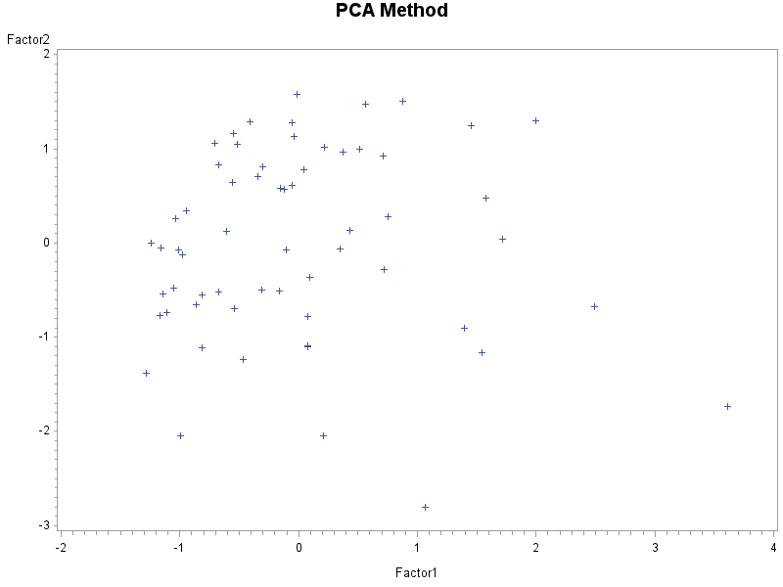

|  |  |  |
| --- | --- | --- |
| Factor Pattern | | |
|  | **Factor1** | **Factor2** |
| Total_Pop | 0.31232 | -0.17383 |
| Prof_Degree | -0.06005 | 0.99820 |
| Employed | 0.99999 | -0.00520 |
| Gov_Empl | -0.40931 | 0.34922 |
| Med_HV | -0.00678 | 0.68612 |

|  |  |  |
| --- | --- | --- |
| Variance Explained by Each Factor | | |
| Factor | **Weighted** | **Unweighted** |
| Factor1 | 0.34771032 | 1.26870166 |
| Factor2 | 1.09586671 | 1.61935446 |

|  |  |  |
| --- | --- | --- |
| Final Communality Estimates and Variable Weights | | |
| Total Communality: Weighted = 1.443577 Unweighted = 2.888056 | | |
| Variable | **Communality** | **Weight** |
| Total_Pop | 0.12776190 | 1.14647594 |
| Prof_Degree | 1.00000000 | Infty |
| Employed | 1.00000000 | Infty |
| Gov_Empl | 0.28948905 | 1.40743784 |
| Med_HV | 0.47080518 | 1.88966325 |

|  |  |  |
| --- | --- | --- |
| Rotated Factor Pattern | | |
|  | **Factor1** | **Factor2** |
| Total_Pop | -0.13593 | 0.33058 |
| Prof_Degree | 0.98423 | -0.17692 |
| Employed | 0.11233 | 0.99367 |
| Gov_Empl | 0.29871 | -0.44750 |
| Med_HV | 0.68057 | -0.08735 |

|  |  |  |
| --- | --- | --- |
| Variance Explained by Each Factor | | |
| Factor | **Weighted** | **Unweighted** |
| Factor1 | 1.02201493 | 1.55220178 |
| Factor2 | 0.42156210 | 1.33585435 |

|  |  |  |
| --- | --- | --- |
| Final Communality Estimates and Variable Weights | | |
| Total Communality: Weighted = 1.443577 Unweighted = 2.888056 | | |
| Variable | **Communality** | **Weight** |
| Total_Pop | 0.12776190 | 1.14647594 |
| Prof_Degree | 1.00000000 | Infty |
| Employed | 1.00000000 | Infty |
| Gov_Empl | 0.28948905 | 1.40743784 |
| Med_HV | 0.47080518 | 1.88966325 |

|  |
| --- |
| ML Method |

|  |  |  |
| --- | --- | --- |
| Obs | Factor1 | Factor2 |
| 1 | 0.50253 | -0.38063 |
| 2 | 0.16763 | 0.19157 |
| 3 | 1.86556 | -1.08524 |
| 4 | 1.11040 | -0.14305 |
| 5 | 1.77669 | 0.27414 |
| 6 | -0.14234 | -2.38705 |
| 7 | 0.16955 | -0.61555 |
| 8 | -0.60053 | -0.50151 |
| 9 | 0.38412 | 1.52317 |
| 10 | -0.36650 | 0.20068 |
| 11 | 0.05462 | -0.96418 |
| 12 | 0.36204 | 1.47305 |
| 13 | 0.37149 | 1.68922 |
| 14 | -0.98388 | -0.08980 |
| 15 | 0.75412 | -0.23500 |

