|  |  |  |
| --- | --- | --- |
| Assignment 3 | August 20  15338673 | |
| Paul-Willem Janse van Rensburg | | Survival Analysis |

Question 1

**Table 1**  
*Estimation of incubation times of individuals known to have a sexually transmitted disease (STD) after a known encounter time with someone having an STD*

|  |  |  |  |  |  |
| --- | --- | --- | --- | --- | --- |
| Ti | Xi | Ri | di | Yi | Pr(X < xi | X ≤ 42) |
| 25 | 4 | 38 |  |  |  |
| 36 | 4 | 38 | 2 | 2 | 0.00000 |
| 8 | 6 | 36 |  |  |  |
| 10 | 6 | 36 |  |  |  |
| 35 | 6 | 36 | 3 | 5 | 0.04467 |
| 4 | 7 | 35 | 1 | 5 | 0.11167 |
| 6 | 8 | 34 |  |  |  |
| 11 | 8 | 34 |  |  |  |
| 33 | 8 | 34 | 3 | 7 | 0.13959 |
| 15 | 9 | 33 | 1 | 8 | 0.24428 |
| 16 | 11 | 31 | 1 | 8 | 0.27918 |
| 5 | 12 | 30 | 1 | 9 | 0.31907 |
| 15 | 13 | 29 |  |  |  |
| 23 | 13 | 29 | 2 | 11 | 0.35895 |
| 17 | 15 | 27 |  |  |  |
| 20 | 15 | 27 |  |  |  |
| 26 | 15 | 27 | 3 | 14 | 0.43871 |
| 8 | 16 | 26 |  |  |  |
| 13 | 16 | 26 | 2 | 16 | 0.55836 |
| 18 | 17 | 25 | 1 | 16 | 0.63813 |
| 20 | 18 | 24 | 1 | 16 | 0.68067 |
| 14 | 19 | 23 | 1 | 17 | 0.72605 |
| 7 | 25 | 17 | 1 | 14 | 0.77143 |
| 4 | 27 | 15 | 1 | 13 | 0.83077 |
| 2 | 30 | 12 | 1 | 10 | 0.90000 |

With the data being right truncated, we invert the times by setting Ri = τ – Xi so that Riis now left truncated.

We observe that the probability is a cumulative increasing function of time. We estimate the probability function as:

$P\left(X<x | X<42\right)= \prod_{x_{i}≤X}{{d_{i}}/{y_{i}}}$

Question 2

We estimate the survival function as:

$\hat{S(t)}= 1-P\left(X<x\right|X ≤ τ)$

With τ = 42

Question 3

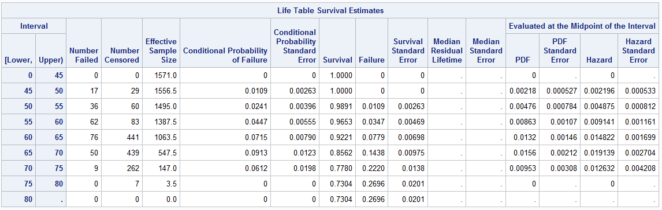

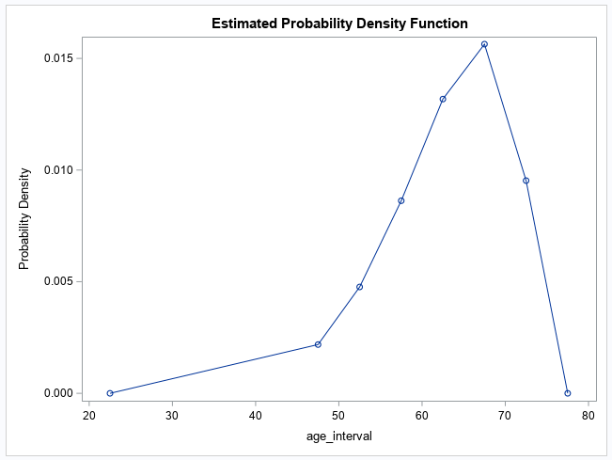

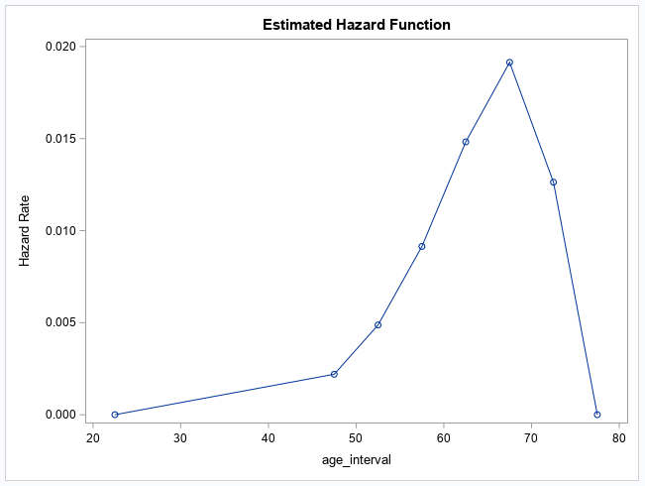

Question 4

Looking at the above graphs, we notice